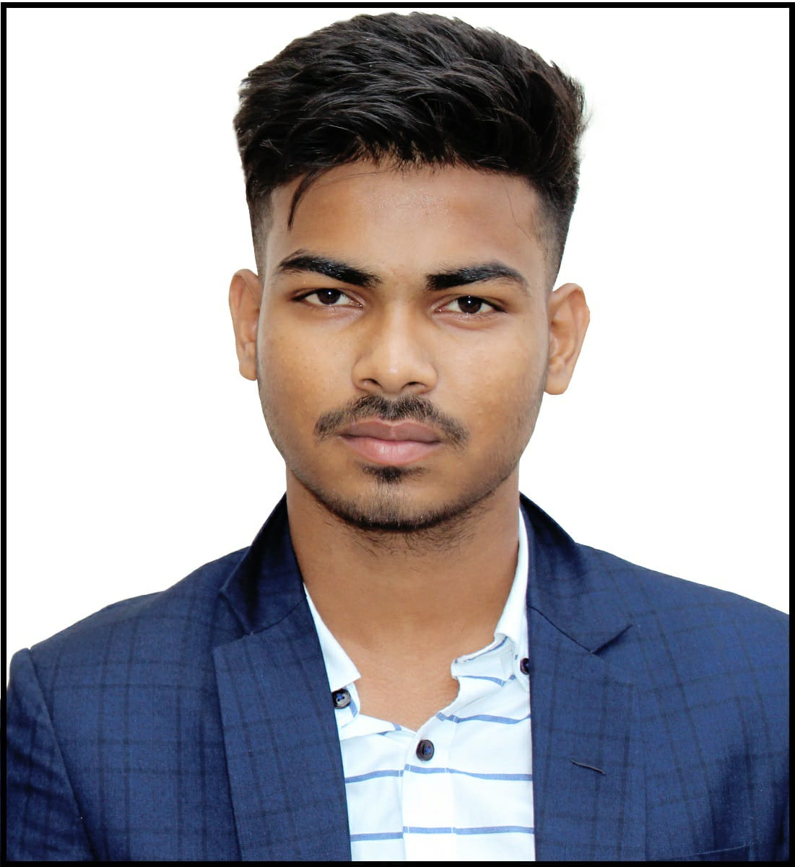

**Interview Form**

|  |  |
| --- | --- |
| Job Applicant Name: Rashmiranjan Dash | Date of Interview: 03 - 06 - 2022 |
| Email Id: [guddudash73@gmail.com](mailto:guddudash73@gmail.com) | Contact #: 7749064894 |
| Expected Date Of Joining:  01-07-2022 | College Name: Kiit University |
| Are you comfortable to sign a Service Agreement / Bond for 18 months, if you get selected: Please tick | YES yes NO |
| Current Address:  Same as permanent Address | Hometown/Permanent Address:  At/po – Nalgunda, Via- motto, P.S- Chandbali, Bhadrak, Odisha, 756132 |

|  |  |
| --- | --- |
| For Office Use Only | |
| Round 1 Feedback |  |
| Round 2 Feedback |  |
| Round 3 Feedback |  |
| Overall Feedback |  |