**LAB 1**

**Q1 i. WAP to input name, roll number and marks in 5 subjects for a student, and display it.**

**#include <stdio.h>**

**char name[50];**

**int roll;**

**float marks,a,b,c,d;**

**int main() {**

**printf("Enter information:\n");**

**printf("Enter name: ");**

**scanf("%s",&name);**

**printf("Enter roll number: ");**

**scanf("%d", &roll);**

**printf("Enter subject 1 mark: ");**

**scanf("%f", &marks);**

**printf("Enter subject 2 mark: ");**

**scanf("%f", &a);**

**printf("Enter subject 3 mark: ");**

**scanf("%f", &b);**

**printf("Enter subject 4 mark: ");**

**scanf("%f", &c);**

**printf("Enter subject 5 mark: ");**

**scanf("%f", &d);**

**printf("Displaying Information:\n");**

**printf("Name: ");**

**printf("%s", name);**

**printf("\nRoll number: %d\n", roll);**

**printf("subject 1 mark:: %f\n", marks);**

**printf("subject 2 mark:: %f\n", a);**

**printf("subject 3 mark:: %f\n", b);**

**printf("subject 4 mark:: %f\n", c);**

**printf("subject 5 mark:: %f\n", d);**

**return 0;**

**}**

**OUTPUT:-**

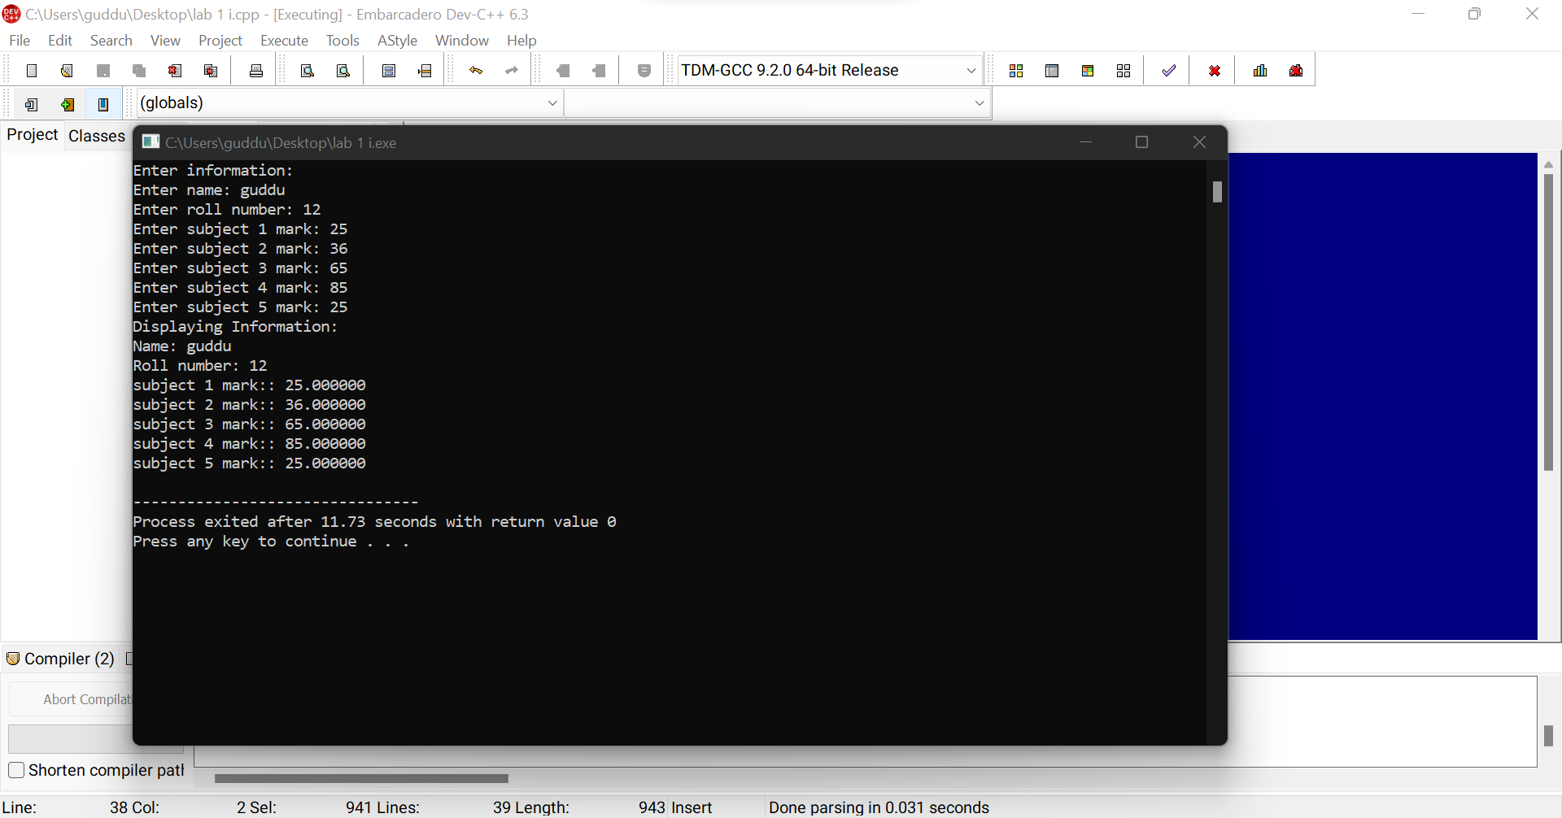

**Q2.ii. WAP to input name, roll number and marks in 5 subjects for n number of students. Write**

**functions to:-**

**a. Find total marks and percentage of all n students.**

**b. Display details of a student with a given roll number.**

**c. Display the details for all the students having percentage in a given range.**

**d. Sort the array in ascending order of marks.**

**Ans:-**

**#include<stdio.h>**

**#include<conio.h>**

**struct Student{**

**char name[30];**

**int rollNumber;**

**int marks[5];**

**int totalMarks;**

**float percentage;**

**};**

**//a. Find total marks and percentage of all n students.**

**void findTotalMarksPercentageStudents(struct Student students[],int numberStudents){**

**int i,m;**

**for(i=0;i<numberStudents;i++){**

**students[i].totalMarks=0;**

**students[i].percentage=0.0;**

**for(m=0;m<5;m++){**

**students[i].totalMarks+=students[i].marks[m];**

**students[i].percentage+=students[i].marks[m]*0.2;**

**}**

**}**

**}**

**//b. Display details of a student with a given roll number.**

**void displayDetailsStudent(struct Student students[],int numberStudents,int rollNumber){**

**int i,m;**

**for(i=0;i<numberStudents;i++){**

**if(rollNumber==students[i].rollNumber){**

**printf("The student's name: %s\n",students[i].name);**

**printf("The student's roll number: %d\n",students[i].rollNumber);**

**printf("The student's marks\n");**

**for(m=0;m<5;m++){**

**printf("%d ",students[i].marks[m]);**

**}**

**printf("\nThe student's total marks: %d\n",students[i].totalMarks);**

**printf("The student's percentage: %.2f\n",students[i].percentage);**

**printf("\n");**

**break;**

**}**

**}**

**}**

**//c. Display the details for all the students having percentage in a given range.**

**void displayDetailsSudentsPercentageRange(struct Student students[],int numberStudents,float percentage1,float percentage2 ){**

**int i,m;**

**for(i=0;i<numberStudents;i++){**

**if(students[i].percentage>=percentage1 && students[i].percentage<=percentage2){**

**printf("The student's name: %s\n",students[i].name);**

**printf("The student's roll number: %d\n",students[i].rollNumber);**

**printf("The student's marks\n");**

**for(m=0;m<5;m++){**

**printf("%d ",students[i].marks[m]);**

**}**

**printf("\nThe student's total marks: %d\n",students[i].totalMarks);**

**printf("The student's percentage: %.2f\n",students[i].percentage);**

**printf("\n");**

**}**

**}**

**}**

**//d. Sort the array in ascending order of marks.**

**void sortArrayInAscendingOrderMark(struct Student students[],int numberStudents){**

**int i,j,m;**

**for (i = 0; i < numberStudents - 1; i++){**

**for (j = 0; j < numberStudents - i - 1; j++){**

**if (students[j].totalMarks > students[j + 1].totalMarks)**

**{**

**// swap temp and elements[i]**

**struct Student temp = students[j];**

**students[j] = students[j + 1];**

**students[j + 1] = temp;**

**}**

**}**

**}**

**for(i=0;i<numberStudents;i++){**

**printf("The student's name: %s\n",students[i].name);**

**printf("The student's roll number: %d\n",students[i].rollNumber);**

**printf("The student's marks\n");**

**for(m=0;m<5;m++){**

**printf("%d ",students[i].marks[m]);**

**}**

**printf("\nThe student's total marks: %d\n",students[i].totalMarks);**

**printf("The student's percentage: %.2f\n",students[i].percentage);**

**printf("\n");**

**}**

**}**

**void main()**

**{**

**struct Student students[100];**

**int numberStudents,i,m;**

**int rollNumber;**

**float percentage1;**

**float percentage2;**

**printf("Enter the number of students: ");**

**scanf("%d",&numberStudents);**

**for(i=0;i<numberStudents;i++){**

**fflush(stdin);**

**printf("Enter the student's name: ");**

**gets(students[i].name);**

**printf("Enter the student's roll number: ");**

**scanf("%d",&students[i].rollNumber);**

**for(m=0;m<5;m++){**

**printf("Enter the student's mark %d: ",(m+1));**

**scanf("%d",&students[i].marks[m]);**

**}**

**printf("\n");**

**}**

**findTotalMarksPercentageStudents(students,numberStudents);**

**printf("Enter the student's roll number to search: ");**

**scanf("%d",&rollNumber);**

**displayDetailsStudent(students,numberStudents,rollNumber);**

**printf("Enter the student's percentage 1 to search: ");**

**scanf("%f",&percentage1);**

**printf("Enter the student's percentage 2 to search: ");**

**scanf("%f",&percentage2);**

**displayDetailsSudentsPercentageRange(students,numberStudents,percentage1,percentage2);**

**printf("\nSort the array in ascending order of marks.\n");**

**sortArrayInAscendingOrderMark(students,numberStudents);**

**printf("\n");**

**getch();**

**getch();**

**}**

**Output :-**

