PYTHON PROGRAMMING
ACTIVITY - BASED LEARNING
10 Case Studies with Solutions

• Name: Gudela.Yashwanth kumar
• Roll Number: 26000906
• Branch: Computer Science & Engineering (AI & ML)
• Section: CSM1
• Course: Python Programming
• Institution: Dr. RVR NRI Institute of Technology

Contents : -
Case Study 1: ATM Transaction Sequence Simulation (ATM trsaction.py)
Case Study 2: Mobile Plan Data Validity & Cost Optimization (data validity.py)
Case Study 3: Progressive Electricity Billing System (elctricity bill.py)
Case Study 4: Food Waste Monitoring System (food.py)
Case Study 5: Fuel Consumption and Cost Comparison (fuel consumption.py)
Case Study 6: Hospital Billing and Patient Classification (hospital bill.py)
Case Study 7: Smart Parking Fee Management (smart parkingfee.py)
Case Study 8: University Scholarship Allocation (student Scholarship.py)
Case Study 9: Attendance Recovery Computation (student attendence.py)
Case Study 10: Traffic Violation Penalty Calculator (traffic rules.py)

CASE STUDY 1: ATM Transaction Sequence Simulation
1. Problem Statement
Automated Teller Machines (ATMs) require an automated session management system to process sequential deposit and withdrawal transactions while checking withdrawal limits of Rs. 3000, enforcing available balance constraints, tracking rejected operations, and reporting account closing totals upon session exit.
2. Objectives
• Initialize account opening balance to Rs. 5000 and maintain cumulative deposit/withdrawal counters.
• Process customer transactions iteratively through a continuous while loop interface.
• Verify that withdrawal requests do not exceed the per-transaction cap of Rs. 3000 or the current account balance.
• Track and report successful deposits, withdrawals, rejected attempts, and the final account balance.
3. Assumptions
• Opening balance is set to a baseline of Rs. 5000.
• Deposit amounts must be strictly positive integers.
• Maximum withdrawal per single transaction is capped at Rs. 3000.
• Entering choice 0 exits the transaction loop and generates a transaction summary.
4. Algorithm
Start.
Initialize balance = 5000, deposits = 0, withdrawals = 0, and rejected = 0.
Display options: 1. Deposit, 2. Withdraw, 0. Exit, and input user choice.
If choice is 1, read deposit amount; if amount > 0, update balance and deposits counter; else increment rejected.
If choice is 2, read withdrawal amount; if amount <= 0 or amount > 3000 or amount > balance, reject transaction and increment rejected; else deduct from balance and add to withdrawals counter.
If choice is 0, terminate the interactive loop.
If choice is invalid, increment rejected counter.
Display total deposits, total withdrawals, rejected count, and closing balance.
Stop.
5. Flowchart
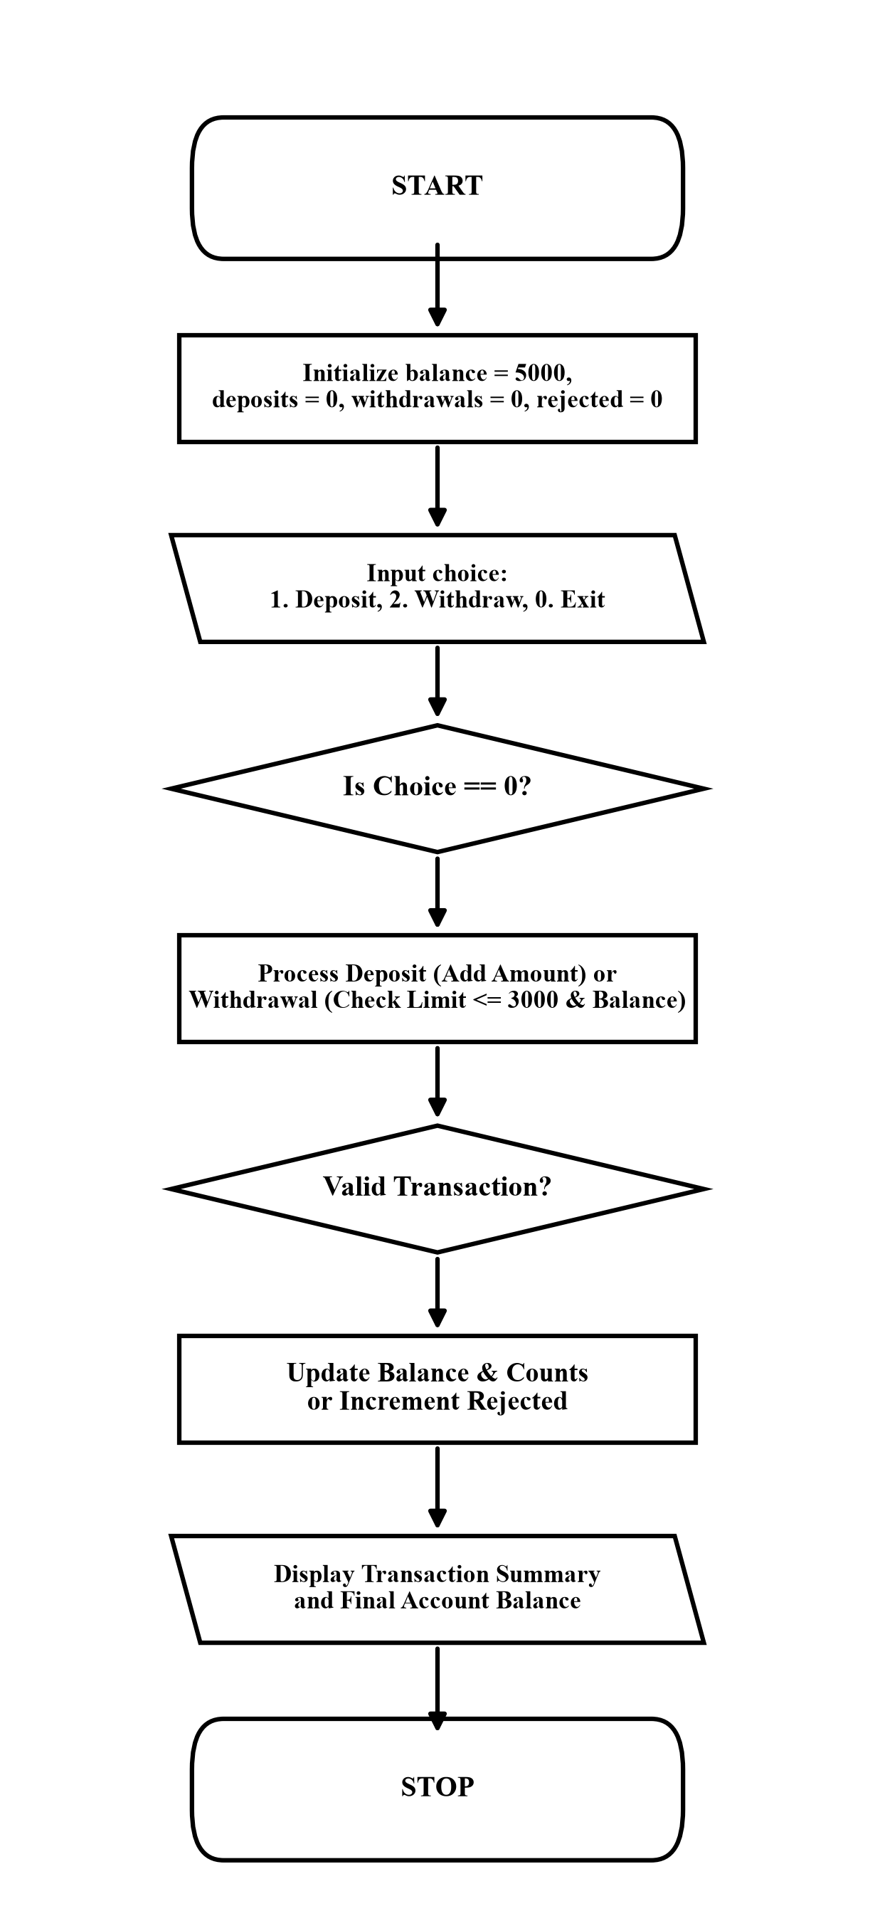

6. Pseudocode
START
balance = 5000
deposits = 0, withdrawals = 0, rejected = 0
WHILE TRUE DO
INPUT choice
IF choice == 1 THEN
INPUT amount
IF amount > 0 THEN balance = balance + amount, deposits = deposits + amount
ELSE rejected = rejected + 1
ELSE IF choice == 2 THEN
INPUT amount
IF amount <= 0 OR amount > 3000 OR amount > balance THEN rejected = rejected + 1
ELSE balance = balance - amount, withdrawals = withdrawals + amount
ELSE IF choice == 0 THEN BREAK
ELSE rejected = rejected + 1
END WHILE
PRINT deposits, withdrawals, rejected, balance
STOP
7. Python Source Code (ATM trsaction.py)
print("ATM TRANSACTION SYSTEM")
balance = 5000
deposits = 0
withdrawals = 0
rejected = 0
while True:
print("\n1. Deposit")
print("2. Withdraw")
print("0. Exit")
choice = int(input("Enter your choice: "))
if choice == 1:
amount = int(input("Enter deposit amount: "))
if amount > 0:
balance = balance + amount
deposits = deposits + amount
print("Deposit successful")
else:
print("Invalid amount")
rejected = rejected + 1
elif choice == 2:
amount = int(input("Enter withdrawal amount: "))
if amount <= 0:
print("Invalid amount")
rejected = rejected + 1
elif amount > 3000:
print("Withdrawal limit exceeded")
rejected = rejected + 1
elif amount > balance:
print("Insufficient balance")
rejected = rejected + 1
else:
balance = balance - amount
withdrawals = withdrawals + amount
print("Withdrawal successful")
elif choice == 0:
break
else:
print("Invalid choice")
rejected = rejected + 1
print("\nTRANSACTION SUMMARY")
print("Total Deposits:", deposits)
print("Total Withdrawals:", withdrawals)
print("Rejected Transactions:", rejected)
print("Final Balance:", balance)
8. Test Cases
Input / Situation | Expected Result | Purpose
Deposit: 1500, Withdraw: 500, Exit: 0 | Deposits: 1500, Withdrawals: 500, Rejected: 0, Final: 6000 | Normal sequential banking operations
Withdraw: 3500 from 5000 | Rejection: Withdrawal limit exceeded, Rejected count: 1 | Single transaction ceiling cap check
Withdraw: 6000 from 5000 | Rejection: Insufficient balance, Rejected count: 1 | Account solvency protection verification
9. Output screenshots
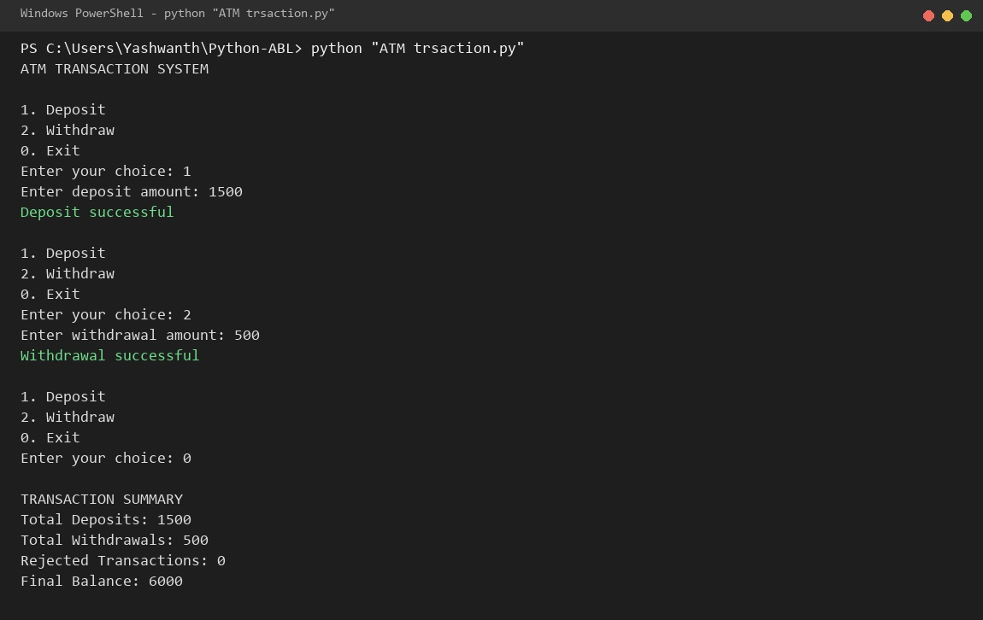
10. Conclusion
The ATM transaction program implements a robust state machine using while loops and conditional guards, ensuring account integrity and strict withdrawal ceiling compliance.

CASE STUDY 2: Mobile Plan Data Validity & Cost Optimization
1. Problem Statement
Mobile subscribers frequently struggle to select the most economical cellular recharge plan that satisfies their daily high-speed internet data consumption, required validity duration, and financial spending budget across competing operator tiers.
2. Objectives
• Read subscriber daily data usage requirement (GB), validity days, and maximum budget constraint.
• Model subscription specifications for Plan A (Rs.199, 1GB/day, 28d), Plan B (Rs.299, 1.5GB/day, 56d), and Plan C (Rs.399, 2GB/day, 84d).
• Evaluate eligibility conditions across all three subscription plans against user criteria.
• Recommend the most cost-effective feasible cellular plan within budget limits.
3. Assumptions
• Daily data requirements and validity days are non-negative numerical inputs.
• Subscribers require uninterrupted daily allocation meeting or exceeding usage.
• Among eligible compliant plans, the lowest subscription price is selected.
4. Algorithm
Start.
Input subscriber daily data usage (GB), required validity days, and spending budget (Rs.).
Define plan parameters: Plan A (199, 1GB, 28d), Plan B (299, 1.5GB, 56d), Plan C (399, 2GB, 84d).
Initialize best_price = 0 and best_plan = ''.
Check Plan A eligibility: if data1 >= usage and validity1 >= days and price1 <= budget, set best_plan = 'Plan A', best_price = price1.
Check Plan B eligibility: if criteria satisfied and (best_price == 0 or price2 < best_price), select Plan B.
Check Plan C eligibility: if criteria satisfied and (best_price == 0 or price3 < best_price), select Plan C.
If an eligible plan is identified, display best plan name and price; otherwise report no suitable plan available.
Stop.
5. Flowchart
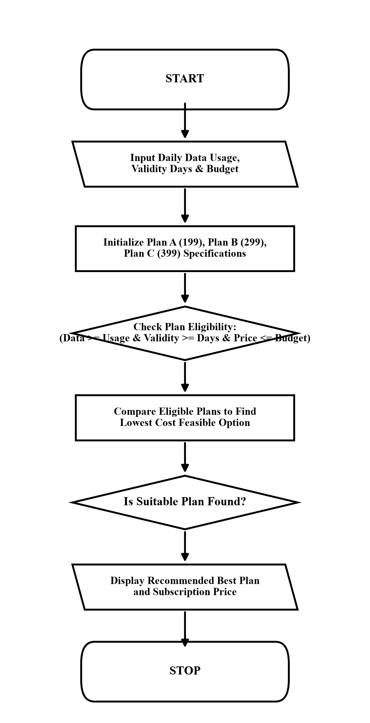

6. Pseudocode
START
INPUT usage, days, budget
best_price = 0, best_plan = ""
IF 1.0 >= usage AND 28 >= days AND 199 <= budget THEN
best_price = 199, best_plan = "Plan A"
END IF
IF 1.5 >= usage AND 56 >= days AND 299 <= budget THEN
IF best_price == 0 OR 299 < best_price THEN best_price = 299, best_plan = "Plan B"
END IF
IF 2.0 >= usage AND 84 >= days AND 399 <= budget THEN
IF best_price == 0 OR 399 < best_price THEN best_price = 399, best_plan = "Plan C"
END IF
IF best_price > 0 THEN PRINT best_plan, best_price
ELSE PRINT "No suitable plan available"
STOP
7. Python Source Code (data validity.py)
print("MOBILE PLAN COMPARISON")
usage = float(input("Enter your daily data usage: "))
days = int(input("Enter required validity days: "))
budget = int(input("Enter your budget: "))
price1 = 199
data1 = 1
validity1 = 28
price2 = 299
data2 = 1.5
validity2 = 56
price3 = 399
data3 = 2
validity3 = 84
best_price = 0
best_plan = ""
if data1 >= usage and validity1 >= days and price1 <= budget:
best_price = price1
best_plan = "Plan A"
if data2 >= usage and validity2 >= days and price2 <= budget:
if best_price == 0 or price2 < best_price:
best_price = price2
best_plan = "Plan B"
if data3 >= usage and validity3 >= days and price3 <= budget:
if best_price == 0 or price3 < best_price:
best_price = price3
best_plan = "Plan C"
if best_price > 0:
print("Best Plan:", best_plan)
print("Plan Price:", best_price)
else:
print("No suitable plan available")
8. Test Cases
Input / Situation | Expected Result | Purpose
Usage: 1.2 GB, Days: 28, Budget: 300 | Best Plan: Plan B, Plan Price: 299 | Intermediate data requirement tier selection
Usage: 0.8 GB, Days: 25, Budget: 200 | Best Plan: Plan A, Plan Price: 199 | Budget-conscious baseline tier selection
Usage: 3.5 GB, Days: 30, Budget: 500 | No suitable plan available | Excessive daily quota exceeding all plans
9. Output screenshots
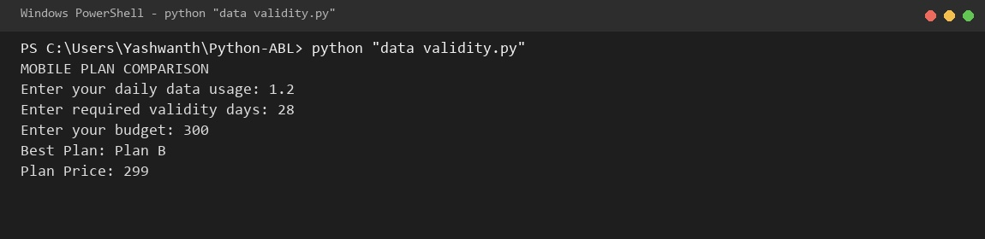
10. Conclusion
The mobile plan validation system optimizes telecom subscription costs by screening multi-attribute constraints and selecting the most economical tariff.

CASE STUDY 3: Progressive Electricity Billing System
1. Problem Statement
An electric utility provider charges consumers using tiered progressive energy slabs, applies fixed connection fees, adds high-consumption surcharges, grants prompt conservation rebates for low usage, and conducts a 3-month trend audit to detect anomalous surges.
2. Objectives
• Read monthly electricity units consumed across three consecutive billing cycles.
• Compute progressive slab energy charges (0-100 @ Rs.2, 101-200 @ Rs.3, >200 @ Rs.5).
• Add fixed connection fees (Rs. 50), compute 5% surcharge, and apply 10% low-usage conservation rebate.
• Compare bills across quarters and flag unusual consumption surges exceeding 1.5x previous periods.
3. Assumptions
• Monthly consumption units are non-negative integer readings.
• Fixed service charge of Rs. 50 applies to each monthly billing statement.
• Prompt conservation rebate of 10% is awarded only when monthly usage <= 100 units.
• A billing increase of more than 50% (> 1.5x) triggers an anomaly notification.
4. Algorithm
Start.
Input units consumed for Month 1, Month 2, and Month 3 into a list.
Iterate through months 1 to 3 using a for loop.
Compute base energy charge: if units <= 100, units * 2; elif units <= 200, 200 + (units - 100) * 3; else 500 + (units - 200) * 5.
Add fixed charge of Rs. 50. Calculate 5% surcharge and add to bill.
If units <= 100, calculate 10% conservation rebate and deduct from bill; else rebate = 0.
Append calculated final bill to bills list.
Display monthly bill statement and compare: if bill[1] > 1.5 * bill[0], flag Month 2 surge; if bill[2] > 1.5 * bill[1], flag Month 3 surge.
Stop.
5. Flowchart
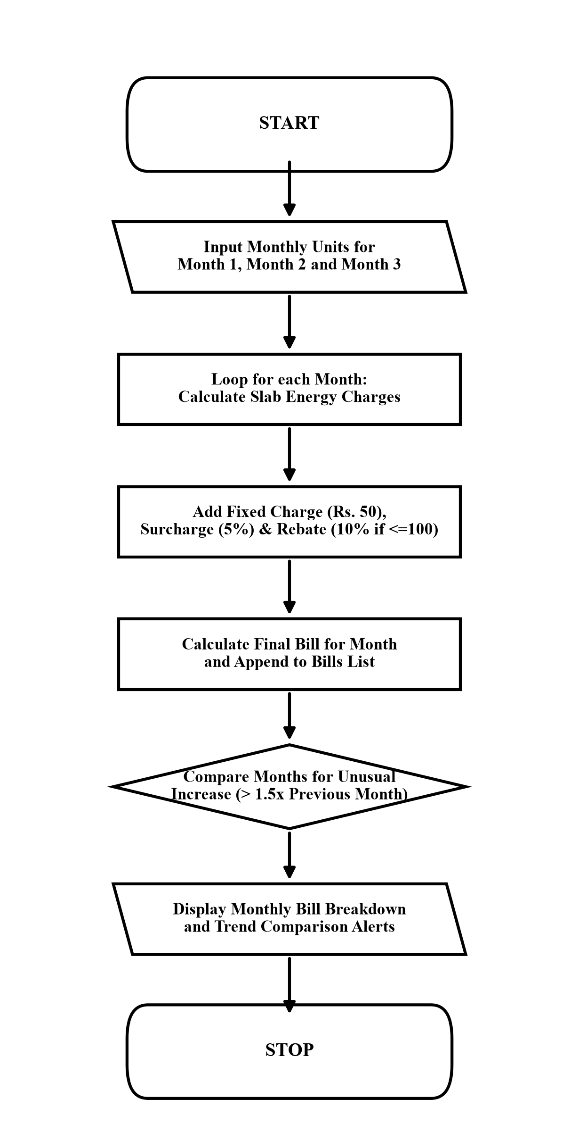

6. Pseudocode
START
INPUT units1, units2, units3
units = [units1, units2, units3], bills = []
FOR i = 0 TO 2 DO
IF units[i] <= 100 THEN bill = units[i] * 2
ELSE IF units[i] <= 200 THEN bill = 200 + (units[i] - 100) * 3
ELSE bill = 500 + (units[i] - 200) * 5
bill = bill + 50
surcharge = bill * 0.05
bill = bill + surcharge
IF units[i] <= 100 THEN rebate = bill * 0.10 ELSE rebate = 0
bill = bill - rebate
bills.APPEND(bill)
END FOR
IF bills[1] > bills[0] * 1.5 THEN PRINT "Unusual increase in Month 2"
IF bills[2] > bills[1] * 1.5 THEN PRINT "Unusual increase in Month 3"
STOP
7. Python Source Code (elctricity bill.py)
# Electricity Billing System
units1 = int(input("Enter Month 1 units: "))
units2 = int(input("Enter Month 2 units: "))
units3 = int(input("Enter Month 3 units: "))
units = [units1, units2, units3]
bills = []
for i in range(3):
print("\nMonth", i + 1)
print("Units:", units[i])
if units[i] <= 100:
bill = units[i] * 2
elif units[i] <= 200:
bill = 200 + (units[i] - 100) * 3
else:
bill = 500 + (units[i] - 200) * 5
print("Energy charge:", bill)
bill = bill + 50
print("Fixed charge: 50")
surcharge = bill * 0.05
bill = bill + surcharge
print("Surcharge:", round(surcharge, 2))
if units[i] <= 100:
rebate = bill * 0.10
else:
rebate = 0
bill = round(bill - rebate, 2)
print("Rebate:", round(rebate, 2))
print("Final bill: Rs.", bill)
bills.append(bill)
print("\n--- Monthly Comparison ---")
print("Month 1 bill:", bills[0])
print("Month 2 bill:", bills[1])
print("Month 3 bill:", bills[2])
if bills[1] > bills[0] * 1.5:
print("Unusual increase in Month 2")
if bills[2] > bills[1] * 1.5:
print("Unusual increase in Month 3")
8. Test Cases
Input / Situation | Expected Result | Purpose
Month 1: 80, Month 2: 150, Month 3: 250 | M1: Rs. 198.45, M2: Rs. 420.0, M3: Rs. 840.0; Surge: M2 and M3 | Progressive slab transition and surge alert
Month 1: 60, Month 2: 70, Month 3: 80 | All months eligible for 10% rebate; No surge warnings | Consistent baseline low-consumption rebate
Month 1: 100, Month 2: 100, Month 3: 100 | Bills identical (Rs. 236.25); Stable trend line | Steady quarterly consumption stability
9. Output screenshots
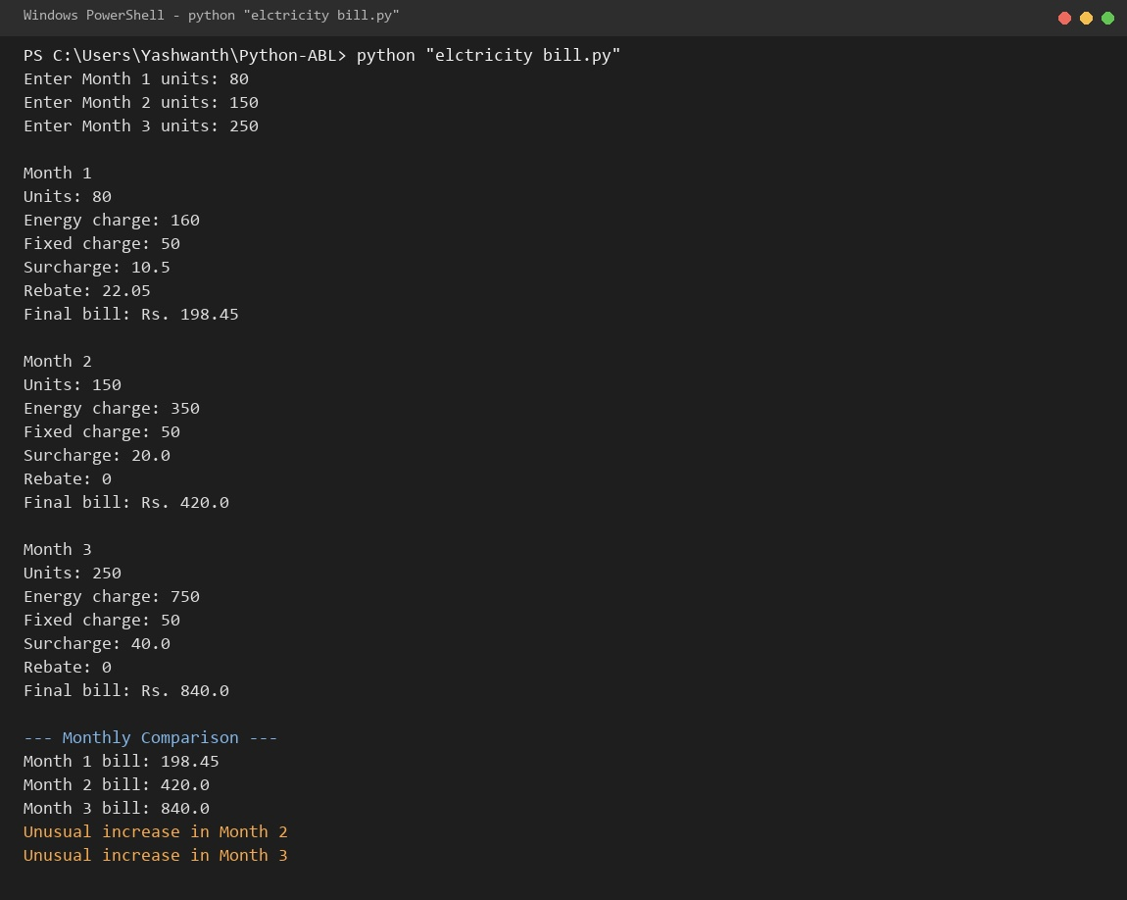
10. Conclusion
The progressive electricity billing system automates utility accounting, providing transparent tariff tiering and proactive quarterly surge detection.

CASE STUDY 4: Food Waste Monitoring System
1. Problem Statement
Institutional cafeterias and hospitality dining halls require automated food waste tracking to monitor meals prepared versus meals served, calculate leftover percentages, and issue immediate warnings when wastage exceeds acceptable thresholds.
2. Objectives
• Read total number of operational days monitored in the assessment window.
• Iterate across daily dining cycles and read prepared meal and served meal quantities.
• Compute daily leftover food and percentage wastage = (leftover / prepared) * 100.
• Evaluate wastage against the statutory 10% limit and issue high wastage alert warnings.
3. Assumptions
• Prepared meal counts are strictly positive integers.
• Served meal counts are non-negative and do not exceed prepared counts.
• The acceptable statutory threshold for food wastage is capped at 10%.
4. Algorithm
Start.
Input number of monitoring days.
Set allowable wastage limit = 10%.
For each day from 1 to days:
a. Input food prepared and food served.
b. Calculate leftover = prepared - served.
c. Calculate wastage percentage = (leftover / prepared) * 100.
d. Display leftover quantity and wastage percentage.
e. If wastage percentage > limit, print 'High food wastage!'; else print 'Food wastage is under control.'.
Stop.
5. Flowchart
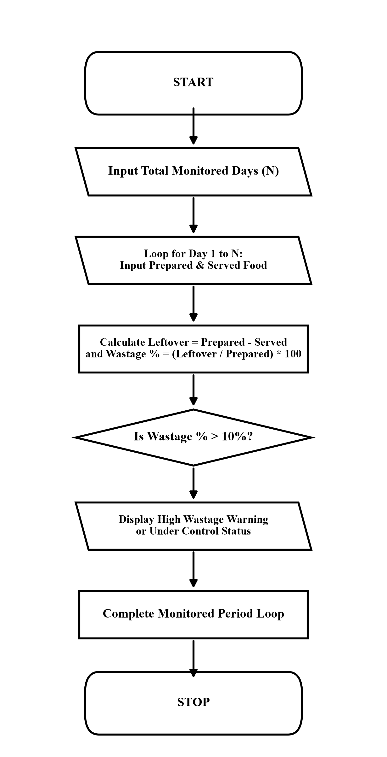

6. Pseudocode
START
INPUT days
limit = 10
FOR i = 1 TO days DO
INPUT prepared, served
leftover = prepared - served
wastage = (leftover / prepared) * 100
PRINT leftover, wastage
IF wastage > limit THEN
PRINT "High food wastage!"
ELSE
PRINT "Food wastage is under control."
END IF
END FOR
STOP
7. Python Source Code (food.py)
print("FOOD WASTE MONITORING SYSTEM")
days = int(input("Enter number of days: "))
limit = 10
for i in range(days):
print("\nDay", i + 1)
prepared = int(input("Enter food prepared: "))
served = int(input("Enter food served: "))
leftover = prepared - served
wastage = (leftover / prepared) * 100
print("Leftover food:", leftover)
print("Food wastage:", wastage, "%")
if wastage > limit:
print("High food wastage!")
else:
print("Food wastage is under control.")
8. Test Cases
Input / Situation | Expected Result | Purpose
Day 1: 100 prep, 92 serv; Day 2: 120 prep, 105 serv | Day 1: 8.0% (Under control), Day 2: 12.5% (High wastage warning) | Threshold breach identification
Day 1: 150 prep, 150 serv | Leftover: 0, Wastage: 0.0% (Under control) | Zero wastage optimal efficiency check
Day 1: 80 prep, 60 serv | Leftover: 20, Wastage: 25.0% (High wastage warning) | Severe wastage detection test
9. Output screenshots
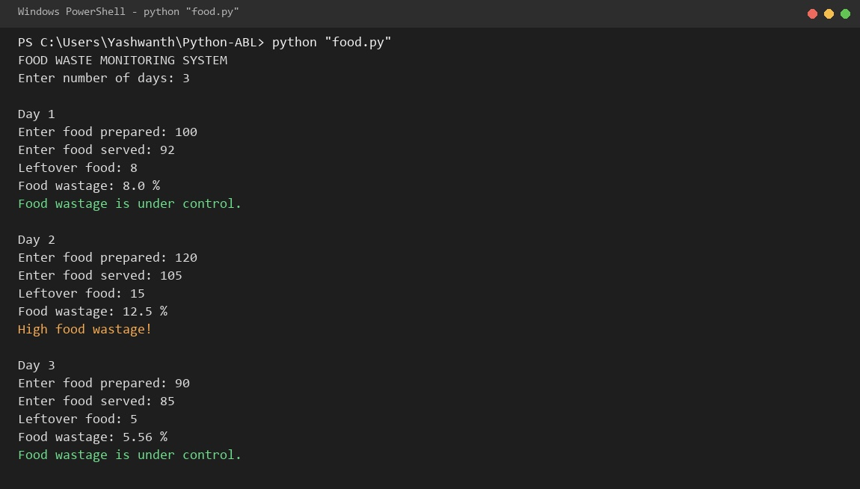
10. Conclusion
The food waste monitoring system enables dining halls to identify operational food inefficiencies, supporting resource sustainability through loop-based daily audits.

CASE STUDY 5: Fuel Consumption and Cost Comparison
1. Problem Statement
Travelers and transportation fleet operators need an automated cost comparison tool to determine the most economical vehicle choice across two-wheelers, sedans, and SUVs for a designated trip distance, accounting for fuel price and safety reserves.
2. Objectives
• Read journey trip distance in kilometers from user input.
• Model vehicle mileage profiles: Bike (40 km/l), Car (20 km/l), and SUV (12 km/l).
• Incorporate a 2-liter mandatory safety reserve fuel buffer and price of Rs. 105 per liter.
• Compute total trip costs across all vehicle classes and recommend the cheapest travel alternative.
3. Assumptions
• Trip distance is a positive floating-point numerical value.
• Fuel price is fixed at Rs. 105 per liter with a 2-liter reserve margin across all vehicles.
• Vehicle fuel ratings remain constant over the duration of the trip.
4. Algorithm
Start.
Input journey distance in km.
Set fuel price = Rs. 105/liter and reserve = 2 liters.
Define fuel mileage ratings: Bike = 40 km/l, Car = 20 km/l, SUV = 12 km/l.
Compute total fuel and cost for Bike: fuel = (dist / 40) + 2, cost = fuel * 105.
Compute total fuel and cost for Car: fuel = (dist / 20) + 2, cost = fuel * 105.
Compute total fuel and cost for SUV: fuel = (dist / 12) + 2, cost = fuel * 105.
Compare computed costs and identify lowest-cost vehicle class.
Display cost summary, cheapest vehicle recommendation, and required fuel volume.
Stop.
5. Flowchart
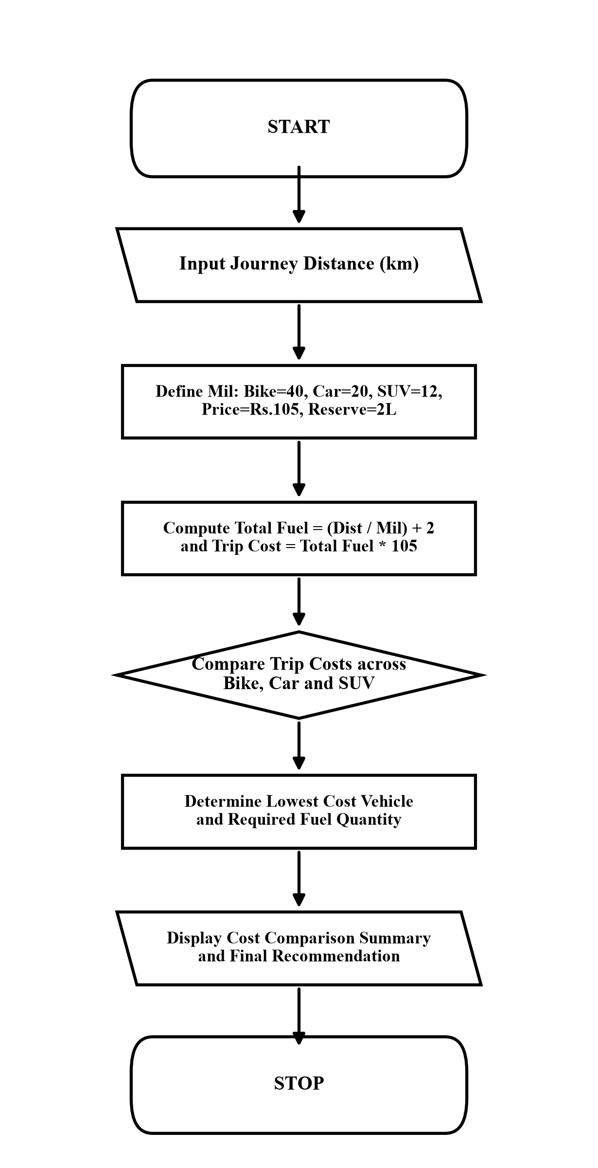

6. Pseudocode
START
INPUT distance
price = 105, reserve = 2
bike_total = (distance / 40) + reserve; bike_cost = bike_total * price
car_total = (distance / 20) + reserve; car_cost = car_total * price
suv_total = (distance / 12) + reserve; suv_cost = suv_total * price
PRINT bike_cost, car_cost, suv_cost
IF bike_cost <= car_cost AND bike_cost <= suv_cost THEN
PRINT "Lowest Cost Vehicle: Bike", bike_total
ELSE IF car_cost <= suv_cost THEN
PRINT "Lowest Cost Vehicle: Car", car_total
ELSE
PRINT "Lowest Cost Vehicle: SUV", suv_total
END IF
STOP
7. Python Source Code (fuel consumption.py)
print("FUEL COST COMPARISON")
distance = float(input("Enter journey distance in km: "))
price = 105
reserve = 2
bike = 40
car = 20
suv = 12
bike_fuel = distance / bike
bike_total = bike_fuel + reserve
bike_cost = bike_total * price
car_fuel = distance / car
car_total = car_fuel + reserve
car_cost = car_total * price
suv_fuel = distance / suv
suv_total = suv_fuel + reserve
suv_cost = suv_total * price
print("Bike Cost:", bike_cost)
print("Car Cost:", car_cost)
print("SUV Cost:", suv_cost)
if bike_cost <= car_cost and bike_cost <= suv_cost:
print("Lowest Cost Vehicle: Bike")
print("Total Fuel Required:", bike_total)
elif car_cost <= suv_cost:
print("Lowest Cost Vehicle: Car")
print("Total Fuel Required:", car_total)
else:
print("Lowest Cost Vehicle: SUV")
print("Total Fuel Required:", suv_total)
8. Test Cases
Input / Situation | Expected Result | Purpose
Distance: 250 km | Bike: Rs. 866.25, Car: Rs. 1522.50, SUV: Rs. 2397.50 -> Lowest: Bike | Standard comparative vehicle routing
Distance: 100 km | Bike: Rs. 472.50, Car: Rs. 735.00, SUV: Rs. 1085.00 -> Lowest: Bike | Short-haul commute cost optimization
Distance: 600 km | Bike: Rs. 1785.00, Car: Rs. 3360.00, SUV: Rs. 5460.00 -> Lowest: Bike | Long-distance highway travel analysis
9. Output screenshots
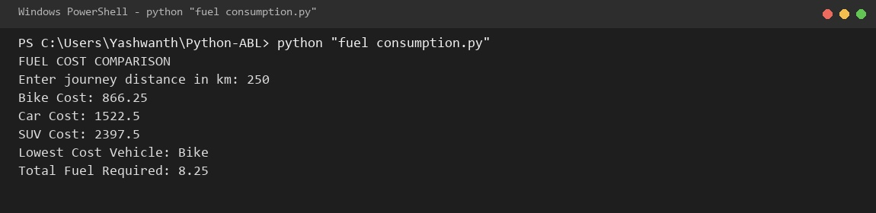
10. Conclusion
The fuel cost evaluation tool provides data-driven decision making for commuters by analyzing consumption rates, safety buffers, and monetary expenses.

CASE STUDY 6: Hospital Billing and Patient Classification
1. Problem Statement
Healthcare facilities need an automated patient billing system that aggregates consultation, diagnostic, and clinical treatment fees, awards institutional discounts for bills exceeding Rs. 3000, and categorizes patients into Full Payment or Concession Payment tiers.
2. Objectives
• Read consultation, diagnostic laboratory, and clinical treatment charges.
• Calculate total hospital invoice = consultation + diagnostic + treatment.
• Apply statutory institutional discount of Rs. 500 when gross bill reaches Rs. 3000.
• Categorize patient settlement status into 'Full Payment' or 'Concession Payment'.
3. Assumptions
• All medical expense line-items are non-negative integer values.
• A flat concession of Rs. 500 is applied if aggregate charges reach or exceed Rs. 3000.
• Final invoices of Rs. 3000 or above are classified as Full Payment; otherwise Concession Payment.
4. Algorithm
Start.
Input consultation charges, diagnostic charges, and treatment charges.
Compute total bill = consultation + diagnostic + treatment.
Display total bill amount.
If total bill >= 3000, set discount = 500; else discount = 0.
Compute final bill = total bill - discount.
If final bill >= 3000, set category = 'Full Payment'; else category = 'Concession Payment'.
Display discount applied, final payable bill, and patient classification category.
Stop.
5. Flowchart
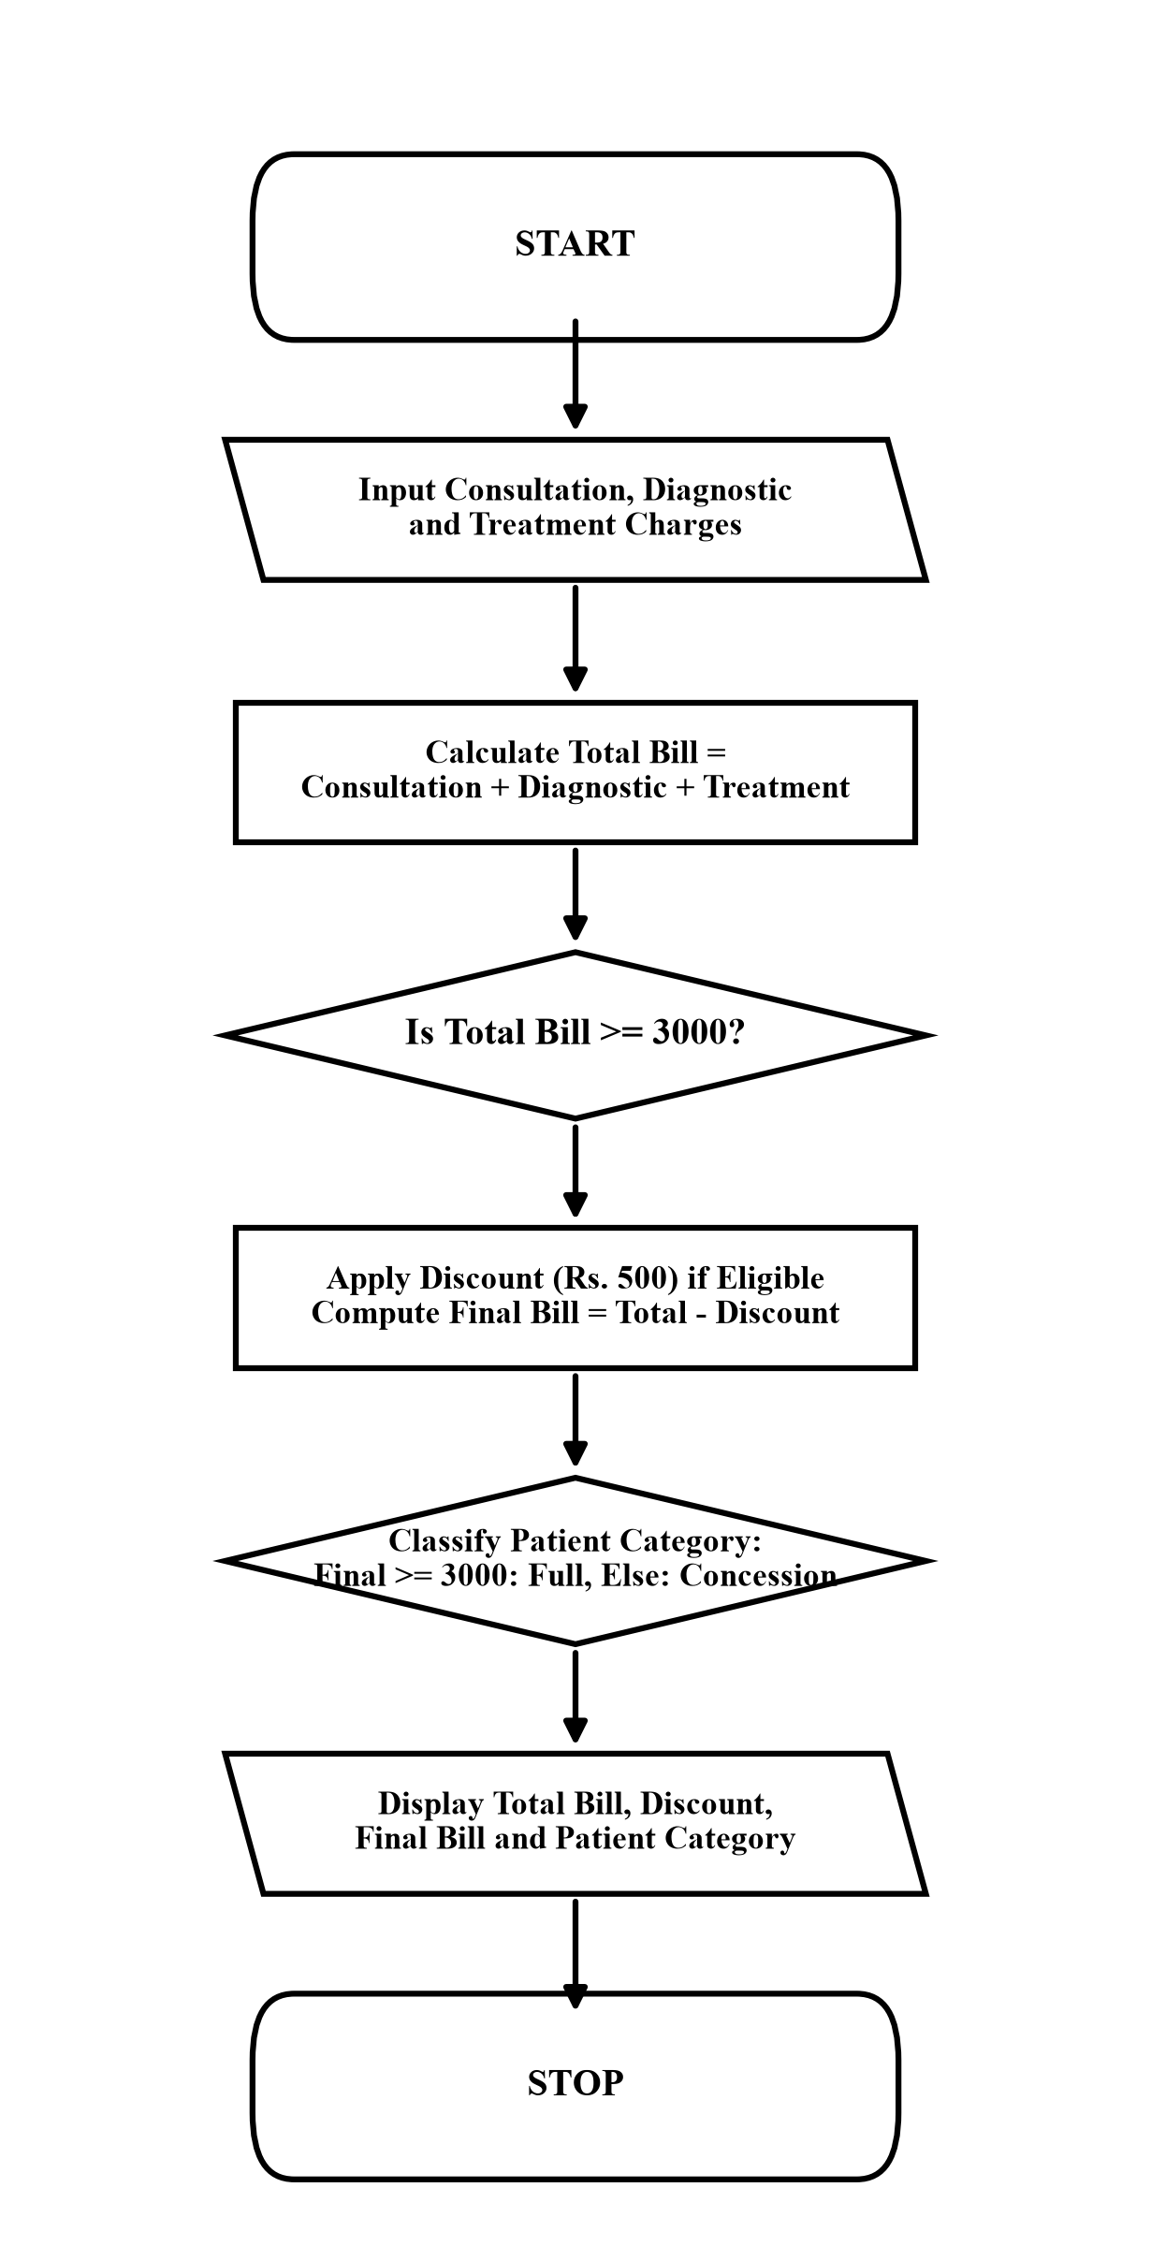

6. Pseudocode
START
INPUT consultation, diagnostic, treatment
total = consultation + diagnostic + treatment
IF total >= 3000 THEN discount = 500 ELSE discount = 0
final_bill = total - discount
IF final_bill >= 3000 THEN category = "Full Payment"
ELSE category = "Concession Payment"
PRINT discount, final_bill, category
STOP
7. Python Source Code (hospital bill.py)
print("HOSPITAL BILLING SYSTEM")
consultation = int(input("Enter consultation charges: "))
diagnostic = int(input("Enter diagnostic charges: "))
treatment = int(input("Enter treatment charges: "))
total = consultation + diagnostic + treatment
print("Total Bill:", total)
if total >= 3000:
discount = 500
else:
discount = 0
final_bill = total - discount
if final_bill >= 3000:
category = "Full Payment"
else:
category = "Concession Payment"
print("Discount:", discount)
print("Final Bill:", final_bill)
print("Patient Category:", category)
8. Test Cases
Input / Situation | Expected Result | Purpose
Consult: 500, Diag: 1500, Treat: 1200 | Total: 3200, Discount: 500, Final: 2700, Category: Concession Payment | High total qualifying for discount and concession tier
Consult: 1000, Diag: 2000, Treat: 1500 | Total: 4500, Discount: 500, Final: 4000, Category: Full Payment | Upper tier retaining Full Payment classification
Consult: 500, Diag: 800, Treat: 700 | Total: 2000, Discount: 0, Final: 2000, Category: Concession Payment | Sub-threshold billing without discount
9. Output screenshots
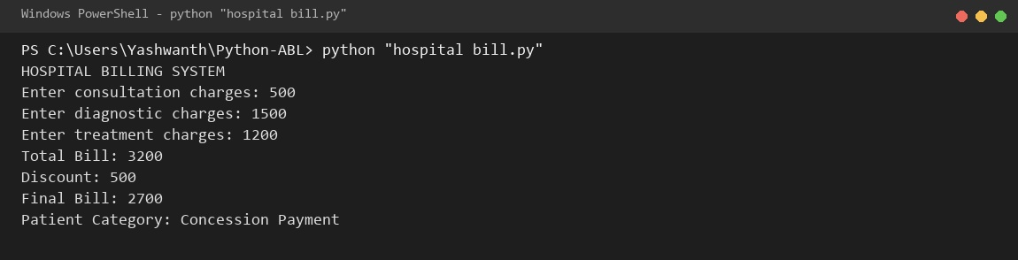
10. Conclusion
The hospital billing system automates patient invoicing and concession management, ensuring clear accounting and automated patient tier classification.

CASE STUDY 7: Smart Parking Fee Management
1. Problem Statement
Municipal smart parking facilities require an automated billing engine that applies vehicle-specific hourly rates (Bike, Car, Bus), supports 24-hour clock rolling across midnight, enforces minimum and maximum pricing boundaries, and adds an overnight surcharge.
2. Objectives
• Read vehicle type (bike/car/bus), entry hour (0-23), and exit hour (0-23).
• Validate 24-hour clock boundaries and detect overnight parking across midnight.
• Apply category hourly rates: Bike (Rs. 10), Car (Rs. 20), Bus (Rs. 40).
• Enforce minimum fee (Rs. 20), maximum fee cap (Rs. 200), and add Rs. 50 overnight surcharge.
3. Assumptions
• Entry and exit hours are integers between 0 and 23 inclusive.
• Parking duration cannot be zero (entry != exit).
• When exit hour < entry hour, the vehicle has parked overnight across midnight.
• Minimum billing is Rs. 20 and base fee is capped at Rs. 200 before overnight surcharge.
4. Algorithm
Start.
Input vehicle type string, entry hour, and exit hour.
If entry < 0 or entry > 23 or exit < 0 or exit > 23, display 'Invalid time' and stop.
If entry == exit, display 'Invalid parking time' and stop.
Determine hourly rate: bike = 10, car = 20, bus = 40; if unknown, display 'Invalid vehicle type'.
Compute parked duration: if exit < entry, hours = (24 - entry) + exit, overnight = 1; else hours = exit - entry, overnight = 0.
Calculate fee = hours * rate. If fee < 20, fee = 20; if fee > 200, fee = 200.
If overnight == 1, fee = fee + 50.
Display vehicle, parked hours, overnight status, and final fee.
Stop.
5. Flowchart
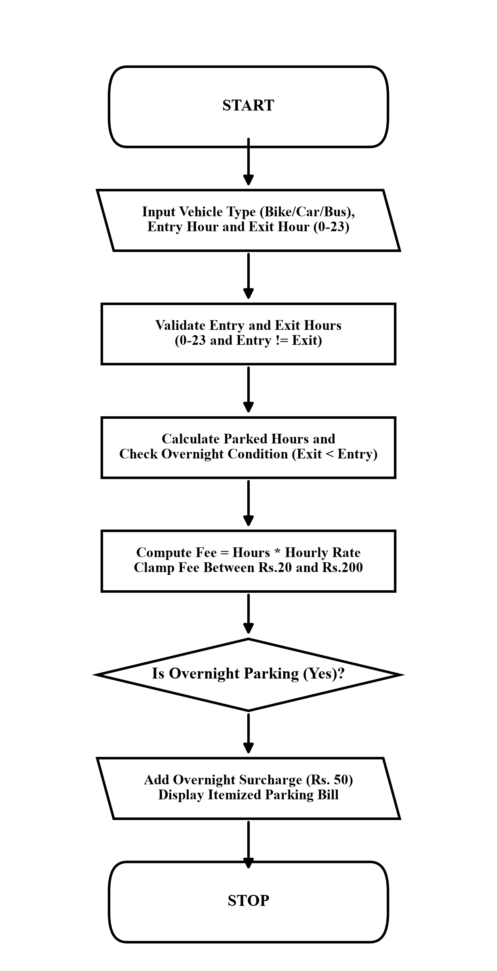

6. Pseudocode
START
INPUT vehicle, entry, exit
IF entry < 0 OR entry > 23 OR exit < 0 OR exit > 23 THEN PRINT "Invalid time"
ELSE IF entry == exit THEN PRINT "Invalid parking time"
ELSE
IF vehicle == "bike" THEN rate = 10
ELSE IF vehicle == "car" THEN rate = 20
ELSE IF vehicle == "bus" THEN rate = 40
ELSE PRINT "Invalid vehicle type", STOP
IF exit < entry THEN hours = (24 - entry) + exit, overnight = 1
ELSE hours = exit - entry, overnight = 0
fee = hours * rate
IF fee < 20 THEN fee = 20
IF fee > 200 THEN fee = 200
IF overnight == 1 THEN fee = fee + 50
PRINT vehicle, hours, overnight, fee
END IF
STOP
7. Python Source Code (smart parkingfee.py)
print("SMART PARKING FEE SYSTEM")
vehicle = input("Enter vehicle type (bike/car/bus): ").lower()
entry = int(input("Enter entry hour (0-23): "))
exit = int(input("Enter exit hour (0-23): "))
if entry < 0 or entry > 23 or exit < 0 or exit > 23:
print("Invalid time")
elif entry == exit:
print("Invalid parking time")
else:
if vehicle == "bike":
rate = 10
elif vehicle == "car":
rate = 20
elif vehicle == "bus":
rate = 40
else:
rate = 0
if rate == 0:
print("Invalid vehicle type")
else:
if exit < entry:
hours = (24 - entry) + exit
overnight = 1
else:
hours = exit - entry
overnight = 0
fee = hours * rate
if fee < 20:
fee = 20
if fee > 200:
fee = 200
if overnight == 1:
fee = fee + 50
print("Vehicle:", vehicle)
print("Parking Hours:", hours)
print("Overnight:", overnight)
print("Final Parking Fee:", fee)
8. Test Cases
Input / Situation | Expected Result | Purpose
Vehicle: car, Entry: 10, Exit: 16 | Hours: 6, Overnight: 0, Fee: Rs. 120 | Standard daytime single-day parking
Vehicle: bike, Entry: 22, Exit: 6 | Hours: 8, Overnight: 1, Fee: Rs. 130 (80+50) | Midnight rollover overnight parking
Vehicle: bus, Entry: 8, Exit: 20 | Hours: 12, Fee: Rs. 200 (capped from 480) | Maximum fee boundary cap enforcement
9. Output screenshots
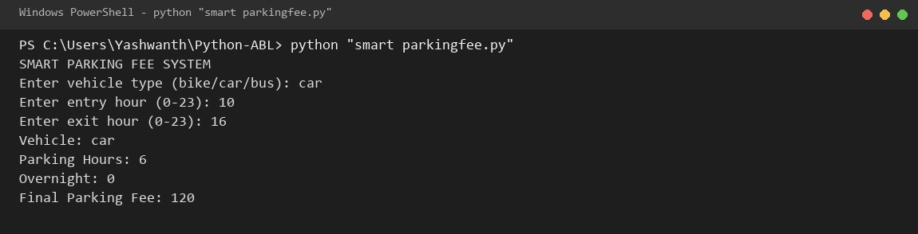
10. Conclusion
The smart parking fee calculator handles real-world 24-hour rollover conditions and implements defensive clamping to guarantee fair municipal billing.

CASE STUDY 8: University Scholarship Allocation
1. Problem Statement
University scholarship boards require an automated applicant screening system to evaluate aggregate marks, subject-wise minimum cutoffs, attendance percentage, and family annual income to grant merit-cum-means awards.
2. Objectives
• Read applicant student name, 3 subject examination scores, attendance percentage, and annual income.
• Compute total marks (out of 300) and aggregate academic percentage.
• Verify that candidate satisfies all minimum criteria: aggregate >= 75%, each subject >= 60, attendance >= 75%, income <= Rs. 500000.
• Display comprehensive applicant academic dossier and scholarship eligibility verdict.
3. Assumptions
• Subject scores are numerical integers between 0 and 100.
• Attendance percentage is a floating-point number between 0 and 100.
• Failure to satisfy any single criterion disqualifies the applicant.
4. Algorithm
Start.
Input student name, subject 1 marks, subject 2 marks, subject 3 marks, attendance percentage, and family income.
Calculate total marks = mark1 + mark2 + mark3.
Calculate aggregate percentage = total / 3.
Display student name, subject scores, total marks, aggregate percentage, attendance, and income.
If aggregate >= 75 and mark1 >= 60 and mark2 >= 60 and mark3 >= 60 and attendance >= 75 and income <= 500000:
Print 'Result: Eligible for scholarship'.
Else:
Print 'Result: Not eligible for scholarship'.
Stop.
5. Flowchart
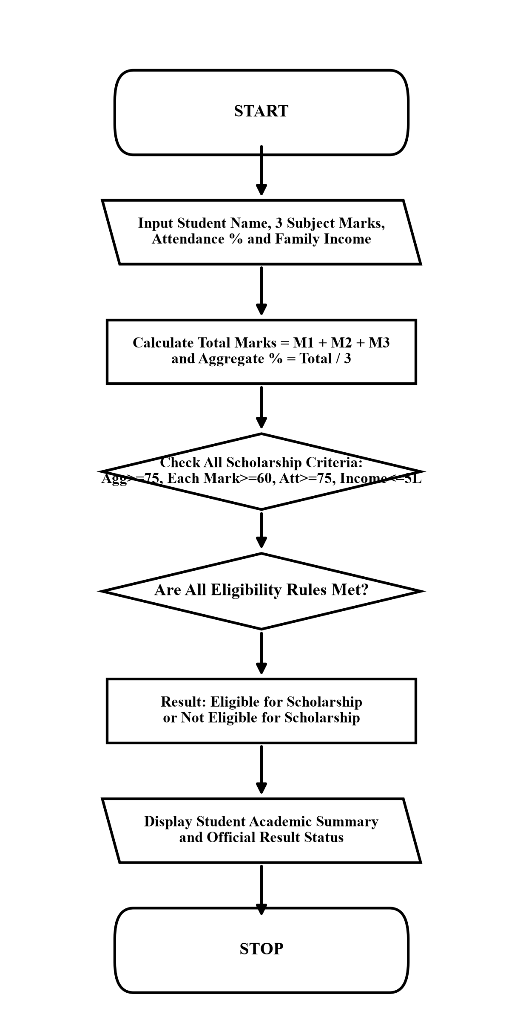

6. Pseudocode
START
INPUT name, mark1, mark2, mark3, attendance, income
total = mark1 + mark2 + mark3
aggregate = total / 3
PRINT name, mark1, mark2, mark3, total, aggregate, attendance, income
IF aggregate >= 75 AND mark1 >= 60 AND mark2 >= 60 AND mark3 >= 60 AND attendance >= 75 AND income <= 500000 THEN
PRINT "Result: Eligible for scholarship"
ELSE
PRINT "Result: Not eligible for scholarship"
END IF
STOP
7. Python Source Code (student Scholarship.py)
# student Scholarship System
name = input("Enter student name: ")
mark1 = int(input("Enter subject 1 marks: "))
mark2 = int(input("Enter subject 2 marks: "))
mark3 = int(input("Enter subject 3 marks: "))
attendance = float(input("Enter attendance percentage: "))
income = int(input("Enter family income: "))
total = mark1 + mark2 + mark3
aggregate = total / 3
print("\n========== STUDENT DETAILS ==========")
print("Student name:", name)
print("Subject 1 marks:", mark1)
print("Subject 2 marks:", mark2)
print("Subject 3 marks:", mark3)
print("Total marks:", total, "out of 300")
print("Aggregate:", aggregate, "%")
print("Attendance:", attendance, "%")
print("Family income: Rs.", income)
if (aggregate >= 75 and mark1 >= 60 and mark2 >= 60 and mark3 >= 60 and attendance >= 75 and income <= 500000):
print("Result: Eligible for scholarship")
else:
print("Result: Not eligible for scholarship")
8. Test Cases
Input / Situation | Expected Result | Purpose
Gudela Yashwanth, Marks: 85, 78, 92, Att: 85%, Inc: 250000 | Aggregate: 85.0%, Result: Eligible for scholarship | Fully compliant merit-cum-means profile
Ravi, Marks: 55, 80, 85, Att: 80%, Inc: 200000 | Result: Not eligible (Subject 1 below 60 cutoff) | Individual subject minimum cutoff failure
Pooja, Marks: 90, 85, 88, Att: 70%, Inc: 300000 | Result: Not eligible (Attendance below 75%) | Mandatory attendance shortfall rejection
9. Output screenshots
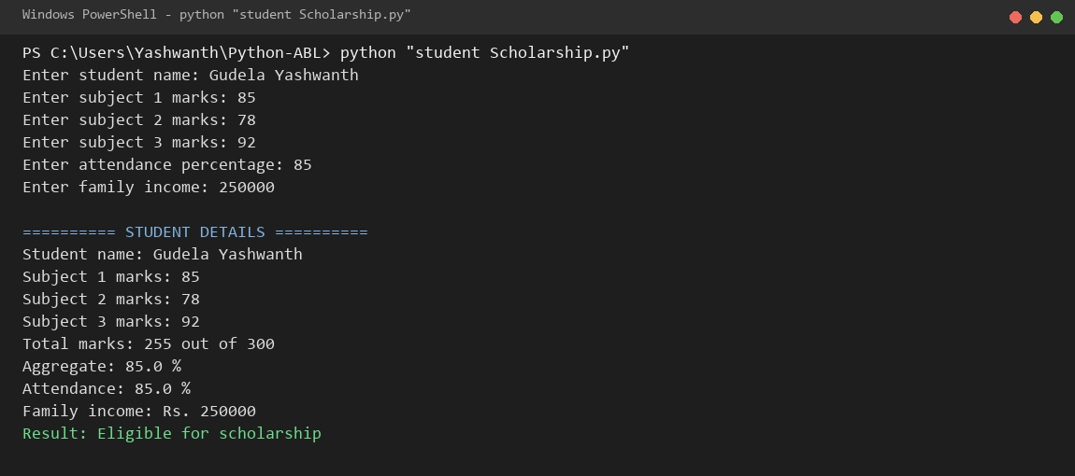
10. Conclusion
The scholarship screening system demonstrates compound logical condition evaluations, ensuring strict adherence to university eligibility policies.

CASE STUDY 9: Attendance Recovery Computation
1. Problem Statement
Undergraduate students with attendance shortages need an interactive calculator to determine their current attendance percentage and compute the exact minimum consecutive future lectures they must attend without absence to attain the statutory 75% examination threshold.
2. Objectives
• Read total classes conducted, classes attended, and required attendance percentage.
• Validate numerical input bounds (positive total, attended <= total, required in 0-100).
• Calculate current attendance percentage and check if already eligible.
• Use an iterative while loop to calculate the exact consecutive future classes needed.
3. Assumptions
• Total conducted classes is a positive integer greater than zero.
• Classes attended is a non-negative integer less than or equal to total classes.
• The student attends every upcoming recovery class consecutively without missing any.
4. Algorithm
Start.
Input total classes, attended classes, and required attendance percentage.
Validate input ranges: total <= 0 or attended < 0 or attended > total or required <= 0 or required > 100.
If invalid, print 'Invalid input' and stop.
Calculate current percentage = (attended / total) * 100.
Display current attendance percentage.
If current >= required, print 'You are already eligible'.
Otherwise, initialize future = 0.
While ((attended + future) / (total + future)) * 100 < required: future = future + 1.
Display minimum classes to attend.
Stop.
5. Flowchart
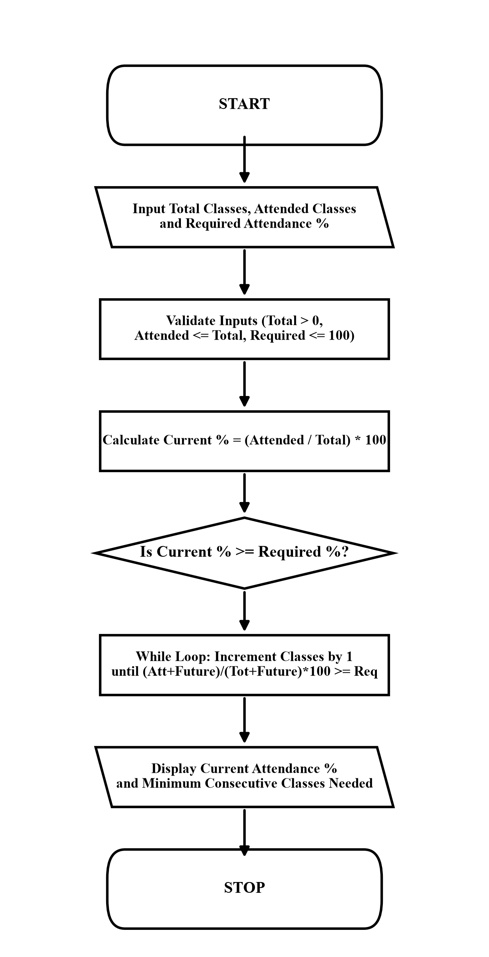

6. Pseudocode
START
INPUT total, attended, required
IF total <= 0 OR attended < 0 OR attended > total OR required <= 0 OR required > 100 THEN
PRINT "Invalid input"
ELSE
current = (attended / total) * 100
PRINT current
IF current >= required THEN
PRINT "You are already eligible"
ELSE
future = 0
WHILE ((attended + future) / (total + future)) * 100 < required DO
future = future + 1
END WHILE
PRINT future
END IF
END IF
STOP
7. Python Source Code (student attendence.py)
print("ATTENDANCE RECOVERY CALCULATOR")
total = int(input("Enter total classes: "))
attended = int(input("Enter attended classes: "))
required = float(input("Enter required attendance percentage: "))
if total <= 0 or attended < 0 or attended > total or required <= 0 or required > 100:
print("Invalid input")
else:
current = (attended / total) * 100
print("Current Attendance:", current, "%")
if current >= required:
print("You are already eligible")
else:
future = 0
while ((attended + future) / (total + future)) * 100 < required:
future = future + 1
print("Minimum classes to attend:", future)
print("You will reach the required attendance")
8. Test Cases
Input / Situation | Expected Result | Purpose
Total: 70, Attended: 48, Required: 75% | Current: 68.57%, Minimum classes to attend: 18 | Attendance shortage iterative recovery
Total: 100, Attended: 80, Required: 75% | Current: 80.0%, You are already eligible | Pre-qualified threshold verification
Total: 50, Attended: 60, Required: 75% | Invalid input | Boundary validation (attended > total)
9. Output screenshots
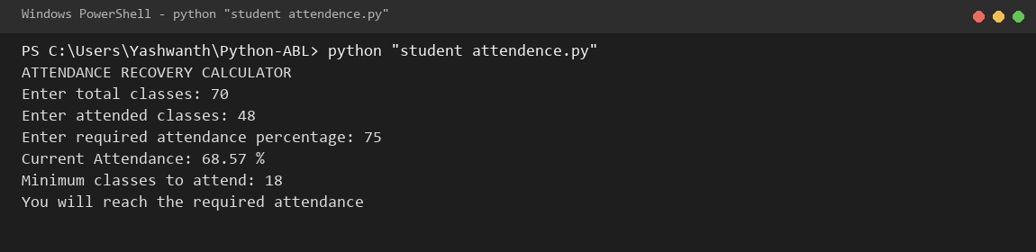
10. Conclusion
The attendance recovery tool provides precise academic remedial guidance using natural while-loop iteration to solve ratio convergence.

CASE STUDY 10: Traffic Violation Penalty Calculator
1. Problem Statement
Municipal traffic regulatory authorities require an automated e-challan violation penalty calculator that tallies statutory penalties across multiple offenses, doubles fines for repeat offenders, and flags drivers for license disqualification when cumulative infractions reach two or more.
2. Objectives
• Read number of traffic violations committed by the driver in the incident.
• Iterate across infractions and read offense category (No Helmet, No License, Using Mobile).
• Double fines for repeat offenses: Helmet (500/1000), License (1000/2000), Mobile (1500/3000).
• Calculate total fine, count violations, and trigger driver disqualification if violations >= 2.
3. Assumptions
• Violation selection options: 1: No Helmet, 2: No License, 3: Using Mobile.
• Repeat offense status is answered with 'yes' or 'no'.
• A driver committing two or more violations is flagged for driving license disqualification.
4. Algorithm
Start.
Initialize fine = 0, count = 0.
Input number of violations n.
For i from 0 to n - 1:
a. Display violation menu and input offense number.
b. Input repeat offense status ('yes' or 'no').
c. If offense == 1, fine = fine + (1000 if repeat=='yes' else 500), count = count + 1.
d. If offense == 2, fine = fine + (2000 if repeat=='yes' else 1000), count = count + 1.
e. If offense == 3, fine = fine + (3000 if repeat=='yes' else 1500), count = count + 1.
f. Else print 'Invalid offence'.
Display total fine and total violation count.
If count >= 2, print 'Disqualification: Yes'; else print 'Disqualification: No'.
Stop.
5. Flowchart
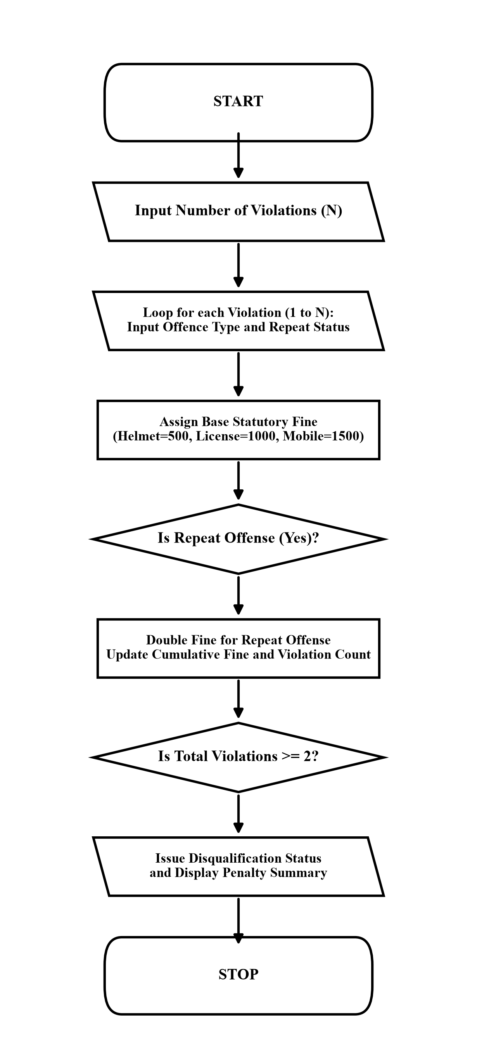

6. Pseudocode
START
fine = 0, count = 0
INPUT n
FOR i = 1 TO n DO
INPUT offence, repeat
IF offence == 1 THEN
IF repeat == "yes" THEN fine = fine + 1000 ELSE fine = fine + 500
count = count + 1
ELSE IF offence == 2 THEN
IF repeat == "yes" THEN fine = fine + 2000 ELSE fine = fine + 1000
count = count + 1
ELSE IF offence == 3 THEN
IF repeat == "yes" THEN fine = fine + 3000 ELSE fine = fine + 1500
count = count + 1
END IF
END FOR
PRINT fine, count
IF count >= 2 THEN PRINT "Disqualification: Yes" ELSE PRINT "Disqualification: No"
STOP
7. Python Source Code (traffic rules.py)
print("TRAFFIC VIOLATION PENALTY CALCULATOR")
fine = 0
count = 0
n = int(input("Enter number of violations: "))
for i in range(n):
print("\n1. No Helmet")
print("2. No Licence")
print("3. Using Mobile")
offence = int(input("Enter offence number: "))
repeat = input("Is it a repeat offence? (yes/no): ").lower()
if offence == 1:
if repeat == "yes":
fine = fine + 1000
else:
fine = fine + 500
count = count + 1
elif offence == 2:
if repeat == "yes":
fine = fine + 2000
else:
fine = fine + 1000
count = count + 1
elif offence == 3:
if repeat == "yes":
fine = fine + 3000
else:
fine = fine + 1500
count = count + 1
else:
print("Invalid offence")
print("\nTRAFFIC PENALTY SUMMARY")
print("Total Fine:", fine)
print("Total Violations:", count)
if count >= 2:
print("Disqualification: Yes")
else:
print("Disqualification: No")
8. Test Cases
Input / Situation | Expected Result | Purpose
Violations: 2; Offence 1: Helmet (no), Offence 2: License (yes) | Total Fine: 2500, Violations: 2, Disqualification: Yes | Compound multi-offense penalty check
Violations: 1; Offence 1: Helmet (no) | Total Fine: 500, Violations: 1, Disqualification: No | Single first-time infraction without disqualification
Violations: 1; Offence 3: Mobile (yes) | Total Fine: 3000, Violations: 1, Disqualification: No | Repeat mobile usage penalty without disqualification
9. Output screenshots
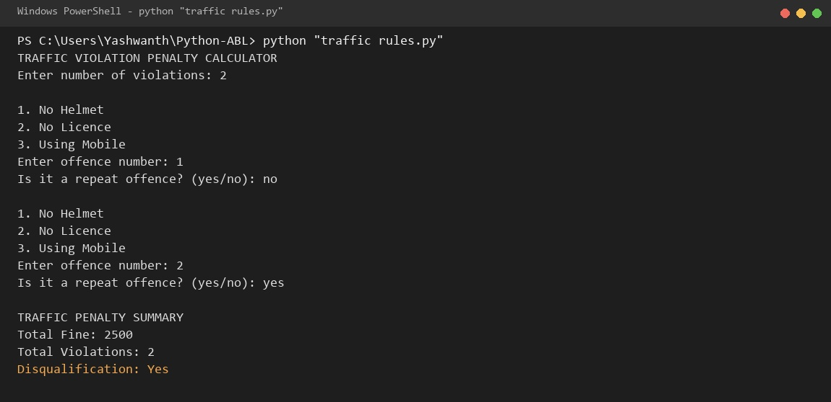
10. Conclusion
The traffic violation penalty calculator enforces road safety regulations through tiered multi-offense fines and automated driver disqualification tracking.

