**CS 6364.002 ARTIFICIAL INTELLIGENCE**

**Programming Assignment – 2**

**October 24, 2017**

**Dileep Gudena (dxg161730)**

**Gokul Surendra (gxs161530)**

**Exercise 1:**

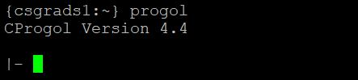

**Exercise 2:**

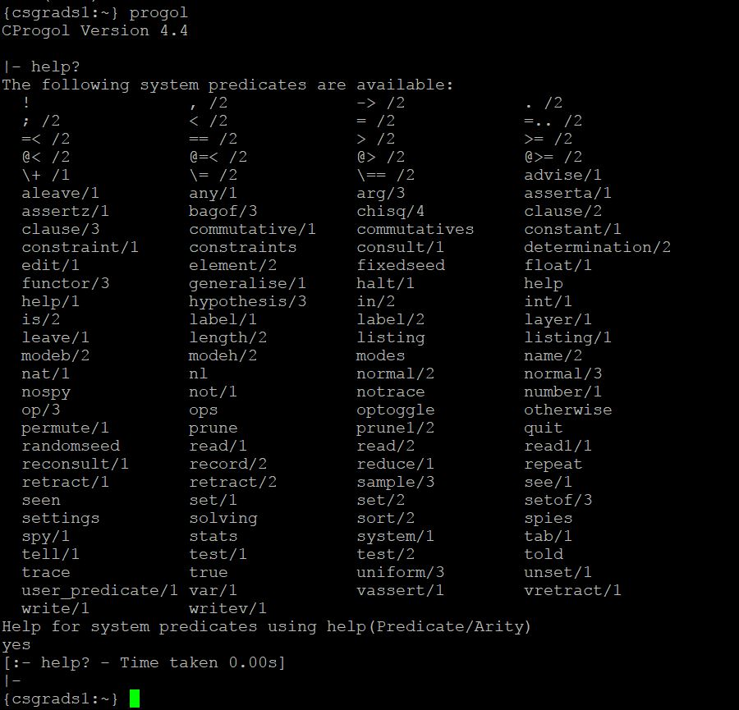

**Exercise 3:**

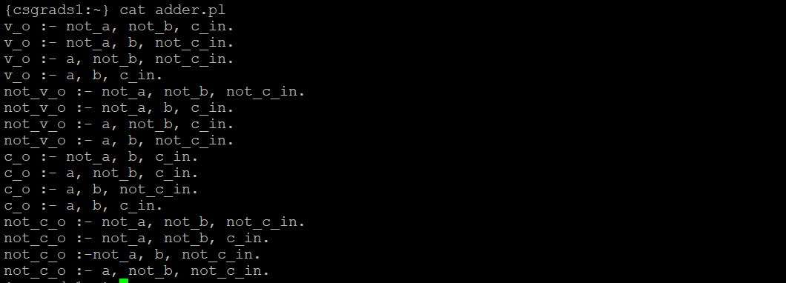 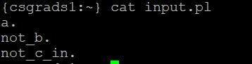 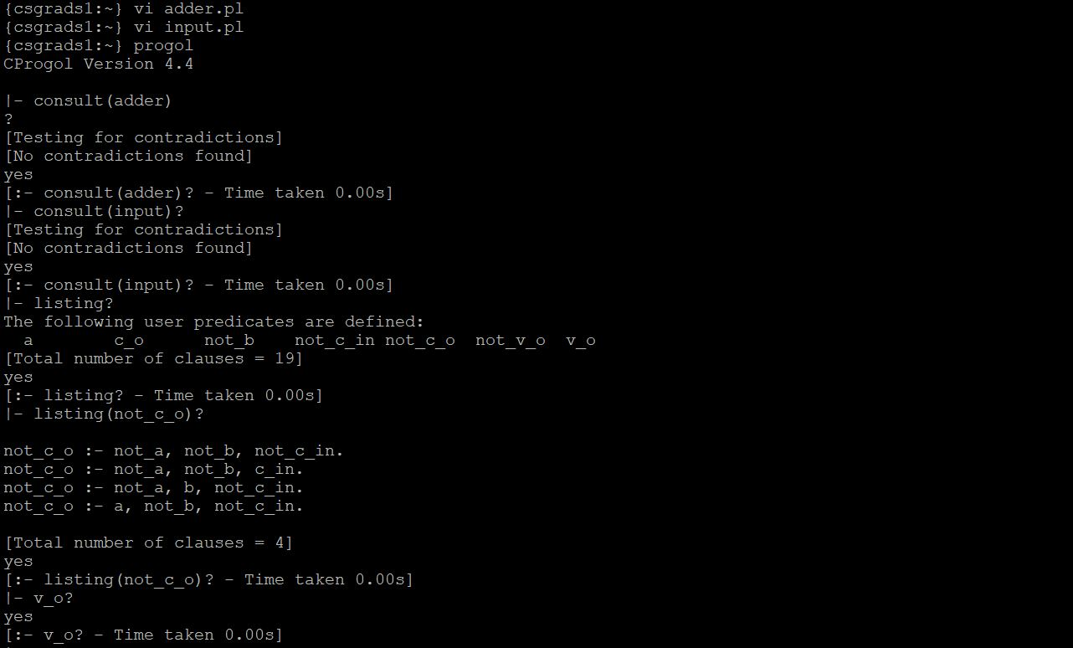

**Exercise 4:**

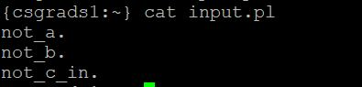 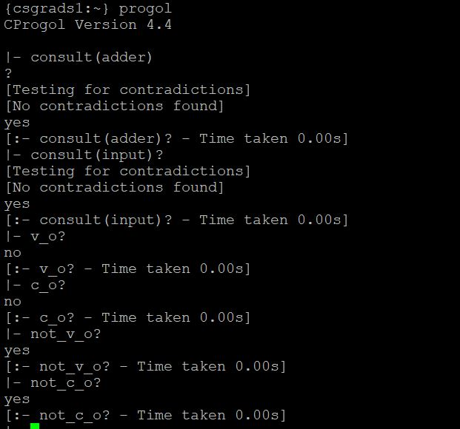

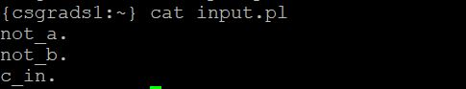 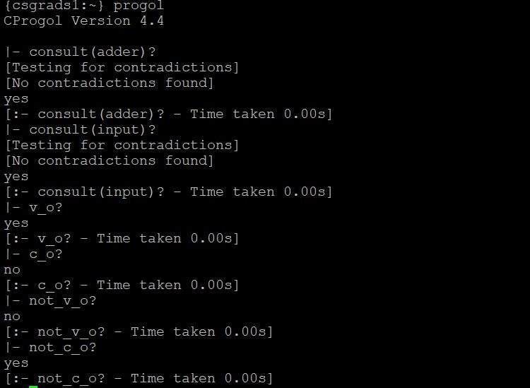

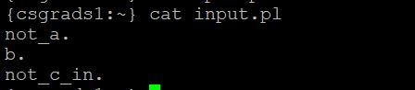 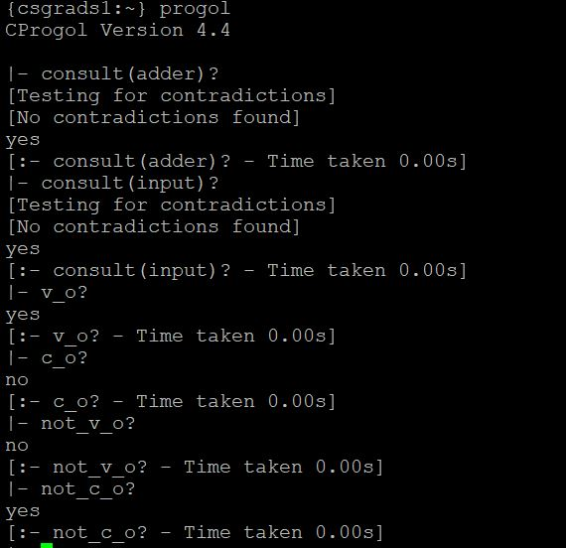

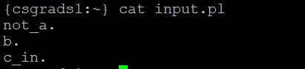 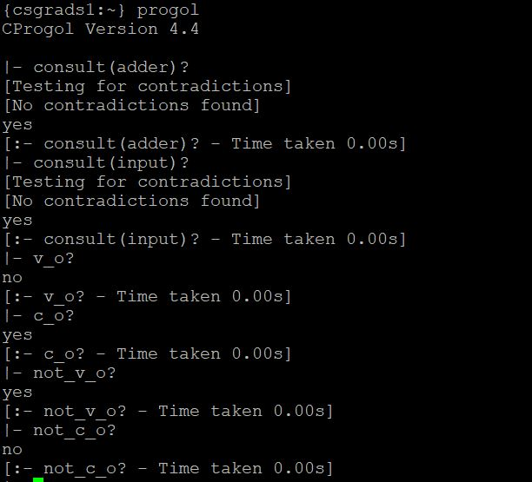

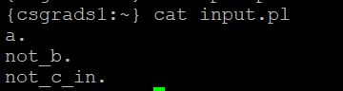 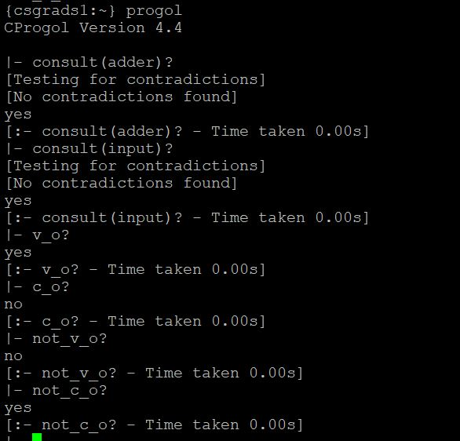

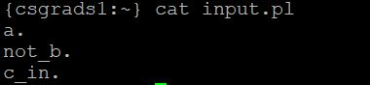 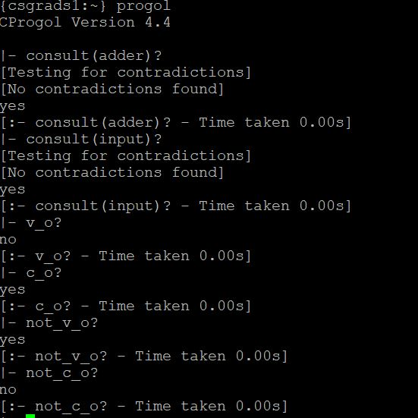

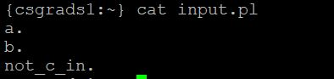 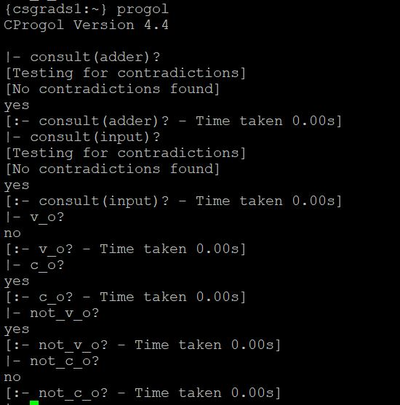

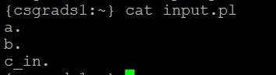 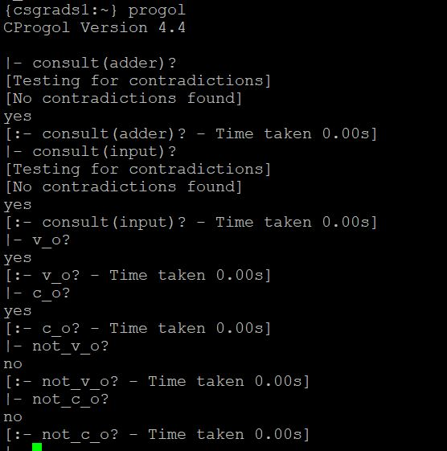

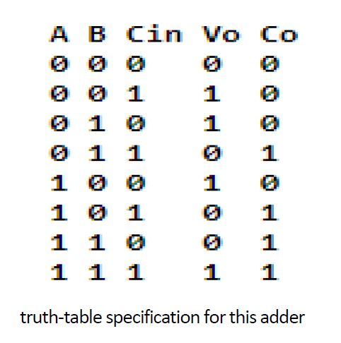

The truth table is verified and the results are as per the table.

b)

Yes. We can simplify further. As there are 4 output predicates (v_o,c_o,not_v_o and not_c_out), we can cut iyt down to 2 by only defining v_o and c_o. We use a meta-logical predicate called not() for the definitions not_v_o as not(v_o) and not_c_o as not(c_o)

**Exercise 5:**

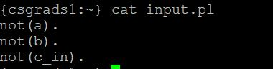 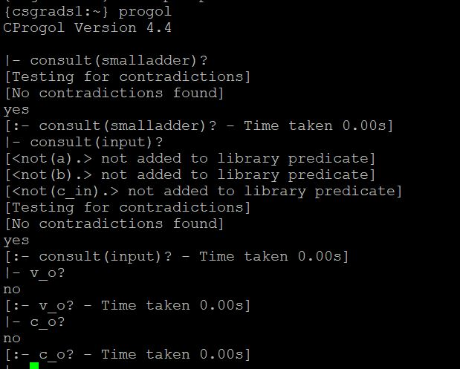

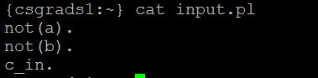 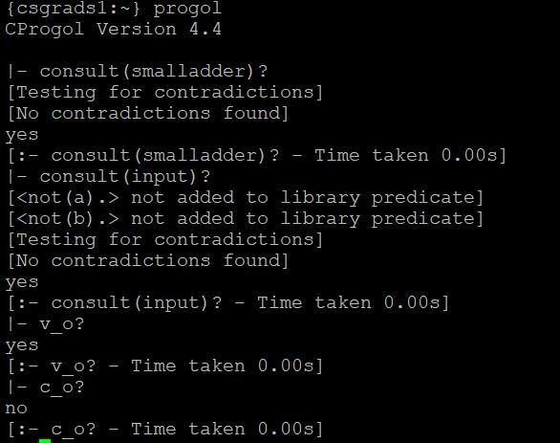

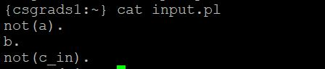 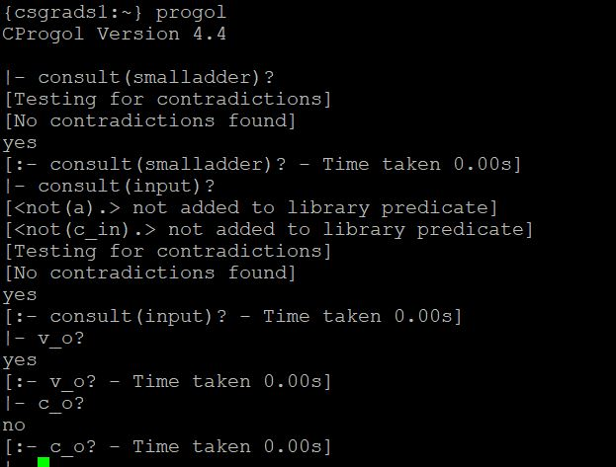

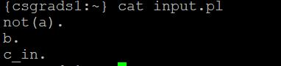 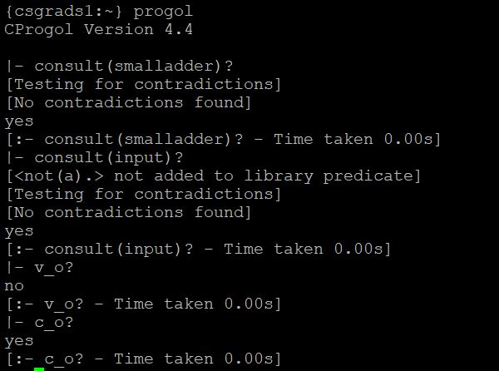

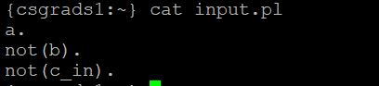 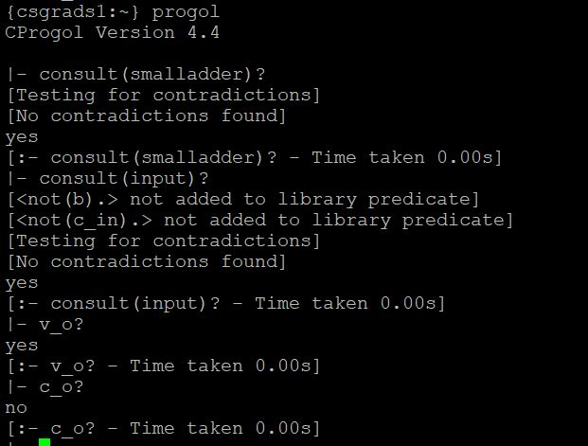

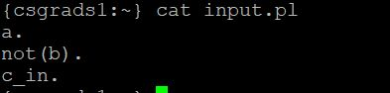 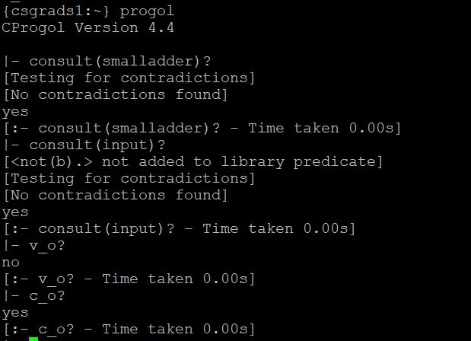

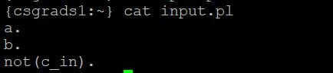 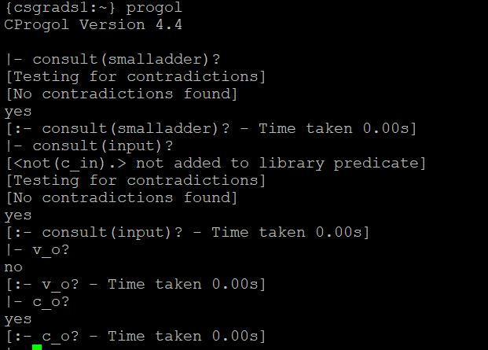

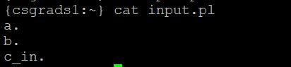 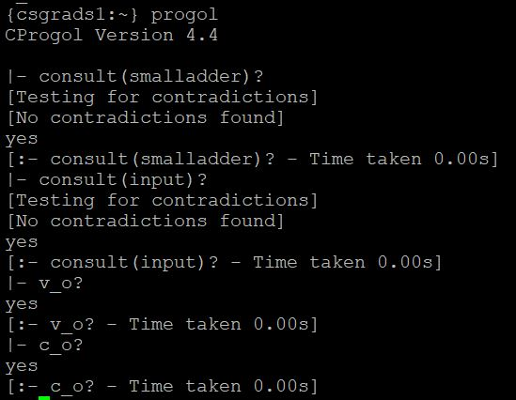

**Exercise 6:**

a) x in S1 & S2 iff x in S1 and x in S2

Definite clause:

in_inter(X, S1, S2) :- elem(X, S1), elem(X, S2).

b)<x,y> in S1 x S2 iff x in S1 and y in S2

Definite clause:

in_binary(<X,Y>, S1, S2) :- elem(X, S1), elem(Y, S2).

c) x in S1 \ S2 iff x in S1 and x not in S2

Definite clause:

in_diff(X, S1, S2) :- elem(X, S1), not(elem(Y, S2)).

**Exercise 7:**

a) less_than5({<x,y> | x in N5, y in N5, and x<y)--Given

Extensional definition:

less_than5(0,1).

less_than5(0,2).

less_than5(0,3).

less_than5(0,4).

less_than5(1,2).

less_than5(1,3).

less_than5(1,4).

less_than5(2,3).

less_than5(2,4).

less_than5(3,4).

b)

lt_AxB(0,1).

lt_AxB(0,2).

lt_AxB(0,3).

lt_AxB(0,4).

lt_AxB(1,2).

lt_AxB(1,3).

lt_AxB(1,4).

lt_AxB(2,3).

lt_AxB(2,4).

lt_AxB(3,4).

**Exercise 8:**

a,b)

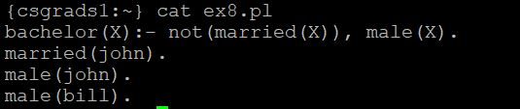 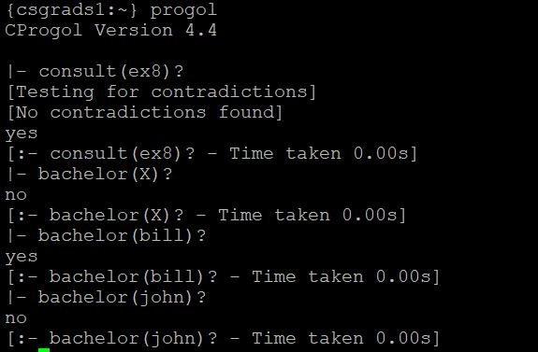

c)

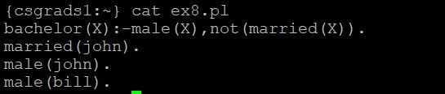 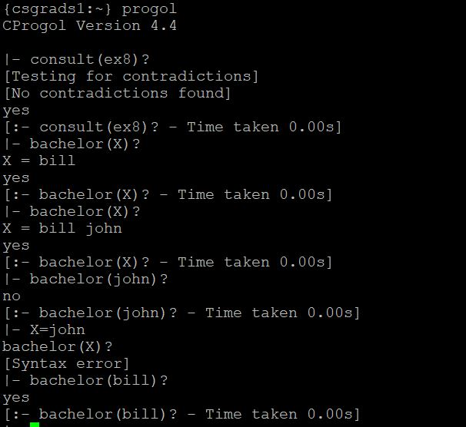

**Exercise 9:**

a)

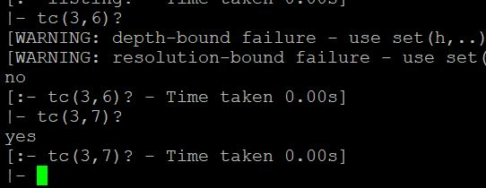

b)

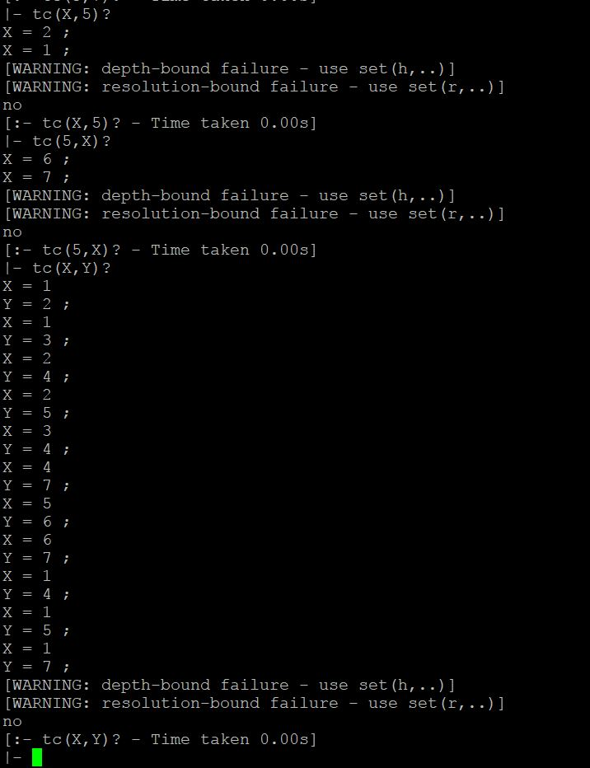

c)

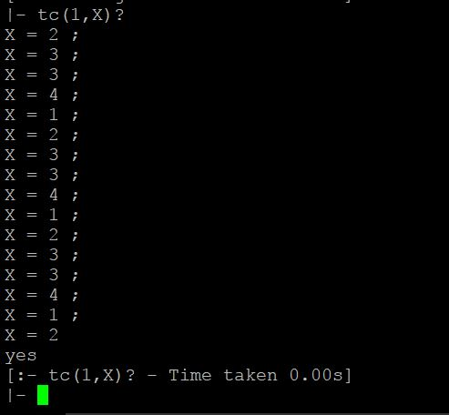

**Exercise 10:**

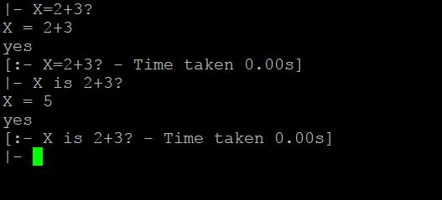

**Exercise 11:**

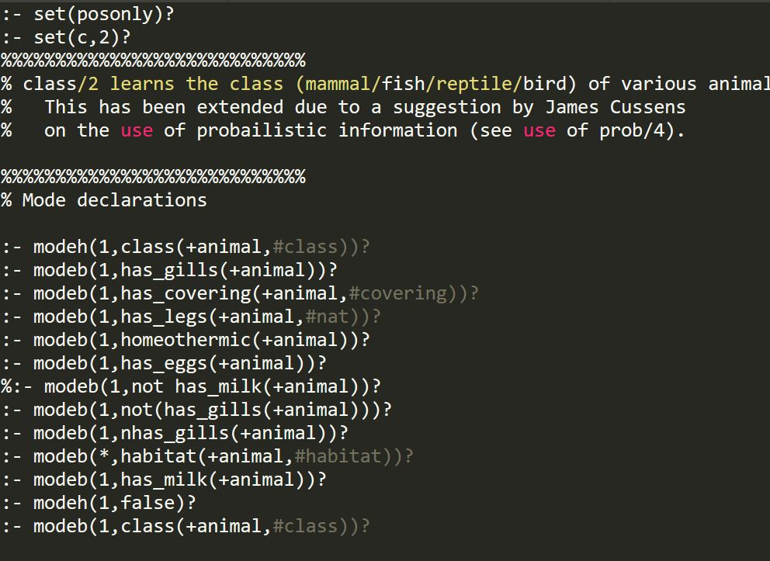

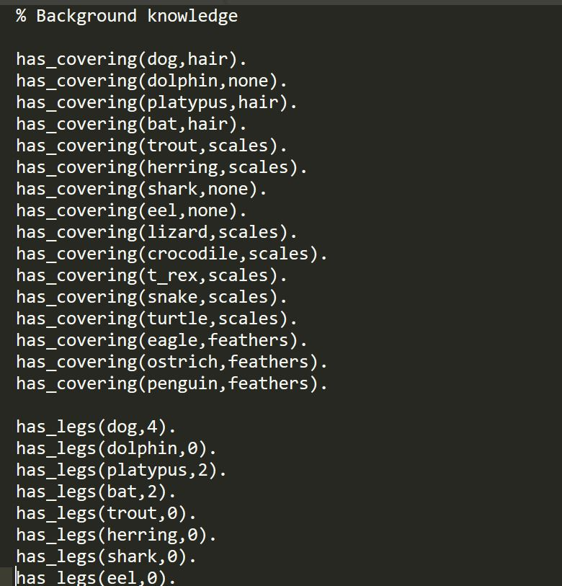

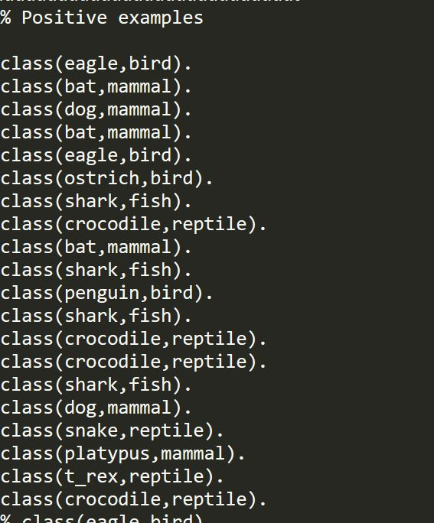

**Exercise 12:**

Predicates are: Here X is type of animal

has_gills(X)

has_covering(X)

has_legs(X)

homeothermic(X)

has_eggs(X)

nhas_gills(X)

habitat(X)

has_milk(X)

**Exercise 13:**

class(X):- member(X,[mammal,fish,reptile,bird]).

It is a valid type definition. First argument is meant to be variable i.e the first argument is an output variable and the second is an input variables.

**Exercise 14:**

a) Clause isn't allowed. Because, in class(+animal,#class), # indicates we must have constants i.e(B). But has_milk takes variable of type animal.

b) Clause allowed. Since , has_milk takes variable of type animal which is A.

c) Clause is allowed. Because has_milk(platypus) is true as platypus is mammal and for any mammal.

d) Clause is allowed. Because has_milk(platypus) is true and platypus is mammal.

e) Clause isn't allowed. Because all mammals won't be having milk.

**Exercise 15:**

Recall number for habitat/2 is *, Because for given input, predicate habitat succeeds more than once.(or finite times)

Eg: For input bat, habitat successeds multiple times i.e air , caves

For input crocodile, habitat successeds multiple times i.e land , water

**Exercise 16:**

a) :- modeh(1,mult(+num,+num,-num)).

:- modeb(1,dec(+num,-num)).

:- modeb(1,plus(+num,+num,-num)).

:- modeb(1,nat(+num)).

b) :- modeh(1,n_choose_m((+num,+num,-num)).

:- modeb(1,dec(+num,-num)).

:- modeb(1,multiply(+num,+num,-num)).

:- modeb(1,divide(+num,+num,-num)).

:- modeb(1,nat(+num)).