ASSIGNMENT 2 – DATA VISUALIZATION

DASARATHA GUDI

10387212

INTRODUCTION:

All great things are simple and many can be expressed in a single word: freedom, justice, honor and duty said “ Winston Churchill “. In contrast, there are number of countries that has faced a rapid decline in freedom and civil liberties. Naturally decline in freedom will affect in the happiness of the people. This exploratory analysis of Human, Economic and Personal freedom will help us understand the cause and effect behind decline of freedom. We will also be able to come up with a solution for the decline.

This exploratory analysis is made interactive using python code along with few packages installed.

CHOSEN DATASET:

This project is for visualizing the decline in the freedom, the growth of a region and to analyze more about the region and its happiness. The appropriate dataset to serve our purpose is taken from Kaggle a trusted source for datasets. The data set is of the name ‘The Human Freedom Index’. This data set has the measure of economic freedom which includes freedom of trade, the degree of extent to which people enjoy their freedom. There are lot other factors included in this dataset.We also include nine variables pertaining to women-specific freedoms that are found in various categories of the index.

An Overview of the Dataset

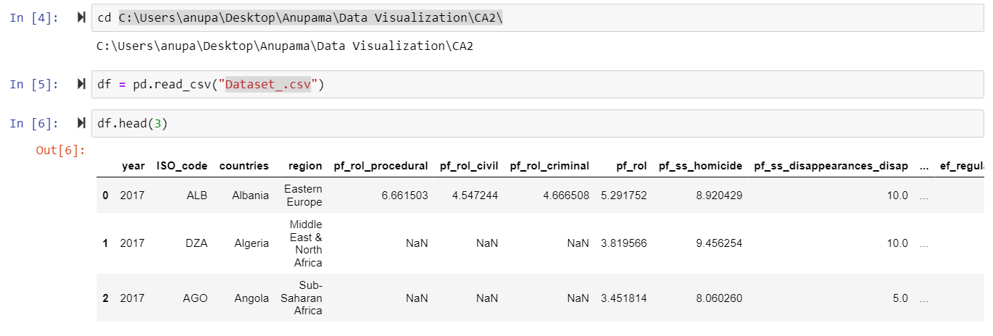

GRAPHICAL REPRESENATATION:

Freedom in one form can be explained as the right an individual has to express themselves. One can be categorized if they have given proper freedom or not on scale of 1 to 10 where 1 is the least and 10 is the most. In the below graph we are to visualize the regions that have the different freedom of expression and along with the regions that have been controlled freedom.

1)Expression of Speech:

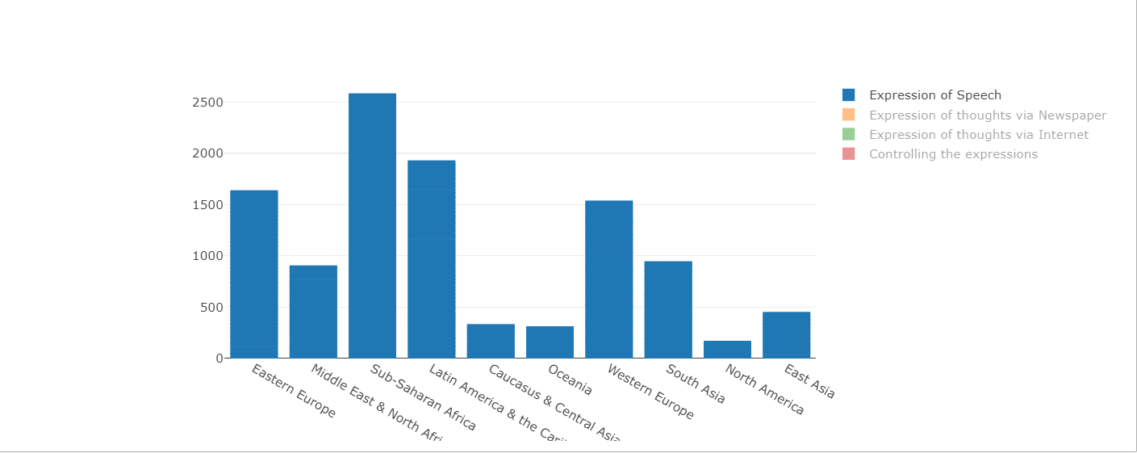

From the graph we can see that Sub-Saharan-Africa has the highest freedom of speech with the score of 6.04.

2)Expression of thoughts via Newspaper:

While press and newspaper are considered to be trusted sources for communication media, the below graphical representation tells us the region with the highest score in being expressive via newspapers

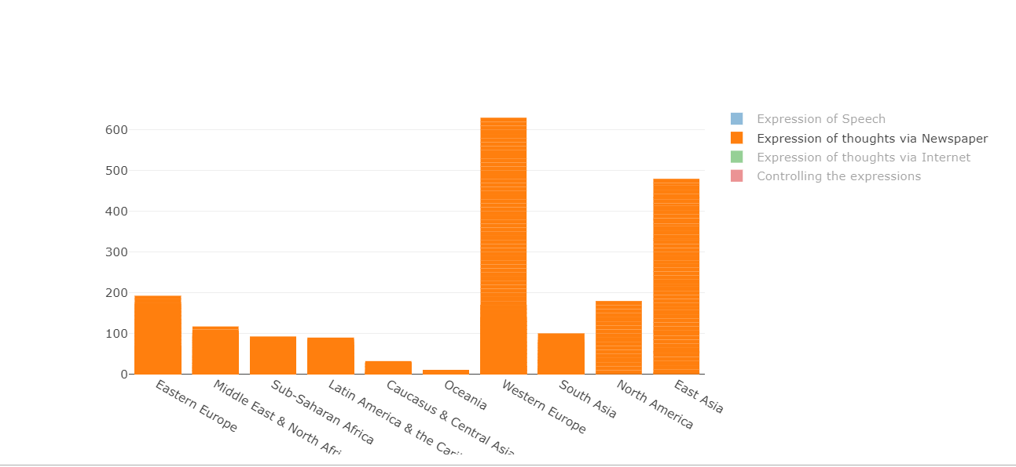

Western Europe is considered to be the top region which gives freedom of expression via newspaper.

3)Expression of Thoughts via Internet:

Telecommunication and wireless communication have become the top most medium of communication. While certain countries does not even have the power to express themselves there are few other regions that are properly utilizing the internet as medium of expressing thoughts and views.

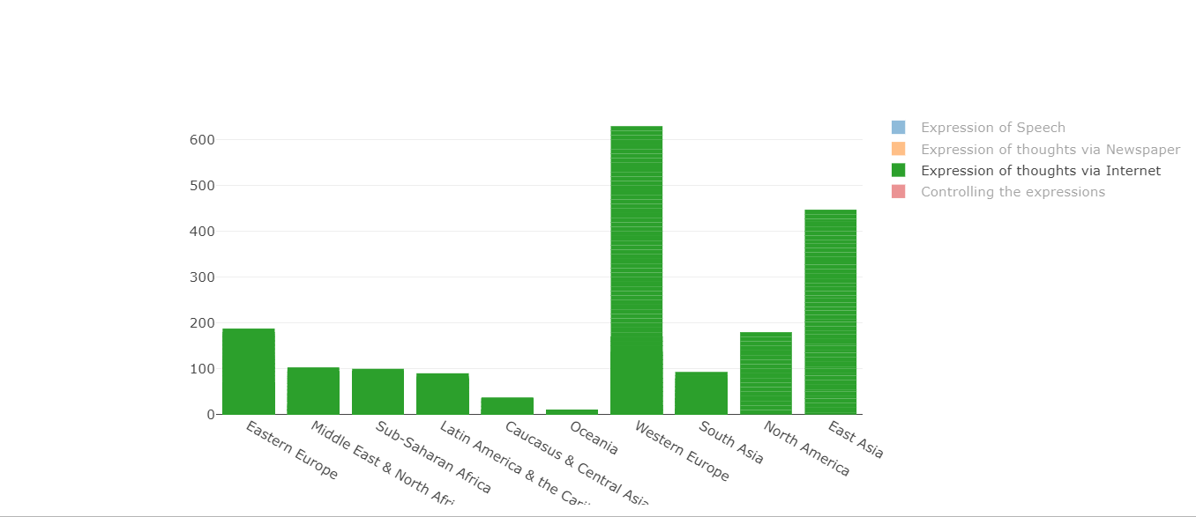

Western Europe again is the top most region that gives freedom for expressing the thoughts and views.

4)Restriction in freedom of expression:

While there are countries who enjoy freedom of expression either by speech or internet or atleast via newspaper, there are regions who have been denied from all the above medium pf expressions, where democracy is least followed.

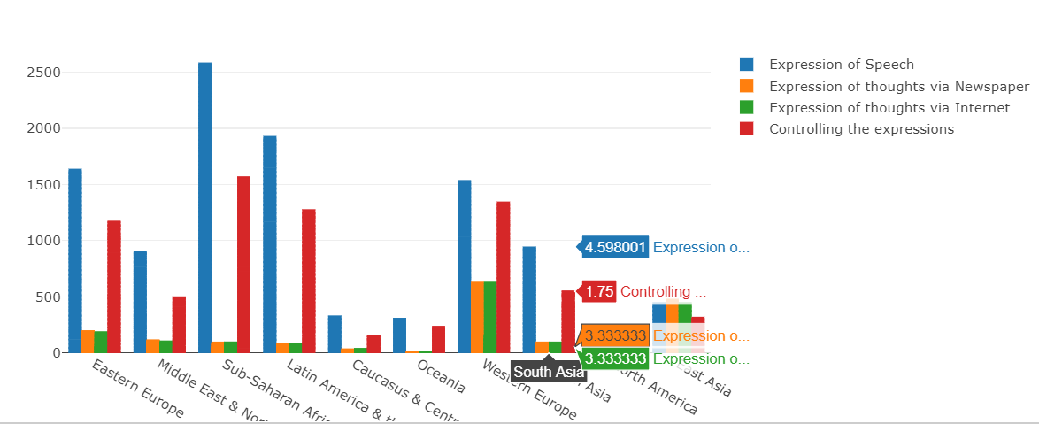

From the graph we could see that South Asian region is the region that gives least importance to freedom of expression with the score 1.75.

COMPARING THE SECURITY RATE AMONG THE 10 REGIONS

Security is the most important aspect. It tells us how safe and secured a region is for any person to start their livelihood in that place. Being safe and secured is what most of the people have it as a priority to choose a place.

With increasing women assaults and tortures, this data set has features/attributes related to women, like security, harassment rate, divorces, widows, empowerment etc. This below graph visualizes rational security compared with women security in that region.

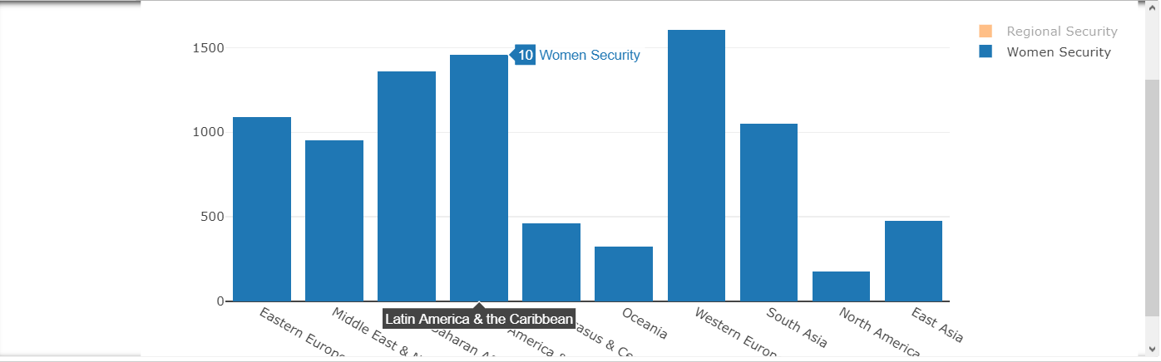

Latin America and the Caribbean and Western Europe (more or less equal to that of Caribbean) gives highest importance for women empowerment and also takes high responsibility for their security and hence stands tall among the 10 regions that has been listed.

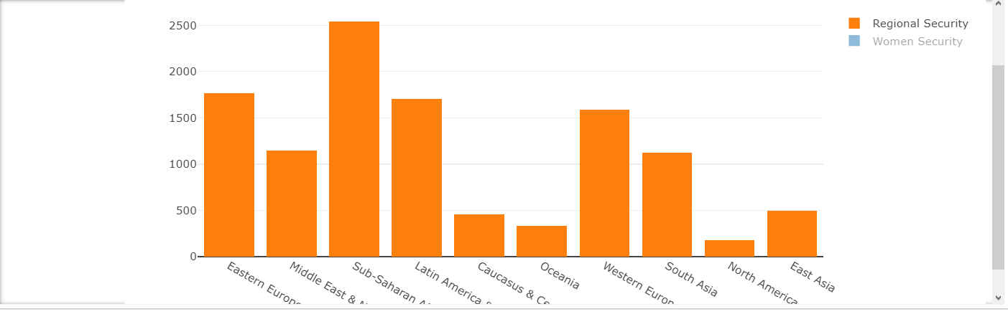

When overall regional security is taken into consideration as visualized in the below graph Sub-Saharan Africa

The above shown two snippets are filtered to show interactiveness. The actual graph used here to compare the data is stacked bar.

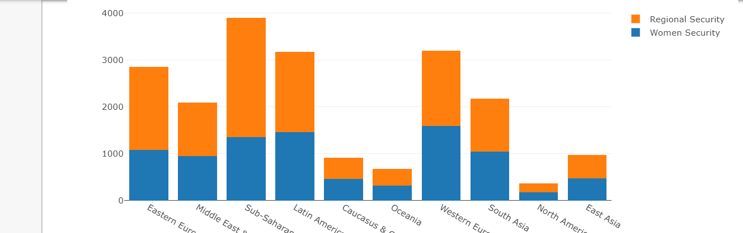

**COMPARISON OF PERSONAL FREEDOM RATE PER YEAR:**

DATA PREPARATION:

To segregate the data based on the personal freedom values

* Removed NA/NULL values
* we have grouped the data by region
* Within that region data was again sub grouped based on the personal freedom attributes.

The below pie graph gives us a glimpse of Personal freedom based on Identity, Women freedom, disappearances, freedom of expression and homicide. The slider

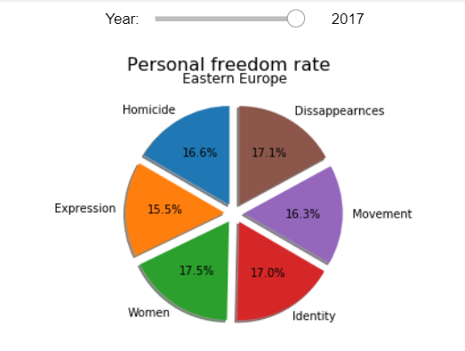 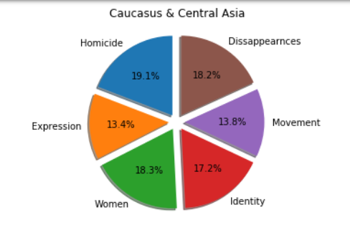

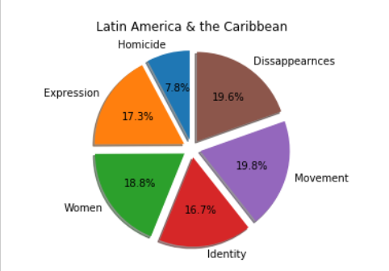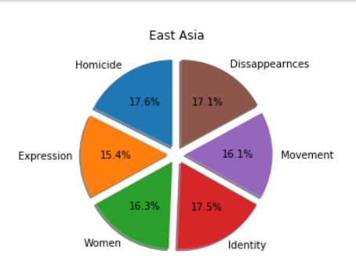

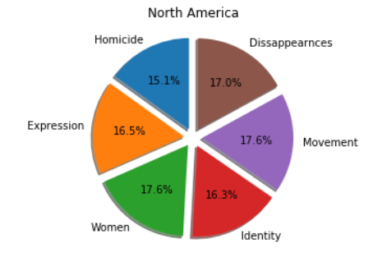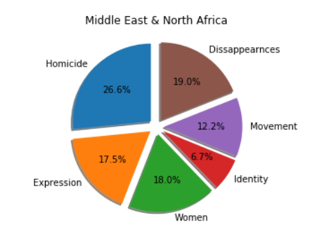

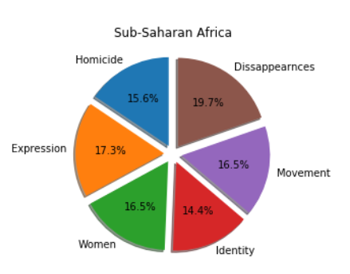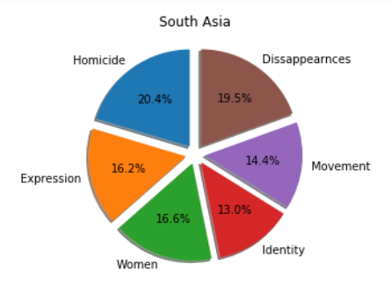

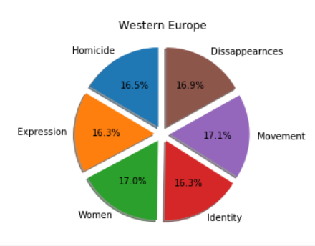 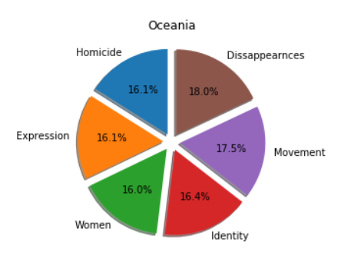

Each region has been classified based on the various personal freedom index like homicide, disappearances, movement, Identity, Women and expression. This clearly shows that which region has more hindrance towards the personal freedom which can be filtered by each year, where in the year of 2017, Middle East and North Africa shows a major variation in the exploded pie, statistics of disappearances and women safety has risen in ratio where all the other region has almost equivalent change in the pie. From this happiness score also can be determined in a way that middle is affected the most than other countries.

**COMPARISON OF CRIMES THAT ARE LEGALIZED AND RESTRICTED:**

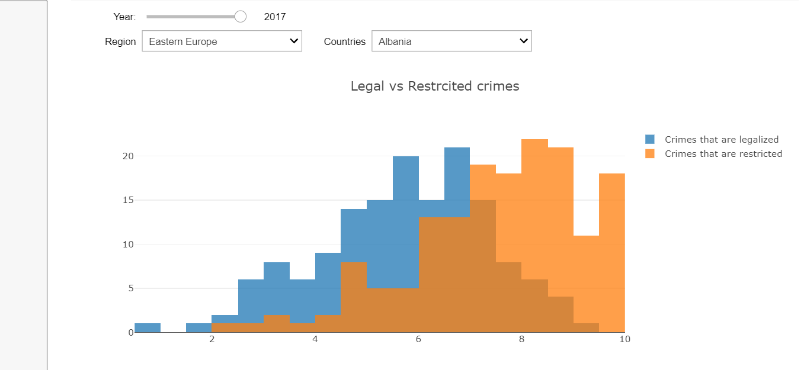

There are crimes that can also be legally done like with license or some authentication. For eg., owning a gun by a public is a crime but that person should have a license, in that case the crime made with a gun comes under legalized crimes.

In the region of Eastern Europe, Albania taken into consideration for we could see that both the legal and restricted crime rate for the year 2017 is mostly overlapping and could say the rate is almost similar.

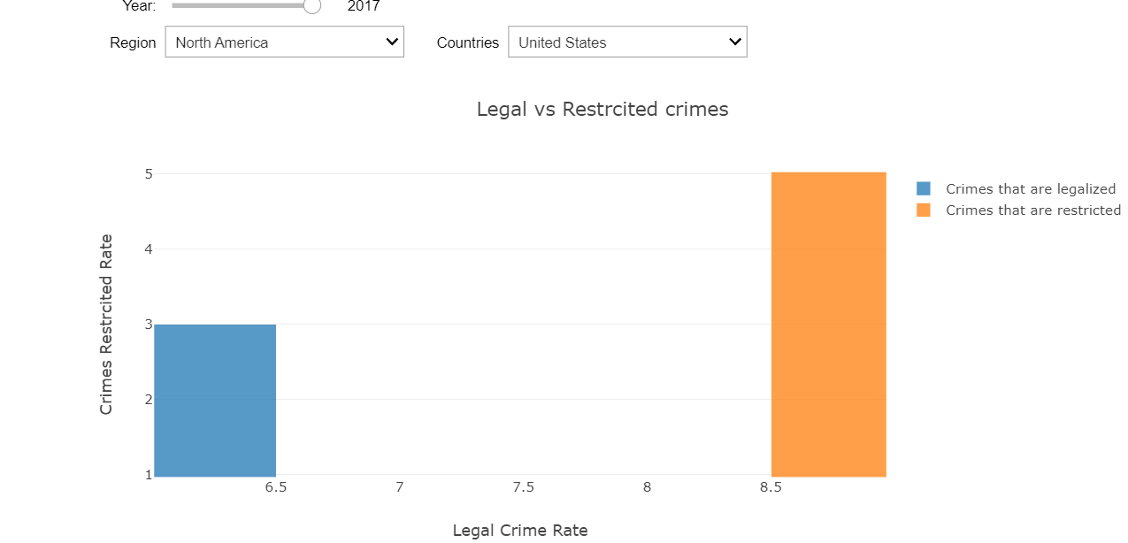

In North America, crimes restricted are higher compared to legal crimes.

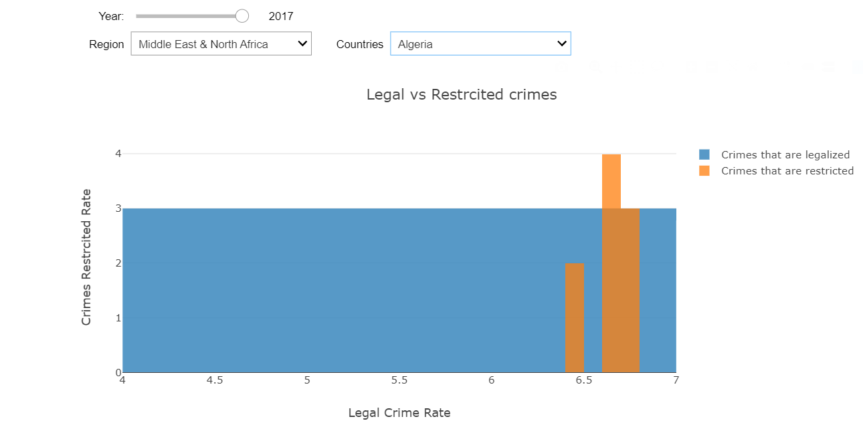

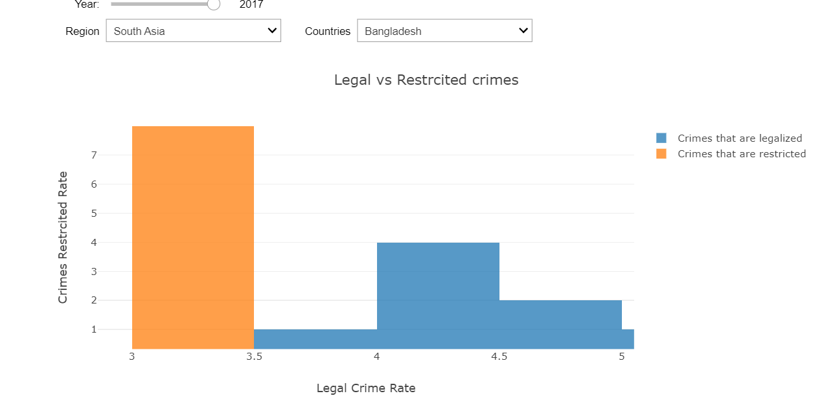

In the region of South Asia, India and Bangladesh the crimes restricted are way higher than legal crimes. We can say that the rules and regulations of this country is strict compared with other countries.

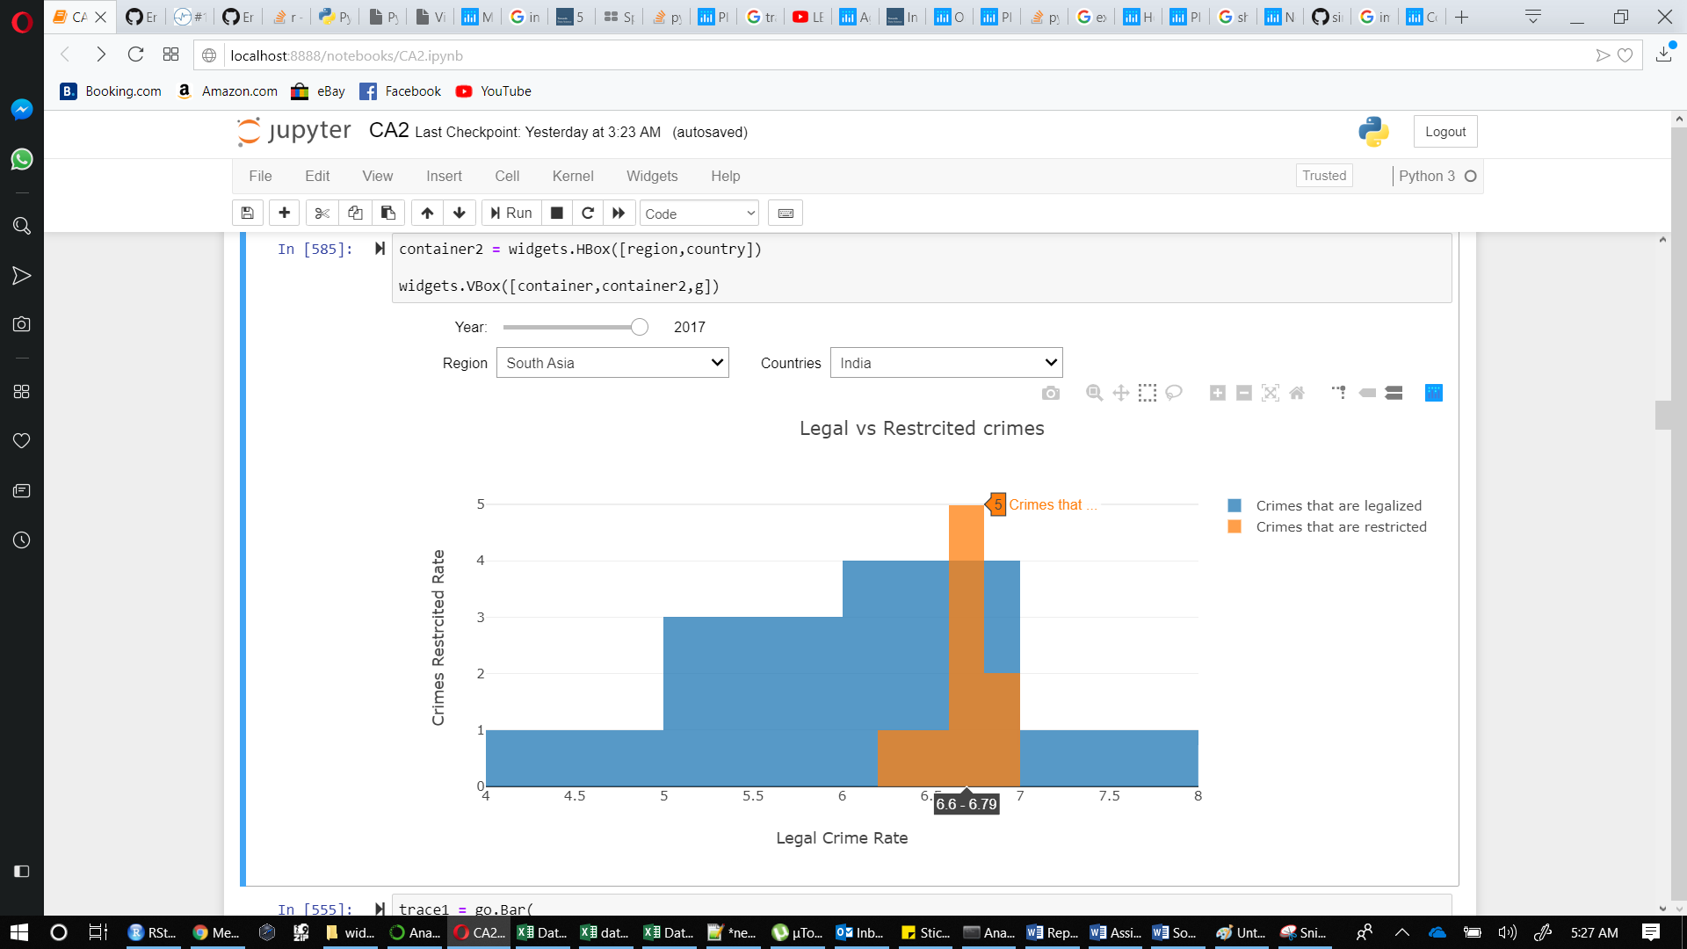

Safer and secure are the countries where the crimes restriction is more. Those are the places where no violations of rules will be encouraged.

**GLOBAL HUMAN FREEDOM:**

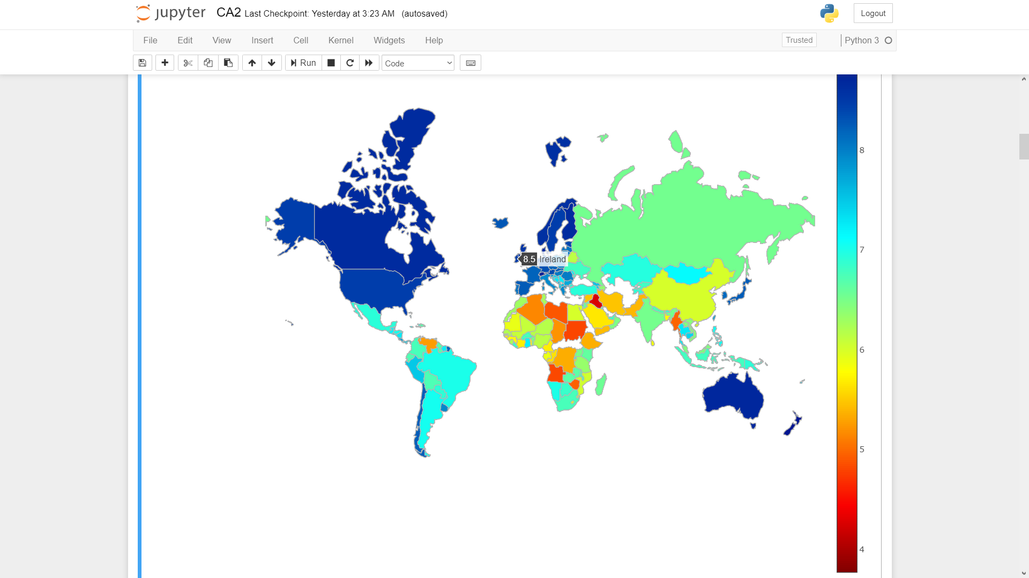

This world map graph created using Seaborn package in python to depict the countries that are free and not free. The color scale from Red to Blue indicates the freedom score from being restricted a lot to being free respectively. The corresponding Scale ranges from 1 to 10 where 1 being the most restricted and 10 being the freest.

This above graph depicts the freedom score of Ireland which is 8.5 stating that this country will fall under the freest country group.

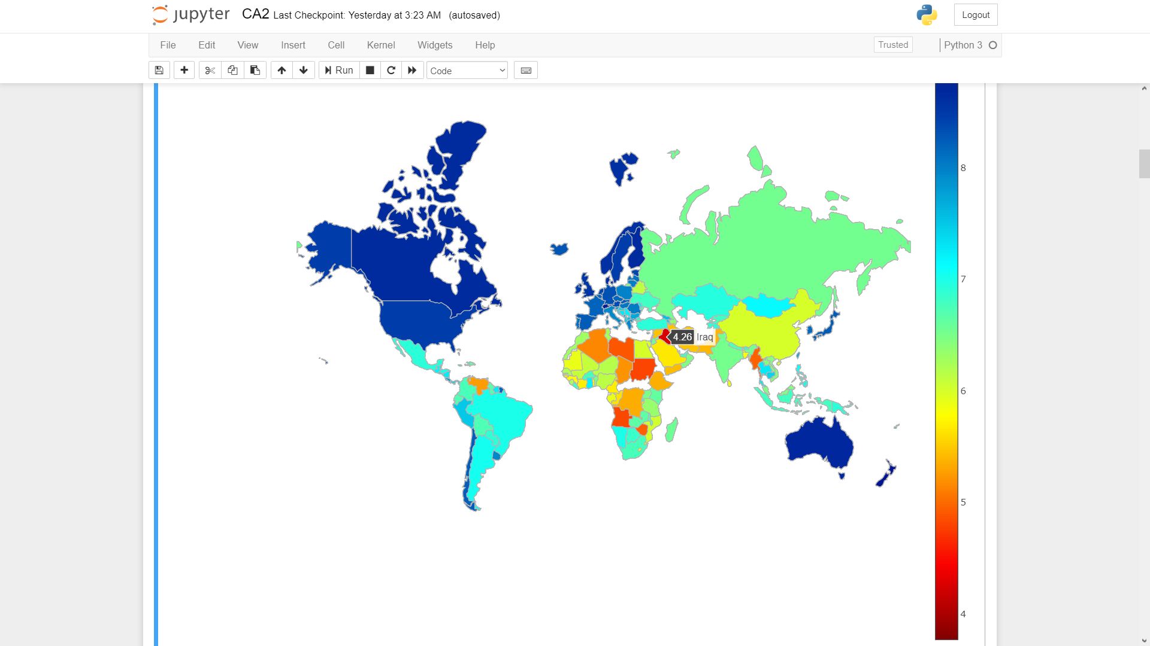

The above graph depicts the freedom score of country Iraq which is around 4 and thus it will fall under the country group that is most restricted right from identity to freedom of expressions.

**CONCLUSION:**

Record shows that there has been consecutive decline in the global freedom. Democracy is retreating. Countries like Iraq, Ethiopia, Brazil all fall under the most restricted country category till now. In short democracies often determined to wait for misrule to boom into national catastrophe before any action is taken. When democratic rule was established for the sake of individuals freedom, the chance of misusing the same has increased drastically. Seeing the tantrums faced/facing by the countries that are democratic but still been refused basic rights we should learn to watch events happening around the world. We are marching towards being successful and restriction imposed should be hindrance for that. The growth of the country is based on how free the people are allowed to express themselves. This is growth will directly relate to the happiness of the individuals in that country.