**Analysis of Women Safety in Indian Cities Using Machine Learning on Tweets**

In this paper author is describing concept to analyse women safety using social networking messages and by applying machine learning algorithms on it. Now-a-days almost all peoples are using social networking sites to express their feelings and if any women feel unsafe in any area then she will express negative words in her post/tweets/messages and by analysing those messages we can detect which area is more unsafe for women’s.

Author implementing following modules to analyse women safety.

In propose work author using TWEEPY package from python to download tweets from twitter but every time INTERNET will not available to download tweets online so we downloaded MEETOO tweets on women safety and safe inside dataset folder. Application will read this tweets to detect women’s sentiments.

Author using NLTK (natural language tool kit) to remove special symbols and stop words from tweets and to make them clean.

Author using TEXTBLOB corpora package and dictionary to count positive, negative and neutral polarity and the tweets which has polarity value less than 0 will consider as negative as and greater than 0 and less than 0.5 will consider as neutral and polarity greater than 0.5 will consider as positive.

To run this project install python software and then run below command to install packages

Pip install numpy

Pip install pandas==0.25.3

After installing above packages double click on ‘download_nltk.bat’ file and then a window will appear and then click on ‘download’ button from that window and wait for 10 minutes to allow application to download all TEXTBLOB corpora packages. Internet must be there in your system to download this package. Once all packages download then that window turn to green colour to indicate download process complete and then you can close that window.

Now double click on ‘run.bat’ file to run project and to get below screen

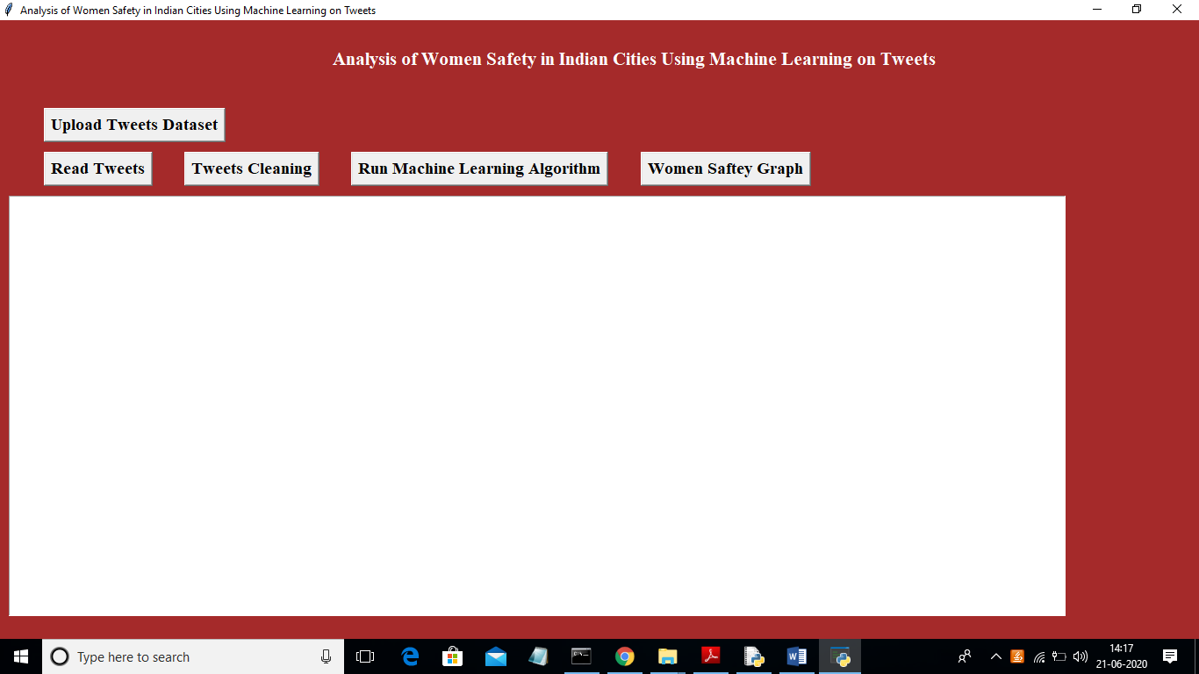

In above screen click on ‘Upload Tweets Dataset’ button and upload tweets

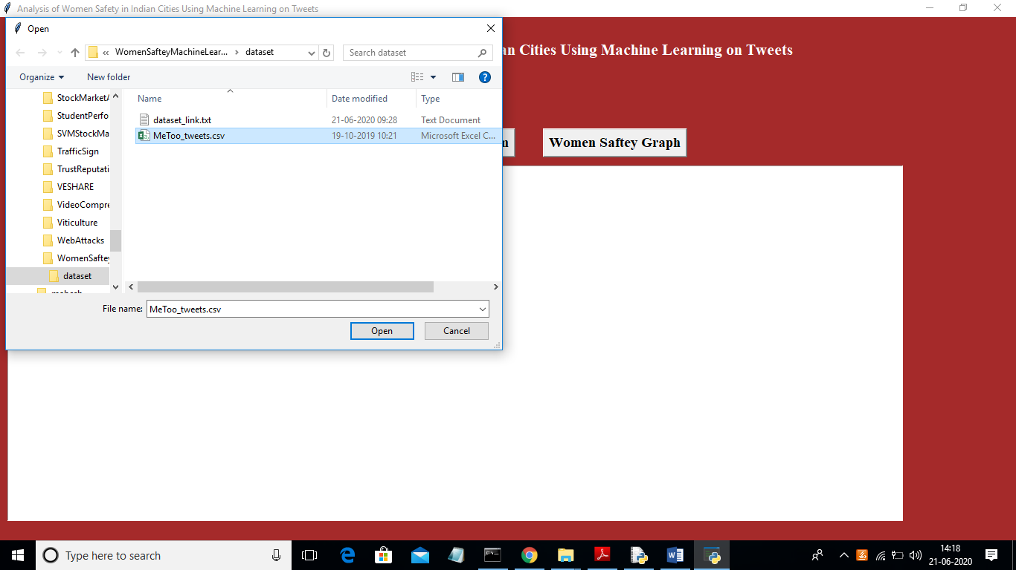

In above screen uploading MeeToo_tweets.csv file and then click on ‘Open’ button to load dataset and to get below screen

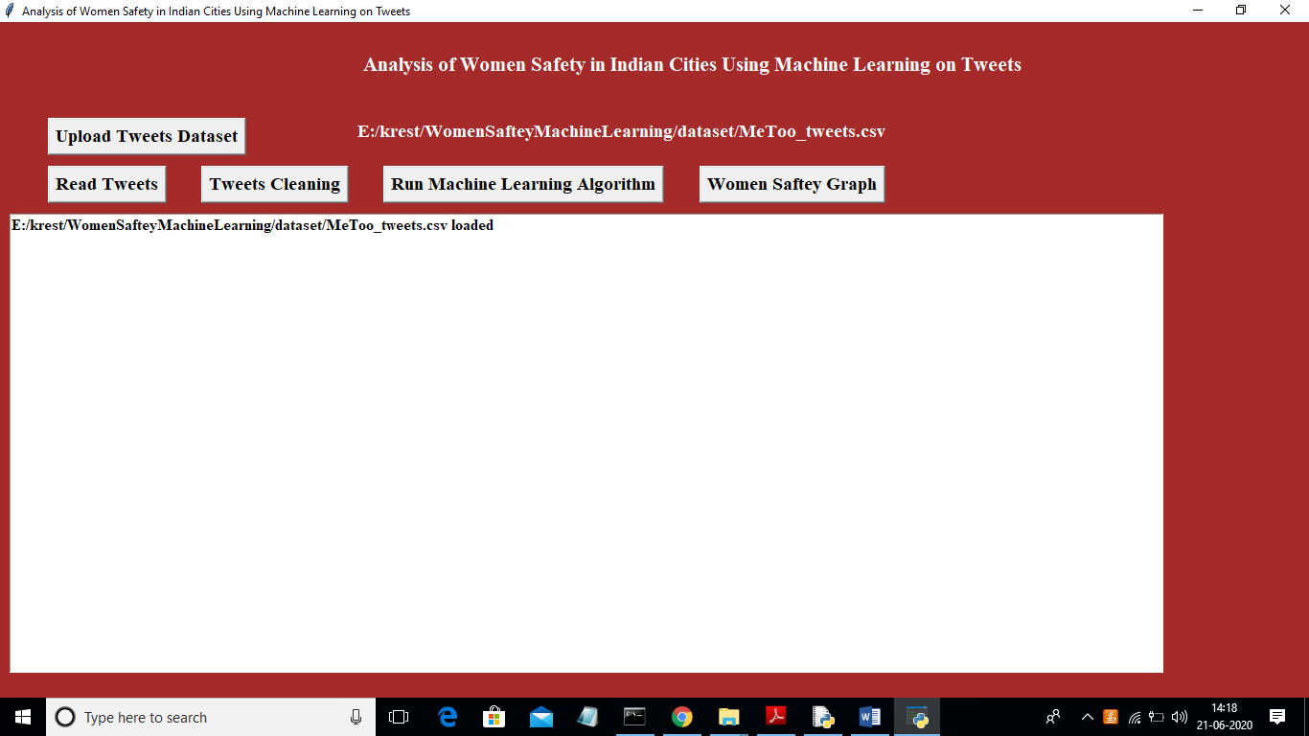

In above screen tweets dataset loaded and now click on ‘Read Tweets’ button to read tweets from dataset

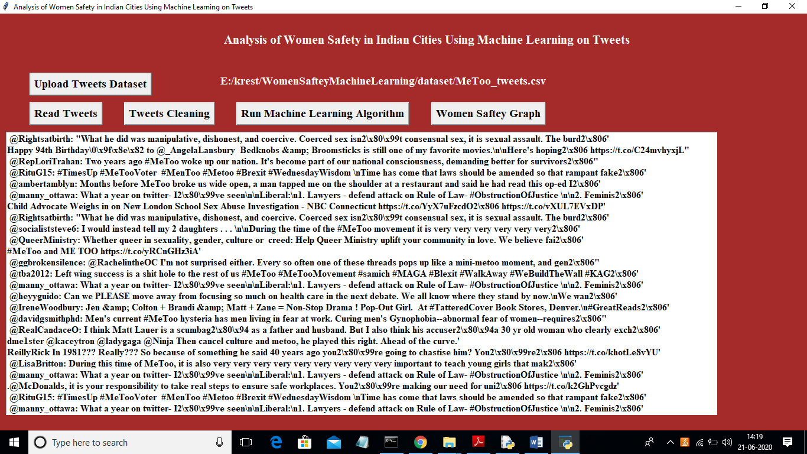

In above screen each line represents one tweet and you can scroll down above screen text area to view all tweets. In above screen we can see all tweets contains special symbols and stop words and to clean those tweets click on ‘Tweets Cleaning’ button

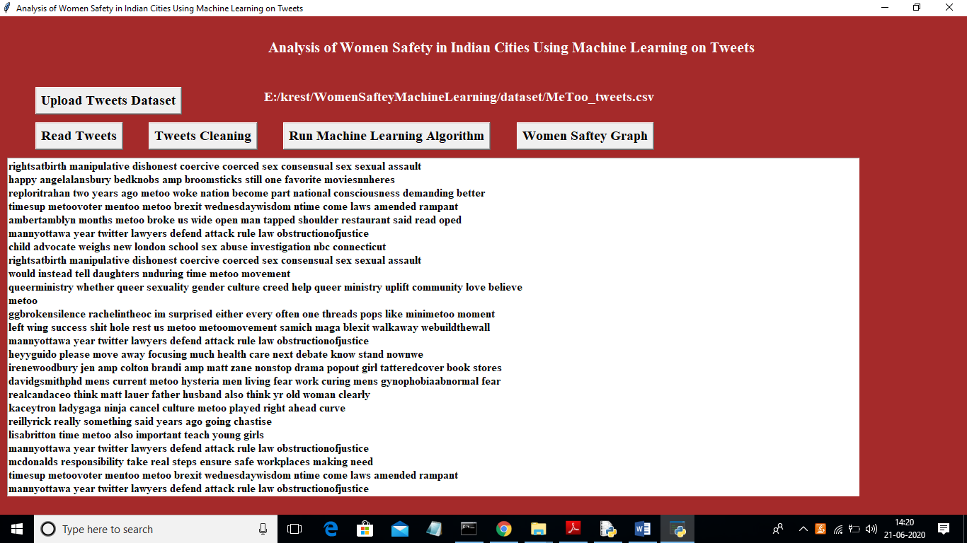

In above screen we can see all special symbols and stop words remove from tweets and only clean words are there and now click on ‘Run Machine Learning Algorithm’ button to predict sentiments from tweets

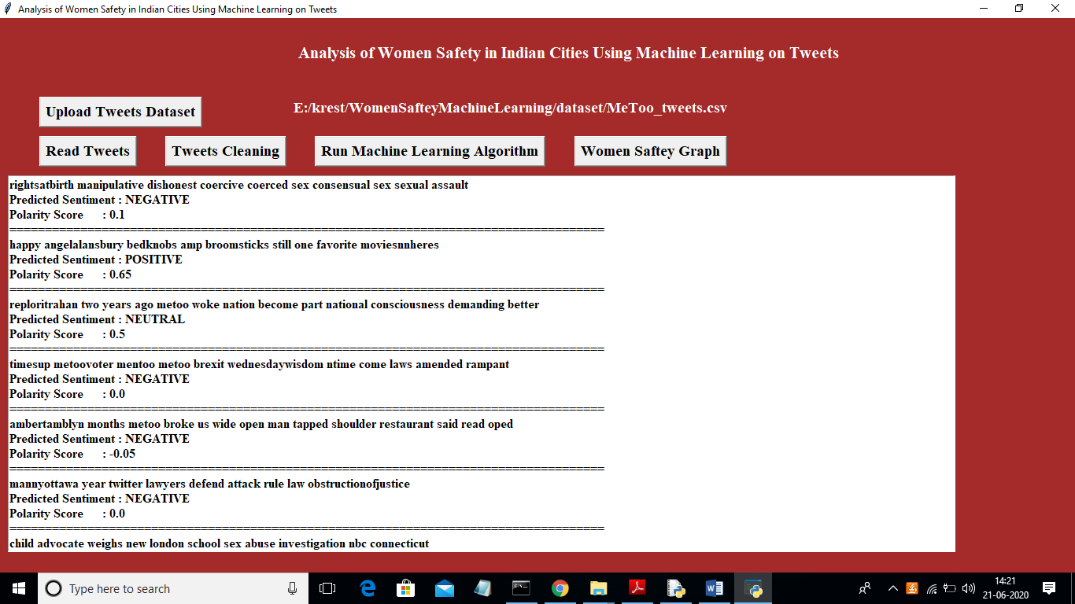

In above screen each tweet having tweet text and then displaying tweets sentiments with polarity score. Scroll down above text area to see all tweets. Now click on ‘Women Saftey Graph’ button to get below results and by seeing that result user can easily understand whether area is safe or not. If area is safe then more peoples will express either positive or neutral tweets and if not safe then more peoples will discuss negative tweets.

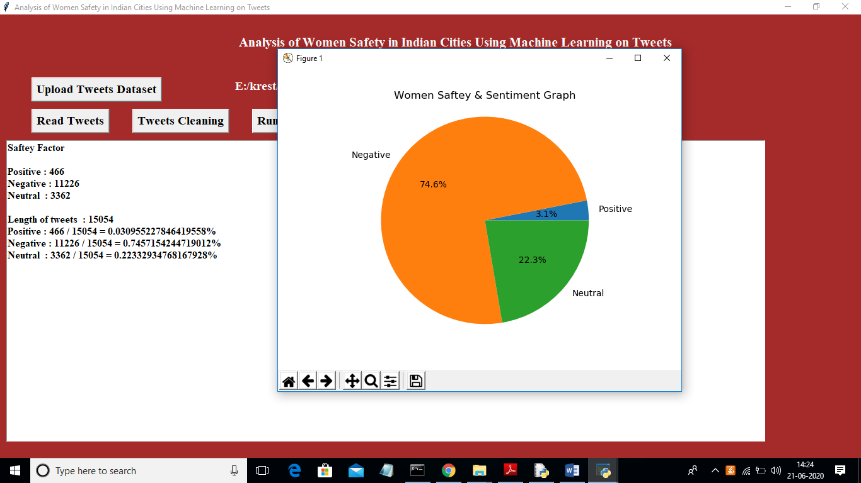

In above screen 0.74 multiply by 100 will give 74% which means 74% peoples are talking negative and area is not safe and only 22 and 3% peoples are talking positive and neutral.