Automated Volunteer CRM && Social Scheduling Platform
Team Name: CTR-CRM Platform
Members: Jaime Gudino & Alice Hui
Industry Sponsor: Conversations to Remember, a nonprofit connecting college students with isolated seniors through weekly video visits
Industry Mentor: Robert Lefkowitz
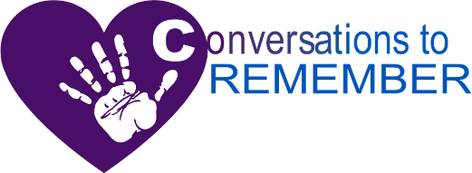
Abstract:
Conversations to Remember needed software to coordinate volunteers who hold weekly conversations with seniors and keep its social media consistent. This project aims to deliver two tools: a CRM for seniors, volunteers, teams, meetings, and feedback, and a scheduler for Facebook, Instagram, and LinkedIn posts. The CRM uses Baserow and n8n workflows that create Google Calendar events. The scheduler, a React and Express application with MariaDB in Docker, fills monthly posting slots from a content library by post type and color, protects fixed-date posts, and sends each post to Google Calendar for n8n to publish. Constraints include client-controlled Google Workspace access, platform image rules, and testing kept off live accounts. Future work could add engagement analytics to guide posting times, a manager approval step before posts publishes, draft posts built from student quotes in the CRM, more social platforms, volunteer impact reports for grant applications, and mobile app for staff.

