**Setup ScreenShot**

**Venv creation**

python -m venv flask

source flask/bin/activate # On Windows: venv\Scripts\activate

pip install flask pymongo dnspython

1. **Flask /api Route to Return JSON from File**

**Directory Structure:**

project/

├── app.py

├── data.json

├── templates/

│ └── form.html

│ └── success.html

**data.json Example:**

[

{"name": "Avalon", "age": 31},

{"name": "Mohammad", "age": 29}

]

**Script:**

from flask import Flask, jsonify

app = Flask(__name__)

@app.route('/api')

def api():

import json

with open('data.json') as file:

data = json.load(file)

return jsonify(data)

if __name__ == '__main__':

app.run(debug=True)

**Explanation:**

**Flask /api route**:

* We read JSON data from data.json using Python’s json module.
* Flask’s jsonify() returns it as a valid JSON API response.
* Useful for sending backend-stored data to frontend/other systems.

**ScreenShot:**

1. **Submit Form to MongoDB Atlas**

**Script**:

**Form.py**

from flask import Flask, request, render_template

from pymongo import MongoClient

# Initialize Flask app

app = Flask(__name__)

# MongoDB connection

client = MongoClient("your_mongodb_uri")

db = client['tutorial']

collection = db['tutorial']

@app.route('/', methods=['GET', 'POST'])

def index():

if request.method == 'POST':

name = request.form['name']

age = int(request.form['age'])

collection.insert_one({'name': name, 'age': age})

return 'Data Submitted'

return '''

<form method="POST">

Name: <input name="name"><br>

Age: <input name="age"><br>

<input type="submit">

</form>

'''

if __name__ == '__main__':

app.run(debug=True)

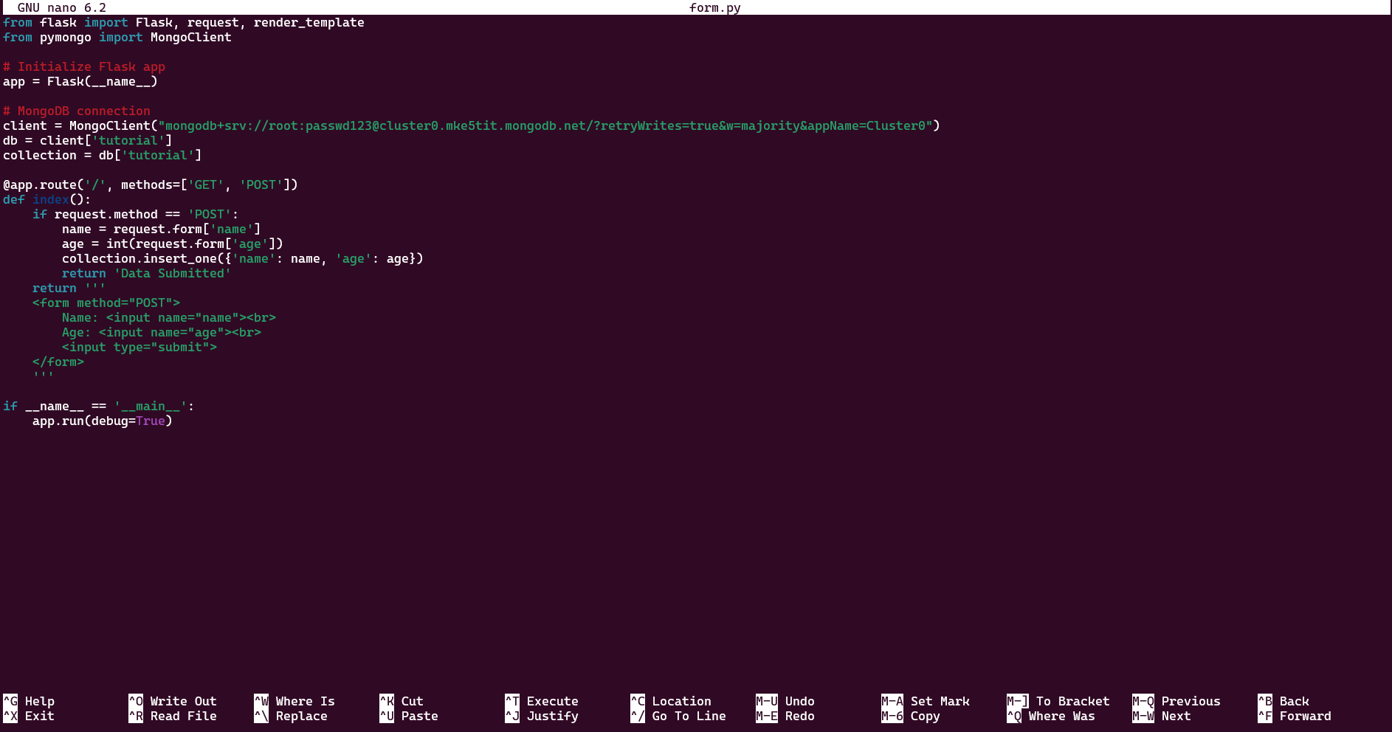

**templates/form.html:**

<!DOCTYPE html>

<html>

<head><title>Submit Data</title></head>

<body>

<h2>Submit Your Info</h2>

{% if error %}<p style="color:red">{{ error }}</p>{% endif %}

<form method="POST">

Name: <input type="text" name="name" required><br><br>

Age: <input type="number" name="age" required><br><br>

<input type="submit" value="Submit">

</form>

</body>

</html>

**templates/success.html:**

<!DOCTYPE html>

<html>

<head><title>Success</title></head>

<body>

<h2>Data submitted successfully</h2>

</body>

</html>

**Explanation:**

Form Submission to MongoDB Atlas:

* We created a form in HTML and handled the POST request in Flask.
* Using pymongo, we inserted form data into MongoDB Atlas.
* On success, user is redirected to a success page.
* On failure, the error is shown on the same form page.

**ScreenShot:**

