**1. Creating and Renaming Files/Directories**

**Step 1: Create a directory named test_dir**

Command: - mkdir test_dir

* **Explanation**: The mkdir command creates a new directory named test_dir in your current working directory.

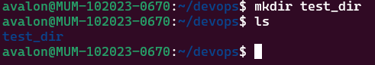

**Step 2: Create an empty file called example.txt inside test_dir**

Command: - touch test_dir/example.txt

* **Explanation**: The touch command creates an empty file named example.txt inside the test_dir directory.

**Step 3: Rename example.txt to renamed_example.txt**

Command: - mv test_dir/example.txt test_dir/renamed_example.txt

* **Explanation**: The mv command is used here to rename the file example.txt to renamed_example.txt within the test_dir directory.

**2. Viewing File Contents**

**Step 1: Display the contents of /etc/passwd**

Command: - cat /etc/passwd

* **Explanation**: The cat command displays the entire content of the /etc/passwd file, which contains user account information.

**Step 2: Display only the first 5 lines of /etc/passwd**

Command: - head -n 5 /etc/passwd

* **Explanation**: The head command with the -n 5 option shows the first 5 lines of the file.

**Step 3: Display only the last 5 lines of /etc/passwd**

Command: - tail -n 5 /etc/passwd

* **Explanation**: The tail command with the -n 5 option shows the last 5 lines of the file.

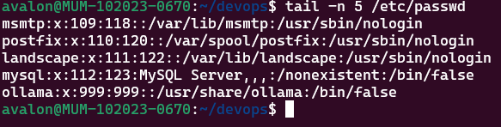

**3. Searching for Patterns**

**Step: Find all lines containing the word "root" in /etc/passwd**

Command: - grep "root" /etc/passwd

* **Explanation**: The grep command searches for the string "root" in the /etc/passwd file and displays all matching lines.

**4. Zipping and Unzipping**

**Step 1: Compress the test_dir directory into test_dir.zip**

Command: - zip -r test_dir.zip test_dir

* **Explanation**: The zip command with the -r option recursively compresses the test_dir directory into a file named test_dir.zip.

**Step 2: Unzip test_dir.zip into a new directory named unzipped_dir**

Command: - mkdir unzipped_dir

unzip test_dir.zip -d unzipped_dir

* **Explanation**: First, mkdir creates a new directory named unzipped_dir. Then, the unzip command extracts the contents of test_dir.zip into the unzipped_dir directory.

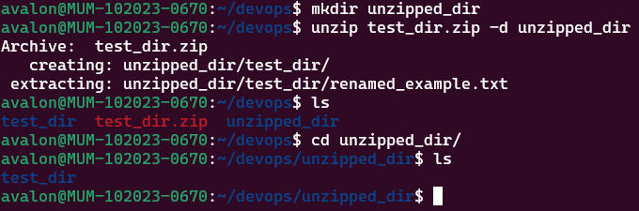

**5. Downloading Files**

**Step: Download a file from a URL using wget**

Command: - wget https://example.com/sample.txt

* **Explanation**: The wget command downloads the file from the specified URL (https://example.com/sample.txt) to the current directory.

Checked the page on browser:

**6. Changing Permissions**

**Step: Create a file named secure.txt and change its permissions to read-only for everyone**

Command: - touch secure.txt

chmod 444 secure.txt

* **Explanation**: The touch command creates an empty file named secure.txt. The chmod 444 command sets the file permissions to read-only for the owner, group, and others.

**7. Working with Environment Variables**

**Step: Set a new environment variable called MY_VAR with the value "Hello, Linux!"**

Command: - export MY_VAR="Hello, Linux!"

* **Explanation**: The export command sets the environment variable MY_VAR with the value "Hello, Linux!" for the current session.

