

Bahir Dar University
Bahir Dar Institute of Technology
Faculty of Computing
Department of Software Engineering

Course Title: software testing and quality assurance

Name ID
Ermias Desalegn ……………………………………….1404196

Submitted to: Dr. Mequanint
BAHIR DAR, ETHIOPIA

Run the load test for a website with a link: -
https://www.plex.tv/watch-free/

Summary report :

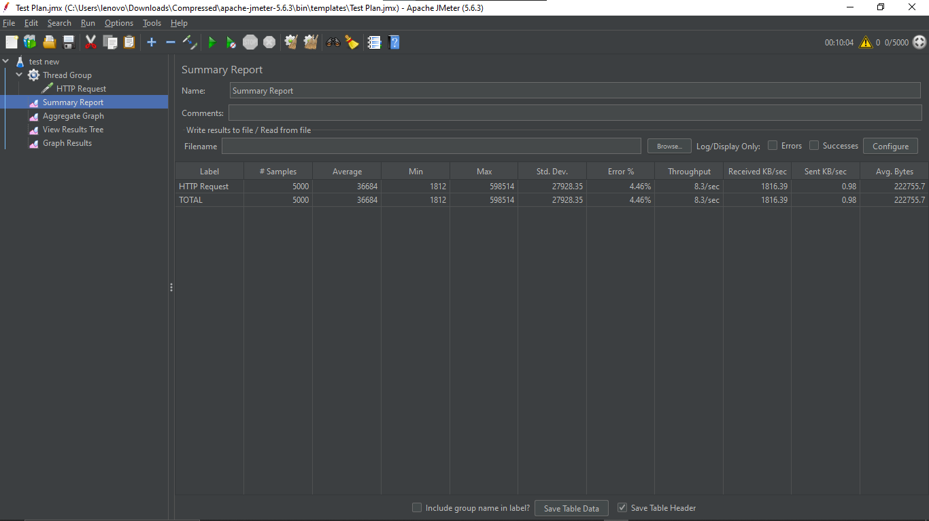

Result tree:
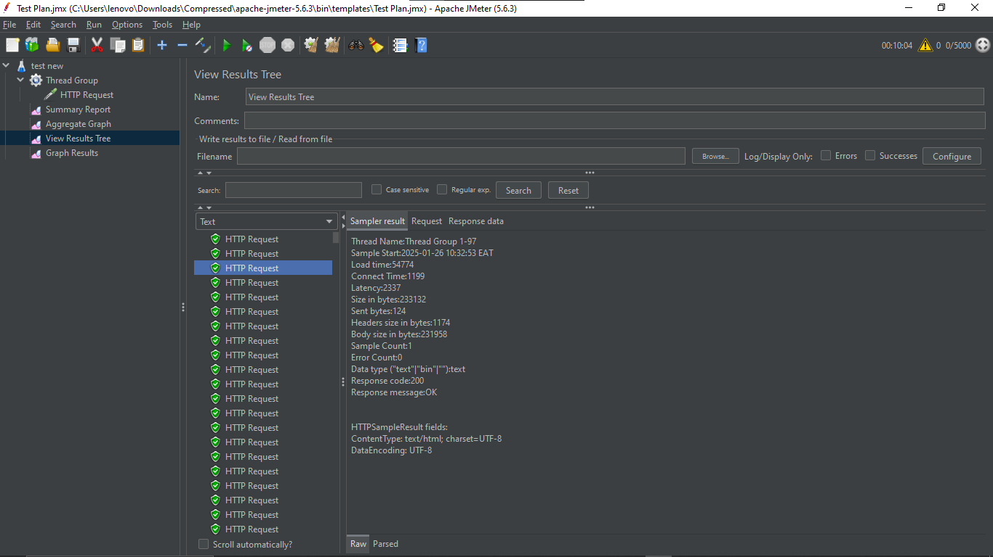

Graph Results
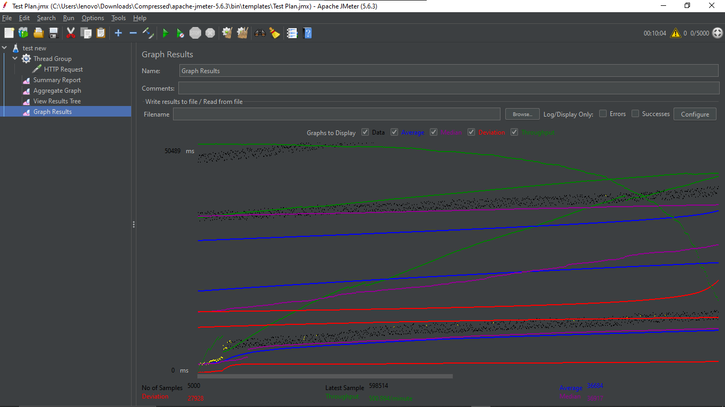
Aggregate Graph view:
