Access the demo insurance project at demo guru99.com (http://demo.guru99.com)
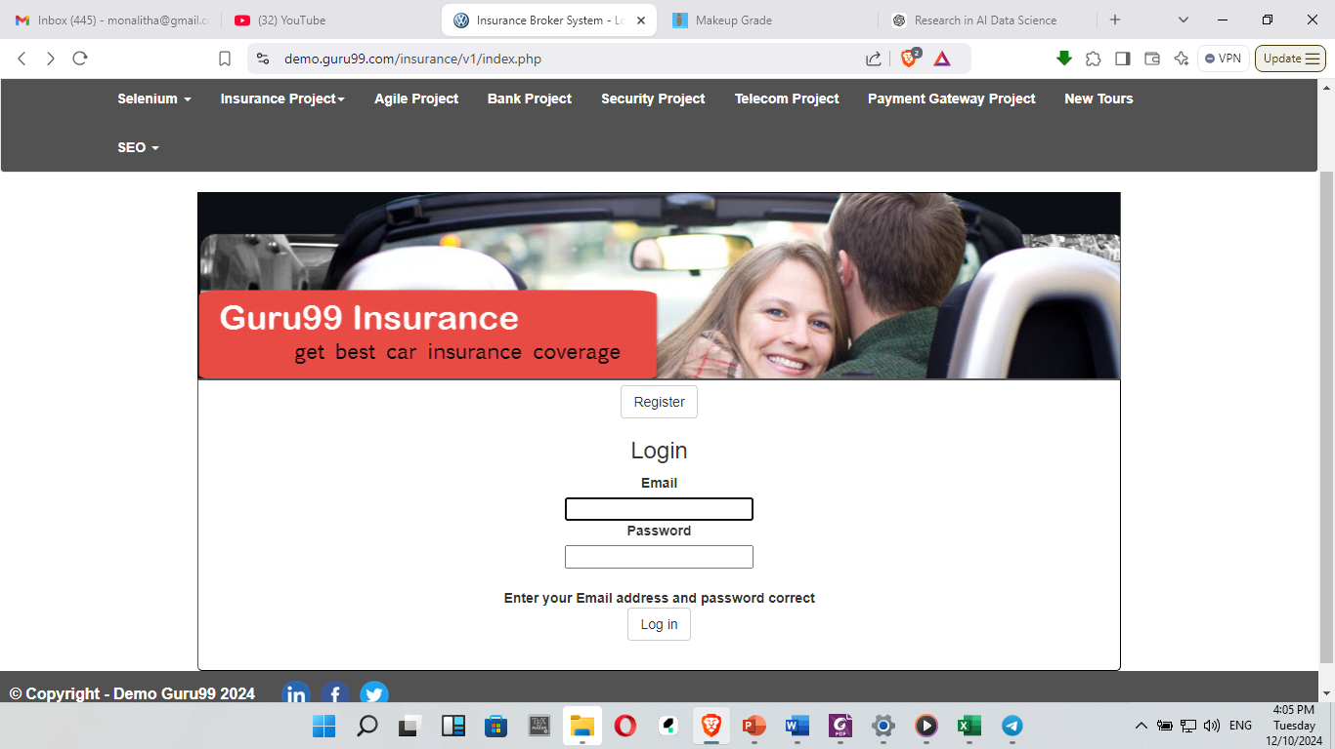
Testable features or test scenarios
  - Login page (using email address)
  - Register as a new user
Prepare all possible test cases from the above test scenarios as follows:
Test Scenario | Test Case | Test Step | Test Data | Expected Result | Actual Result | Status (P/F)
TS1-Check yyy yyy yyy yyy | TC1- aaa aaa aaa
 | TC2- bbb bbb
 | TC3- ccc ccc ccc
TS2-Check yyy yyy yyy yyy | TC4- ddd ddd
 | TC5- eee eee eee
 | TC6- fff fff fff fff
 | TC7- ggg ggg ggg

Execute test cases and compute test
- Ran rate
- Pass rate
Prepare defect report based on the following format:
Defect_ID | Defect Description | Version | Steps | Date Raised | Reference | Detected By | Status | Fixed by | Date Closed | Severity | Priority

While reporting the defect to developers, your defect report should contain the following data.
  - Defect_ID - Unique identification number for the defect.
  - Defect Description - Detailed description of the defect including information about the module in which the defect was found.
  - Version - Version of the application in which defect was found.
  - Steps - Detailed steps along with screenshots with which the developer can rectify the defects.
  - Date Raised - Date when the defect is raised
  - Reference- Provide reference to the documents such as requirements, design, architecture or maybe even screenshots of the error to help understand the defect
  - Detected By - Name/ID of the tester who raised the defect
  - Status - Status of the defect
  - Fixed by - Name/ID of the developer who fixed it
  - Date Closed - Date when the defect is closed
  - Severity - which describes the impact of the defect on the application
  - Priority - which is related to defect fixing urgency.

Group members:
1.
2.
Submission date: December 15, 2024
Submission email address: monalitha@gmail.com

