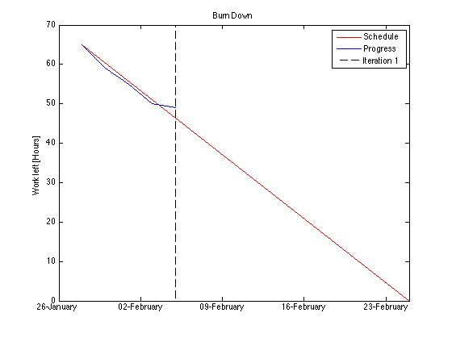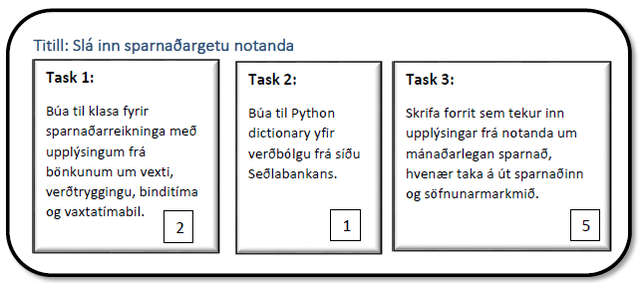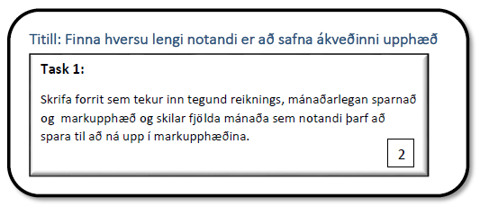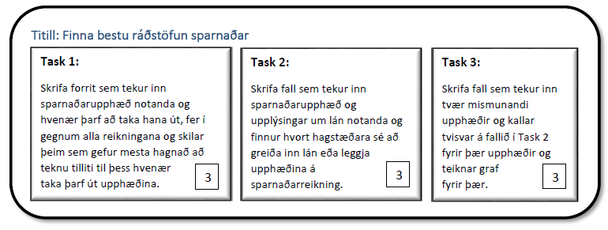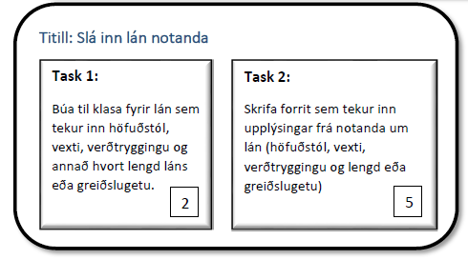

Burn Down

Complete

In Progress

User stories

**llllllllllllllllllllllllllllllllllll**

**llllllllllllllllllllllllllllllllllll**

- - - - - - - - - - - - - - - - - - - - - - - - - - - - - - -

- - - - - - - - - - - - - - - - - - - - - - - - - - - - - - - - - - - - - - - - - - - - - - -

- - - - - - - - - - - - - - - - - - - - - - - - - - - - - -

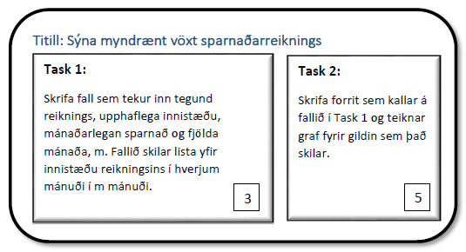

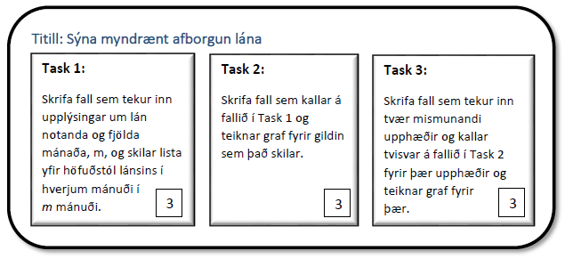

**llllllllllllllllllllllllllllllllllll**

- - - - - - - - - - - - - - - - - - - - - - - - - - - - - - - - - - - - - - - - - - - - - - - -

**llllllllllllllllllllllllllllllllllll**



                                              

                             

                                                                       