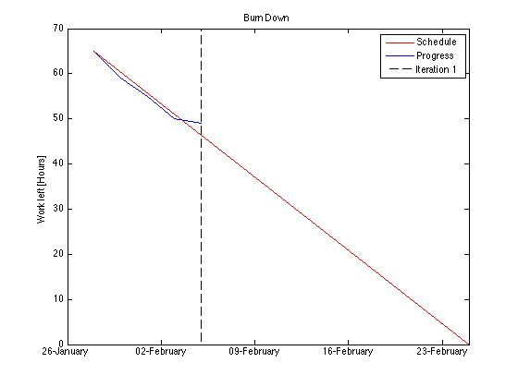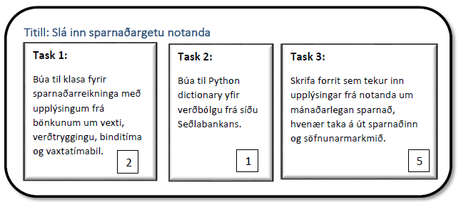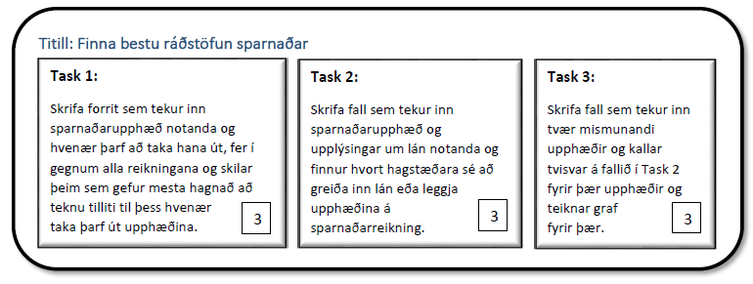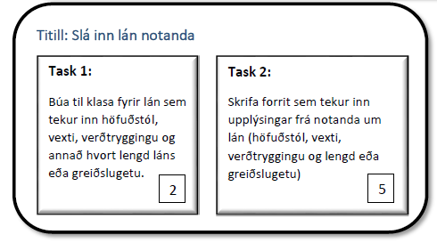

1 Ítrun

Burn Down

Complete

In Progress

User stories

**llllllllllllllllllllllllllllllllllll**

**llllllllllllllllllllllllllllllllllll**

- - - - - - - - - - - - - - - - - - - - - - - - - - - - - - -

- - - - - - - - - - - - - - - - - - - - - - - - - - - - - - - - - - - - - - - - - - - - - - -

Next

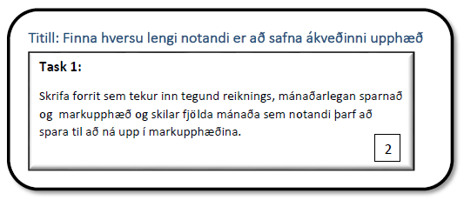

- - - - - - - - - - - - - - - - - - - - - - - - - - - - - - - - - - - - - - - - - - - - - - - - - - - - - - - - - - - - - - - - - - - - - - - - -- -

Completed

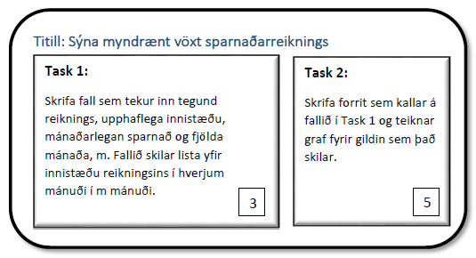

2 Ítrun

User stories

Burn Down

Complete

In Progress

**llllllllllllllllllllllllllllllllllll**

**llllllllllllllllllllllllllllllllllll**

- - - - - - - - - - - - - - - - - - - - - - - - - - - - - - -

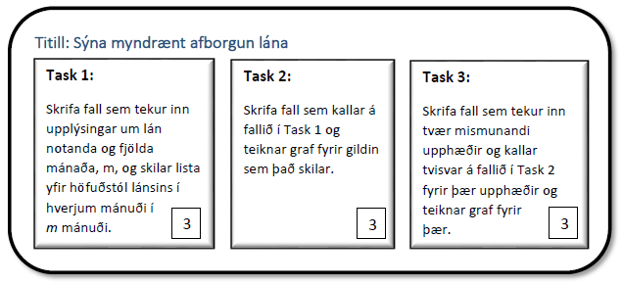

- - - - - - - - - - - - - - - - - - - - - - - - - - - - - - - - - - - - - - - - - - - - - - -

Next

- - - - - - - - - - - - - - - - - - - - - - - - - - - - - - - -- - - - - - - - - - - - - - - - - - - - - - - - - - - - - - - - - - -- - - - - - - -

Completed

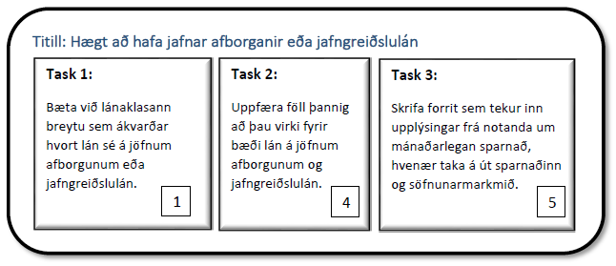

3 Ítrun

User stories

Burn Down

Complete

In Progress

**llllllllllllllllllllllllllllllllllll**

**llllllllllllllllllllllllllllllllllll**

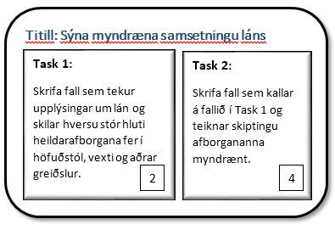

- - - - - - - - - - - - - - - - - - - - - - - - - - - - - - -

- - - - - - - - - - - - - - - - - - - - - - - - - - - - - - - - - - - - - - - - - - - - - - -

Next

- - - - - - - - - - - - - - - - - - - - - - - - - - - - - - - -- - - - - - - - - - - - - - - - - - - - - - - - - - - - - - - - - - -- - - - - - - -

Completed

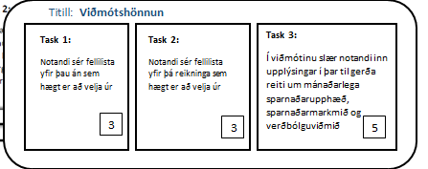

4 Ítrun

User stories

Burn Down

Complete

In Progress

**llllllllllllllllllllllllllllllllllll**

**llllllllllllllllllllllllllllllllllll**

- - - - - - - - - - - - - - - - - - - - - - - - - - - - - - -

- - - - - - - - - - - - - - - - - - - - - - - - - - - - - - - - - - - - - - - - - - - - - - -

Next

Completed

- - - - - - - - - - - - - - - - - - - - - - - - - - - - - - - - - - - - - - - - - - - - - - - - - - - - - - - - - - - - - - - - - - - - - - - - -- -