GUDURU KRUTHI
1WN24CS105
Lab program 3:

3a) Queue Using Array

WAP to simulate the working of a queue of integers using an array.
Provide the following operations:
- Insert
- Delete
- Display
The program should print appropriate messages for queue empty and queue overflow conditions.

#include <stdio.h>
#include <stdlib.h>
#define MAX 50
int queue_array[MAX];
int rear = -1;
int front = -1;
void insert();
void delete();
void display();
int main() {
int choice;
while (1) {
printf("\n1. Insert\n");
printf("2. Delete\n");
printf("3. Display\n");
printf("4. Exit\n");
printf("Enter your choice: ");
scanf("%d", &choice);
switch (choice) {
case 1:
insert();
break;
case 2:
delete();
break;
case 3:
display();
break;
case 4:
exit(0);
default:
printf("Invalid choice\n");
}
}
}
void insert() {
int add_item;
if (rear == MAX - 1) {
printf("Queue Overflow\n");
} else {
if (front == -1)
front = 0;
printf("Insert the element in queue: ");
scanf("%d", &add_item);
rear = rear + 1;
queue_array[rear] = add_item;
}
}
void delete() {
if (front == -1 || front > rear) {
printf("Queue Underflow\n");
} else {
printf("Deleted Element is: %d\n", queue_array[front]);
front = front + 1;
}
}
void display() {
int i;
if (front == -1 || front > rear) {
printf("Queue is empty\n");
} else {
printf("Queue is:\n");
for (i = front; i <= rear; i++)
printf("%d ", queue_array[i]);
printf("\n");
}
}
CODE AND OUTPUT:
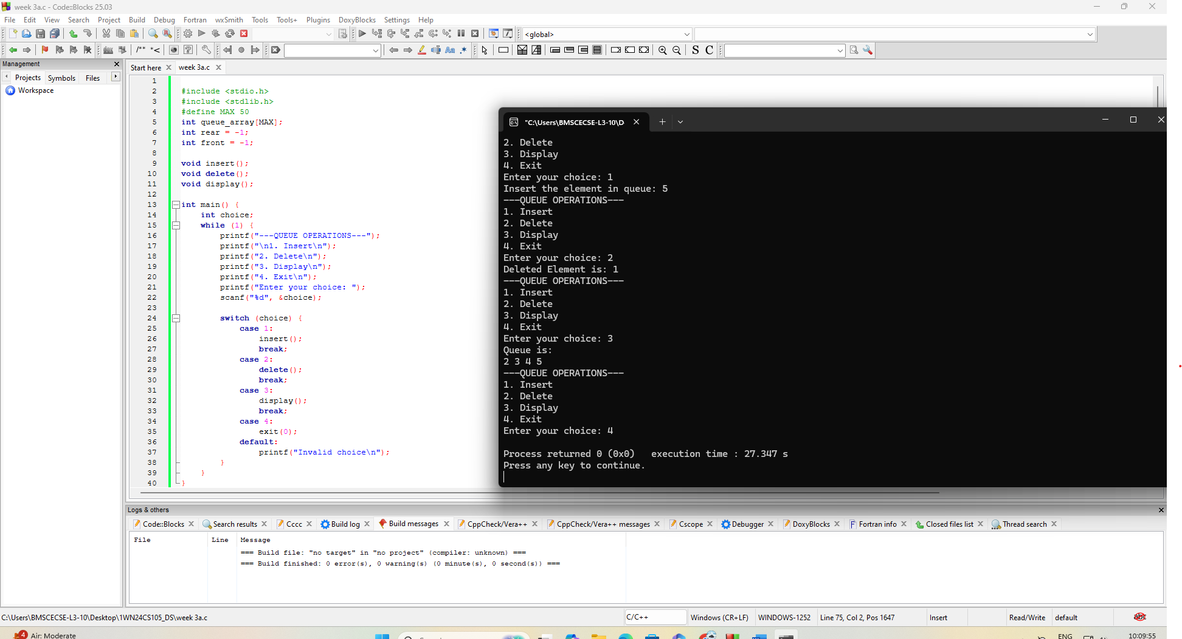

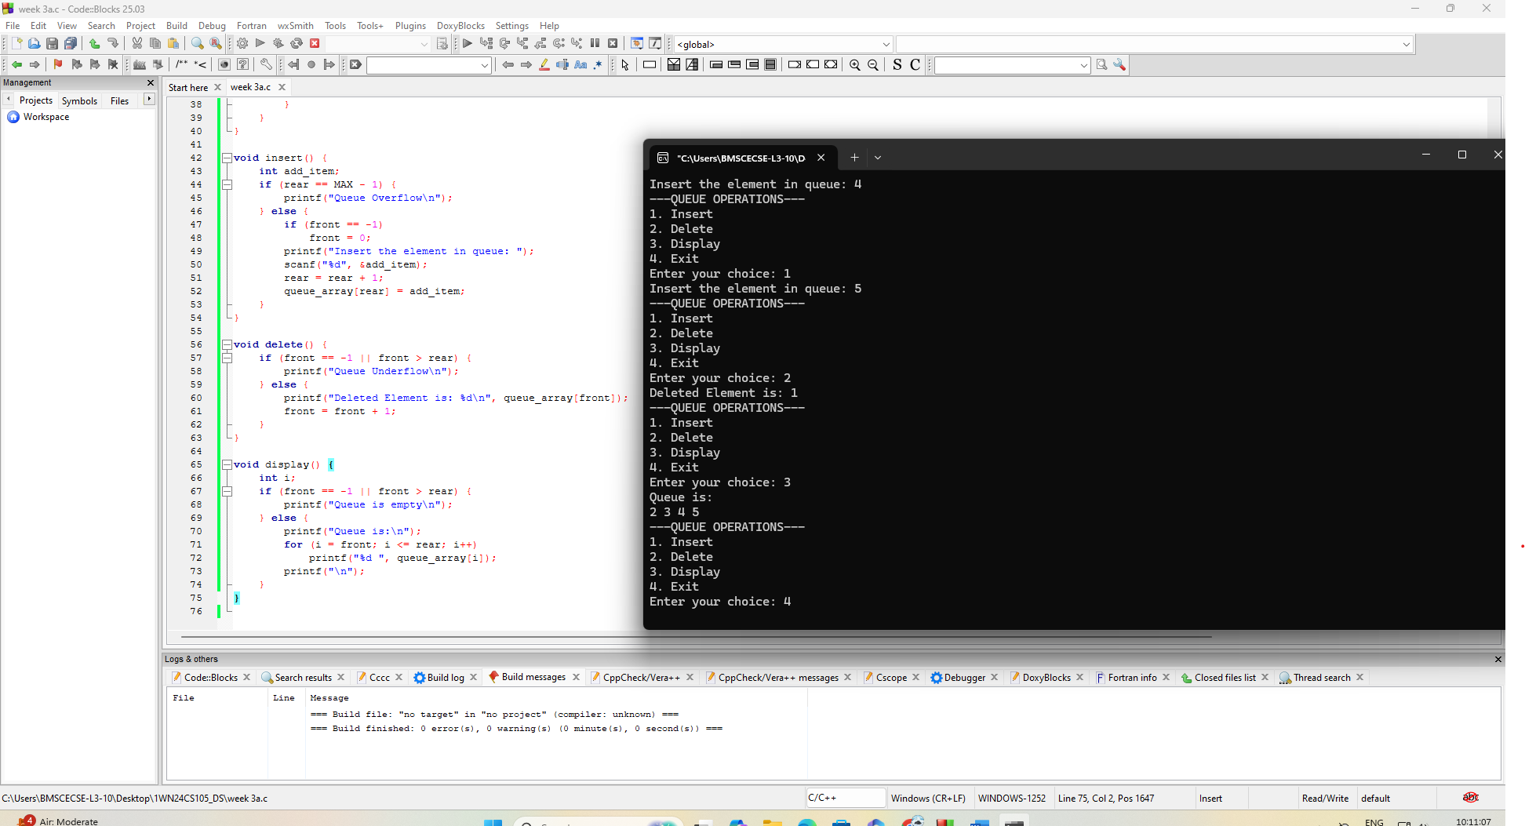

3b) Circular Queue Using Array
WAP to simulate the working of a circular queue of integers using an array.
Provide the following operations:
- Insert
- Delete
- Display
The program should print appropriate messages for queue empty and queue overflow conditions.

#include <stdio.h>
#include <stdlib.h>
#define SIZE 5
int items[SIZE];
int front = -1, rear = -1;
int isFull() {
return ((front == rear + 1) || (front == 0 && rear == SIZE - 1));
}
int isEmpty() {
return (front == -1);
}
int deQueue() {
int element;
if (isEmpty()) {
printf("\nQueue is empty!!\n");
return -1;
} else {
element = items[front];
if (front == rear) {
front = -1;
rear = -1;
} else {
front = (front + 1) % SIZE;
}
printf("\nDeleted element -> %d\n", element);
return element;
}
}
void enQueue(int element) {
if (isFull()) {
printf("\nQueue is full!!\n");
} else {
if (front == -1)
front = 0;
rear = (rear + 1) % SIZE;
items[rear] = element;
printf("\nInserted -> %d\n", element);
}
}
void display() {
int i;
if (isEmpty()) {
printf("\nEmpty Queue\n");
} else {
printf("\nItems - ");
for (i = front; i != rear; i = (i + 1) % SIZE) {
printf("%d ", items[i]);
}
printf("%d\n", items[i]);
}
}

int main() {
int option, val, del;
do {
printf("\n***** MAIN MENU *****");
printf("\n1. Insert an element");
printf("\n2. Delete an element");
printf("\n3. Display the queue");
printf("\n4. EXIT");
printf("\nEnter your option: ");
scanf("%d", &option);

switch (option) {
case 1:
printf("\nEnter the number to be inserted in the queue: ");
scanf("%d", &val);
enQueue(val);
break;
case 2:
del = deQueue();
if (del != -1)
printf("\nThe number deleted is: %d\n", del);
break;
case 3:
display();
break;
case 4:
exit(0);
default:
printf("\nInvalid option! Please try again.\n");
}
} while (option != 4);
return 0;
}

CODE AND OUTPUT:
