GUDURU KRUTHI
1WN24CS105

Lab Program 8:
Write a program
a) To construct a binary search tree.
b) To traverse the tree using all the methods i.e., in-order, pre-order and post-order.
c) To display the elements in the tree.

#include <stdio.h>
#include <stdlib.h>
typedef struct node {
int data;
struct node *left;
struct node *right;
} node;
node* create(int value) {
node *newnode = (node*)malloc(sizeof(node));
newnode->data = value;
newnode->left = NULL;
newnode->right = NULL;
}
struct node* insert(node* root, int value) {
if (root == NULL)
return create(value);
if (value < root->data)
root->left = insert(root->left, value);
else if (value > root->data)
root->right = insert(root->right, value);
return root;
}
struct node* find_min(node* ptr) {
node *current = ptr;
while (current && current->left != NULL)
current = current->left;
return current;
}
node* delete(node* root, int key) {
if (root == NULL)
return root;
if (key < root->data)
root->left = delete(root->left, key);
else if (key > root->data)
root->right = delete(root->right, key);
else {
if (root->left == NULL) {
node* temp = root->right;
free(root);
return temp;
}
else if (root->right == NULL) {
node* temp = root->left;
free(root);
return temp;
}
node* temp = find_min(root->right);
root->data = temp->data;
root->right = delete(root->right, temp->data);
}
return root;
}
void inorder_trav(node* root) {
if (root != NULL) {
inorder_trav(root->left);
printf("%d -> ", root->data);
inorder_trav(root->right);
}
}
void preorder_trav(node* root) {
if (root != NULL) {
printf("%d -> ", root->data);
preorder_trav(root->left);
preorder_trav(root->right);
}
}
void postorder_trav(node* root) {
if (root != NULL) {
postorder_trav(root->left);
postorder_trav(root->right);
printf("%d -> ", root->data);
}
}
int main() {
node *root = NULL;
int choice, value;
while (1) {
printf("\n--- Binary Search Tree Menu ---\n");
printf("1. Insert a node\n");
printf("2. Delete a node\n");
printf("3. Inorder Traversal\n");
printf("4. Preorder Traversal\n");
printf("5. Postorder Traversal\n");
printf("6. Exit\n");
printf("Enter your choice: ");
if (scanf("%d", &choice) != 1) {
printf("Invalid input. Exiting.\n");
break;
}
switch (choice) {
case 1:
printf("Enter value to insert: ");
scanf("%d", &value);
root = insert(root, value);
break;
case 2:
printf("Enter value to delete: ");
scanf("%d", &value);
root = delete(root, value);
break;
case 3:
printf("Inorder Traversal: ");
inorder_trav(root);
printf("NULL\n");
break;
case 4:
printf("Preorder Traversal: ");
preorder_trav(root);
printf("NULL\n");
break;
case 5:
printf("Postorder Traversal: ");
postorder_trav(root);
printf("NULL\n");
break;
case 6:
printf("Exiting...\n");
return 0;
default:
printf("Invalid choice. Please try again.\n");
}
}
return 0;
}
CODE:
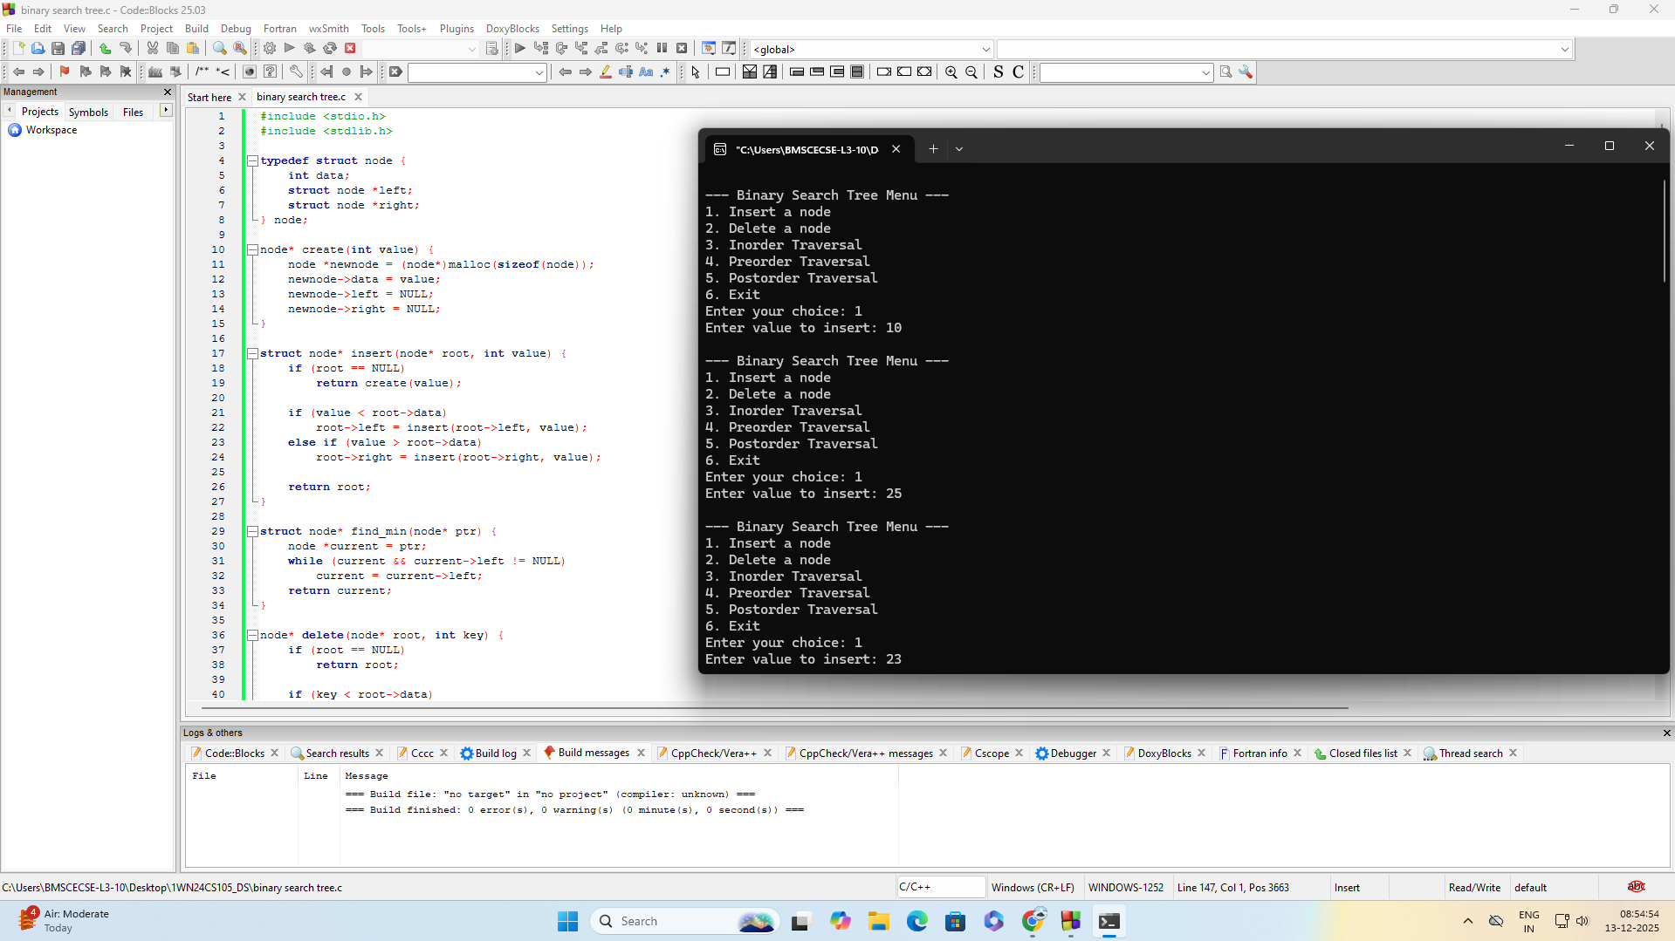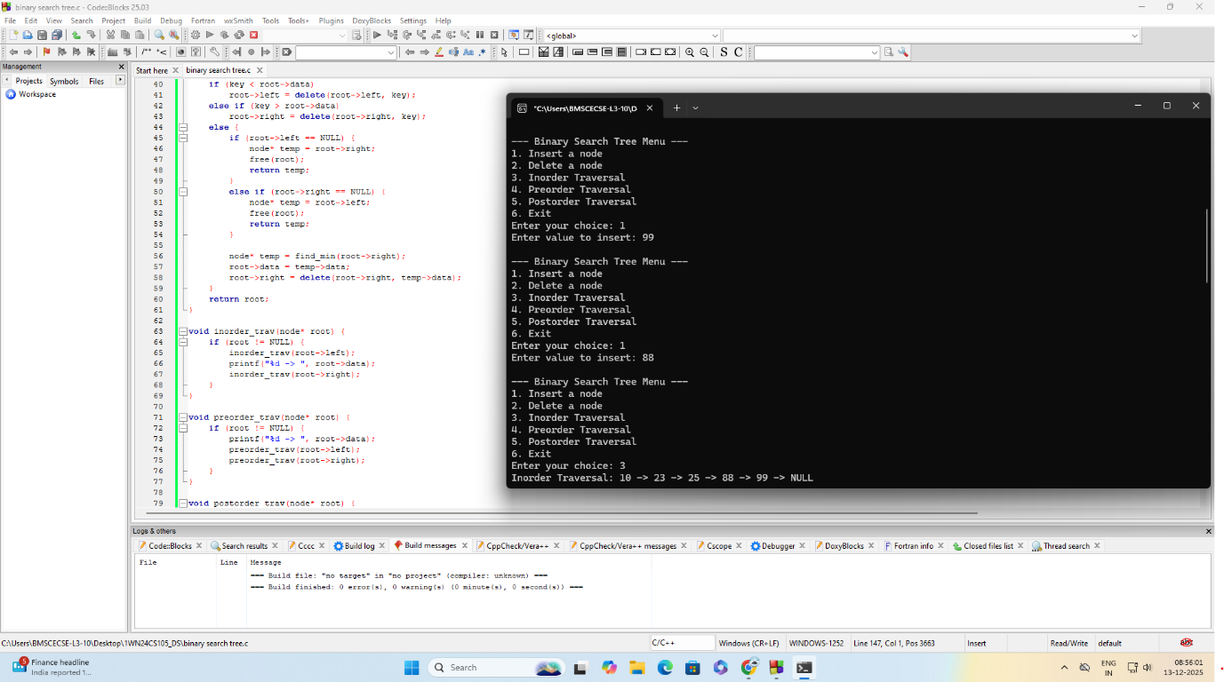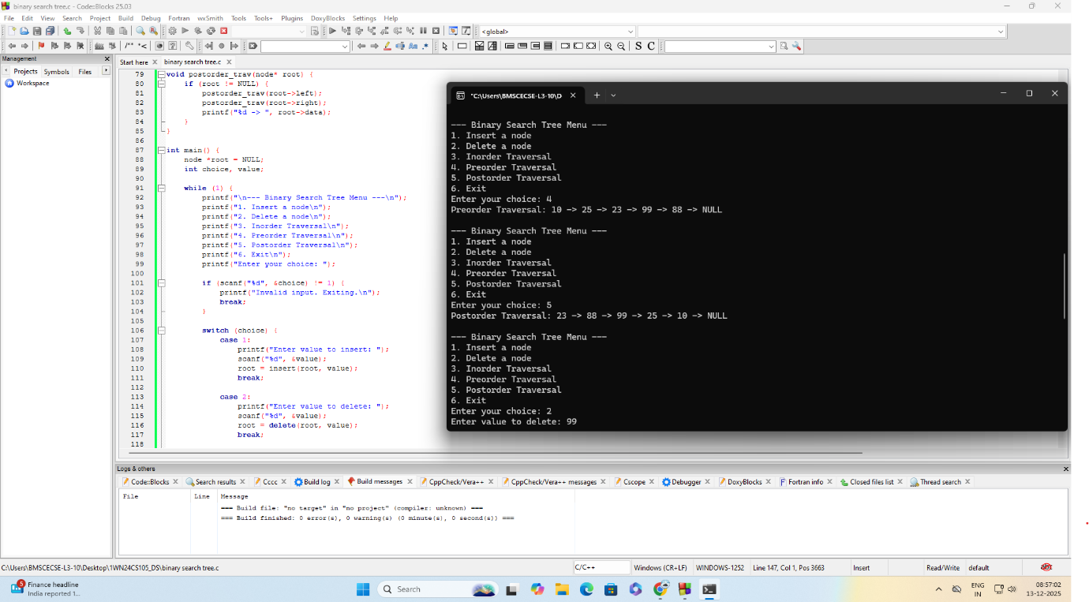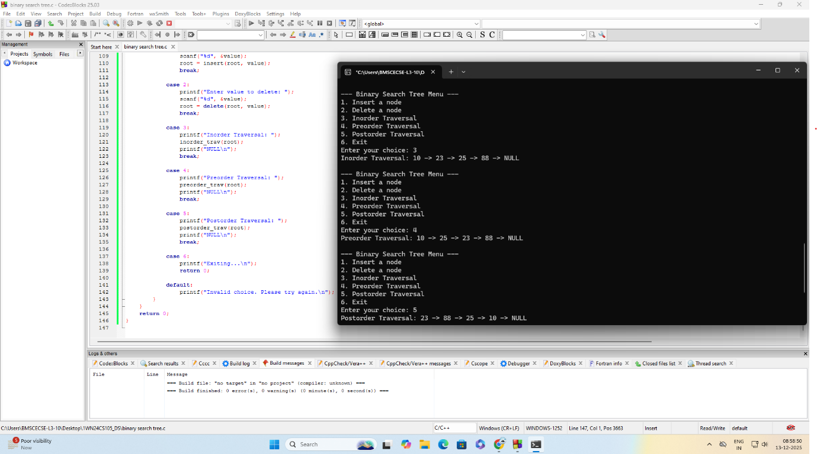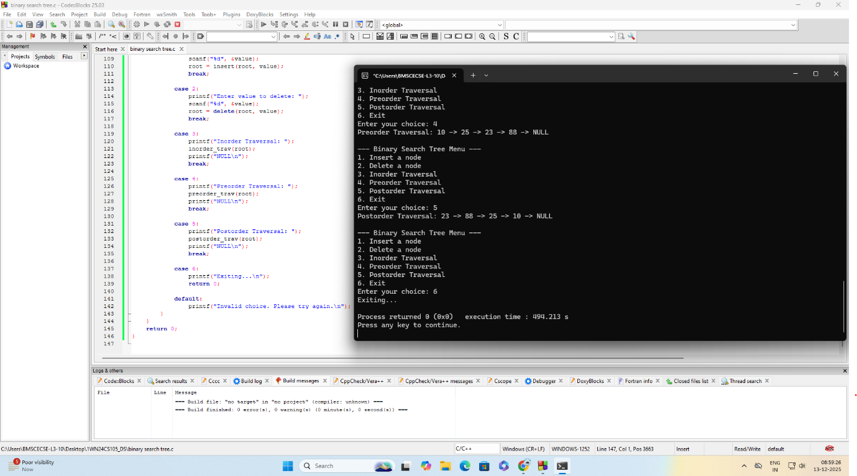
Leet code:
