GUDURU KRUTHI
1WN24CS105

Lab Program 6:
Singly linked list lab cycle 3b
Write a program to implement Singly linked list to simulate Stack and Queue Operations

#include <stdio.h>
#include <stdlib.h>
struct node {
int data;
struct node *next;
};
struct node *top = NULL; // For Stack
struct node *front = NULL; // For Queue
struct node *rear = NULL; // For Queue
struct node* createNode(int value) {
struct node* newNode = (struct node*)malloc(sizeof(struct node));
newNode->data = value;
newNode->next = NULL;
return newNode;
}

/* -------------------- STACK OPERATIONS -------------------- */
void push(int value) {
struct node *newNode = createNode(value);
newNode->next = top;
top = newNode;
printf("Pushed %d\n", value);
}
void pop() {
if (top == NULL) {
printf("Stack Underflow\n");
return;
}
struct node *temp = top;
top = top->next;
printf("Popped %d\n", temp->data);
free(temp);
}
void displayStack() {
if (top == NULL) {
printf("Stack is empty\n");
return;
}
struct node *temp = top;
printf("Stack: ");
while (temp != NULL) {
printf("%d -> ", temp->data);
temp = temp->next;
}
printf("NULL\n");
}

/* -------------------- QUEUE OPERATIONS -------------------- */
void enqueue(int value) {
struct node *newNode = createNode(value);
if (rear == NULL) {
front = rear = newNode;
} else {
rear->next = newNode;
rear = newNode;
}
printf("Enqueued %d\n", value);
}
void dequeue() {
if (front == NULL) {
printf("Queue Underflow\n");
return;
}
struct node *temp = front;
printf("Dequeued %d\n", temp->data);
front = front->next;
if (front == NULL)
rear = NULL;
free(temp);
}
void displayQueue() {
if (front == NULL) {
printf("Queue is empty\n");
return;
}
struct node *temp = front;
printf("Queue: ");
while (temp != NULL) {
printf("%d -> ", temp->data);
temp = temp->next;
}
printf("NULL\n");
}
int main() {
int choice, value;
while (1) {
printf("\n--- MENU ---\n");
printf("1. PUSH (Stack)\n");
printf("2. POP (Stack)\n");
printf("3. Display Stack\n");
printf("4. ENQUEUE (Queue)\n");
printf("5. DEQUEUE (Queue)\n");
printf("6. Display Queue\n");
printf("7. Exit\n");
printf("Enter choice: ");
scanf("%d", &choice);

switch (choice) {
case 1:
printf("Enter value: ");
scanf("%d", &value);
push(value);
break;
case 2:
pop();
break;
case 3:
displayStack();
break;
case 4:
printf("Enter value: ");
scanf("%d", &value);
enqueue(value);
break;
case 5:
dequeue();
break;
case 6:
displayQueue();
break;
case 7:
exit(0);
default:
printf("Invalid choice! Try again.\n");
}
}
}
CODE:
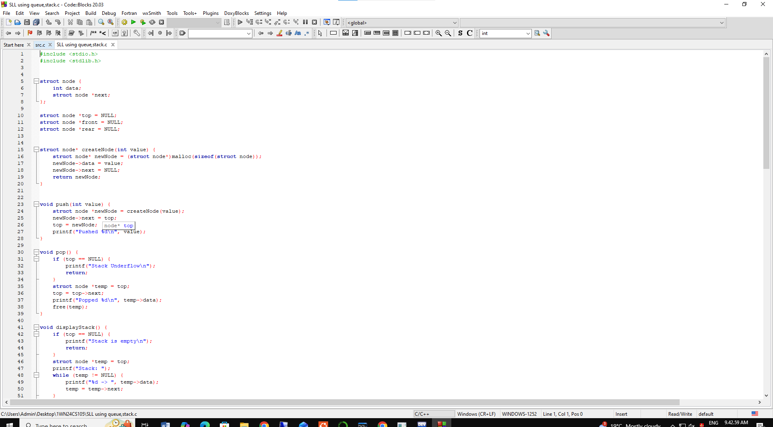
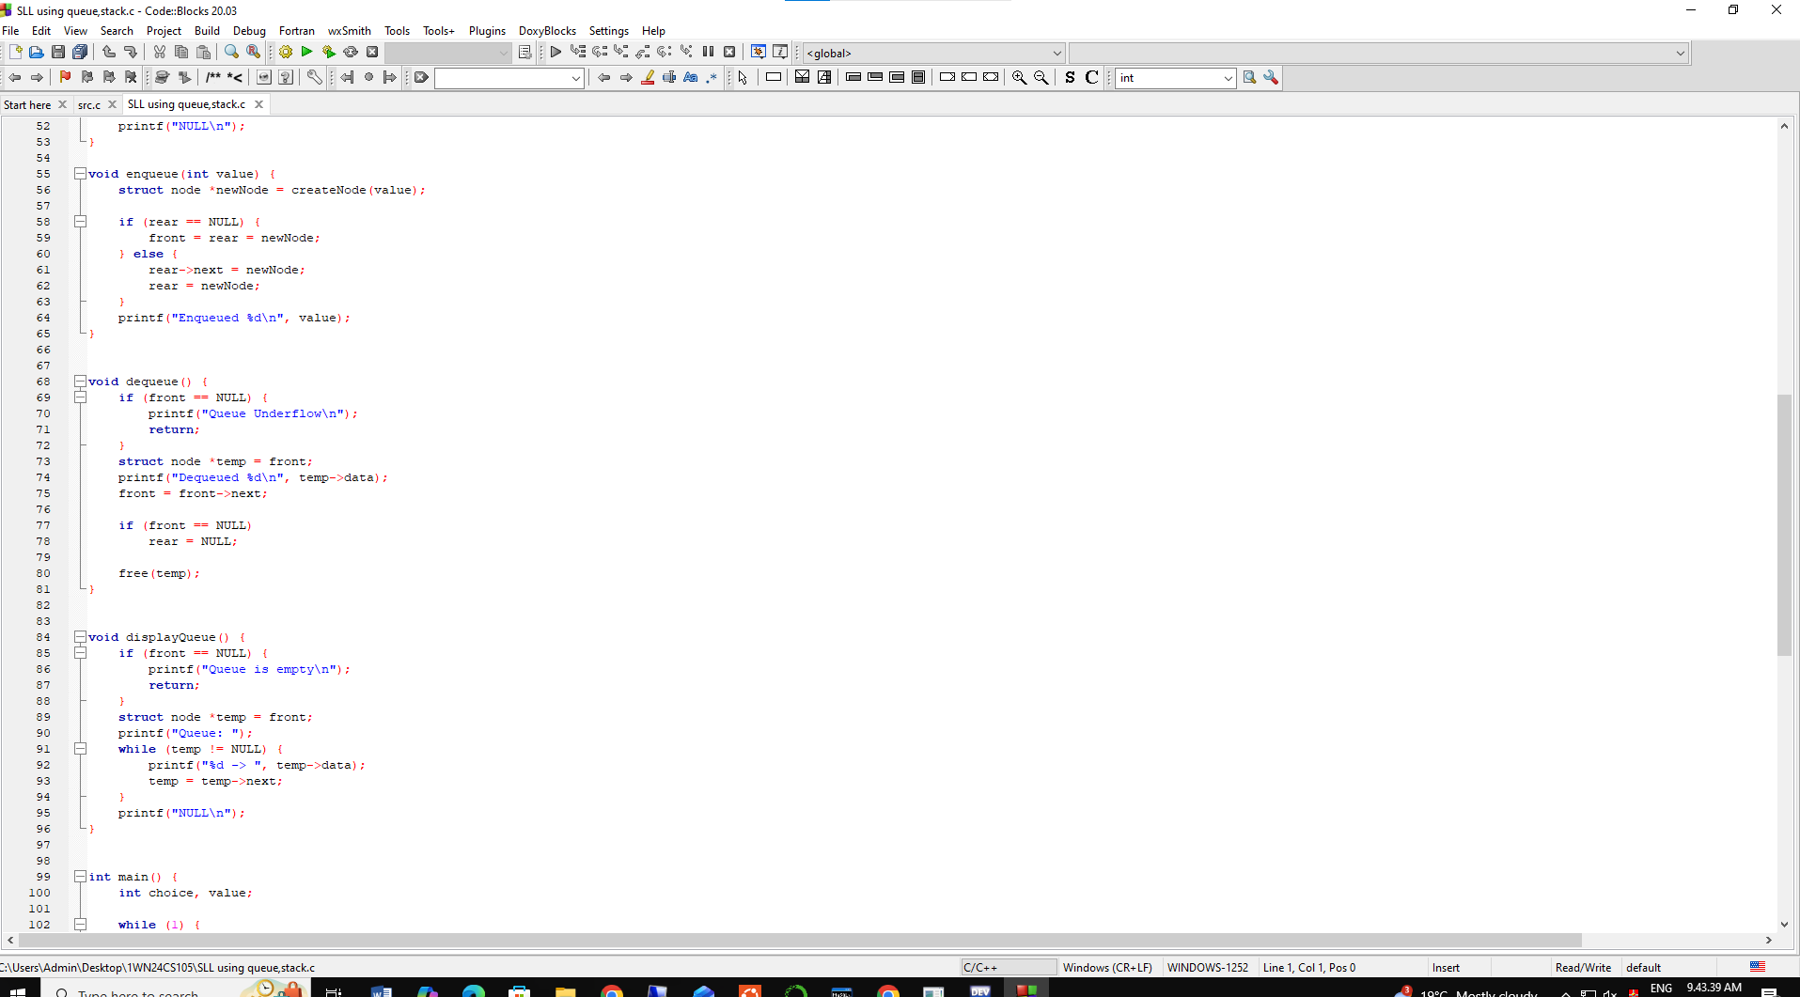
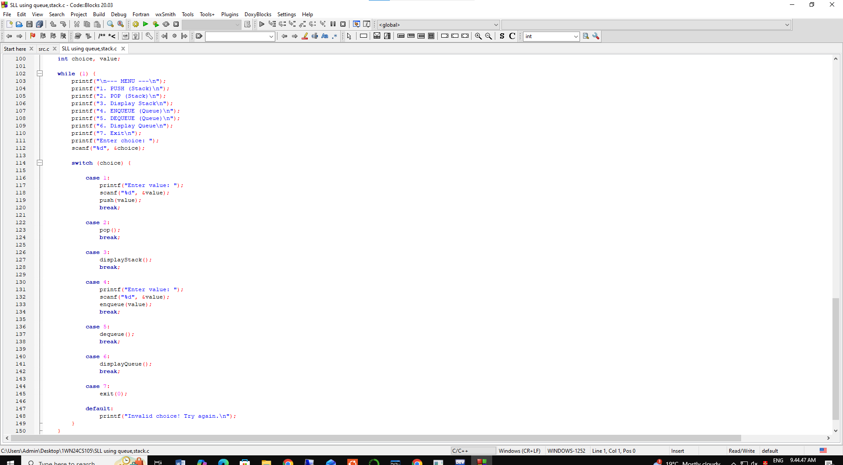

OUTPUT:
