Data Visualization and Insight Communication using R
Week 2 Project Report | Dataset: mtcars
Prepared as a practical demonstration of visualization design, reproducible R code, and communicating analytical findings to a non-technical audience.

1. Executive Summary
This report explores the relationship between vehicle design and fuel economy using the built-in mtcars dataset in R. Four complementary visualizations—a bar chart, scatter plot, histogram, and line chart—are used to compare average miles per gallon (mpg), examine the relationship between vehicle weight and fuel economy, inspect the distribution of mpg values, and summarize how average fuel economy changes across engine-cylinder groups. The charts suggest that cars with fewer cylinders tend to achieve higher fuel economy, and heavier cars generally achieve lower mpg. The histogram also shows meaningful variation across the 32 vehicles rather than a single typical value. These are descriptive patterns in a small historical dataset, not proof that any single vehicle feature causes fuel consumption.

2. Dataset Overview
The mtcars dataset is included with R in the datasets package and contains fuel consumption and ten design/performance variables for 32 automobiles (1973–1974 model years, as documented with the dataset). Because it ships with R, the analysis is reproducible without downloading a separate file. The dataset is small and convenient for learning, but it is not representative of today’s vehicle market.
Variable | Meaning | Use in this report
mpg | Miles per US gallon | Outcome/fuel-economy measure
cyl | Number of engine cylinders | Grouping variable for average mpg
wt | Vehicle weight in 1,000 lb | Explanatory variable in scatter plot
hp | Gross horsepower | Available for further analysis
am | Transmission (0 = automatic, 1 = manual) | Potential grouping variable
gear | Number of forward gears | Available for follow-up comparisons

3. Visualization Design and Findings

Figure 1. Bar chart: average mpg by cylinder count
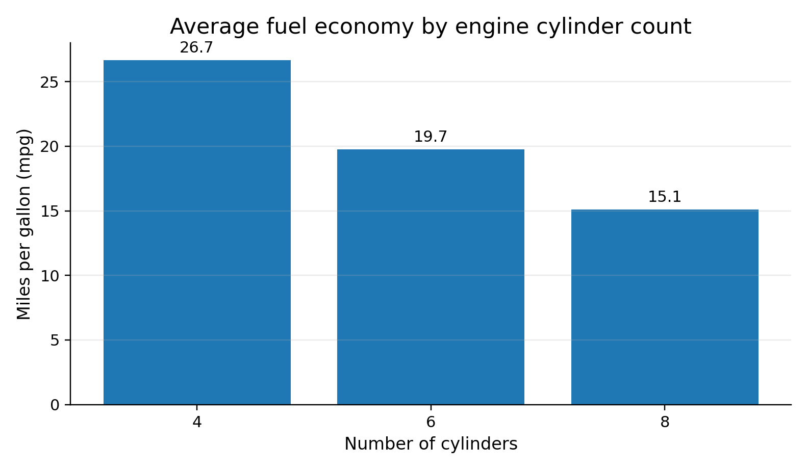
A bar chart is appropriate because cylinder count forms a small set of discrete categories and the question concerns comparing group averages. In this dataset, four-cylinder cars have the highest average fuel economy, six-cylinder cars sit in the middle, and eight-cylinder cars have the lowest average. This gives a quick, accessible comparison for readers who may not want to inspect individual vehicle records. Group averages hide within-group variation, so the chart should be read alongside the scatter plot and histogram.

Figure 2. Scatter plot: weight versus mpg
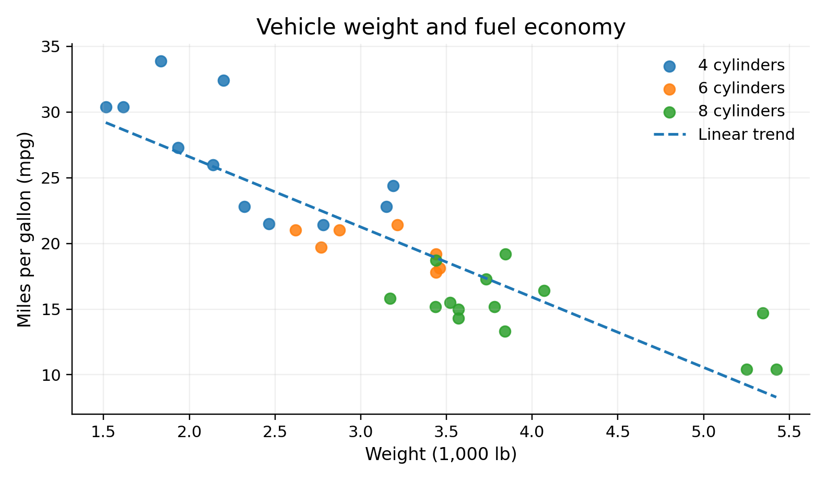
Each point represents one car. Weight is shown on the horizontal axis and mpg on the vertical axis; point colors distinguish cylinder groups, while the dashed line summarizes the overall linear trend. The general downward pattern indicates that heavier vehicles in this sample tend to deliver fewer miles per gallon. The plot also shows that cars with the same cylinder count can differ, so weight is not the only factor associated with fuel economy. Association does not establish causation, and the small sample limits generalization.

Figure 3. Histogram: distribution of mpg
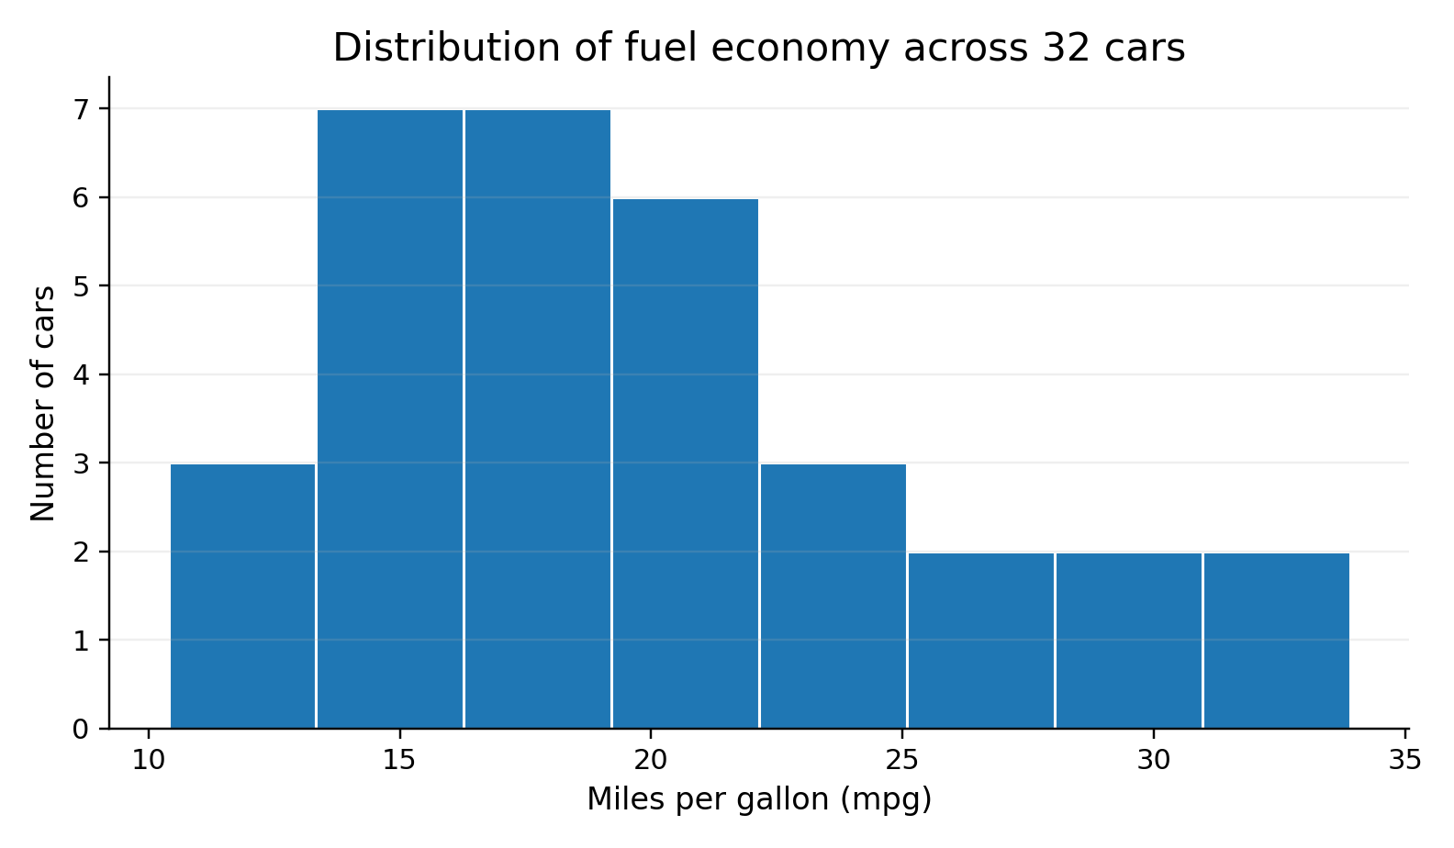
The histogram groups vehicles into mpg intervals and counts how many fall in each interval. This chart is useful for understanding the spread and shape of a numeric variable, rather than comparing categories. The values span a wide range, from low-mpg vehicles to several high-mpg compact cars. That spread means a single overall average would not fully describe the sample. Histogram appearance depends on bin width, so the chosen eight bins are a practical summary rather than a unique or definitive representation.

Figure 4. Line chart: average mpg across cylinder groups
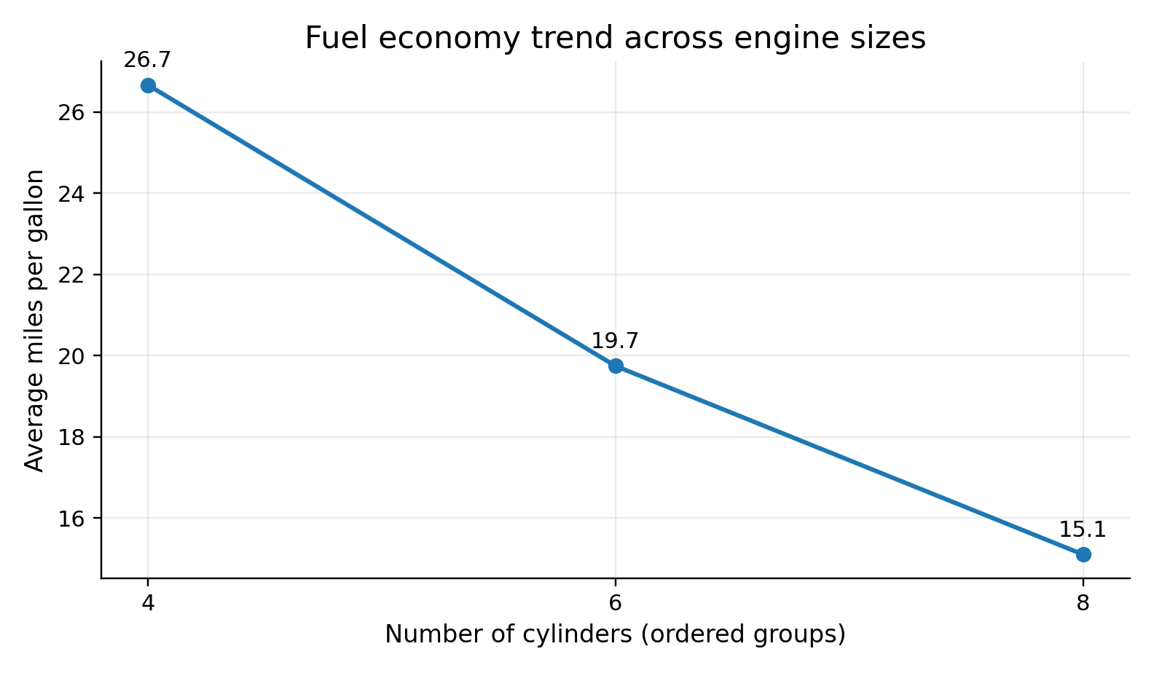
The line chart emphasizes the ordered progression from four to six to eight cylinders. Average mpg declines across these groups, reinforcing the pattern seen in the bar chart in a compact form. Cylinder count is discrete rather than continuous, so the connecting line should be understood as a visual guide between ordered group summaries—not as evidence that intermediate cylinder counts exist or that the relationship is linear. The line chart is included to demonstrate how an ordered trend can be communicated, while the bar chart remains the more natural chart for comparing separate categories.

4. Reproducible R Code
The following script uses base R plotting functions and the built-in mtcars dataset. Run it in R or RStudio. It saves each chart as a high-resolution PNG file in the current working directory.
# Week 2: Data Visualization and Insight Communication
# Dataset is built into R; no external download is required.
data(mtcars)
cars <- mtcars
cars$cyl_f <- factor(cars$cyl, levels = c(4, 6, 8))

# Figure 1: Bar chart of average mpg by cylinder count
avg_mpg <- aggregate(mpg ~ cyl, data = cars, FUN = mean)
png("chart1_bar.png", width = 1400, height = 850, res = 160)
barplot(avg_mpg$mpg,
names.arg = avg_mpg$cyl,
col = "steelblue",
main = "Average fuel economy by engine cylinder count",
xlab = "Number of cylinders", ylab = "Miles per gallon (mpg)")
text(seq_along(avg_mpg$mpg), avg_mpg$mpg,
labels = round(avg_mpg$mpg, 1), pos = 3)
dev.off()

# Figure 2: Scatter plot of weight and fuel economy
png("chart2_scatter.png", width = 1400, height = 850, res = 160)
plot(cars$wt, cars$mpg, pch = 19,
col = c("darkorange", "steelblue", "darkgreen")[cars$cyl_f],
main = "Vehicle weight and fuel economy",
xlab = "Weight (1,000 lb)", ylab = "Miles per gallon (mpg)")
abline(lm(mpg ~ wt, data = cars), lty = 2, lwd = 2)
legend("topright", legend = levels(cars$cyl_f),
title = "Cylinders", pch = 19,
col = c("darkorange", "steelblue", "darkgreen"), bty = "n")
dev.off()

# Figure 3: Histogram of mpg
png("chart3_hist.png", width = 1400, height = 850, res = 160)
hist(cars$mpg, breaks = 8, col = "skyblue",
border = "white",
main = "Distribution of fuel economy across 32 cars",
xlab = "Miles per gallon (mpg)", ylab = "Number of cars")
dev.off()

# Figure 4: Line chart of average mpg by ordered cylinder group
png("chart4_line.png", width = 1400, height = 850, res = 160)
plot(avg_mpg$cyl, avg_mpg$mpg, type = "b", pch = 19,
col = "steelblue", lwd = 2,
xaxt = "n",
main = "Fuel economy trend across engine sizes",
xlab = "Number of cylinders (ordered groups)",
ylab = "Average miles per gallon")
axis(1, at = avg_mpg$cyl, labels = avg_mpg$cyl)
text(avg_mpg$cyl, avg_mpg$mpg,
labels = round(avg_mpg$mpg, 1), pos = 3)
dev.off()

# Optional numerical checks
print(avg_mpg)
print(cor(cars$wt, cars$mpg))

5. Communicating the Insights to a General Audience
The central message is simple: within this sample, lighter cars and cars with fewer cylinders tend to have better fuel economy. The bar chart gives the group comparison, the scatter plot reveals the relationship between two numeric variables, the histogram explains how widely mpg varies, and the line chart emphasizes the ordered group pattern. Using multiple chart types prevents the report from relying on a single view of the data. Clear axis labels, descriptive titles, restrained colors, and short interpretations help readers understand what each graph shows without needing to read the code.

6. Limitations and Further Work
The dataset contains only 32 older vehicles, and the analysis is descriptive. Other variables—such as horsepower, transmission, gearing, and engine design—may also relate to mpg. A larger and more recent public dataset would be needed to make claims about current vehicles. Follow-up work could compare automatic and manual cars, explore horsepower against mpg, or fit a multiple regression model while checking assumptions and uncertainty.

7. Conclusion
This project demonstrates how visualizations can turn a small dataset into an understandable analytical story. The four charts answer different questions and complement one another: compare groups, inspect relationships, understand distributions, and summarize ordered patterns. The most important practice is to match each chart to the question, state the insight in plain language, and acknowledge what the data cannot establish.

Appendix: 200+ Word Submission Description
This project, titled “Data Visualization and Insight Communication using R,” explores the built-in mtcars dataset to demonstrate how visual analytics can communicate meaningful patterns to both technical and non-technical audiences. The dataset contains information about 32 automobiles, including miles per gallon, engine-cylinder count, vehicle weight, horsepower, transmission type, and number of gears. The analysis uses four visualizations: a bar chart, a scatter plot, a histogram, and a line chart. Each visualization was selected to answer a different analytical question and is accompanied by reproducible R code and a plain-language interpretation. The bar chart compares average fuel economy across four-, six-, and eight-cylinder cars. The scatter plot investigates the relationship between vehicle weight and miles per gallon, using a fitted trend line to make the overall pattern easier to see. The histogram summarizes the distribution and spread of fuel economy values, while the line chart highlights how average mpg changes across ordered cylinder groups. Together, these visualizations suggest that lighter vehicles and vehicles with fewer cylinders tend to have higher fuel economy within this sample. The report also explains the limitations of the dataset, including its small size and historical context, and cautions that observed associations do not prove causation. The R script relies on the built-in datasets package and base plotting functions, making it straightforward to reproduce in R or RStudio without downloading additional data. Overall, the project emphasizes thoughtful chart selection, readable design, accurate interpretation, and transparent code as essential skills for turning data into clear and responsible insights.

References
R Core Team. R: A language and environment for statistical computing. R Foundation for Statistical Computing. Dataset documentation: help(mtcars) in R.
Suggested validation: run the script in RStudio and confirm that all four PNG files are created before submission.

