User wants to group by club, therefore user has to select any cell in column C:

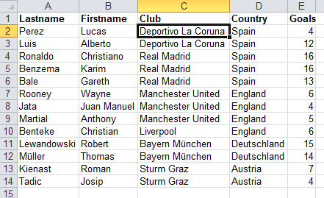

The following files will be generated:  
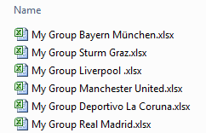

Example of a file generated:

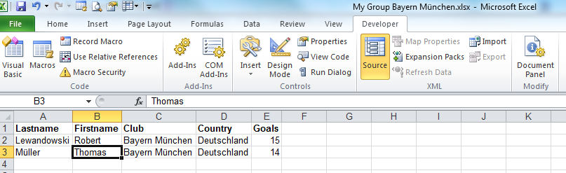

User wants to group by country, therefore user has to select any cell in column D:

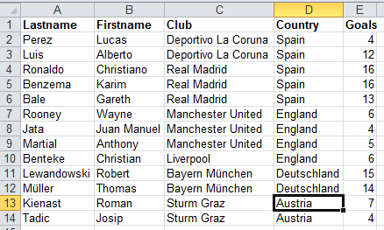

The following files will be generated:  
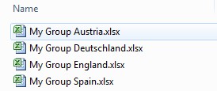

Example of a file generated:

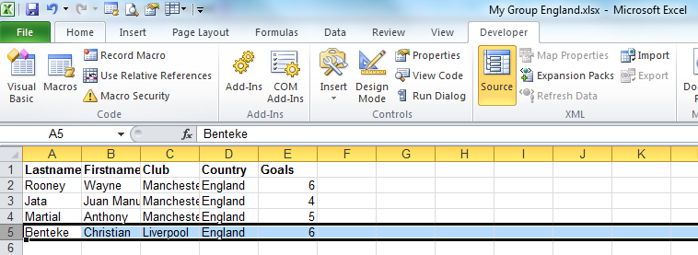

Code can be found in football.xlsm / Developer / Macros:

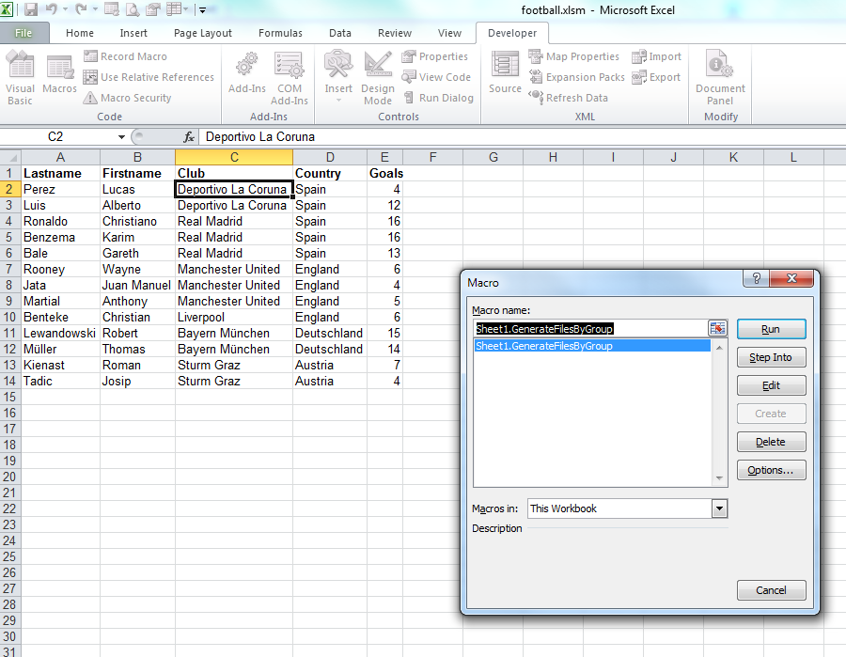

Choose “Run” to execute the macro – do not forget to select the grouping column before.

Choose “Edit” if you want to look or change the code.