Us

Zhang, David J

2213233

User manual for lab 3 fpga game: Random Number Generator and Timer

ECE 6370

# System Description

This is a user manual depicting the play area and correct operation for this iteration of the FPGA-based Mental Binary Math Game. This iteration retains the previous password login feature and load number features but removes the logout feature.

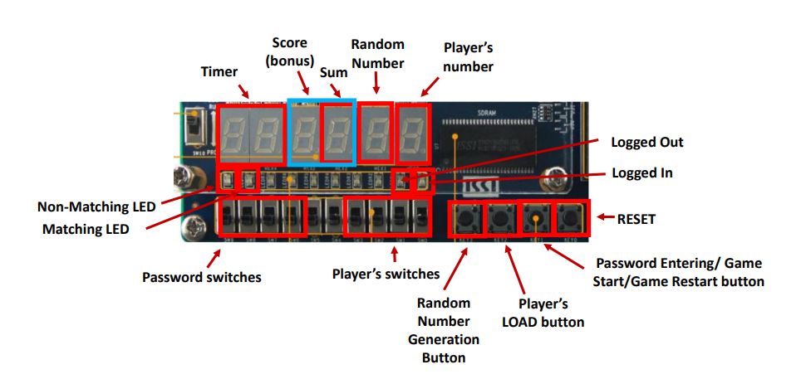

Figure : Play Area of Lab 3

The figure above depicts the play area of this iteration. All player input methods are referenced using this figure.

After correctly logging in using the password 3-2-3-3 on Password switches and Password Entering button, the system will automatically show 99 in the Timer displays. At this point, the Password Entering button becomes the Game Start button, and all player switches and buttons will not cause any discernible changes until the Game Start button is pressed. Once the Game Start button has been pressed, the timer will begin counting down from 99 seconds and player inputs are enabled. Players at this point are free to press the Random Number Generation (RNG) Button to obtain a random number from 0 to F to display on the Random Number (RNG) display and load numbers via Player’s switches and LOAD button.

When the timer reaches 0 seconds, all play functions cease, and players are locked out of their inputs. The middle two displays will then switch from showing the output sum of RNG and player to showing the players score—how many correct sums of F they got. At this point, players who wish to play another round can hit the Game Start button—which is now Game Restart—again to load 99 seconds, and then press it again to start another round.

# Example Play-by-Play

After logging in correctly, the timer will display 99 seconds and the Logged In LED will be lit instead of Logged Out.

Player presses Game Start button, starting the countdown for the timer.

Player presses RNG button for random amount of time, resulting in a display of E on RNG Display.

Player flips their rightmost switch and presses LOAD, resulting in a 1 on their display. The sum display now shows F, with the matching LED turning on and the non-matching LED turning off.

Player presses RNG button for arbitrary amount of time, resulting in a new number of C on RNG display. The matching LED turns off and non-matching turns on.

Player incorrectly presses LOAD, resulting in a 1 on their display. Sum display shows D, with non-matching LED remaining lit and matching LED remaining off.

After game ends, Sum switches over to Score displaying 01, for 1 correct match. Pressing RNG or LOAD at this point does not result in anything changing.

Pressing Game Start (now Game Restart) will add 99 again to Timer and switch Score back to Sum.

Pressing Game Start will initiate countdown again—second round of game has begun.