EatSafe DC: Official Documentation

Author: Giancarlo M. Guerra

Date last updated: 28 April 2014

**Table of Contents**

Initial Setup and Execution 3

Bugs so far 5

**I. Initial Setup**

Since the application is currently under development, it has not been hosted in a server. Because of this, the application will work under a local server. The following are instructions on installing Flask and all required packages for the correct functioning of EatSafe DC. It is recommended that you use a Linux OS distribution.

1. Remove the attached zip file in the BlackBoard submission. Place the contents of this submission in your desktop area. The directory with all the code will be called *eatsafedc.*

2. Navigate to the bin directory by issuing the following commands in the terminal:

*cd Desktop/eatsafedc/flask/bin*

3. After you have navigated to the *bin* directory, please input the following commands in the terminal:

*pip install flask==0.9*

*pip install flask-login*

*pip install flask-openid*

*pip install flask-mail==0.7.6*

*pip install sqlalchemy==0.7.9*

*pip install flask-sqlalchemy==0.16*

*pip install sqlalchemy-migrate==0.7.2*

*pip install flask-whooshalchemy==0.55a*

*pip install flask-wtf==0.8.4*

*pip install pytz==2013b*

*pip install flask-babel==0.8*

*pip install flup*

Because these packages are already installed within the *eatsafedc* folder, the terminal should just update these packages. These commands are run in case the new computer does not have these packages installed or does not recognize them for some reason.

4. After all the above has been successfully installed, please navigate back to the *eatsafedc* directory root by issuing the following commands in the terminal **twice**:

*cd ..*

After you issue these commands, your terminal should be pointing towards */user/Desktop/eatsafedc*

5. Because all the code has been written, to start the server, just input the following into the terminal:

*python run.py*

That command will initialize the server. You should see something like this appear in your terminal:

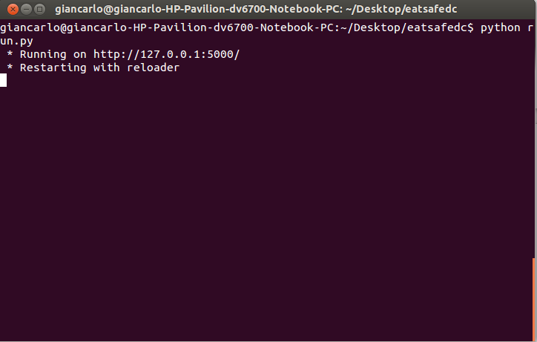

6. After this point, the application is ready to be used! Open up your favorite web browser, and on the URL bar enter the following:

*localhost:5000*

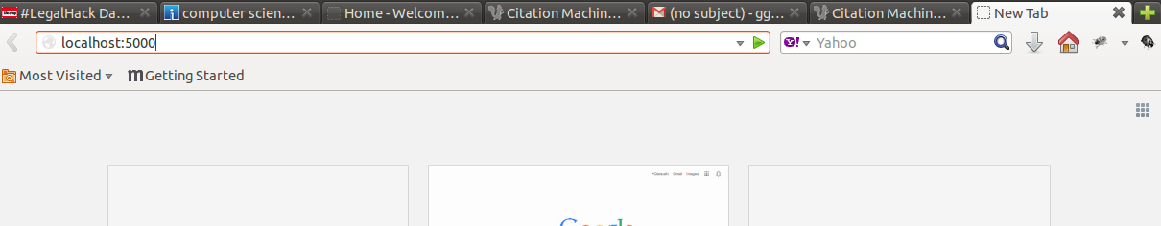

After this step, you should see this page display on your browser:

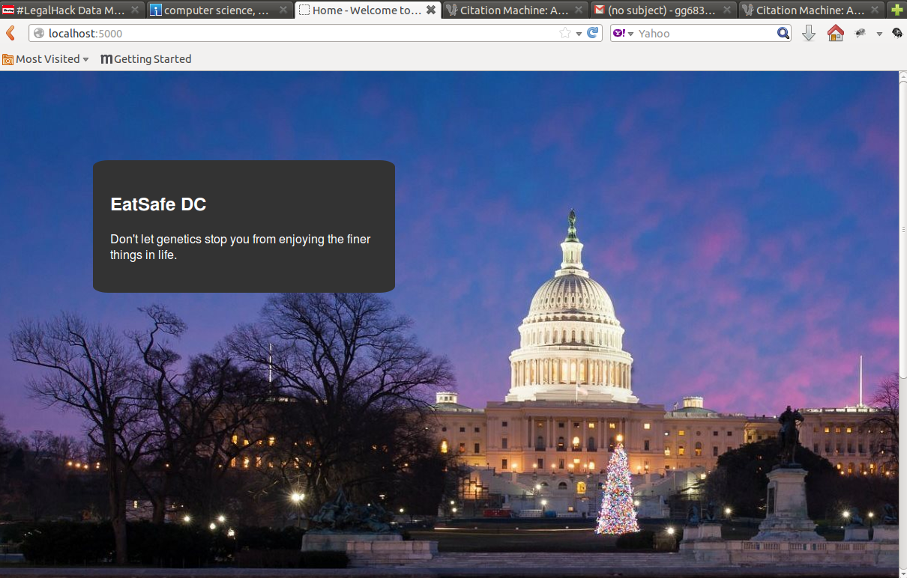

**II. Bugs so far**

1. Problem: After the user hits the search button, the page will revert back to the original state. In other words, content is not updated dynamically. This means that the section where content is displayed will disappear and the application will only display the first box with the *EatSafe DC* title.

Solution: The application still works in the back-end, and to display the information the user just clicks on this box once more, like the first time.

2. Problem: The random generator is not perfect. Because it is a very small data set so far, there may be the illusion that the application did not update with a new restaurant.

Solution: The application did update, but it just randomly selected the same restaurant. The user should try to hit the search button various times with different check-box options and the restaurant should display accordingly.

3. Problem: Google Map does not display

Solution: This is usually due to a slow Internet connection. Either check your connection, or refresh the application.