Robotics Series 1

Exercise 3:

a) The e-puck starts turning right since left wheel turns twice as fast as right wheel. Once counter reaches 200 speed.left and speed.right switch, thus e-puck changes direction and now turns left. When counter reaches 400 it is set to 0 again and the whole procedure starts again. It should be moving in some kind of sinuous line.

b) The e-puck behaved pretty much like we expected, but we thought it would make a half turn at most for each direction. Instead in the simulator the e-puck makes almost a full circle, which means that when changing direction he is positioned a little behind his starting position. Ultimately the e-puck is moving backwards.

The ratio between speed.left and speed.right determine the radius of the circle. A big ratio results in a small radius, likewise a small ratio means a big radius. The angle α of the rotation depends on the radius, speed of the robot and the counter. The direction in which this sinuous line goes is in turn determined by the angle.

Exercise 4:

The actual e-puck has a different angle then in the simulation, meaning it is not moving in the same direction than the one in the simulation. Since ratio of speed.left and speed.right is the same as in the simulation the reason for this difference in behaviour is either found in the speed or the counter.
Maybe the robot moves slower than in the simulation or the time needed to complete one cycle of the loop is shorter than in the simulation. The faster a cycle is completed the smaller the angle.
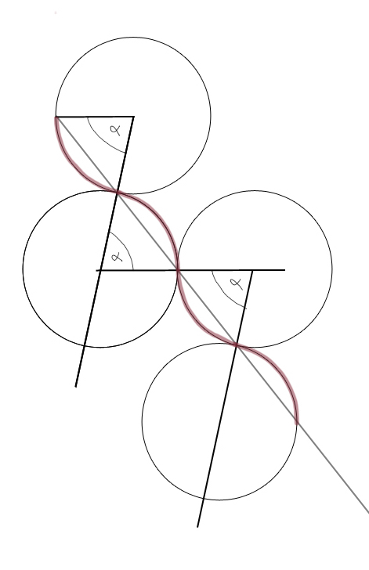Sinuous line of e-puck

