ATTESTIFY
A Blockchain-Based Credential Verification System
Developed By

Member 1 UOC-CS-F2022-034
Member 2 UOC-CS-F2022-036

Supervised By

Mr. Faizan Saleem

Department of Computer Science and Information Technology
Faculty of Computing and Information Technology

The University of Chakwal
Bachelor of Science in Computer Science (2022-2026)

Table of Contents

CHAPTER 1
INTRODUCTION 4
1.1 Introduction 4
1.2 Scope 4
1.3 Purpose 5
1.4 Objective 5
1.5 Tools and Technologies 5
CHAPTER 2
LITERATURE REVIEW & EXISTING SYSTEMS 6
2.1 Literature Review 6
2.2 Problem Statement 6
2.3 Proposed Solution 6
2.4 Comparative Analysis 7
CHAPTER 3
SOFTWARE REQUIREMENTS SPECIFICATIONS 8
3.1 Functional Requirements 8
3.2 Non-Functional Requirements 8
3.3 Use Case Diagram 9
3.4 Methodology: Agile Development 10
CHAPTER 4
DESIGN AND ARCHITECTURE 11
4.1 Entity Relationship Diagram (ERD) 11
4.2 Sequence Diagrams 12
4.3 Architecture Design 15
4.4 Class Diagram 16
4.5 Database Design (NoSQL) 17
4.6 Activity Diagram 18
CHAPTER 5
Interface Design 19

References

ATTESTIFY
A Blockchain-Based Credential Verification System

CHAPTER 1

INTRODUCTION

1.1 Introduction
In the digital age, the authenticity of academic and professional credentials has become increasingly difficult to maintain. Attestify is a cutting-edge, decentralized application (DApp) designed to revolutionize the way these credentials are issued, stored, and verified. By leveraging the power of Ethereum blockchain technology, Attestify removes the need for centralized intermediaries and manual background checks.
The platform ensures that every credential issued is tamper-proof, immutable, and globally verifiable. Institutions can issue digital certificates that are cryptographically anchored to the blockchain, while third parties (such as potential employers or other academic bodies) can verify their authenticity instantly without needing to contact the original issuer. This creates a "trustless" environment where the validity of a document is guaranteed by mathematics and code rather than institutional reputation alone.

1.2 Scope
The scope of this project involves the design and development of a full-stack, Web3-integrated application. The system caters to three primary stakeholders:
- Admins (Issuers): University registrars or HR departments who have the authority to generate and sign digital certificates.
- Students (Holders): Individuals who receive, store, and present their credentials to third parties.
- Verifiers: External organizations (employers, licensing boards) that need to validate a presented credential.
The lifecycle covered includes:
- Cryptographic Hashing: Transforming document data into a unique SHA-256 fingerprint.
- Decentralized Storage: Using IPFS (InterPlanetary File System) to store the actual certificate files, ensuring they are not dependent on a single server. [1]
- On-Chain Recording: Storing the hash and IPFS CID on the Ethereum Sepolia testnet. [2]
- Public Verification Portal: A low-barrier entry point for anyone to verify a file via drag-and-drop.

1.3 Purpose
The fundamental purpose of Attestify is to eliminate credential fraud, a multi-billion dollar global issue. Traditional verification is plagued by "degree mills," sophisticated PDF forgeries, and slow, manual administrative processes that can take weeks. Attestify aims to provide an infrastructure where a document's integrity is verified in seconds, reducing administrative overhead and providing graduates with lifelong, self-sovereign control over their achievements.

1.4 Objective
The key objectives of the project are:
- To eliminate counterfeit academic degrees and professional certificates.
- To provide an instant, real-time verification mechanism available 24/7.
- To reduce the administrative burden and costs associated with manual verification for institutions.
- To give individuals ownership and control over their digital credentials.
- To demonstrate the practical application of blockchain technology in solving real-world data integrity problems.

1.5 Tools and Technologies
Frontend:
- React + Vite: For building a fast, interactive user interface.
- TailwindCSS: For modern, responsive styling.
- Ethers.js: For interacting with the Ethereum blockchain and smart contracts. [3]
- React Router & Axios: For navigation and API communication.
Backend:
- Node.js & Express.js: Server runtime and web framework.
- MongoDB & Mongoose: NoSQL database for managing user profiles and off-chain metadata. [4]
- Nodemailer & Multer: For email notifications and file upload handling.
Blockchain & Smart Contracts:
- Solidity: Language for writing smart contracts.
- Hardhat: Environment for compiling, deploying, and testing. [5]
- Ethereum (Sepolia Testnet): The underlying blockchain network. [6]
- OpenZeppelin: Standard libraries for secure contract development. [7]

CHAPTER 2

LITERATURE REVIEW & EXISTING SYSTEMS

2.1 Literature Review
Research into decentralized identity and credentialing highlights a shift from "Siloed Identity" (centralized) to "Self-Sovereign Identity" (SSI).
- Blockcerts (MIT Media Lab): The first major open standard. While it proved the concept, it faced hurdles with Bitcoin’s high transaction fees and a complex user onboarding process. [8] [9]
- OpenCerts (Singapore): A highly successful national implementation. However, it is largely centralized around the Singaporean government’s specific infrastructure, making it less accessible for private global institutions. [10]
- Credly/Badgr: These represent the current "Gold Standard" in Web2. While user-friendly, they are centralized. If the company closes, the "trust" and the links to certificates disappear. [11]

2.2 Problem Statement
Current verification methods are:
- Vulnerable: Paper and digital PDFs are easily forged using standard design tools.
- Slow: Background checks often require manual emails and phone calls.
- Fragmented: There is no universal, "trustless" way to verify degrees from different countries or institutions.
Attestify solves this by providing a decentralized registry that is globally accessible and cryptographically secure. For the developer, this project serves as a deep dive into the intersection of traditional backend (Web2) and decentralized blockchain (Web3) architectures. [12]

2.3 Proposed Solution
The solution is a multi-tier DApp that utilizes the Ethereum Blockchain as a permanent, public registry.
- Hashing Mechanism: The system does not store personal data on the blockchain. Instead, it stores a SHA-256 hash. This preserves privacy while ensuring integrity. [13]
- Verification Flow: A verifier does not need an account. They simply upload the file to the portal; the system calculates the hash locally and checks if that exact fingerprint exists on the blockchain.

2.4 Comparative Analysis

Feature | Manual/Centralized | Proposed Solution (Attestify)
Data Storage | Centralized Databases | Decentralized Blockchain
Verification Speed | Slow (Days/Weeks) | Instant (Real-time)
Cost | High (Admin fees) | Low (Minimal gas fees)
Security | Low (Forgery risk) | High (Cryptographic proof)
Single Point of Failure | Yes | No

CHAPTER 3

SOFTWARE REQUIREMENTS SPECIFICATIONS

3.1 Functional Requirements

3.1.1 User Management and Authentication
- Multi-Role Authentication: The system shall support distinct login portals for Admins (Issuers) and Students (Holders).
- Web3 Wallet Integration: Admins must be able to connect and authenticate using MetaMask to sign blockchain transactions.
- Session Management: The system shall implement JWT (JSON Web Tokens) for secure off-chain session persistence.

3.1.2 Credential Issuance (Admin Flow)
- Digital Certificate Generation: Admins shall be able to generate PDF certificates by inputting student data (Name, Degree, Graduation Date).
- Automated Hashing: Upon generation, the system shall automatically calculate a SHA-256 hash of the certificate file.
- Decentralized Storage (IPFS): The system shall upload the certificate to IPFS and retrieve a unique Content Identifier (CID).
- Blockchain Registration: The system shall trigger a smart contract transaction to record the student ID, file hash, and IPFS CID on the Ethereum ledger.

3.1.3 Student Features (Holder Flow)
- Personal Repository: Students shall have a dashboard to view all credentials issued to their unique Student ID.
- Credential Export: Students shall be able to download the original PDF certificate and share the IPFS link with third parties.
- Verification Status: Students shall see the real-time status (Valid/Revoked) of their certificates as recorded on the blockchain.

3.1.4 Public Verification (Verifier Flow)
- File-Based Verification: Verifiers shall be able to drag and drop a certificate PDF into a public portal.
- Blockchain Querying: The system shall compute the hash of the uploaded file and check for a match on the blockchain without requiring the verifier to pay gas fees.
- Revocation Check: The system shall explicitly state if a matched hash exists but has been marked as "Revoked" by the issuer.

3.1.5 Administrative Control
- Revocation Logic: Authorized Admins shall have the functional capability to invalidate a credential on-chain in cases of error or academic fraud.
- Audit Trails: The system shall log all issuance and revocation actions in the off-chain database for institutional tracking.

3.2 Non-Functional Requirements

3.2.1 Security and Integrity
- Smart Contract Security: The code shall be protected against common vulnerabilities such as Reentrancy, Integer Overflow, and Unauthorized Access using OpenZeppelin standards.
- Data Privacy: Personal Identifiable Information (PII) shall never be stored on the public blockchain; only cryptographic hashes shall be recorded.
- Immutability: Once a record is finalized on the blockchain, it shall be impossible for any party (including the developer) to delete the record.

3.2.2 Performance and Scalability
- Response Time: Verification results shall be returned within 3 seconds of file upload under normal network conditions.
- Gas Efficiency: The smart contract shall use optimized data types (e.g., bytes32) to minimize transaction costs for the issuer.
- Concurrent Users: The backend API shall be capable of handling up to 100 concurrent requests during peak graduation periods.

3.2.3 Availability and Reliability
- Uptime: The web interface shall maintain 99.9% availability.
- Data Persistence: Records on the Ethereum blockchain shall be considered 100% available and permanent.
- Failover: The system shall provide clear error messaging if the IPFS gateway or Blockchain RPC provider is temporarily unreachable.

3.2.4 Usability and Accessibility
- Responsive Design: The interface shall be fully functional across desktop, tablet, and mobile browsers using TailwindCSS.
- Zero-Gas Verification: Verification shall remain a "Read-only" operation, ensuring that verifiers do not need a wallet or cryptocurrency to use the system.
- User Feedback: The system shall provide visual indicators (loaders, success/error toasts) for all asynchronous blockchain transactions.

3.3 Use Case Diagram

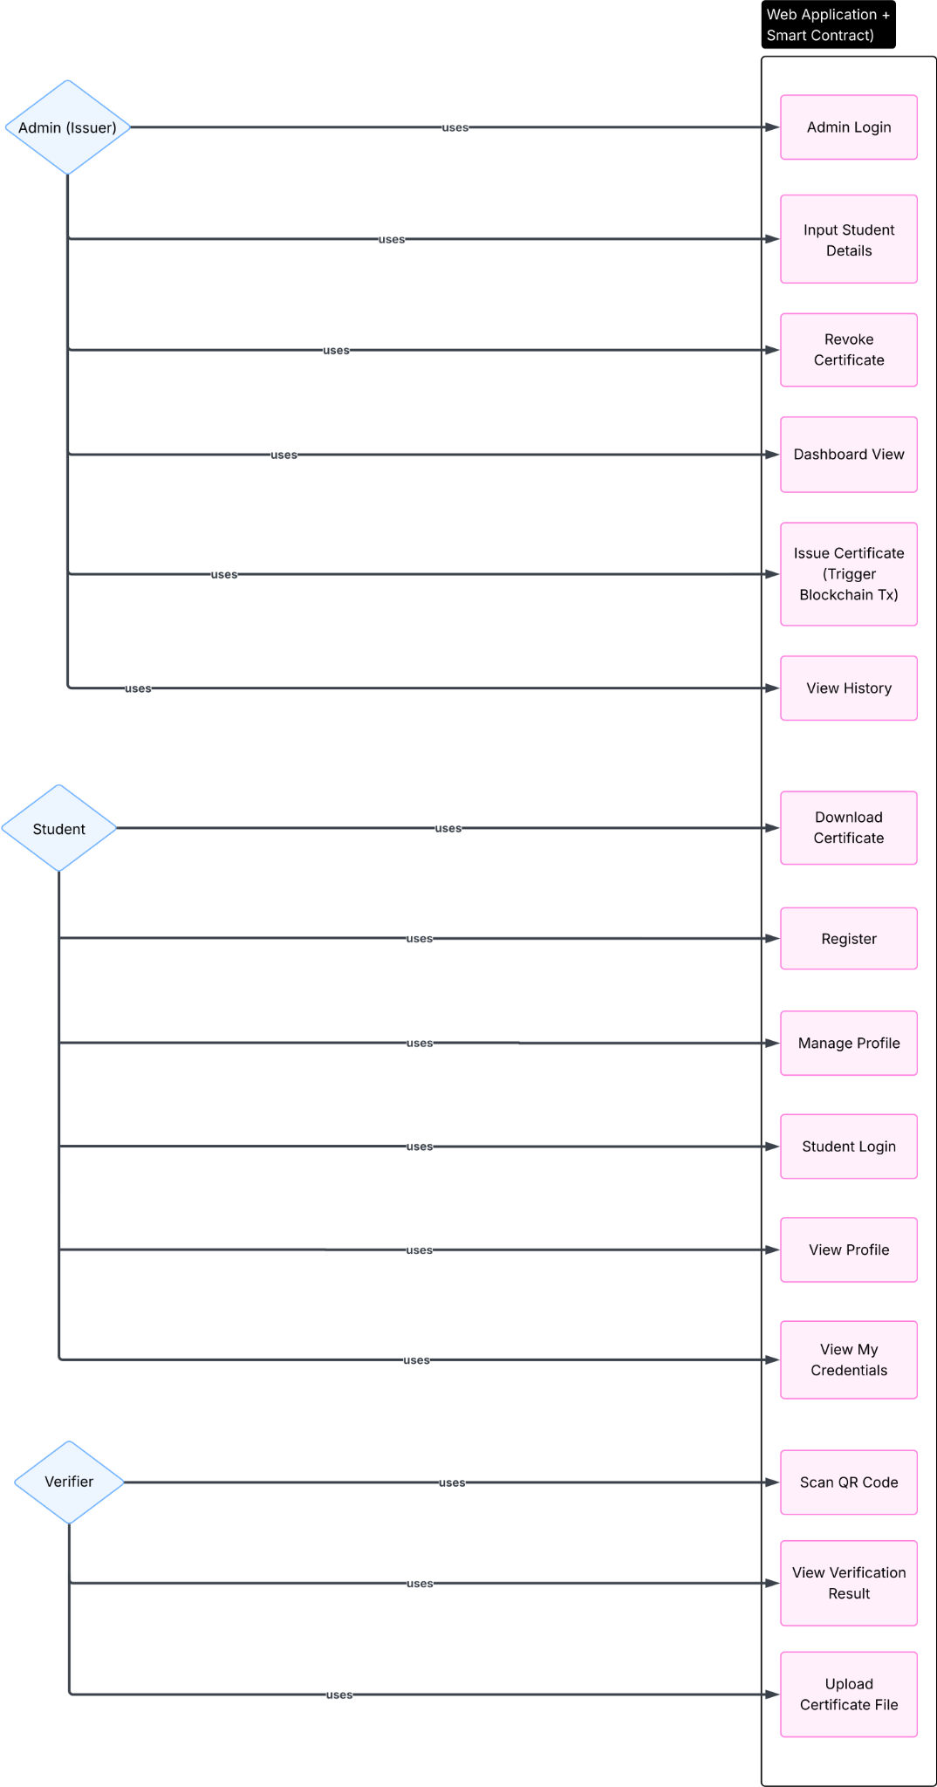

3.4 Methodology: Agile Development
For the Attestify project, the Agile Methodology was chosen to manage the inherent complexities of Web3 and DApp development. Unlike traditional waterfall models, Agile facilitated an iterative and flexible workflow that was essential for the following reasons:
- Iterative Blockchain Development: Smart contract logic is immutable once deployed. Agile allowed us to develop the core logic in small increments, performing rigorous testing on local networks (Hardhat) and testnets (Sepolia) before moving to the next feature set.
- Rapid Prototyping and Feedback: The integration between Web2 (Express/Node) and Web3 (Ethers.js/Solidity) required frequent adjustments. Agile Sprints enabled us to build functional prototypes of the verification portal and student dashboard early, allowing for immediate UX/UI refinements.
- Risk Mitigation: Blockchain development is highly susceptible to security vulnerabilities. Continuous integration and testing (CI/CD) within the Agile framework ensured that security patches and gas optimizations were implemented during the development cycle rather than at the very end.
- Flexibility to Tech Changes: Since the DApp landscape evolves rapidly (e.g., changes in RPC providers or gas fee structures), the Agile approach allowed the team to pivot and adapt tools without disrupting the entire project timeline.

CHAPTER 4

DESIGN AND ARCHITECTURE

4.1 Entity Relationship Diagram (ERD)

4.2 Sequence Diagrams

Issuer Sequence:

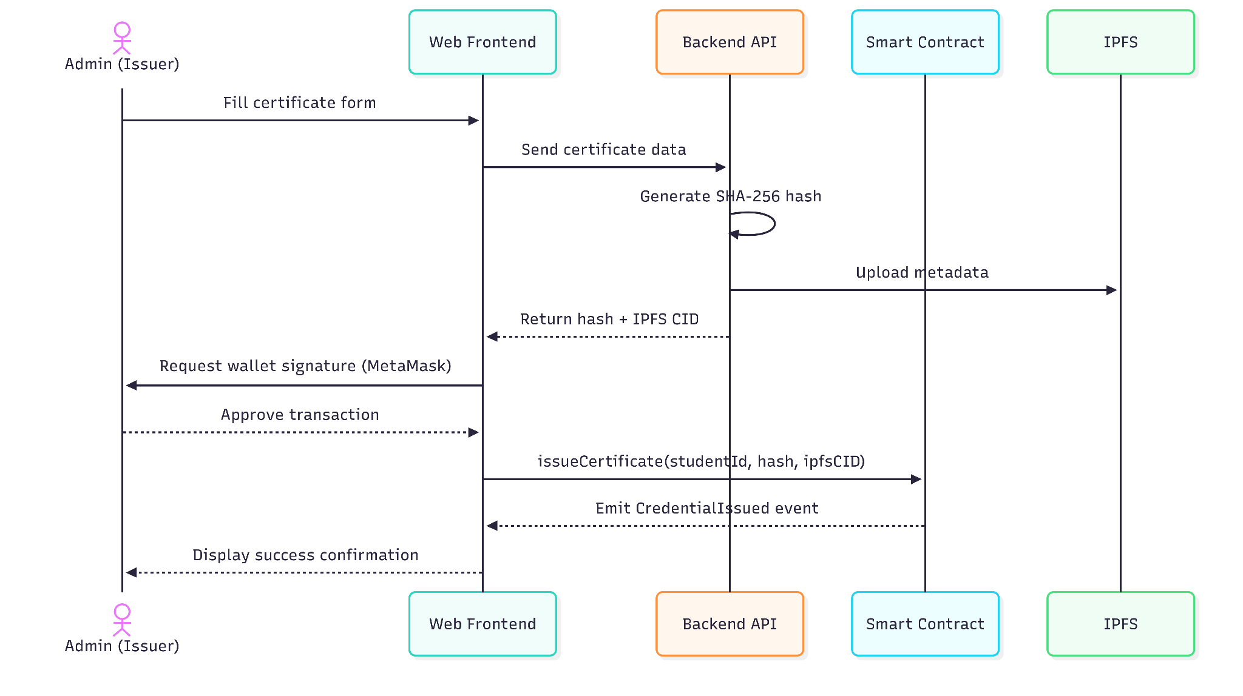
Student Sequence:

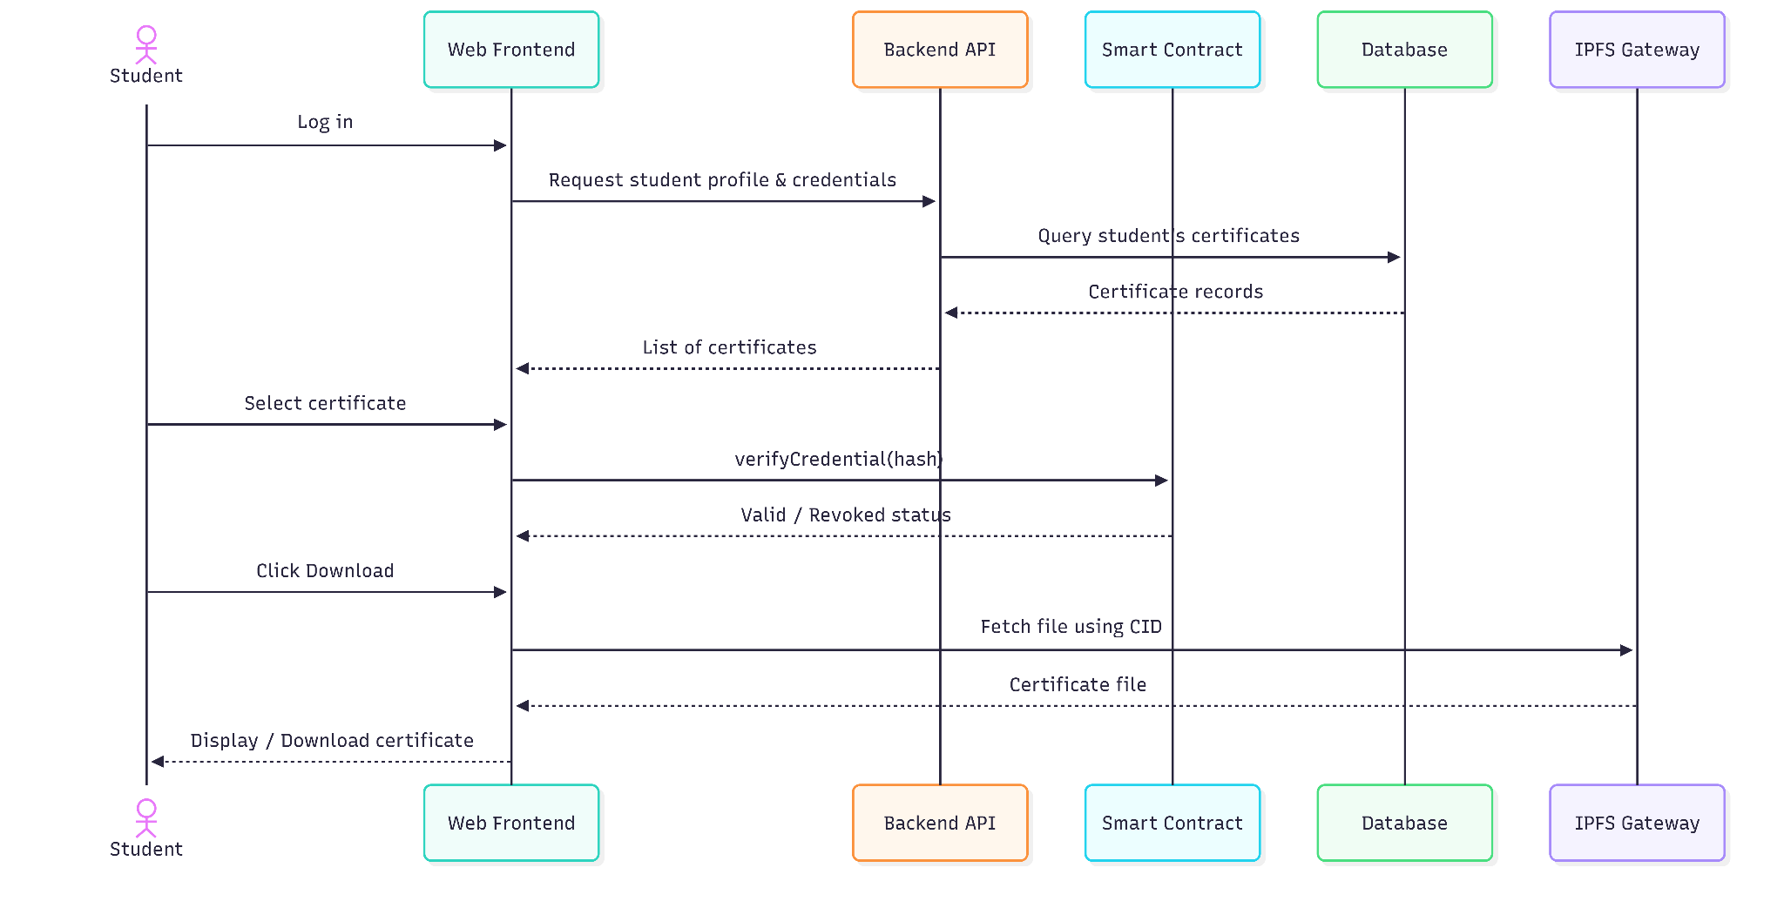

Verifier Sequence:

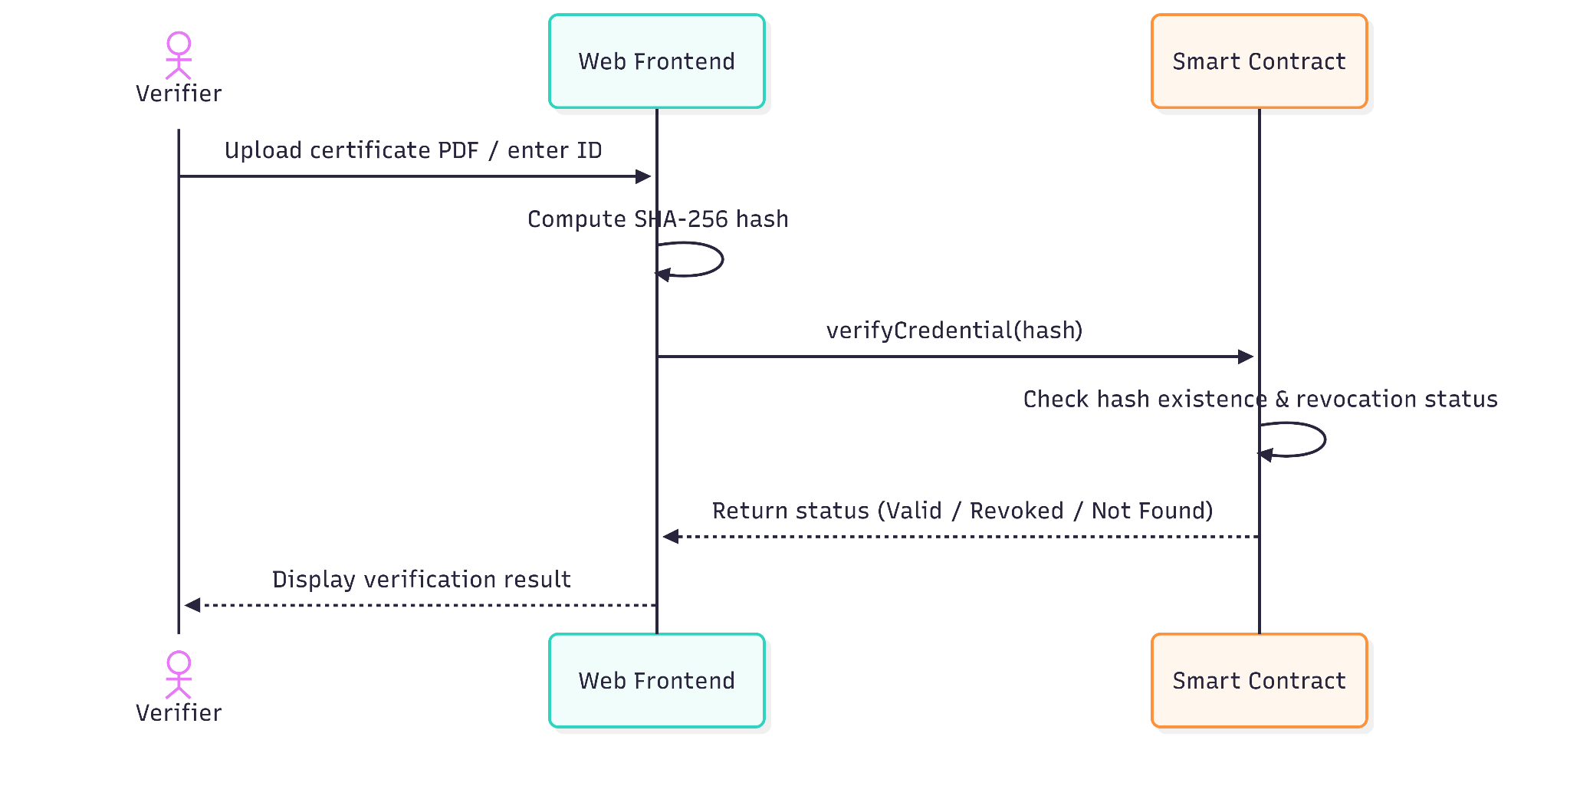

4.3 Architecture Design

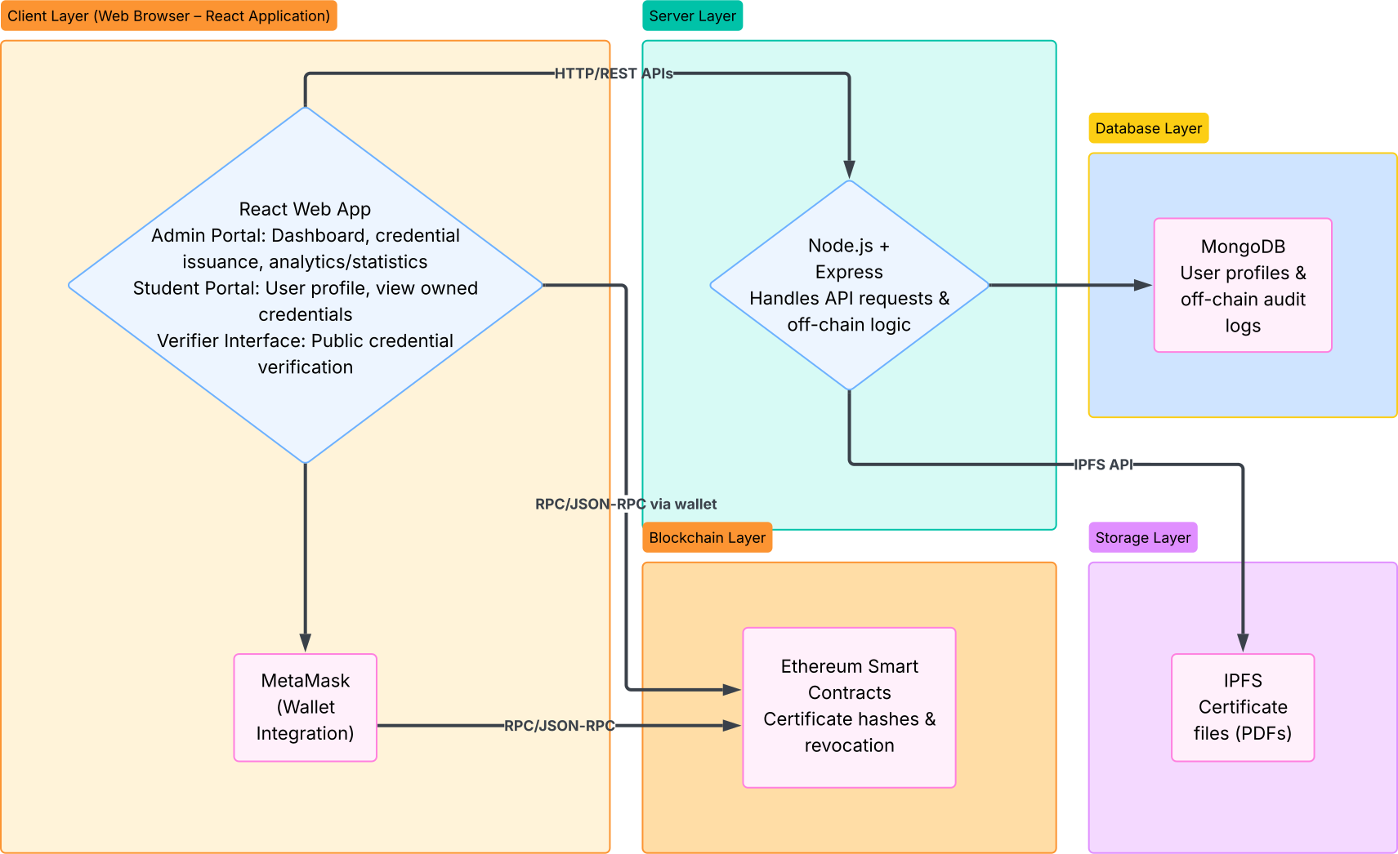

4.4 Class Diagram

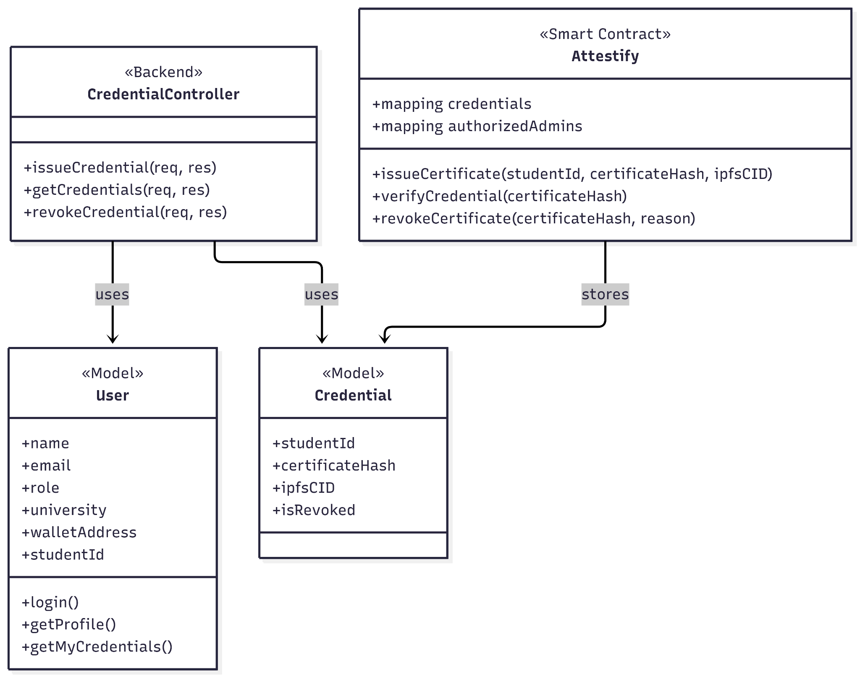

4.5 Database Design (NoSQL)

4.6 Activity Diagram

CHAPTER 5

Interface Design

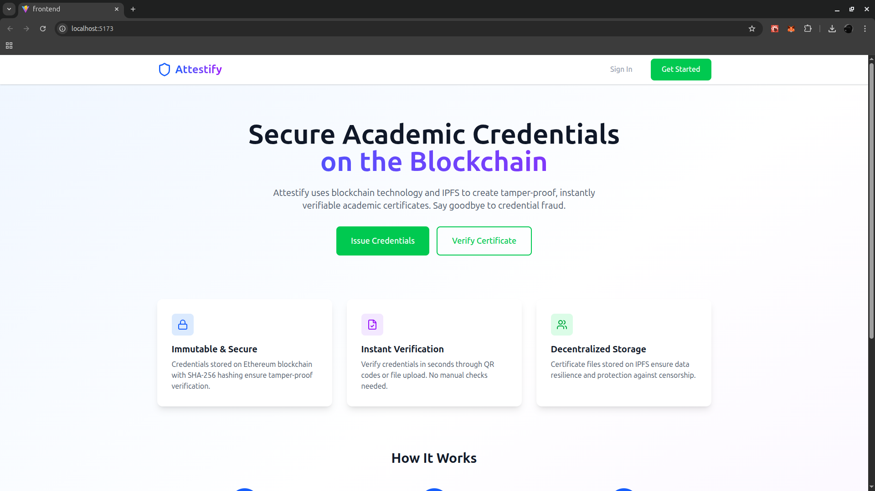
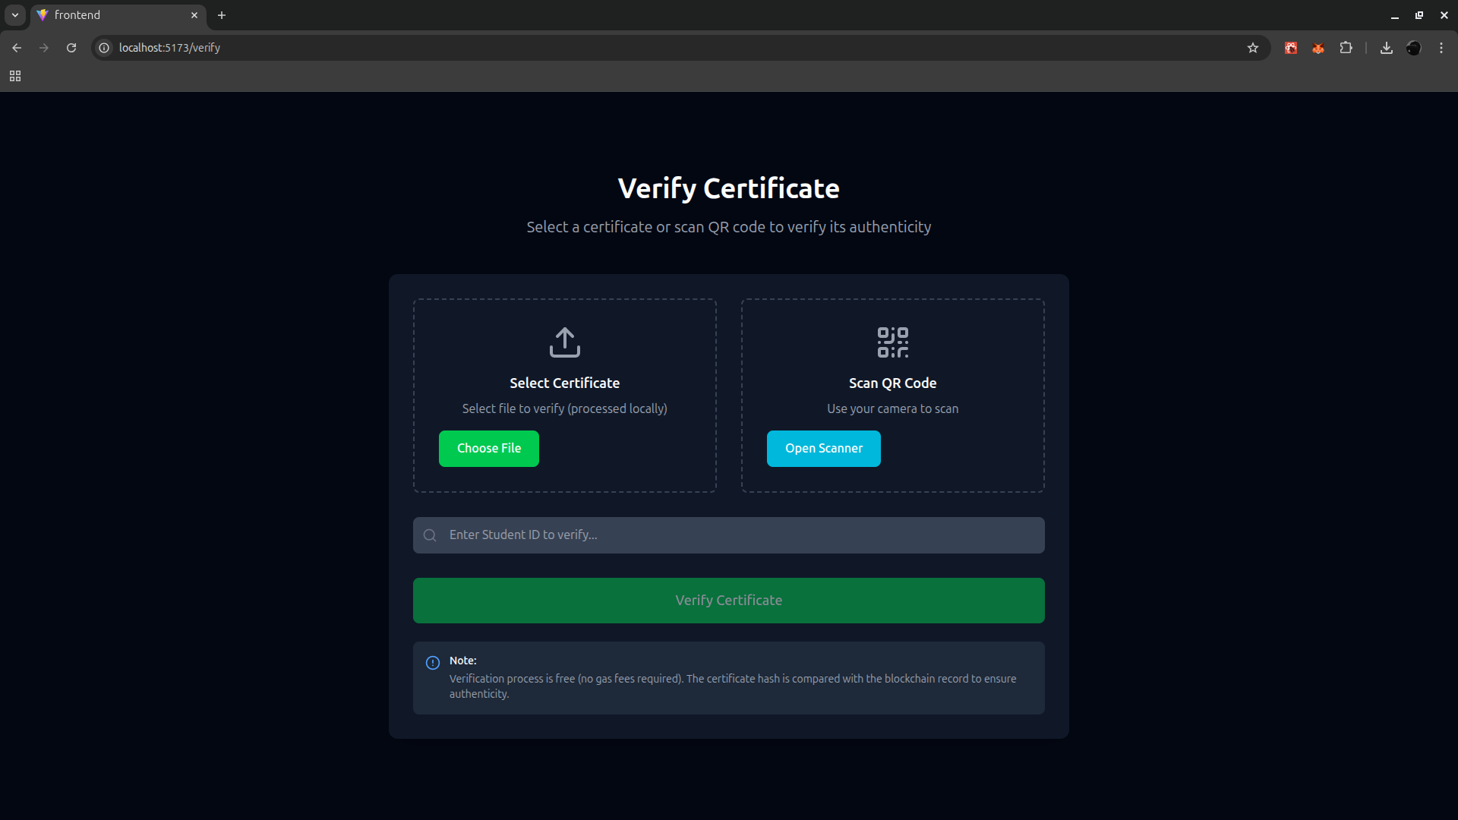

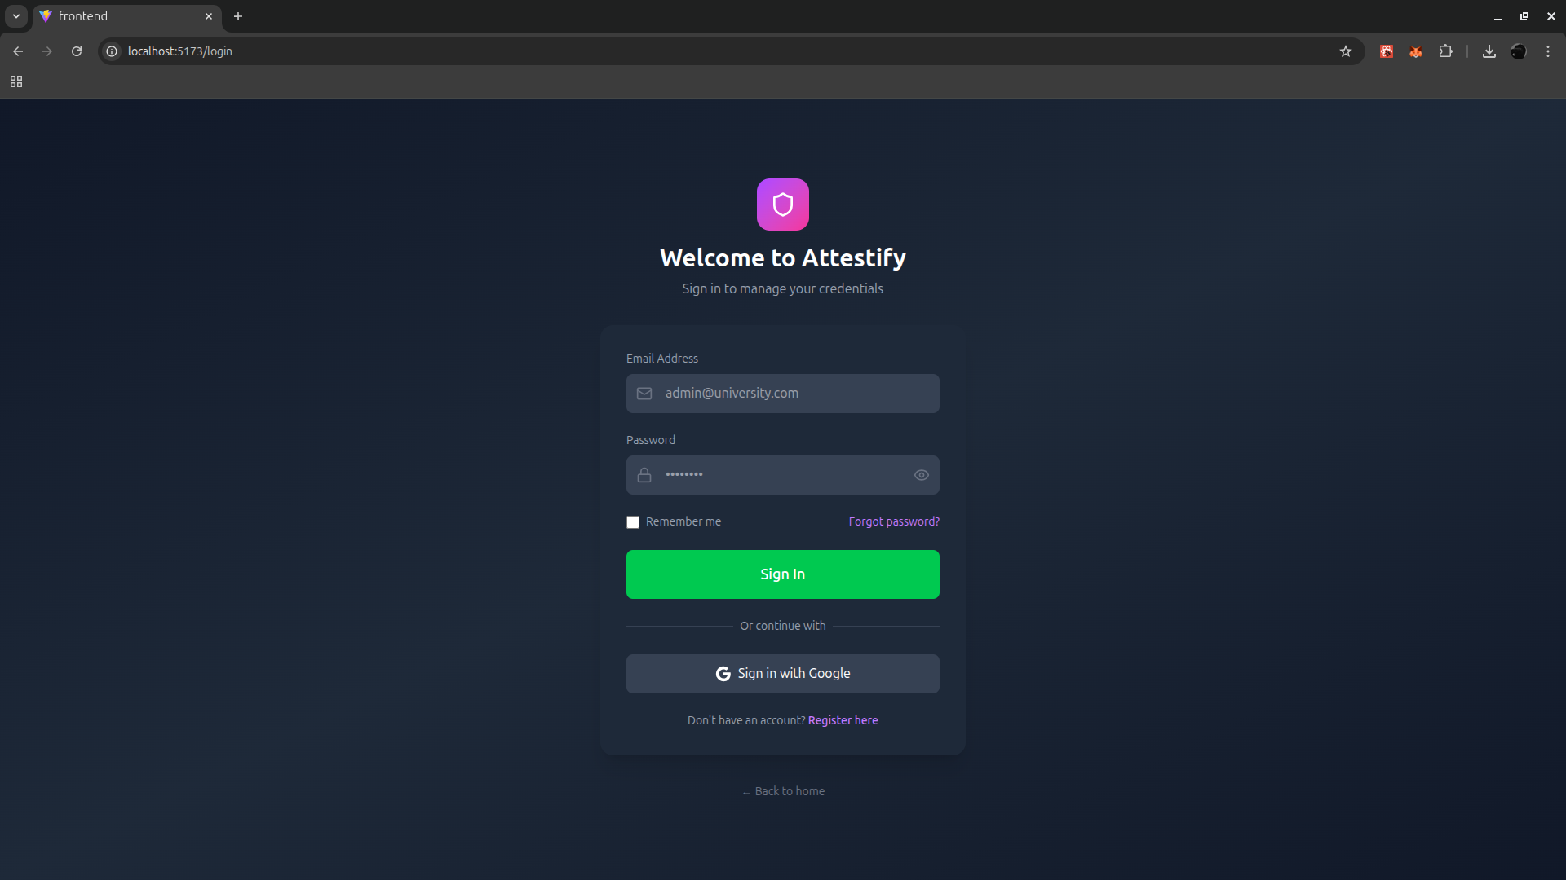

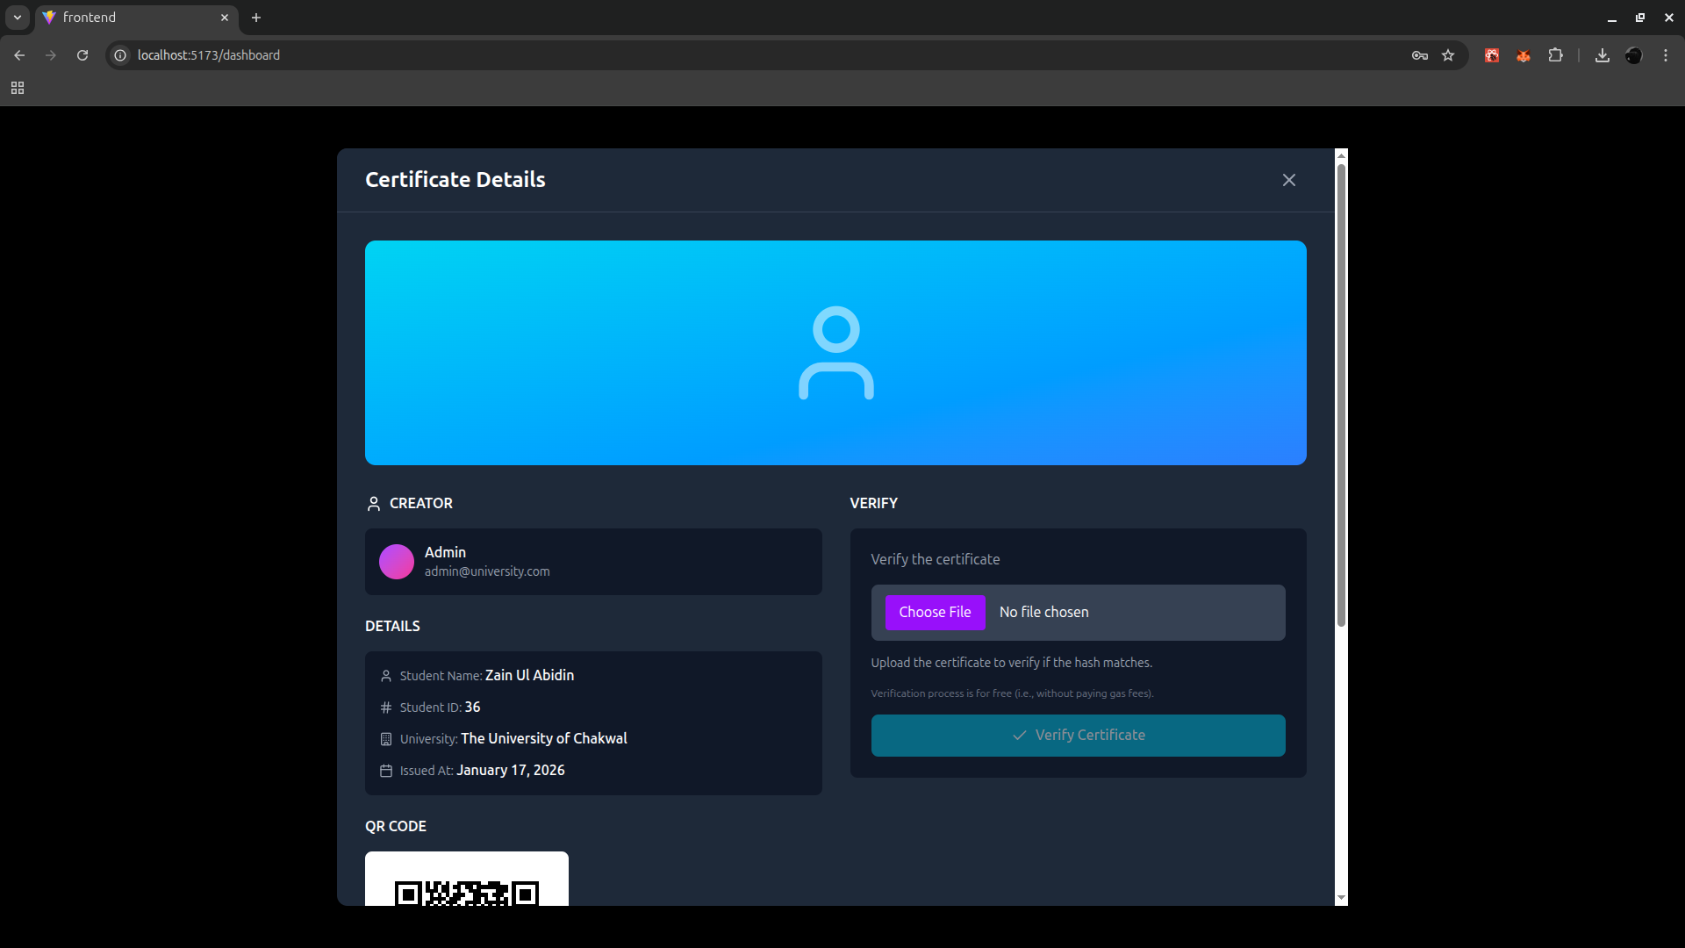

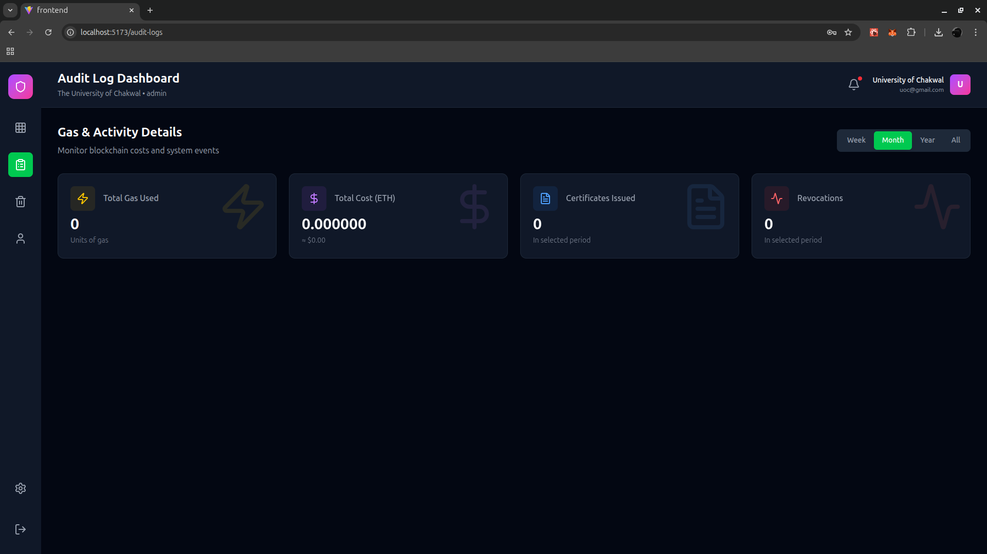

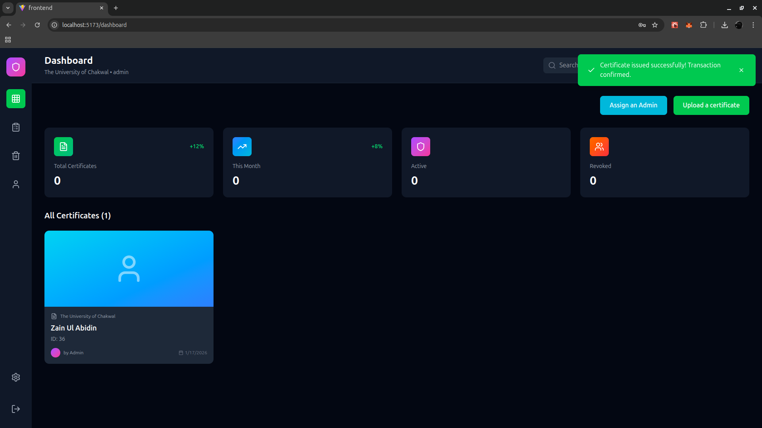

References

- Benet, J. (2014). IPFS - Content Addressed, Versioned, P2P File System. https://ipfs.tech/ (Technical specifications for decentralized file storage).
- Buterin, V. (2014). A Next-Generation Smart Contract and Decentralized Application Platform. Ethereum Whitepaper. https://ethereum.org/en/whitepaper/
- Ethers.js Documentation. (2023). Interacting with the Ethereum Blockchain. https://docs.ethers.org/ (Guidelines for client-side blockchain interaction).
- MongoDB, Inc. (2024). Mongoose: Elegant MongoDB Object Modeling for Node.js. https://mongoosejs.com/docs/ (Guidelines for off-chain metadata schema design).
- Antonopoulos, A. M., & Wood, G. (2018). Mastering Ethereum: Building Smart Contracts and DApps. O'Reilly Media. (Foundational concepts for DApp architecture and Solidity development).
- Hardhat Documentation. (2024). Ethereum Development Environment. https://hardhat.org/docs (Best practices for testing and deploying on the Sepolia testnet).
- OpenZeppelin. (2024). OpenZeppelin Contracts Documentation. https://docs.openzeppelin.com/contracts/ (Security patterns for Ownable and AccessControl modules used in the Attestify smart contract).
- Schmidt, P., & Reed, K. (2016). Digital Certificates: An Open Standard for Academic and Professional Credentials on the Blockchain. MIT Media Lab Report. https://www.blockcerts.org/
- Nakamoto, S. (2008). Bitcoin: A Peer-to-Peer Electronic Cash System. https://bitcoin.org/bitcoin.pdf (Origin of the distributed ledger technology utilized in this project).
- Government Technology Agency of Singapore. (2019). OpenCerts: A Blockchain-based Platform for Verifiable Certificates. https://opencerts.io/ (Framework for region-specific educational credential verification).
- Credly. (2023). The Digital Credentialing Ecosystem: Modernizing Certification Management. https://info.credly.com/ (Centralized badge and digital credential standards).
- W3C. (2022). Decentralized Identifiers (DIDs) v1.0. https://www.w3.org/TR/did-core/ (Standard for self-sovereign identity referenced in the Future Work section).
- Zheng, Z., Xie, S., Dai, H., Chen, X., & Wang, H. (2017). An Overview of Blockchain Technology: Architecture, Consensus, and Future Trends. IEEE 6th International Congress on Big Data.

