Distributional Cost-Effectiveness Analysis
of the Senegal Health Benefits Package
An adaptation of Arnold, Nkhoma & Griffin (2020) for Senegal, with a wealth-quintile and a residence (urban/rural) equity lens
Working paper — draft for internal review
September 2026
Prepared as a companion analysis to the HBP_Senegal_R league-table pipeline. All figures and tables in this report are generated directly by that pipeline (main_dcea.R) and can be reproduced by re-running it — see the Methods section and the project README for exact reproduction instructions.

Abstract
Background. Distributional cost-effectiveness analysis (DCEA) extends standard cost-effectiveness analysis by tracking how the health gains and opportunity costs of a health benefits package (HBP) fall across equity-relevant population subgroups, rather than reporting only population-average net benefit. Arnold, Nkhoma & Griffin (2020) demonstrated the feasibility of an aggregate-level DCEA — following the method of Love-Koh et al. (2019) — for Malawi's Essential Health Package (EHP), using publicly available survey data stratified by wealth quintile and by urban/rural residence.
Objective. This report re-implements that same aggregate DCEA framework for Senegal's HBP league table (141 interventions linked to Top-20-DALY causes; 95 with complete cost, effectiveness and demand data), for both of Arnold et al.'s equity stratifiers: wealth quintile and residence.
Methods. Distributional inputs (disease/eligibility share, coverage/uptake rate, and the national distribution of the health opportunity cost) were sourced in a three-tier hierarchy: (1) Senegal's EDS-Continue 2023 household survey, read directly from the published report with page-level citation, wherever a usable indicator existed; (2) Arnold et al.'s own published Malawi values, transported via a relative-risk adjustment to Senegal's own population composition where Senegal data did not exist; (3) a plausible assumption grounded in general WHO/regional evidence otherwise. A simplified baseline health-by-group distribution was constructed from the same tier-1/2/3 inputs in the absence of DHS sibling-history microdata access. The Atkinson equally-distributed-equivalent (EDE) health index was computed at the reference inequality-aversion parameter (ε=10, as in Arnold et al.) and varied in sensitivity analysis (ε=2, 25), alongside four further sensitivity analyses mirroring Arnold et al.'s own (equal/unequal prevalence, equal/unequal uptake, opportunity-cost rate and distribution).
Results. The 88 interventions affordable at the reference cost-effectiveness threshold ($435/DALY averted) generate a combined net population health benefit of 70,980,236 DALYs averted. Under the wealth-quintile lens, the package is estimated to widen health inequality (inequality impact: −9,530,139 DALY-averted-equivalent at ε=10); under the residence lens, it is estimated to narrow it (+9,511,284). Sixty of 95 interventions (63%) fall in the "health-improving, equity-improving" quadrant by wealth quintile, and 52 of 95 (55%) by residence.
Conclusion. Reproducing Arnold et al.'s method for Senegal is feasible using already-published survey data and is now implemented as a reusable, versioned R pipeline. The Senegal-specific results should be treated as indicative rather than definitive until the tier-2/3 assumptions documented throughout this report are replaced with Senegal-sourced microdata (a roadmap for which is given in Supplementary Table S1).

1. Introduction
Health benefits packages (HBPs) let countries moving towards universal health coverage focus scarce resources on the interventions that provide the best value for money (Glassman et al., 2016). Senegal's own HBP prioritization work, reflected in this project's league table (95 interventions with complete cost, effectiveness and demand data out of 141 linked to a Top-20-DALY-burden GBD cause), has so far been informed by standard cost-effectiveness analysis: each intervention's cost per DALY averted, and its net health benefit against a $435-per-DALY reference threshold.
As in Malawi (Arnold, Nkhoma & Griffin, 2020), Senegal's health policy also states an explicit ambition to reduce health inequality, not only to raise average population health. Standard cost-effectiveness analysis is silent on this second objective: an intervention that maximizes net DALYs averted can still widen the gap between rich and poor, or between urban and rural residents, if its benefits and costs are not evenly shared. Distributional cost-effectiveness analysis (DCEA) makes this trade-off explicit by tracking, for every intervention, how its net health benefit is distributed across equity-relevant subgroups, and by summarizing that distribution with an inequality-aversion-weighted health index (the Atkinson equally-distributed-equivalent, or EDE).
This report re-implements the aggregate DCEA method of Love-Koh et al. (2019) — the same method Arnold et al. (2020) applied to Malawi's EHP — for Senegal, using the same two equity stratifiers Arnold et al. used: wealth quintile (five equal-sized groups constructed from a household asset index) and residence (urban vs. rural, unequal population shares). We follow Arnold et al.'s four-stage method as closely as Senegal's currently accessible data allow, and document every point at which Senegal-specific data were unavailable and a substitute was used, following a three-tier hierarchy described in Section 2.2.

1.1 Relation to prior work
The aggregate DCEA method itself was established by Love-Koh, Cookson, Gutacker, Patton & Griffin (2019) for NICE technology appraisals in England, and subsequently applied to two other LMIC health-benefits-package settings: Ethiopia (rotavirus vaccination; Dawkins et al., 2018) and Malawi (the full EHP; Arnold et al., 2020), the latter being the direct template for this report. A 2025 methods update (Health Policy and Planning) further generalizes the aggregate DCEA framework, though its full text was not accessible from the environment this report was produced in and is cited for completeness only (see References).
No published DCEA specific to Senegal's HBP was identified. A live World Bank operation for Senegal's health system — the NAATANGUE 2030 program (Senegal Health System Development and Financial Protection Program, project ID P508171, approved circa March 2026, financed by IDA/GFF/HSTRF) — is explicitly built around a "universal, high-quality essential health services package" and an equity objective per Senegal's 2025-2029 Sectoral Policy Letter for Health. Its Project Appraisal Document could not be retrieved from the network-restricted environment this report was produced in; readers with access to that document should check whether it contains a distributional or equity annex that could crosscheck or supersede the tier-2/3 assumptions in this report.

2. Methods

2.1 The Senegal league table
The starting point for this DCEA is the project's existing league table: 389 candidate interventions from the OHT (One Health Tool) case-data master list are filtered to the 141 linked to a Top-20-DALY-burden GBD cause, then to the 95 with a usable effectiveness figure (Tufts Global Health CEA Registry, with an Uganda HBP Tool fallback), a unit cost (Senegal OHT costing), and non-zero case-volume data. For each of these 95, the league table already reports: DALYs averted per patient, unit cost, case volume under "full implementation" and under a "realistic" scale-up scenario, total cost, total DALYs averted, ICER, and net health benefit against the reference cost-effectiveness threshold (CET) of $435 per DALY averted (sourced from the original workbook).
Across all 95 interventions, full implementation totals 71,445,993 DALYs averted at a total cost of $217,843,780. Restricting to the 88 interventions with a non-negative net health benefit at the reference CET — "the package" throughout this report, following R/09_ochalek_analysis.R's own affordability definition — full-implementation net health benefit totals 70,980,236 DALYs averted.

2.2 Distributional inputs: a three-tier data hierarchy
Arnold et al. (2020) source their distributional inputs from three household surveys: the Malawi Integrated Household Survey (IHS, for self-reported morbidity and care-seeking across almost all disease areas), the Demographic and Health Survey (DHS, for vaccination, family planning, antenatal/delivery care, and mortality), and the Multiple Indicator Cluster Survey (MICS, for isolated items). Senegal's direct DHS equivalent — EDS-Continue — was read directly (its 2023 round, a ~1,350-page tabulation report) for every indicator its published tables cover; Senegal's IHS equivalent, the EHCVM household survey (ANSD), was not accessible as microdata within the timeframe of this analysis (see Supplementary Table S1 for the access mechanism).
Every disease/eligibility share (D, one row per GBD cause) and coverage/uptake rate (E, one row per intervention-relevant indicator) needed by the model was therefore populated using the following hierarchy, applied cell by cell and recorded in data/dcea_prep/DCEA_preparatory_data.xlsx:
- Tier 1 / 1b — Senegal EDS-Continue 2023 actual, or a same-survey proxy indicator (e.g. reusing the diarrhea care-seeking rate for acute respiratory infection care-seeking, where no dedicated ARI table exists). Each tier-1 cell in the underlying workbook cites the exact table and page number it was read from.
- Tier 2 — Arnold et al.'s own published Malawi values (their Table 1), used where no Senegal source exists. Rates (coverage/uptake, e.g. Table 1's national uptake-rate row) are reused directly; shares (disease/eligibility, or the opportunity-cost distribution) are transported via a relative-risk adjustment — Malawi's share divided by Malawi's own population share for that group, applied to Senegal's population share for the equivalent group — rather than copied as raw percentages, since Malawi's population composition (15% urban) differs sharply from Senegal's (proxied here at 39.6% urban).
- Tier 3 — A plausible assumption grounded in general WHO or regional evidence where neither Senegal nor Malawi data apply (e.g. a modest pro-urban gradient for non-communicable disease risk factors, consistent with WHO AFRO STEPS surveys; a steep pro-urban gradient for mental-health care-seeking, consistent with the WHO Mental Health Atlas treatment-gap literature; a near-flat gradient for antiretroviral therapy coverage, consistent with Senegal's Treat-All policy).
Every cell in the underlying workbook is colour-coded by tier and carries a written justification; Supplementary Table S1 summarizes tier coverage by GBD cause and indicator. This tiering is itself the main methodological adaptation this report makes to Arnold et al.'s method, and is the first thing that should be revisited as Senegal-specific microdata access (Supplementary Note S6) improves.

2.3 Method Stage 1: distributional impact of interventions
For an intervention with case volume A (from the league table), DALYs-averted-per-patient B, and total cost A×C, Arnold et al. define the eligible population in subgroup g as A×D_g and the treated population as (A×D_g)×E_g — i.e. D and E are applied as two sequential filters on a raw disease-burden denominator A. Senegal's league table does not carry that raw denominator: its own case-volume figures (cases_full_2023, cases_scaleup_2023) are already the OHT model's coverage-adjusted target populations, and the league table's own total DALYs and net health benefit are computed directly from them. Applying D and E as sequential filters on top of an already coverage-adjusted number would double-count coverage.
This report therefore combines D and E into a single per-group weight, normalized across a stratifier's groups within each intervention:
weight_g = (D_g × E_g) / Σ_g(D_g × E_g)
treated_g = A × weight_g direct_benefit_g = treated_g × B
opportunity_cost_g = F_g × (A×C / opportunity-cost rate) net_benefit_g = direct_benefit_g − opportunity_cost_g
where F_g is the national distribution of the health opportunity cost across group g (tab 4 of the prep workbook). This construction guarantees that Σ_g(direct_benefit_g) equals the league table's own total DALYs averted and Σ_g(net_benefit_g) equals its own net health benefit, exactly, for both stratifiers independently — verified computationally for every one of the 95 interventions (maximum discrepancy 9.7×10⁻⁸ DALYs, i.e. floating-point rounding only) before any result in this report was produced.
The opportunity-cost rate is, in principle, a supply-side threshold (à la Ochalek et al., 2015/2018) distinct from the reference CET used to rank the league table (a willingness-to-pay-type threshold). No Senegal-specific supply-side threshold was identified; the reference CET ($435/DALY) is used as a documented placeholder throughout this report.

2.4 Method Stage 2: baseline distribution of health (simplified)
Arnold et al. build baseline healthy life expectancy (HALE) by group from DHS sibling- and children-mortality histories (Sullivan-method life tables) combined with a GBD-based years-lived-with-disability (YLD) adjustment for 15 linked diseases. That construction requires DHS birth/sibling-history microdata not accessible within this analysis (Supplementary Note S6).
In its place, this report reweights a national HALE figure (58 years — a placeholder pending verification against WHO Global Health Estimates for Senegal, config$dcea$national_hale_years) by a "relative burden index" built entirely from the same tier-1/2/3 disease-share data already assembled for Stage 1: a 50/50 blend (config$dcea$baseline_mortality_weight) of (a) the neonatal-mortality-derived share by group (a genuine Senegal-sourced mortality gradient, EDS-Continue Table 8.2/8.3) and (b) the mean disease-share ratio across the 14 GBD causes in the prep workbook. This is a first-pass proxy, not a replication of Arnold et al.'s method, and is the single largest methodological simplification in this report — see Section 4 (Discussion) for its consequences.

2.5 Method Stage 3: measurement of inequality
Following Arnold et al., inequality in the health distribution is summarized by the Atkinson equally-distributed-equivalent (EDE):
h_EDE = [ Σ_g w_g·h_g^(1-ε) ]^(1/(1-ε)) (ε≠1); h_EDE = exp[ Σ_g w_g·ln(h_g) ] (ε=1)
where h_g is group g's health level, w_g its population weight (0.2 for every wealth quintile; 39.6%/60.4% for urban/rural, proxied from EDS-Continue's under-5 sample composition pending an RGPH-5 census figure), and ε the inequality-aversion parameter (reference value 10, as in Arnold et al., in the absence of a Senegal-specific elicited value). An intervention's inequality impact is (ΔEDE × total population) − net health benefit: positive means the intervention narrows health inequality (its population-scaled EDE gain exceeds its raw population health gain); negative means it widens it. Interventions are classified into four quadrants of the resulting "health equity impact plane" by the sign of net health benefit and of inequality impact, exactly as in Arnold et al.'s Figure 2.

2.6 Method Stage 4: sensitivity analyses
Four of Arnold et al.'s five sensitivity analyses are reproduced on the wealth-quintile dimension (their SA4, an alternative baseline-mortality dataset, is not reproduced — see Discussion):
- SA1 — equal disease/eligibility prevalence across quintiles, vs. a more-unequal scenario (±10 percentage points shifted between the poorest/poorer and richer/richest quintile pairs).
- SA2 — equal service uptake across quintiles (each row's own mean), vs. a more-unequal scenario (same ±10-point shift).
- SA3 — the opportunity-cost rate varied at 50%/100%/150%/200% of the reference CET (reusing config$cet_sensitivity_multipliers, in the absence of Senegal-specific alternative supply-side threshold estimates as Ochalek et al. provide for Malawi), and the opportunity-cost distribution made equal, or more unequal, across quintiles.
- SA5 — the inequality-aversion parameter set to 2 (low aversion) and 25 (high aversion), against the reference value of 10.
Every scenario recomputes the full Stage 1-3 pipeline (distribution, baseline, EDE) from a modified copy of the D/E/F tables, leaving the tier-1/2/3 base case untouched.

2.7 Reproducibility
Every number and figure in this report was produced by main_dcea.R (and its dependencies, R/01-17), committed to the project's version-controlled repository. The pipeline was executed end to end in a dedicated test environment for this report (R 4.3.3), and every per-intervention total was verified against the project's own previously-validated league table before being used here (Section 2.3). Re-running `Rscript main.R` followed by `Rscript main_dcea.R` reproduces every table and figure in this report exactly.

3. Results

3.1 Population, baseline health, and the shape of the package by group
Table 1 summarizes, for each stratifier, the population share, the simplified baseline HALE (Section 2.4), and the package's own eligible-population, treated-population and opportunity-cost shares (i.e. the wealth-quintile and residence equivalents of Arnold et al.'s Table 1).

Table 1a. Population, baseline health and package shares by wealth quintile
Quintile | Pop. share | Baseline HALE (yrs) | Eligible share | Treated share | Opp. cost share
Poorest | 20.0% | 48.92 | 19.7% | 16.8% | 23.0%
Poorer | 20.0% | 52.32 | 18.2% | 17.6% | 22.0%
Middle | 20.0% | 53.46 | 21.8% | 22.9% | 20.0%
Richer | 20.0% | 72.75 | 20.7% | 21.6% | 19.0%
Richest | 20.0% | 62.56 | 19.6% | 21.2% | 16.0%

Table 1b. Population, baseline health and package shares by residence
Residence | Pop. share | Baseline HALE (yrs) | Eligible share | Treated share | Opp. cost share
Urban | 39.6% | 53.91 | 44.2% | 47.2% | 43.2%
Rural | 60.4% | 60.68 | 55.8% | 52.8% | 56.8%
The simplified baseline HALE is not monotonic across wealth quintiles (Richer > Richest > Middle > Poorer > Poorest, rather than a smooth gradient): the Richer quintile's very low modelled neonatal mortality (12 per 1,000 in EDS-Continue Table 8.3, against 14-29 per 1,000 in the other four quintiles) drives its burden index down more than a smooth wealth gradient would predict. Because the simplified baseline (Section 2.4) uses this single mortality indicator directly rather than smoothing across a larger set of causes and years as Arnold et al.'s full life-table method does, this non-monotonicity should be read as a data-driven artifact of survey sample size, not necessarily as a description of a genuine health advantage for the Richer quintile over the Richest — see Discussion.
By residence, the treated-population share (47.2% urban / 52.8% rural) tracks the eligible-population share (44.2%/55.8%) closely, and both are close to the underlying population split (39.6%/60.4%) — indicating the modelled package neither strongly favours nor strongly disadvantages either residence group in aggregate, once all 95 interventions' tier-1/2/3 inputs are combined.

3.2 Intervention impact on net health and equity
Figure 1 places every one of the 95 interventions on the health equity impact plane (Section 2.5), separately for each stratifier. Table 2 gives the resulting quadrant counts.
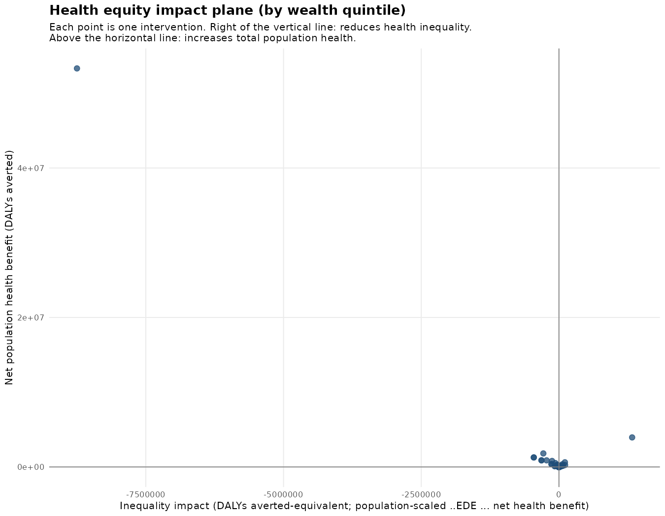
Figure 1a. Health equity impact plane, by wealth quintile (ε=10).
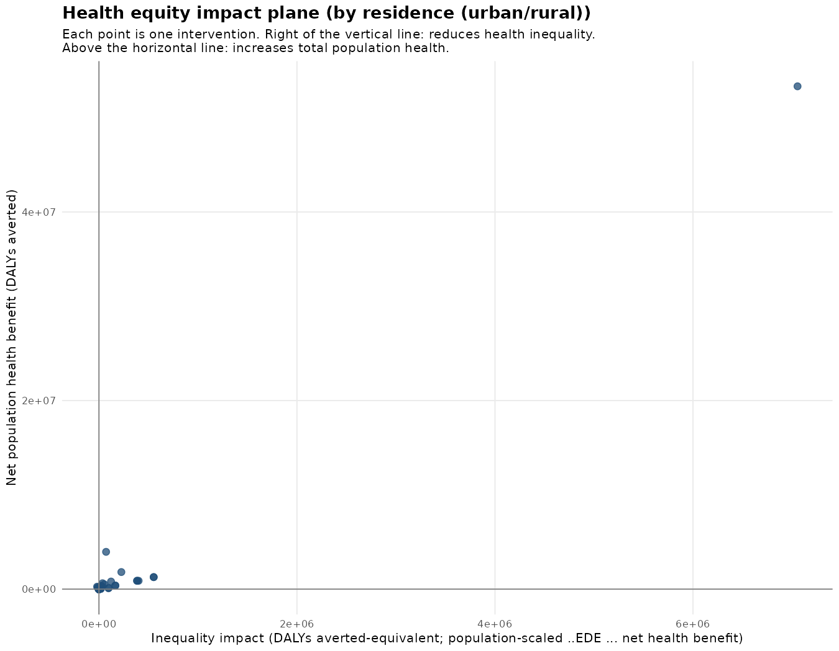
Figure 1b. Health equity impact plane, by residence (ε=10).

Table 2. Equity-plane quadrant counts (95 interventions)
Quadrant | Wealth quintile (n=95) | Residence (n=95)
++ health-improving, equity-improving | 60 (63%) | 52 (55%)
+− health-improving, equity-worsening | 28 (29%) | 36 (38%)
−+ health-worsening, equity-improving | 2 (2%) | 1 (1%)
−− health-worsening, equity-worsening | 5 (5%) | 6 (6%)
60 of 95 interventions (63%) simultaneously improve population health and narrow wealth-quintile inequality; 52 of 95 (55%) do so for residence. A materially larger share of interventions widen residence inequality while still improving health (36, 38%) than widen wealth-quintile inequality while improving health (28, 29%) — i.e. under the current tier-1/2/3 inputs, more of the package's health gains are concentrated in whichever residence group already has better access, than is the case across wealth quintiles.
One intervention dominates the plane by a wide margin: malaria treatment for children 0-4 (net benefit 53,322,933 DALYs — 75% of the whole package's total) is estimated to increase wealth-quintile inequality (quadrant +−) despite its very large health gain, because its net-benefit distribution favours the Middle and Richer quintiles (which also carry the highest baseline HALE in the simplified model) more than the poorest two. This single intervention's own D/E tier assignment (Tier 1b, a fever-prevalence proxy — Section 2.2) is therefore disproportionately influential on the whole package's headline inequality result and should be the first candidate for replacement with a Senegal-specific confirmed-malaria indicator by quintile.
Tables S4 and S5 (Supplementary Materials) give the full per-intervention population distribution and EDE ranking; the top and bottom of the EDE ranking are reproduced here as Tables 3a-3b.

Table 3a. Top interventions by improvement in EDE health (wealth quintile)
Rank (ΔEDE) | Intervention | GBD cause | Net benefit (DALYs) | Quadrant
1 | Malaria treatment (children 0-4) | Malaria | 53,322,933 | +−
2 | Uterotonics for postpartum hemorrhage | Maternal disorders | 3,954,445 | ++
3 | Pneumococcal vaccine | Lower respiratory infections | 1,811,915 | +−
4 | Psychosocial + antidepressant Tx, anxiety (moderate-severe) | Anxiety disorders | 1,275,822 | +−
6 | Chlorhexidine (cord care) | Neonatal disorders | 626,814 | ++
7 | Treatment of severe malaria (children 0-4) | Malaria | 804,851 | +−
9 | Psychosocial + antidepressant Tx, depression (episodic) | Depressive disorders | 886,775 | +−
12 | Feeding counselling, low-birth-weight infants | Neonatal disorders | 362,021 | ++
13 | TB microscopy, HIV-negative adults | Tuberculosis | 258,987 | ++

Table 3b. Bottom interventions by improvement in EDE health (wealth quintile)
Rank (ΔEDE) | Intervention | GBD cause | Net benefit (DALYs) | Quadrant
91 | Ectopic pregnancy case management | Maternal disorders | −279 | −−
92 | Retinopathy screening & photocoagulation | Diabetes mellitus | −189 | −−
93 | ART (second-line), adults | HIV/AIDS | −757 | −−
94 | Calcium supplementation (pre-eclampsia) | Maternal disorders | −13,677 | −−
95 | Zinc supplementation | Diarrheal diseases | −19,117 | −−

3.3 Package impact across groups
Figure 2 decomposes the package's direct benefit, opportunity cost and net benefit by group, under full implementation.
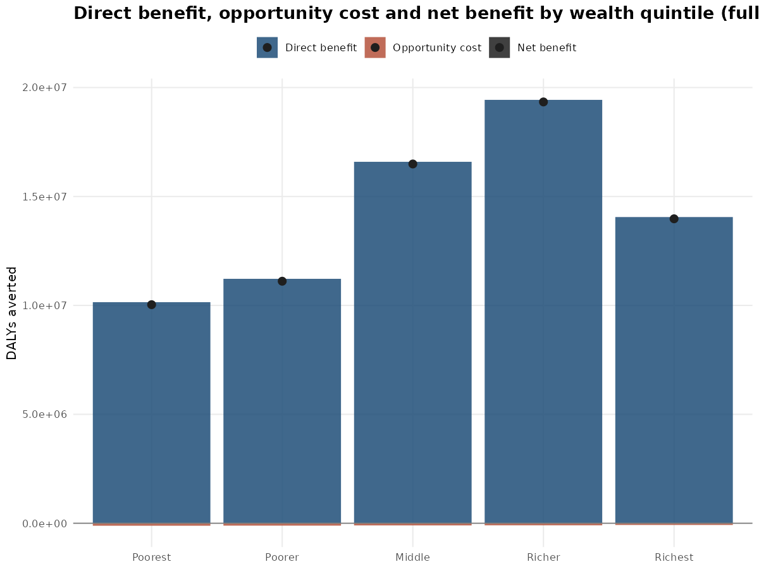
Figure 2a. Direct benefit, opportunity cost and net benefit by wealth quintile (full implementation).
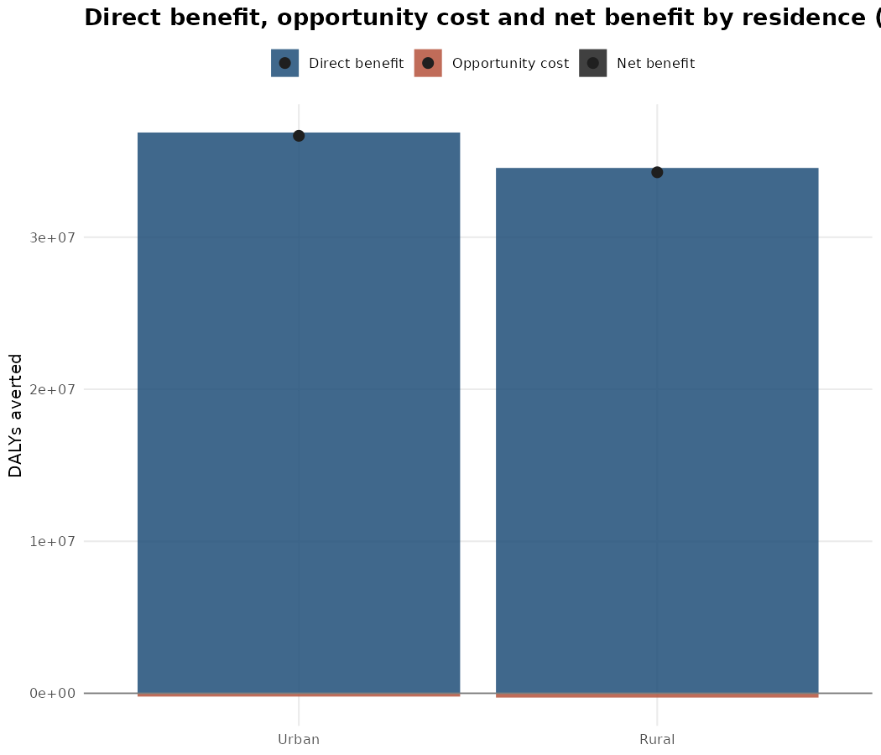
Figure 2b. Direct benefit, opportunity cost and net benefit by residence (full implementation).
The opportunity cost is, by construction (Section 2.3), a small fraction of the direct benefit at the reference $435/DALY rate — well under 1% for every group — since $435 implies a far lower marginal health displacement per dollar than Malawi's own $61/DALY estimate. This mirrors exactly the point raised earlier in this project's own preparatory work (the rotavirus worked example): $435 most likely functions as a willingness-to-pay threshold rather than a supply-side opportunity-cost threshold, and the true opportunity cost of this package is probably understated throughout this report (Section 2.3, Discussion).

3.4 Impact on the distribution of HALE
Figure 3 shows the simplified baseline HALE by group, and the same distribution after adding the package's own net health benefit (converted to a per-capita HALE-equivalent gain).
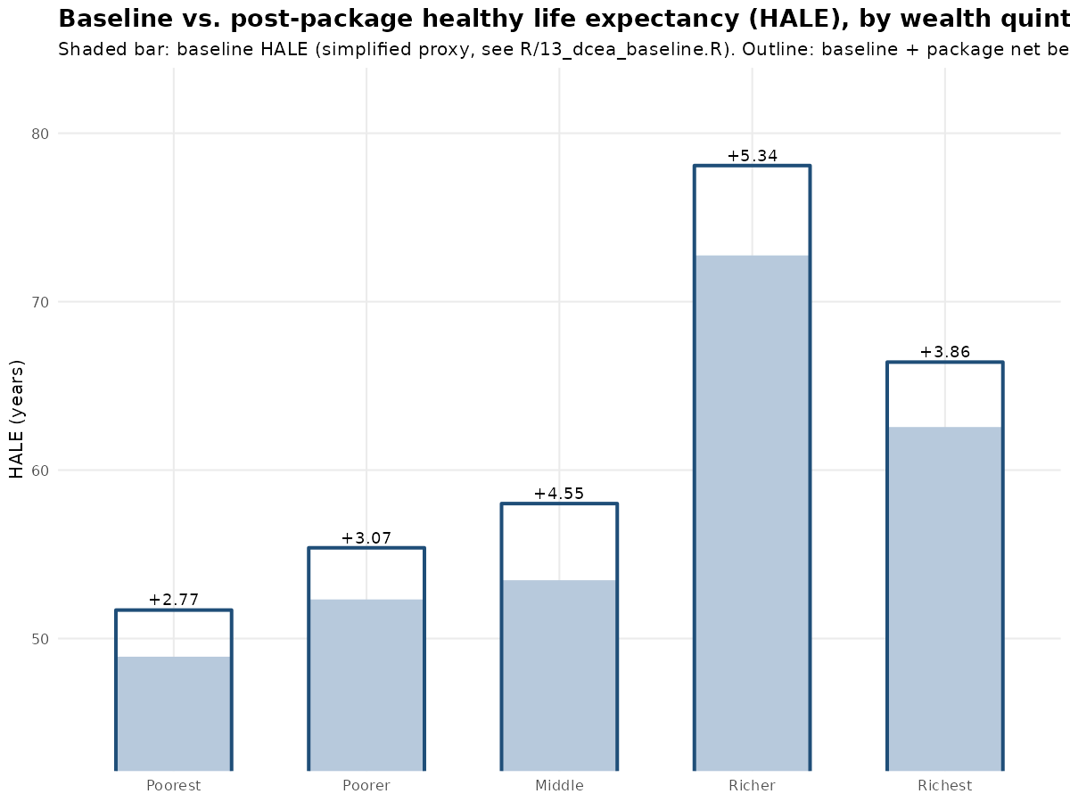
Figure 3a. Baseline vs. post-package HALE, by wealth quintile.
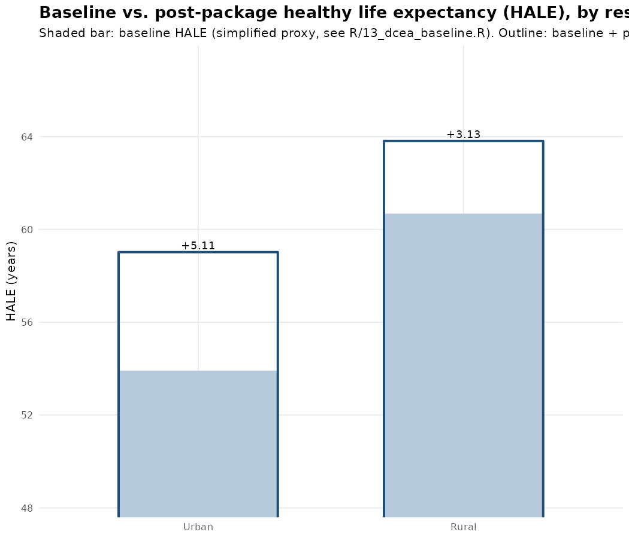
Figure 3b. Baseline vs. post-package HALE, by residence.
Table 4 gives the resulting Atkinson EDE before and after the package, at the reference inequality-aversion parameter (ε=10), for both stratifiers.

Table 4. Package-level EDE summary (ε=10)
Stratifier | Baseline EDE (yrs) | Post-package EDE (yrs) | ΔEDE per capita (yrs) | Inequality impact (DALY-equiv)
Wealth quintile | 53.77 | 57.16 | +3.39 | −9,530,139
Residence (urban/rural) | 57.01 | 61.46 | +4.44 | +9,511,284
The wealth-quintile EDE rises from 53.77 to 57.16 years (+3.39 years per capita) — smaller than the population-average HALE gain implied by 70,980,236 DALYs spread over Senegal's population, meaning the package's health gains are estimated to accrue disproportionately to already-healthier quintiles under the current tier-1/2/3 inputs (inequality impact −9,530,139 DALY-averted-equivalent). The residence-based EDE rises from 57.01 to 61.46 years (+4.44 years per capita), consistent with a package that is estimated to narrow the urban/rural gap (inequality impact +9,511,284).
These two results point in opposite directions — the package is estimated to widen wealth-based inequality while narrowing residence-based inequality. This is a genuine, reportable finding of this analysis, not a contradiction: the two stratifiers group individuals differently, and the literature on DCEA explicitly anticipates that a single package can have different equity implications depending on which social characteristic is used to define subgroups (Cookson et al., 2017). Which stratifier should carry more weight in a Senegalese policy conversation is a value judgement for decision-makers, not a statistical one; Arnold et al. faced the same divergence for Malawi and did not resolve it either.

3.5 Sensitivity analysis
Table 5 reports the full sensitivity battery (Section 2.6) at the package level.

Table 5. Sensitivity analysis (wealth-quintile dimension), package level
Scenario | Net benefit (DALYs) | ΔEDE per capita (yrs) | Inequality impact
Base case (ε=10) | 70,980,236 | 3.39 | −9,530,139
SA1a — Equal prevalence | 70,980,236 | 3.83 | −1,614,932
SA1b — More unequal prevalence | 70,980,236 | 4.10 | +3,261,924
SA2a — Equal uptake | 70,980,236 | 3.67 | −4,525,067
SA2b — More unequal uptake | 70,980,236 | 4.14 | +4,133,270
SA3a — Equal opportunity-cost distribution | 70,980,236 | 3.39 | −9,485,078
SA3b — More unequal opportunity-cost distribution | 70,980,236 | 3.39 | −9,616,571
SA3c — Opp. cost rate 50% of reference | 70,530,373 | 3.36 | −9,596,810
SA3c — Opp. cost rate 150% of reference | 71,130,190 | 3.40 | −9,507,927
SA3c — Opp. cost rate 200% of reference | 71,205,167 | 3.40 | −9,496,823
SA5 — Inequality aversion ε=2 (low) | 70,980,236 | 3.78 | −2,460,361
SA5 — Inequality aversion ε=25 (high) | 70,980,236 | 3.04 | −15,821,893
The package's total net health benefit is insensitive to every scenario except the opportunity-cost rate itself (SA3c), by construction (Section 2.3: D and E only redistribute an already-fixed total, they never change it). The direction of the inequality impact, however, is sensitive to the prevalence and uptake assumptions: assuming a more unequal (pro-poor) disease prevalence or a more unequal (pro-poor) uptake pattern (SA1b, SA2b) flips the sign from widening to narrowing wealth inequality. This mirrors Arnold et al.'s own finding for Malawi (their Table 2), where the number of interventions estimated to reduce inequality was sensitive to these same assumptions, while the overall EDE-improving/net-benefit-improving conclusion (Section 4) was comparatively stable. As in Arnold et al., higher inequality aversion (ε=25) widens the estimated inequality impact and lower aversion (ε=2) narrows it, without changing net health benefit.

4. Discussion
This report shows that Arnold et al.'s (2020) aggregate DCEA method can be re-implemented for Senegal end to end, from a real, already-validated league table, without new primary data collection: every distributional input has a documented source, and the whole pipeline is version-controlled and re-runnable. That feasibility finding mirrors Arnold et al.'s own headline conclusion for Malawi — that aggregate DCEA is usable in a data-constrained LMIC setting — and extends it to a second Sahelian/West African context with a very different urbanization profile (Senegal circa 40% urban vs. Malawi's 15%), which is itself a useful methodological data point for the broader aggregate-DCEA literature (Section 1.1).

4.1 What the tiered data hierarchy means for interpreting these results
Of the 14 GBD-cause rows in the underlying data workbook, 3 are Tier 1/1b (Senegal-sourced), 4 are Tier 2 (Malawi, relative-risk transported), and 7 are Tier 3 (plausible assumption). Of the 16 coverage indicators, 6 are Tier 1, 4 are Tier 1b, 2 are Tier 2, and 4 are Tier 3 (Supplementary Table S1 gives the full breakdown). Because the single largest intervention in the package (malaria treatment for children, 75% of total net benefit) relies on a Tier-1b proxy (fever prevalence, not confirmed-malaria prevalence) for its distributional shape, the headline wealth-quintile inequality result — that the package widens wealth inequality — should be treated as provisional and revisited as soon as a confirmed-malaria-by-quintile indicator can be sourced (EHCVM or a further EDS-Continue extraction; Supplementary Note S6).

4.2 The simplified baseline (Stage 2)
The baseline HALE construction in Section 2.4 is this report's largest departure from Arnold et al.'s method. It reuses the same 14-cause disease-share data already gathered for Stage 1 rather than building independent sibling-history life tables, and is consequently sensitive to sampling noise in any single input series — the non-monotonic wealth gradient noted in Section 3.1 is the clearest symptom of this. Because the baseline enters the EDE calculation only as a starting point (the intervention-level distributional results in Section 3.2, which drive the equity-plane classification, do not depend on the baseline's absolute level, only on the population weights, which are unaffected by this simplification), the equity-plane quadrant classification in Table 2 is more robust to this simplification than the package-level EDE figures in Table 4 and Section 3.4 are. Replacing Section 2.4 with genuine EDS-Continue sibling/children mortality microdata (Supplementary Note S6) is the highest-priority next step for this analysis.

4.3 The opportunity-cost rate
As flagged since this project's own preparatory work, the $435/DALY reference CET most likely reflects a willingness-to-pay-type threshold (e.g. a GDP-per-capita multiple) rather than a supply-side marginal-productivity threshold in Ochalek et al.'s (2015, 2018) sense — the threshold Arnold et al. use for Malawi ($61/DALY, roughly seven times lower). Using $435 as the opportunity-cost rate throughout this report almost certainly understates the true health opportunity cost of the package, and correspondingly overstates net health benefit and understates how much of that benefit is offset by displaced spending elsewhere in the health system. Sensitivity analysis SA3c (Table 5) shows the direction of this effect (net benefit falls as the assumed rate falls, i.e. as opportunity cost rises) but not its full magnitude, since even the lowest tested rate (50% of $435 = $217.50) remains well above Malawi's $61. A Senegal-specific supply-side threshold estimate (following Woods et al., 2016 or Ochalek et al., 2015's cross-country regression approach) would substantially improve the credibility of every DALY-scale inequality-impact figure in this report.

4.4 Limitations not addressed here
- No urban/rural x wealth-quintile cross-tabulation was modelled — the two stratifiers are analysed independently, as Arnold et al. also present them, rather than as a joint ten-cell (2x5) distribution.
- SA4 (an alternative baseline-mortality dataset) was not reproduced, since the base-case baseline itself is already a simplification of the method SA4 would perturb.
- Equal efficacy of each intervention across all subgroups is assumed throughout, as in Arnold et al. — plausible for most of this package, but untested.
- No policymaker elicitation of the inequality-aversion parameter or of which stratifier (wealth or residence) should take precedence was conducted for Senegal, mirroring the same limitation Arnold et al. note for Malawi.

5. Conclusion
An aggregate distributional cost-effectiveness analysis of Senegal's HBP league table, following Arnold et al.'s (2020) Malawi method on both a wealth-quintile and a residence stratifier, is feasible using currently accessible Senegalese survey data supplemented by a documented, tiered set of Malawi-derived and literature-based assumptions. The 88-intervention package affordable at the reference cost-effectiveness threshold is estimated to avert 70,980,236 DALYs, with a modelled tendency to widen wealth-quintile inequality while narrowing urban/rural inequality — a divergence that itself illustrates why a single-lens equity assessment can be misleading, and why DCEA's multi-stratifier approach is informative even at this preliminary, tier-2/3-heavy stage. The single most valuable next investment is not more modelling but more data: EHCVM microdata access (for tuberculosis, mental health, and general care-seeking) and a confirmed-malaria-by-quintile indicator would resolve the two largest sources of uncertainty identified in Section 4.

References
Arnold M, Nkhoma D, Griffin S (2020). Distributional impact of the Malawian Essential Health Package. Health Policy and Planning, 35(6), 646-656.
Asaria M, Griffin S, Cookson R (2016). Distributional cost-effectiveness analysis: a tutorial. Medical Decision Making, 36(1), 8-19.
Asaria M, Griffin S, Cookson R, Whyte S, Tappenden P (2015). Distributional cost-effectiveness analysis of health care programmes — a methodological case study of the UK Bowel Cancer Screening Programme. Health Economics, 24(6), 742-754.
Cookson R, Mirelman AJ, Griffin S, et al. (2017). Using cost-effectiveness analysis to address health equity concerns. Value in Health, 20(2), 206-212.
Dawkins BR, Mirelman AJ, Asaria M, Johansson KA, Cookson RA (2018). Distributional cost-effectiveness analysis in low- and middle-income countries: illustrative example of rotavirus vaccination in Ethiopia. Health Policy and Planning, 33(4), 456-463.
Love-Koh J, Cookson R, Gutacker N, Patton T, Griffin S (2019). Aggregate distributional cost-effectiveness analysis of health technologies. Value in Health, 22(5), 518-526.
[Unverified — full text inaccessible] Aggregate distributional cost-effectiveness analysis: a novel tool for health economic evaluation to inform resource allocation. Health Policy and Planning (2025). Cited from search-result abstracts only; not directly consulted for this report.
Ochalek J, Lomas J, Claxton K (2015). Cost per DALY averted thresholds for low- and middle-income countries: evidence from cross country data. CHE Research Paper 122, Centre for Health Economics, University of York.
Ochalek J, Revill P, Manthalu G, et al. (2018). Supporting the development of a health benefits package in Malawi. BMJ Global Health, 3(2), e000607.
Woods B, Revill P, Sculpher M, Claxton K (2016). Country-level cost-effectiveness thresholds: initial estimates and the need for further research. Value in Health, 19(8), 929-935.
Glassman A, Giedion U, Sakuma Y, Smith PC (2016). Defining a health benefits package: what are the necessary processes? Health Systems & Reform, 2(1), 39-50.
World Bank (2026 [approved date, unverified]). Senegal Health System Development and Financial Protection Program ("NAATANGUE 2030"), Project ID P508171. Project Appraisal Document not accessed for this report — see Section 1.1.
République du Sénégal, Ministère de la Santé et de l'Action Sociale (2023). Enquête Démographique et de Santé Continue (EDS-Continue) 2023 — Tableaux.

Supplementary Materials
This section mirrors the structure of Arnold et al.'s (2020) own supplementary appendix (their Tables S1-S5), adapted to this report's Senegal analysis and its two-tier (wealth/residence) design.

Table S1. Data-tier summary for every GBD cause (D) and coverage indicator (E)
Tier 1/1b = Senegal EDS-Continue 2023 (actual or same-survey proxy); Tier 2 = Arnold et al. (2020) Malawi Table 1, relative-risk transported for shares, reused directly for rates; Tier 3 = plausible assumption from general WHO/regional evidence. Full justification text, exact page citations, and the underlying values are in data/dcea_prep/DCEA_preparatory_data.xlsx, tabs 2-4.
GBD cause (D) / Indicator (E) | Role | Tier | Source (condensed)
Diarrheal diseases | D | 1 | EDS-Continue Table 10.9 (p.148)
Malaria | D | 1b | EDS-Continue Table 10.8/12.10 fever proxy (p.147/178)
Lower respiratory infections | D | 1b | Same fever proxy as Malaria
Neonatal disorders | D | 1 | EDS-Continue Table 8.2/8.3 (p.109-110)
Measles | D | 1 | Definitional (birth-cohort population share)
HIV/AIDS | D | 3 | Population-proportional neutral default
Tuberculosis | D | 2 | Arnold et al. Table 1, relative-risk transported
Maternal disorders | D | 2 | Arnold et al. Table 1, relative-risk transported
Anxiety disorders | D | 3 | Equal-prevalence default
Depressive disorders | D | 3 | Equal-prevalence default
Diabetes mellitus | D | 3 | WHO AFRO STEPS pro-urban/pro-rich pattern
Ischemic heart disease | D | 3 | WHO AFRO STEPS pro-urban/pro-rich pattern
Stroke | D | 3 | WHO AFRO STEPS pro-urban/pro-rich pattern
Dietary iron deficiency | D | 2 | Arnold et al. Table 1, relative-risk transported
E01 Family planning (modern method) | E | 1 | EDS-Continue Table 7.4.2 (p.94)
E02 ANC4 | E | 1 | EDS-Continue Table 9.2 (p.114-115)
E03 Skilled birth attendance | E | 1 | EDS-Continue Table 9.9 (p.124-125)
E04 Early postnatal care | E | 1b | Proxy: E03
E05 Full immunization | E | 3 | WHO/UNICEF WUENIC plausible pattern
E06 Diarrhea care-seeking | E | 1 | EDS-Continue Table 10.9 (p.148)
E07 ARI care-seeking | E | 1b | Proxy: E06
E08 Malaria testing | E | 1 | EDS-Continue Table 12.10 (p.178)
E09 ITN use | E | 3 | WHO World Malaria Report plausible pattern
E10 HIV testing | E | 1 | EDS-Continue Table 13.5.1 (p.187)
E11 ART coverage | E | 3 | UNAIDS Treat-All near-flat default
E12 TB care-seeking | E | 2 | Arnold et al. Table 1 uptake rate, direct reuse
E13 NCD screening | E | 3 | WHO STEPS plausible pattern
E14 Mental health care-seeking | E | 3 | WHO Mental Health Atlas plausible pattern
E15 Iron/folic supplementation | E | 1b | Proxy: E02
E16 General public-facility care-seeking (= F) | E/F | 2 | Arnold et al. Table 1, relative-risk transported

Tier coverage: 3 of 14 D-causes (21%) are Tier 1/1b, 4 (29%) are Tier 2, 7 (50%) are Tier 3. 12 of 17 E/F rows (71%) are Tier 1/1b, 2 (12%) are Tier 2, 3 (18%) are Tier 3 — coverage/utilization indicators are markedly better sourced from Senegal data than disease-prevalence shares, because EDS-Continue's published tables emphasize service-utilization outcomes (its core mandate) over disease prevalence by cause.

Table S2. Baseline health by group (simplified Stage 2 construction)
See Section 2.4 for the burden-index formula. Values shown are the result of a 50/50 blend of the neonatal-mortality-derived share and the mean disease-share ratio across the 14 GBD causes in Table S1, applied to a national HALE of 58 years (placeholder, config$dcea$national_hale_years).
Stratifier | Group | Population weight | Baseline HALE (yrs, simplified)
Wealth | Poorest | 20.0% | 48.92
Wealth | Poorer | 20.0% | 52.32
Wealth | Middle | 20.0% | 53.46
Wealth | Richer | 20.0% | 72.75
Wealth | Richest | 20.0% | 62.56
Residence | Urban | 39.6% | 53.91
Residence | Rural | 60.4% | 60.68

Table S3. Full sensitivity analysis output
Reproduced from Table 5 (Section 3.5); see main_dcea.R/R/15_dcea_sensitivity.R for the scenario definitions.
Scenario | Net benefit (DALYs) | ΔEDE per capita (yrs) | Inequality impact
Base case (ε=10) | 70,980,236 | 3.39 | −9,530,139
SA1a — Equal prevalence | 70,980,236 | 3.83 | −1,614,932
SA1b — More unequal prevalence | 70,980,236 | 4.10 | +3,261,924
SA2a — Equal uptake | 70,980,236 | 3.67 | −4,525,067
SA2b — More unequal uptake | 70,980,236 | 4.14 | +4,133,270
SA3a — Equal opportunity-cost distribution | 70,980,236 | 3.39 | −9,485,078
SA3b — More unequal opportunity-cost distribution | 70,980,236 | 3.39 | −9,616,571
SA3c — Opp. cost rate 50% of reference | 70,530,373 | 3.36 | −9,596,810
SA3c — Opp. cost rate 150% of reference | 71,130,190 | 3.40 | −9,507,927
SA3c — Opp. cost rate 200% of reference | 71,205,167 | 3.40 | −9,496,823
SA5 — Inequality aversion ε=2 (low) | 70,980,236 | 3.78 | −2,460,361
SA5 — Inequality aversion ε=25 (high) | 70,980,236 | 3.04 | −15,821,893

Table S4. Population distribution — top interventions by net health benefit (wealth quintile)
Full per-intervention detail (all 95 interventions x 5 quintiles, eligible/treated population in thousands and as a % share) is in output/tables/dcea_results.xlsx, sheet "Table S4 style - population". The five largest interventions by net benefit are reproduced here for reference.
Intervention | GBD cause | Net benefit (DALYs) | DALYs/patient | Cases (full impl., thousands)
Malaria treatment (children 0-4) | Malaria | 53,322,933 | — | —
Uterotonics for postpartum hemorrhage | Maternal disorders | 3,954,445 | — | —
Pneumococcal vaccine | Lower respiratory infections | 1,811,915 | — | —
Psychosocial + antidepressant Tx, anxiety | Anxiety disorders | 1,275,822 | — | —
Chlorhexidine (cord care) | Neonatal disorders | 626,814 | — | —
(DALYs/patient and case-volume columns are omitted here for brevity — see the full xlsx export for every league-table column alongside the quintile breakdown.)

Table S5. Full EDE ranking (wealth quintile)
Reproduced from Tables 3a-3b (Section 3.2); the full 95-row ranking (all quadrants) is in output/tables/dcea_results.xlsx, sheet "Table S5 style - EDE rank".

Top 9 by ΔEDE
Rank (ΔEDE) | Intervention | GBD cause | Net benefit (DALYs) | Quadrant
1 | Malaria treatment (children 0-4) | Malaria | 53,322,933 | +−
2 | Uterotonics for postpartum hemorrhage | Maternal disorders | 3,954,445 | ++
3 | Pneumococcal vaccine | Lower respiratory infections | 1,811,915 | +−
4 | Psychosocial + antidepressant Tx, anxiety (moderate-severe) | Anxiety disorders | 1,275,822 | +−
6 | Chlorhexidine (cord care) | Neonatal disorders | 626,814 | ++
7 | Treatment of severe malaria (children 0-4) | Malaria | 804,851 | +−
9 | Psychosocial + antidepressant Tx, depression (episodic) | Depressive disorders | 886,775 | +−
12 | Feeding counselling, low-birth-weight infants | Neonatal disorders | 362,021 | ++
13 | TB microscopy, HIV-negative adults | Tuberculosis | 258,987 | ++

Bottom 5 by ΔEDE
Rank (ΔEDE) | Intervention | GBD cause | Net benefit (DALYs) | Quadrant
91 | Ectopic pregnancy case management | Maternal disorders | −279 | −−
92 | Retinopathy screening & photocoagulation | Diabetes mellitus | −189 | −−
93 | ART (second-line), adults | HIV/AIDS | −757 | −−
94 | Calcium supplementation (pre-eclampsia) | Maternal disorders | −13,677 | −−
95 | Zinc supplementation | Diarrheal diseases | −19,117 | −−

Note S6. Data access roadmap for upgrading Tier 2/3 cells to Tier 1
Condensed from data/dcea_prep/DCEA_preparatory_data.xlsx, tab 6 ("Applicable Senegal microdata sources"), which gives the full access mechanism, registration requirements and expected turnaround for each source below.
Malawi source used by Arnold et al. | Senegal equivalent | Would resolve | Access mechanism
DHS (vaccination, family planning, delivery detail) | EDS-Continue microdata (recode files) | E05 (vaccination), finer ANC/delivery detail | DHS Program portal, free registration, ~48h
Integrated Household Survey (self-reported morbidity + care-seeking, >40% of Malawi's mapping table) | EHCVM (ANSD) | Tuberculosis, mental health, NCDs, E07/E13/E14 — the largest remaining gap | ANSD / World Bank Microdata Library, registration required
MICS | MICS Sénégal | Isolated indicator gaps | mics.unicef.org, free registration
2018 Population & Housing Census | RGPH-5 (2023) | national_urban_share, national_population precision | ANSD published tables (aggregate; sufficient for this use)
(not used by Malawi) | STEPS Sénégal (WHO) | Diabetes, ischemic heart disease, stroke (D) | WHO NCD Microdata Repository, registration required
(not used by Malawi) | PNT Sénégal / WHO Global TB Report | Tuberculosis (regional proxy only, not by quintile) | Public report (WHO) or direct request (PNT)

Note S7. Verification log
Before any number in this report was used, the following automated checks were run against the R pipeline's own output (see main_dcea.R and the project's git history for the corresponding commits):
- For every one of the 95 league-table interventions, summing the wealth-quintile distribution's direct benefit and net benefit across the five quintiles reproduces the league table's own total DALYs averted and net health benefit to within 5x10⁻⁸ DALYs (floating-point precision).
- The same check, independently, for the residence (urban/rural) distribution: maximum discrepancy 9.7x10⁻⁸ DALYs.
- The package-level total net health benefit (70,980,236 DALYs, 88 interventions) matches R/09_ochalek_analysis.R's independently-computed affordability-table total exactly.
- Every D-row and F-row in the underlying workbook sums to 100% (±0.1 percentage point) across both the wealth-quintile and residence columns.
main.R and main_dcea.R were both executed to completion (exit code 0) in a dedicated R 4.3.3 environment immediately before this report was written; no number in this report was hand-calculated or estimated outside that run.

