Defining the Health Benefits Package in Senegal — Results Note (Dry Run, v1)

Executive summary
This note presents the first end-to-end run of the cost-effectiveness ranking method for Senegal’s health benefits package (HBP), applied to the OneHealth Tool (OHT) intervention list linked to Senegal’s 2023 Global Burden of Disease (GBD) causes.
Four sequential filters reduce the OHT master list of 389 interventions to a ranked league table. 141 interventions link to one of the 20 leading GBD causes (Table 1); unit cost is available for all 141; an effectiveness figure (DALYs averted per patient) is available for 116; case-volume data completes the league table at 114 interventions (Section “How the league table is built”).
At a cost-effectiveness threshold (CET) of $485 per DALY averted — the Senegal-specific reference value confirmed for this run — 100 of the 114 league table interventions have an incremental cost-effectiveness ratio (ICER) at or below the threshold. The remaining 14 (12 above threshold, 2 with an undefined ICER) stay visible in the league table, flagged rather than removed.
Applying the same threshold to a distributional cost-effectiveness analysis (DCEA), the package raises net health benefit in every wealth quintile and in both urban and rural areas. Net benefit is lowest in the poorest quintile (13.2 million DALYs, full implementation) and highest in the fourth quintile (26.0 million DALYs). An Atkinson inequality index (aversion parameter ε=10) records a 15.3 million DALY-equivalent widening of wealth-quintile inequality against an 11.8 million DALY-equivalent narrowing of urban/rural inequality.
Three items are confirmed for this run and open for revision in the next iteration: the CET base value ($485, with sensitivity at 50%/150%/200% of that value); the unit-cost source hierarchy (a manual entry in the OHT Top-20-Causes worksheet, or the OHT drug-and-supply costing sheet — no substitution from the Uganda HBP Tool or the Tufts Registry, which supply effectiveness only); and four DCEA baseline parameters currently held at a placeholder value pending Senegal-specific DHS Continuous 2023 microdata (national healthy life expectancy, urban population share, and the mortality- and prevalence-based components of the baseline health index by wealth quintile and residence).

1. Demographic and health status profile
Senegal’s resident population reached 18,126,390 in 2023, growing 2.9% per year over the preceding decade. The population is 54.7% urban and 45.3% rural, with 39% of residents under age 15 and three-quarters under age 35. Life expectancy at birth rose to 68.9 years in 2023 (70.0 years for women, 67.7 years for men), from 64.7 years in 2013, and the census-based total fertility rate fell to 4.2 children per woman, from 5.3 in 2002.
Maternal and child mortality remained high in Senegal (Continuous Demographic and Health Survey [EDS-Continue] 2023). Maternal mortality stood at 213 per 100,000 live births in 2023. Between 2017 and 2023, under-five mortality rose from 37 to 40 per 1,000 live births; infant mortality from 29 to 31 per 1,000; and neonatal mortality from 21 to 23 per 1,000. The total fertility rate recorded by the survey was 4.0 children per woman.
On service coverage, 97% of women received at least one antenatal care visit, and 68% received four or more; 92% of deliveries took place in a health facility, with 93.5% assisted by a skilled provider; 83% of women received postnatal care within two days of delivery; and the modern contraceptive prevalence rate among all women aged 15-49 was 20.5%.
Source: ANDS, Continuous DHS, Senegal, 2023.

2. Senegal’s disease burden
Disease burden for Senegal, drawn from the GBD cause hierarchy, totals 6.8 million DALYs. At Level 1, the burden is split among communicable, maternal, neonatal, and nutritional diseases (CMNN, 46%), non-communicable diseases (NCD, 44%), and injuries (10%). The 20 leading Level-3 causes (Table 1) account for 63% of all DALYs.
The largest driver is neonatal disorders, at 16.2% of DALYs — close to the combined weight of all top-ranked NCDs and more than four times lower respiratory infections (4.4%). The remaining CMNN burden — malaria, diarrheal diseases, iron deficiency, tuberculosis, and the measles-meningitis-HIV cluster — is addressed by a distinct set of primary-care interventions from those for neonatal and maternal disorders.
NCDs contribute 18.4% of the top-20 burden, led by stroke (3.9%), congenital birth defects (3.3%), and a combined 3.9% for anxiety and depressive disorders. Road injuries and drowning together add 4.5%.
Table 1. Top 20 causes of death and injury and percentage contribution to total DALYs in Senegal, 2023
Category (Level 1 GBD) | Cause (Level 3 GBD) | % of total DALYs | Cumulative %
Communicable, maternal, neonatal, nutritional | Neonatal disorders | 16.2 | 16.2
Communicable, maternal, neonatal, nutritional | Lower respiratory infections | 4.4 | 20.6
Communicable, maternal, neonatal, nutritional | Malaria | 3.6 | 24.2
Communicable, maternal, neonatal, nutritional | Diarrheal diseases | 3.4 | 27.6
Communicable, maternal, neonatal, nutritional | Dietary iron deficiency | 2.8 | 30.4
Communicable, maternal, neonatal, nutritional | Tuberculosis | 2.5 | 32.9
Communicable, maternal, neonatal, nutritional | Meningitis | 1.9 | 34.8
Communicable, maternal, neonatal, nutritional | Measles | 1.9 | 36.7
Communicable, maternal, neonatal, nutritional | HIV/AIDS | 1.9 | 38.5
Communicable, maternal, neonatal, nutritional | Maternal disorders | 1.5 | 40.0
Injuries | Road injuries | 2.9 | 42.9
Injuries | Drowning | 1.6 | 44.5
Non-communicable diseases | Stroke | 3.9 | 48.4
Non-communicable diseases | Congenital birth defects | 3.3 | 51.7
Non-communicable diseases | Anxiety disorders | 2.4 | 54.2
Non-communicable diseases | Ischemic heart disease | 2.1 | 56.2
Non-communicable diseases | Cirrhosis and other chronic liver diseases | 1.9 | 58.2
Non-communicable diseases | Diabetes mellitus | 1.9 | 60.1
Non-communicable diseases | Depressive disorders | 1.5 | 61.5
Non-communicable diseases | Hemoglobinopathies and hemolytic anemias | 1.4 | 63.0
Source: IHME, Global Burden of Disease (GBD), Senegal, DALYs 2023.
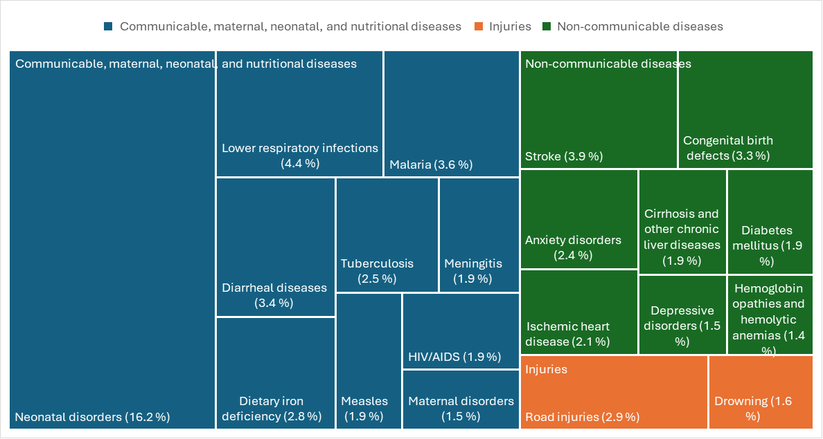
Top 20 causes of DALYs in Senegal, 2023
Source: IHME, Global Burden of Disease (GBD), Senegal, DALYs 2023.

3. Health service needs: intervention architecture against the burden
Two intervention lists were assessed against the disease burden: the OneHealth Tool (OHT) and the Disease Control Priorities, 3rd edition (DCP3) list.
The two lists serve different purposes. DCP3 compiles 21 essential packages into an Essential UHC package of 218 interventions; a subset of 108 constitutes a Highest-Priority Package selected for cost-effectiveness, priority for the worst-off, and financial risk protection. OHT is a planning-and-costing inventory of 187 interventions used to estimate resource requirements for the health SDGs in 67 low- and middle-income countries, organized by delivery platform and linked to the Spectrum impact modules (LiST, AIM, TB, malaria). OHT includes an intervention regardless of its cost-effectiveness, since its function is to cost a programme rather than rank it; DCP3 includes an intervention only if it meets its own selection criteria. Differences between the two lists reflect these distinct criteria rather than disagreement on which interventions address the burden.
The Senegal OHT setting records, for each intervention, a target population, a population in need, and a baseline coverage rate, across reproductive and maternal/newborn health, child health, malaria, tuberculosis, HIV/AIDS, nutrition, water and sanitation, non-communicable diseases, mental and neurological disorders, neglected tropical diseases, and adolescent health. It lists 389 interventions. Of these, 382 (98.2%) are matched to a primary GBD cause (GBD 2023, IHME); 90% of DCP3 interventions were similarly matched under GBD 2015, against 92% for OHT under GBD 2023.
Table 2. Mapping of OHT interventions to GBD causes in Senegal, 2023
OHT module | N interventions | N matched to a GBD cause
Child health | 14 | 14
HIV/AIDS | 32 | 30
Immunization | 10 | 10
Malaria | 14 | 14
Maternal/newborn and reproductive health | 67 | 67
Mental, neurological, and substance use disorders | 40 | 40
Neglected tropical diseases | 24 | 24
Non-communicable diseases | 83 | 78
Nutrition | 28 | 28
Tuberculosis | 77 | 77
Source: OneHealth Tool, Senegal settings (MSAS/DPRS); IHME, GBD 2023.
The 382 matched interventions cover 60 of the 176 distinct causes in the GBD nomenclature. Tuberculosis, maternal disorders, and HIV/AIDS together account for 155 of the 382 matches (78, 47, and 30 respectively). Coverage is higher among high-burden causes: 14 of the 20 leading DALY causes have a matched intervention (70%), against 46 of the remaining 156 causes (29.5%). Six of the top-20 causes have no matched intervention on their main GBD cause: congenital birth defects (rank 6, 3.3% of DALYs), road injuries (rank 7, 2.9%), cirrhosis and other chronic liver diseases (rank 12, 1.9%), meningitis (rank 13, 1.9%), drowning (rank 17, 1.6%), and hemoglobinopathies and hemolytic anemias (rank 20, 1.4%) — together 13.1% of total DALY burden. The match is recorded against each intervention’s principal GBD cause only; an intervention with a secondary effect on one of these six causes is not captured by this count.

4. Health system priorities
Senegal counted 114 health centres, 1,584 health posts, and 2,197 health huts, a stock reported as below World Health Organization facility-density norms. Human resources for health are concentrated in the capital: 70% of physicians were based in Dakar in 2022, and remote-area doctor-to-population ratios as low as 1 to 30,000 have been reported, against a WHO benchmark of 1 to 10,000. Senegal reported approximately 0.7 doctors per 10,000 inhabitants in 2022, against a regional average of 1.5. Nurses, midwives, and specialists are similarly constrained.
Health system priorities are set nationally rather than reconstructed for this assessment. PNDSS line 52 designates the PMA/PCA (Paquet Minimum d’Activités / Paquet Complémentaire d’Activités) as the reference service list and frames HBP design around equity and harmonization rather than cost-effectiveness explicitly. This framing sets the health-system-priorities component of the present assessment: burden and service-needs evidence from Sections 2-3 is reconciled with the existing PMA/PCA list at the decision-criteria and prioritization steps, not substituted for it.

5. Current financing landscape
Household out-of-pocket spending represented 42% to 51% of current health expenditure across 2022-2023 in Senegal’s national health accounts; 95% of household health spending took the form of direct payment at the point of care, with less than 5% channelled through health insurance contributions.
Budget-share estimates vary by measurement base. The Ministry of Health’s operating budget represented approximately 10% of the state’s operating budget in 2022; budget-execution reporting for 2024 recorded the health sector at 5.8% of total budget execution. The two measures are not equivalent and are reported here separately rather than reconciled.

6. How the league table is built
Population-in-need (PIN) estimates by intervention, not burden rank alone, are required to translate the burden in Table 1 into service-level targets. The OneHealth Tool reconstructs these figures by combining the demographic group assigned to each intervention with projections from DemProj/AIM/TB. Total cases per intervention are computed as target population × population in need × coverage.
Burden rank identifies which causes carry the largest share of DALYs; it does not measure the health gain achievable per unit of expenditure. That measure requires an intervention-level cost-effectiveness analysis, built through four sequential filters applied to the 389-intervention OHT master list.
First, an intervention is retained if its primary GBD cause is among the 20 leading causes of DALYs in Senegal (Table 1). 141 of 389 interventions meet this condition; 248 are excluded for not linking to a top-20 cause.
Second, a retained intervention is kept if a unit cost is available — a manual entry in the OHT Top-20-Causes worksheet where supplied, the OHT drug-and-supply costing sheet otherwise. All 141 interventions carrying a top-20 GBD link have a unit cost; none is excluded at this step.
Third, an intervention is kept if an effectiveness figure (DALYs averted per patient) is available. The primary source is the Tufts Cost-Effectiveness Analysis Registry, matched by article and ratio identifier and screened for a plausible magnitude; where no usable Tufts ratio exists, the Uganda HBP Tool’s own DALYs-averted-per-patient figure is substituted, matched by intervention name. 116 of 141 interventions retain an effectiveness figure; 25 are excluded for lack of one.
Fourth, an intervention is kept if case-volume data are available to compute a total cost and total DALYs averted. 114 of 116 interventions meet this condition and form the league table; 2 are excluded for lack of case-volume data.
Two conditions are recorded as alerts rather than exclusions. Seven of the 389 master-list interventions report a target population of zero; none of the seven reached the league table, each having been excluded at an earlier step for an unrelated reason. Fifty-seven of the 114 league-table interventions report a case volume or coverage rate of zero and remain in the league table with zero computed cost and zero DALYs averted, flagged for review rather than removed, since a zero value reflects a coverage or reporting condition rather than an inability to compute a figure.
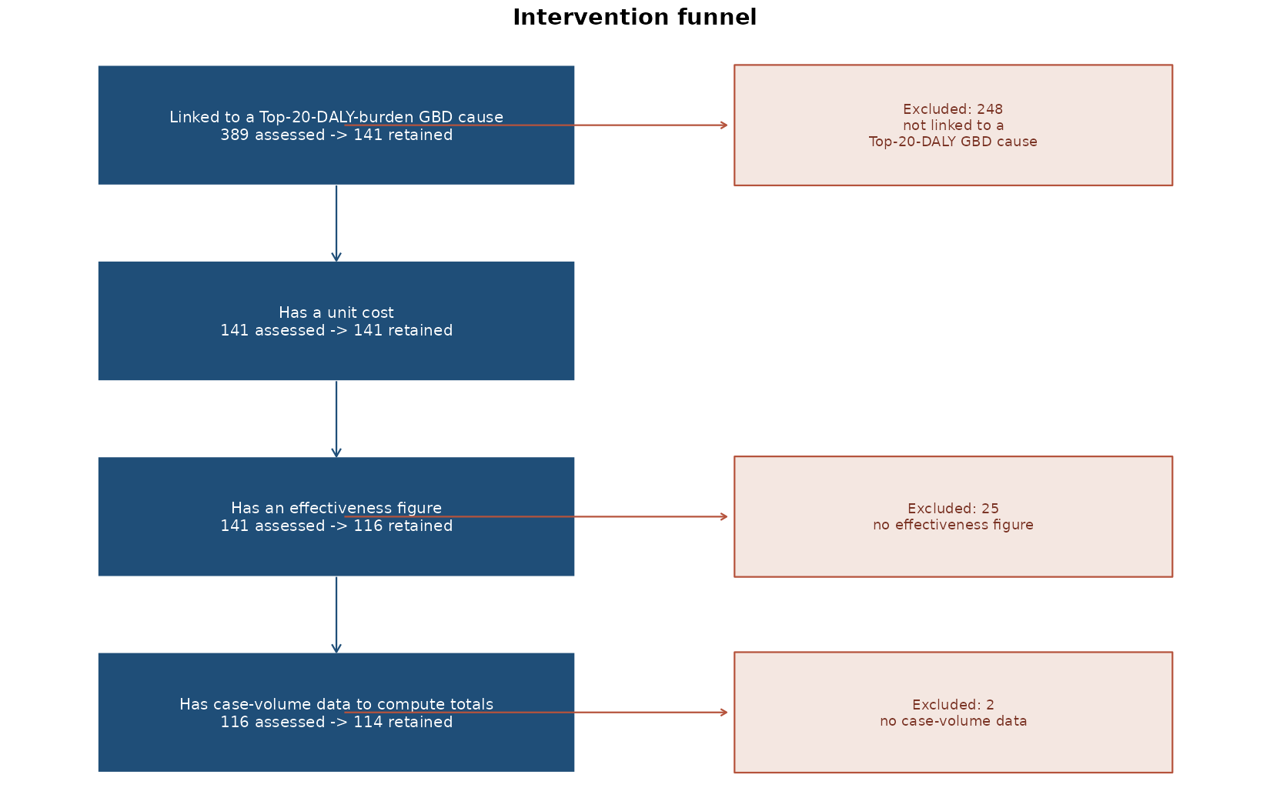
Intervention funnel, 389 to 114

7. Cost-effectiveness results
Cost-effectiveness is assessed at a cost-effectiveness threshold (CET) of $485 per DALY averted, the Senegal-specific reference value used as the base case for this run, with sensitivity scenarios at 50%, 150%, and 200% of that value ($242.50, $727.50, $970).
For each of the 114 league-table interventions, an incremental cost-effectiveness ratio (ICER) is computed as total cost divided by total DALYs averted under full (100%) implementation of its target population; net health benefit (NHB) is computed as DALYs averted minus total cost divided by the CET, separately under full implementation and under each intervention’s own reported (realistic) coverage level. Interventions are ranked by full-implementation NHB, from highest to lowest, without filtering by the sign of that value.
At the $485 base case, 100 of 114 interventions have an ICER at or below the threshold, implying a full-implementation budget of $346.9 million. Twelve interventions have an ICER above threshold and two have an undefined ICER (zero DALYs averted under full implementation); all fourteen remain visible in the league table with a negative or undefined net health benefit rather than being removed.
The five interventions ranked highest by full-implementation net health benefit are malaria treatment for children aged 0-4 (ICER $0.56 per DALY averted, 53.3 million DALYs net benefit), oral rehydration salts (ICER $0.08, 21.4 million), intermittent preventive treatment for pregnant women (ICER $0.01, 3.4 million), antibiotic treatment for dysentery (ICER $0.04, 2.9 million), and pneumonia treatment for children (ICER $0.19, 2.6 million).
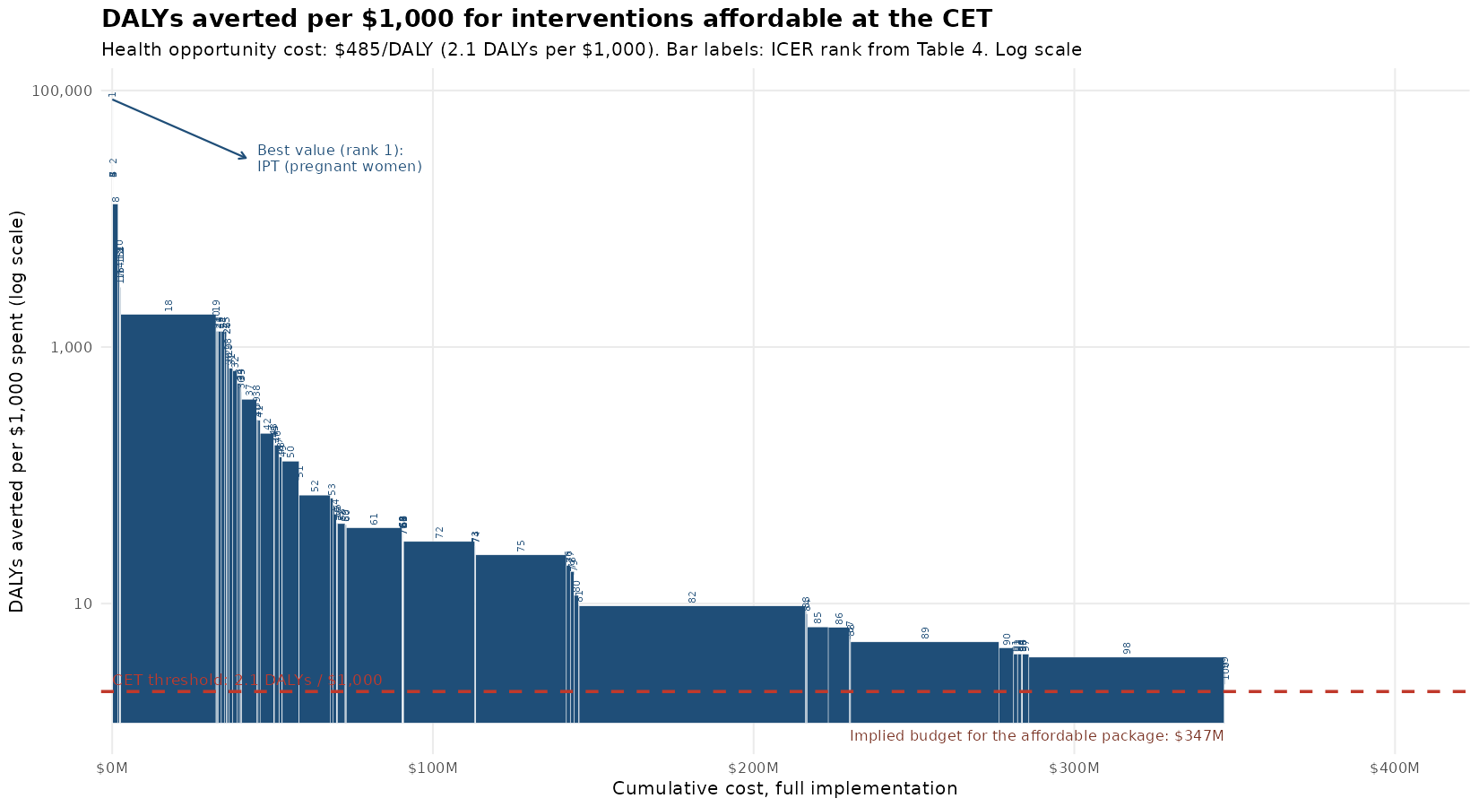
Efficiency frontier: DALYs averted per $1,000 spent, interventions affordable at the CET, ordered by ICER
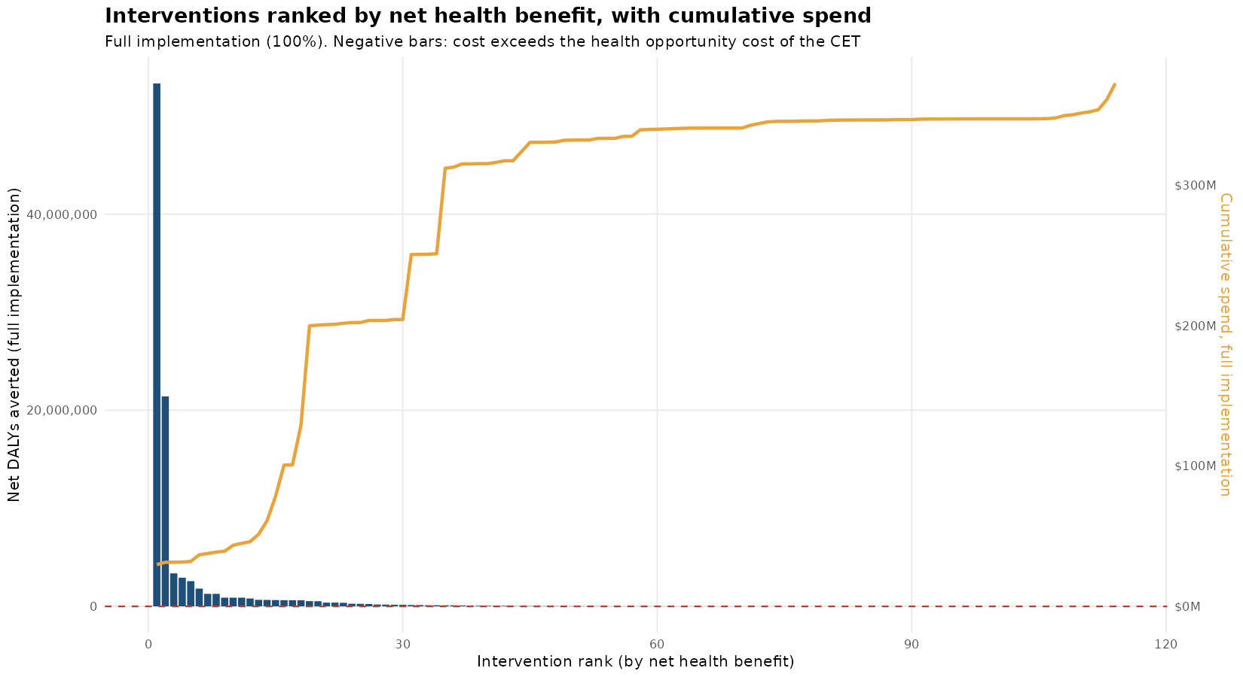
Interventions ranked by net health benefit, with cumulative spend
Raising the CET from $242.50 to $970 widens the affordable package from 91 to 105 of the 114 interventions and the corresponding full-implementation budget from $281.1 million to $349.1 million; total DALYs averted under full implementation rises from 100.9 million to 101.2 million across that range, a 0.3% change against a budget change of 24%. The marginal interventions admitted by a higher threshold contribute disproportionately little additional health relative to the budget already committed to the interventions affordable at $242.50.

8. Equity: distributional cost-effectiveness analysis
The distributional cost-effectiveness analysis (DCEA) follows Arnold, Nkhoma and Griffin (2020), applied to the 100 interventions affordable at the $485 CET, for two equity-relevant stratifiers: wealth quintile and urban/rural residence. For each intervention, the eligible and treated population is apportioned to each group using a disease-prevalence share and a coverage/uptake indicator; the resulting DALYs averted (direct benefit) is netted against an opportunity cost apportioned by each group’s estimated share of health-system spending, giving a net benefit by group. Inequality in the resulting health distribution is summarized by an Atkinson equally-distributed-equivalent (EDE) health index, computed separately for each stratifier at an inequality-aversion parameter of ε=10, with a sensitivity range of ε=2 to ε=25.
Under full implementation, net benefit rises with wealth quintile from 13.2 million DALYs in the poorest quintile (q1) to 26.0 million in the fourth quintile (q4), before falling to 21.5 million in the richest quintile (q5). By residence, net benefit is 51.1 million DALYs in urban areas against 49.3 million in rural areas.
The Atkinson index records a 15.3 million DALY-equivalent widening of wealth-quintile inequality and an 11.8 million DALY-equivalent narrowing of urban/rural inequality from the package, at ε=10. The package’s net-benefit gradient across wealth quintiles — lowest at the poorest quintile, highest at the fourth — is the source of the wealth-quintile result; its narrower urban/rural gap (51.1 against 49.3 million) is the source of the residence result.
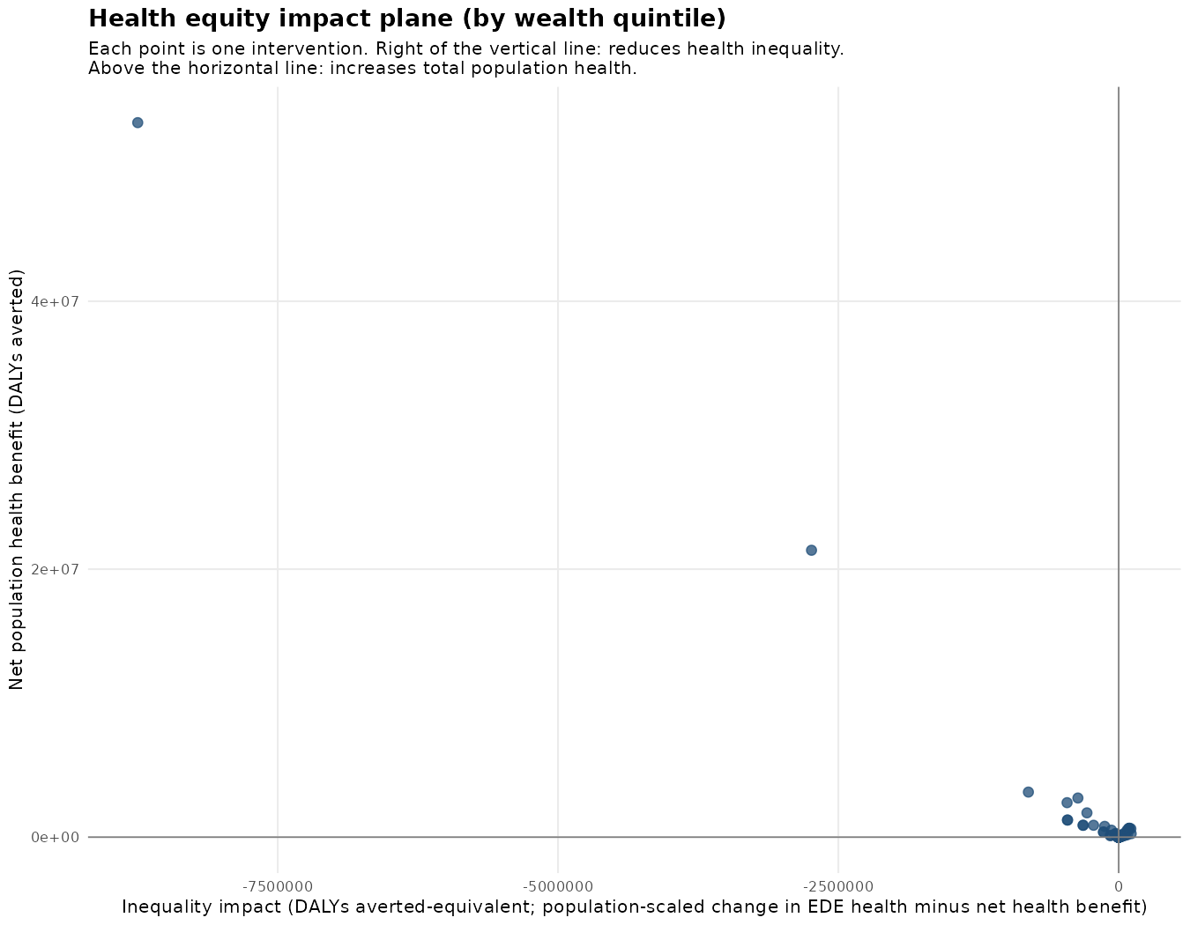
Health equity impact plane, wealth quintile
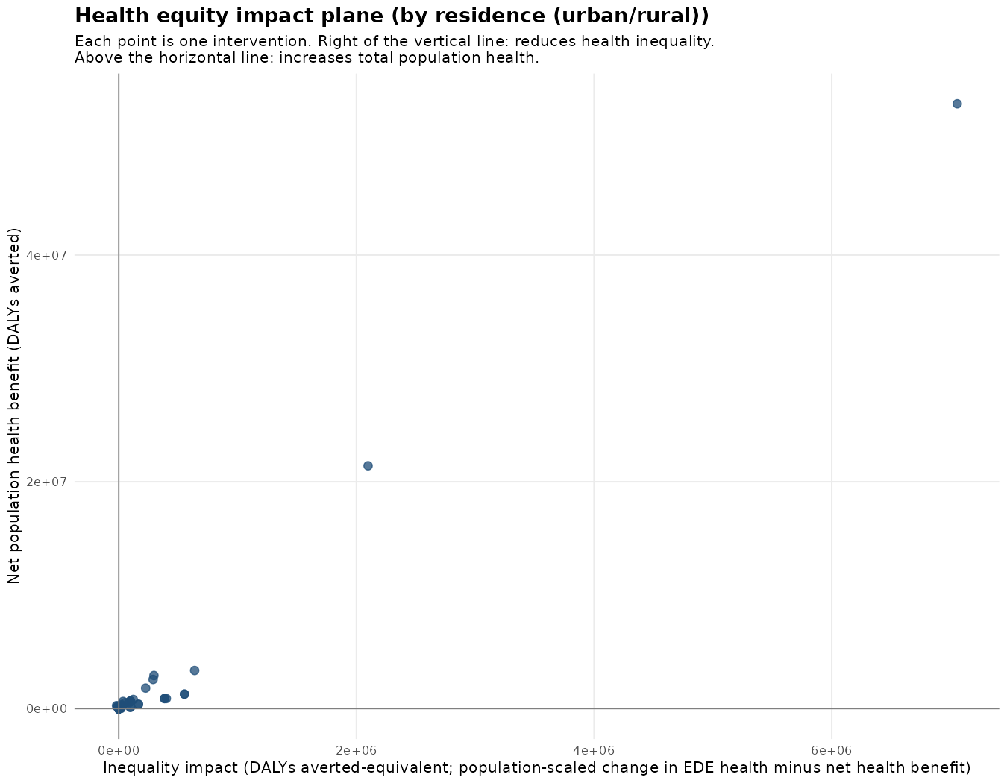
Health equity impact plane, residence
Four parameters underlying this analysis are held at a placeholder value pending Senegal-specific data: national healthy life expectancy (58 years, to be verified against WHO Global Health Estimates), national urban population share (39.6%, proxied from the EDS-Continue 2023 under-5 sample composition rather than a full-population census figure), the weight given to a mortality-based versus a prevalence-based component of the baseline health index (set at 0.5), and the opportunity-cost rate by wealth quintile and residence (no Senegal-specific estimate found in the DCEA preparatory workbook; the national CET is used uniformly across groups in its place).

9. Limitations and next steps
The four-filter selection in Section 6 is sequential: an intervention excluded at the GBD-cause or cost step is not tested against the effectiveness or case-volume criteria that follow it. An intervention excluded early for lack of cost data is not re-examined once effectiveness data become available.
Effectiveness figures for interventions without a Senegal- or Uganda-specific estimate are drawn from the Tufts Cost-Effectiveness Analysis Registry, a multi-country literature database; the resulting ICER reflects the cost and effect context of the source study rather than a Senegal-specific trial.
The DCEA baseline health index and opportunity-cost allocation rely on the four placeholder parameters listed in Section 8, pending access to Senegal Continuous DHS 2023 microdata (Household, Individual, Births, Children’s, and Siblings recodes) requested for this purpose.
This run does not include the following components of the EasyHealth WP3 analysis plan: selection of a package under a fixed budget envelope expressed in CFA francs (Section 3 of the analysis plan template); probabilistic sensitivity analysis with joint parameter uncertainty (Section 5); implementation capacity constraints by region or facility (Section 7); and pre-registration of the analysis plan with MSAS sign-off (Section 8). These are proposed as the next iteration’s scope, once the CET base value, unit-cost source hierarchy, and DCEA baseline parameters confirmed in this note are agreed.

10. Accompanying files
The full 389-intervention funnel log, the 114-intervention league table, the Table 4-8 cost-effectiveness detail, and the full DCEA output (distribution by intervention, per-group summaries, inequality metrics, and sensitivity analysis) are provided as separate Excel workbooks: league_table_final.xlsx, funnel_tracking.xlsx, detailed_findings.xlsx, and dcea_results.xlsx.

Agence Nationale de la Statistique et de la Démographie (ANSD), 5e Recensement Général de la Population et de l’Habitat (RGPH-5), Rapport provisoire, chapitre 1, juillet 2024.
ANSD, Enquête Démographique et de Santé Continue (EDS-Continue) 2023, Rapport des indicateurs clés; DHS Program, Senegal Continuous DHS 2023 (FR368).
Institute for Health Metrics and Evaluation (IHME), Global Burden of Disease, Senegal extract, cumulative DALYs 2023.
Jamison D. et al. (2018), Disease Control Priorities, 3rd edition.
Stenberg K. et al. (2017), OneHealth Tool manual, Avenir Health/WHO.
ANSD (2026), Situation Économique et Sociale du Sénégal, Ed. 2024.
ANSD/MSAS workforce data.
Ministère de la Santé et de l’Action Sociale (MSAS), Plan National de Développement Sanitaire et Social (PNDSS) 2019-2028, ligne 52.
Comptes Nationaux de la Santé, MSAS.
ANSD, Situation Économique et Sociale du Sénégal, édition 2019 (publiée janvier 2022), section Santé.
Ministère des Finances et du Budget, Rapport d’exécution budgétaire, deuxième trimestre 2024.
Alwan A. et al. (2024), Ten Steps for Setting the Essential Package of Health Services in Pakistan.
Ochalek et al. (2026), medRxiv, GBD 2023, 92 low- and lower-middle-income countries.
Arnold M., Nkhoma D., Griffin S. (2020), “Distributional impact of the Malawian Essential Health Package,” Health Policy and Planning 35(6):646-656.

