Defining the Health Benefits Package in Senegal — Results Note (Dry Run, v7)

Abstract
We present the first end-to-end run of the cost-effectiveness ranking method for Senegal’s health benefits package (HBP), applied to the OneHealth Tool (OHT) intervention list linked to Senegal’s 2023 Global Burden of Disease (GBD) causes.
Four sequential filters reduce the OHT master list of 389 interventions to a ranked league table. 141 interventions link to one of the 20 leading GBD causes (Table 1); unit cost is available for all 141; an effectiveness figure (DALYs averted per patient) is available for 97; case-volume data completes the league table at 95 interventions (Section “How the league table is built”).
At a cost-effectiveness threshold (CET) of $485 per DALY averted — the Senegal-specific reference value confirmed for this run — 86 of the 95 league table interventions have an incremental cost-effectiveness ratio (ICER) at or below the threshold. The remaining 9 (7 above threshold, 2 with an undefined ICER) stay visible in the league table, flagged rather than removed.
We run a first constrained optimization, using a provisional $120 million consumables budget as the only constraint, retaining 76 of the 86 cost-effective interventions while using 100% of that budget, with net DALYs averted essentially unchanged (70.9 million vs 71.0 million) relative to no budget constraint at all. A scenario that also applies health-workforce time constraints shows pharmaceutical and mental-health staff time — not the budget — as the binding constraint (Section 3.2).
Applying the same threshold to a distributional cost-effectiveness analysis (DCEA), the package raises net health benefit in every wealth quintile and in both urban and rural areas. Net benefit is lowest in the poorest quintile (10.0 million DALYs, full implementation) and highest in the fourth quintile (19.3 million DALYs). An Atkinson inequality index (aversion parameter ε=10) records a 9.5 million DALY-equivalent widening of wealth-quintile inequality against a 9.5 million DALY-equivalent narrowing of urban/rural inequality.
We confirm four items for this run, open to revision in the next iteration: the CET base value ($485, with sensitivity at 50%/150%/200% of that value); the unit-cost source hierarchy (a manual entry in the OHT Top-20-Causes worksheet, or the OHT drug-and-supply costing sheet — no substitution from the Uganda HBP Tool or the Tufts Registry, which supply effectiveness only); four DCEA baseline parameters currently held at a placeholder value pending Senegal-specific DHS Continuous 2023 microdata (national healthy life expectancy, urban population share, and the mortality- and prevalence-based components of the baseline health index by wealth quintile and residence); and the provisional consumables budget used in the constrained optimization ($120 million, Section 3.2).

1. Introduction
Senegal's Ministry of Health and Social Action (MSAS) is defining a national health benefits package (HBP) to guide priority-setting under resource constraints. We apply two complementary economic methods to a policy-relevant intervention list for Senegal, drawn from the OneHealth Tool (OHT) and the 2023 Global Burden of Disease (GBD) study: cost-effectiveness ranking against a health-opportunity-cost threshold, and constrained optimization under a resource envelope. It reports a first, dry-run application of both methods, together with a distributional (equity) extension, and sets out the data and modelling gaps that remain before the results can inform policy.

1.1 Demographic and health status profile
Senegal’s resident population reached 18,126,390 in 2023, growing 2.9% per year over the preceding decade. The population is 54.7% urban and 45.3% rural, with 39% of residents under age 15 and three-quarters under age 35. Life expectancy at birth rose to 68.9 years in 2023 (70.0 years for women, 67.7 years for men), from 64.7 years in 2013, and the census-based total fertility rate fell to 4.2 children per woman, from 5.3 in 2002.
Maternal and child mortality remained high in Senegal (Continuous Demographic and Health Survey [EDS-Continue] 2023). Maternal mortality stood at 213 per 100,000 live births in 2023. Between 2017 and 2023, under-five mortality rose from 37 to 40 per 1,000 live births; infant mortality from 29 to 31 per 1,000; and neonatal mortality from 21 to 23 per 1,000. The total fertility rate recorded by the survey was 4.0 children per woman.
On service coverage, 97% of women received at least one antenatal care visit, and 68% received four or more; 92% of deliveries took place in a health facility, with 93.5% assisted by a skilled provider; 83% of women received postnatal care within two days of delivery; and the modern contraceptive prevalence rate among all women aged 15-49 was 20.5%.
Source: ANDS, Continuous DHS, Senegal, 2023.

1.2 Health system priorities
Senegal counted 114 health centres, 1,584 health posts, and 2,197 health huts, a stock reported as below World Health Organization facility-density norms. Human resources for health are concentrated in the capital: 70% of physicians were based in Dakar in 2022, and remote-area doctor-to-population ratios as low as 1 to 30,000 have been reported, against a WHO benchmark of 1 to 10,000. Senegal reported approximately 0.7 doctors per 10,000 inhabitants in 2022, against a regional average of 1.5. Nurses, midwives, and specialists are similarly constrained.
Health system priorities are set nationally rather than reconstructed for this assessment. PNDSS line 52 designates the PMA/PCA (Paquet Minimum d’Activités / Paquet Complémentaire d’Activités) as the reference service list and frames HBP design around equity and harmonization rather than cost-effectiveness explicitly. This framing sets the health-system-priorities component of the present assessment: burden and service-needs evidence from Sections 2.1.1-2.1.2 is reconciled with the existing PMA/PCA list at the decision-criteria and prioritization steps, not substituted for it.

2. Methodology and data

2.1 Data sources

2.1.1 Disease burden
Disease burden for Senegal, drawn from the GBD cause hierarchy, totals 6.8 million DALYs. At Level 1, the burden is split among communicable, maternal, neonatal, and nutritional diseases (CMNN, 46%), non-communicable diseases (NCD, 44%), and injuries (10%). The 20 leading Level-3 causes (Table 1) account for 63% of all DALYs.
The largest driver is neonatal disorders, at 16.2% of DALYs — close to the combined weight of all top-ranked NCDs and more than four times lower respiratory infections (4.4%). The remaining CMNN burden — malaria, diarrheal diseases, iron deficiency, tuberculosis, and the measles-meningitis-HIV cluster — is addressed by a distinct set of primary-care interventions from those for neonatal and maternal disorders.
NCDs contribute 18.4% of the top-20 burden, led by stroke (3.9%), congenital birth defects (3.3%), and a combined 3.9% for anxiety and depressive disorders. Road injuries and drowning together add 4.5%.
Table 1: Top 20 causes of death and injury and percentage contribution to total DALYs in Senegal, 2023
Category (Level 1 GBD) | Cause (Level 3 GBD) | % of total DALYs | Cumulative %
Communicable, maternal, neonatal, nutritional | Neonatal disorders | 16.2 | 16.2
Communicable, maternal, neonatal, nutritional | Lower respiratory infections | 4.4 | 20.6
Communicable, maternal, neonatal, nutritional | Malaria | 3.6 | 24.2
Communicable, maternal, neonatal, nutritional | Diarrheal diseases | 3.4 | 27.6
Communicable, maternal, neonatal, nutritional | Dietary iron deficiency | 2.8 | 30.4
Communicable, maternal, neonatal, nutritional | Tuberculosis | 2.5 | 32.9
Communicable, maternal, neonatal, nutritional | Meningitis | 1.9 | 34.8
Communicable, maternal, neonatal, nutritional | Measles | 1.9 | 36.7
Communicable, maternal, neonatal, nutritional | HIV/AIDS | 1.9 | 38.5
Communicable, maternal, neonatal, nutritional | Maternal disorders | 1.5 | 40.0
Injuries | Road injuries | 2.9 | 42.9
Injuries | Drowning | 1.6 | 44.5
Non-communicable diseases | Stroke | 3.9 | 48.4
Non-communicable diseases | Congenital birth defects | 3.3 | 51.7
Non-communicable diseases | Anxiety disorders | 2.4 | 54.2
Non-communicable diseases | Ischemic heart disease | 2.1 | 56.2
Non-communicable diseases | Cirrhosis and other chronic liver diseases | 1.9 | 58.2
Non-communicable diseases | Diabetes mellitus | 1.9 | 60.1
Non-communicable diseases | Depressive disorders | 1.5 | 61.5
Non-communicable diseases | Hemoglobinopathies and hemolytic anemias | 1.4 | 63.0
Source: IHME, Global Burden of Disease (GBD), Senegal, DALYs 2023.
Figure 1: Top 20 causes of DALYs in Senegal, 2023
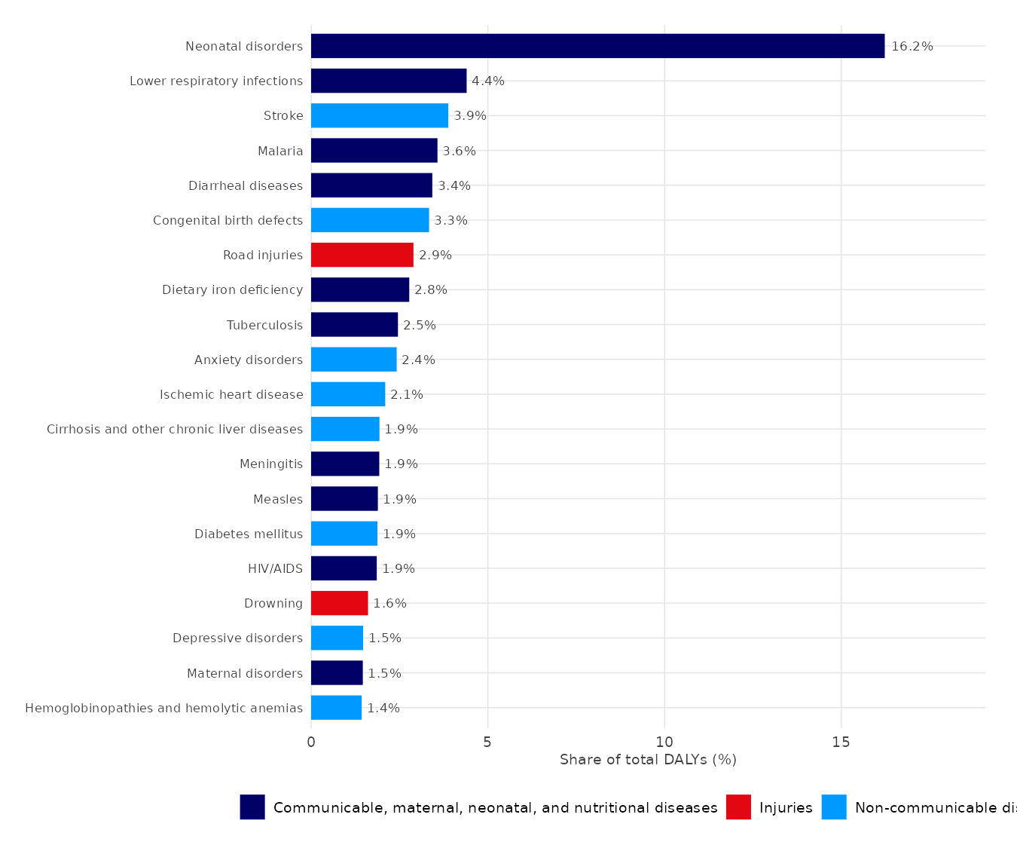
Note: colour marks the Level-1 GBD category (communicable/maternal/neonatal/nutritional, injuries, non-communicable diseases).
Source: IHME, Global Burden of Disease (GBD), Senegal, DALYs 2023.

2.1.2 Intervention architecture
Two intervention lists were assessed against the disease burden: the OneHealth Tool (OHT) and the Disease Control Priorities, 3rd edition (DCP3) list.
The two lists serve different purposes. DCP3 compiles 21 essential packages into an Essential UHC package of 218 interventions; a subset of 108 constitutes a Highest-Priority Package selected for cost-effectiveness, priority for the worst-off, and financial risk protection. OHT is a planning-and-costing inventory of 187 interventions used to estimate resource requirements for the health SDGs in 67 low- and middle-income countries, organized by delivery platform and linked to the Spectrum impact modules (LiST, AIM, TB, malaria). OHT includes an intervention regardless of its cost-effectiveness, since its function is to cost a programme rather than rank it; DCP3 includes an intervention only if it meets its own selection criteria. Differences between the two lists reflect these distinct criteria rather than disagreement on which interventions address the burden.
The Senegal OHT setting records, for each intervention, a target population, a population in need, and a baseline coverage rate, across reproductive and maternal/newborn health, child health, malaria, tuberculosis, HIV/AIDS, nutrition, water and sanitation, non-communicable diseases, mental and neurological disorders, neglected tropical diseases, and adolescent health. It lists 389 interventions. Of these, 382 (98.2%) are matched to a primary GBD cause (GBD 2023, IHME); 90% of DCP3 interventions were similarly matched under GBD 2015, against 92% for OHT under GBD 2023.
Table 2: Mapping of OHT interventions to GBD causes in Senegal, 2023
OHT module | N interventions | N matched to a GBD cause
Child health | 14 | 14
HIV/AIDS | 32 | 30
Immunization | 10 | 10
Malaria | 14 | 14
Maternal/newborn and reproductive health | 67 | 67
Mental, neurological, and substance use disorders | 40 | 40
Neglected tropical diseases | 24 | 24
Non-communicable diseases | 83 | 78
Nutrition | 28 | 28
Tuberculosis | 77 | 77
Source: OneHealth Tool, Senegal settings (MSAS/DPRS); IHME, GBD 2023.
The 382 matched interventions cover 60 of the 176 distinct causes in the GBD nomenclature. Tuberculosis, maternal disorders, and HIV/AIDS together account for 155 of the 382 matches (78, 47, and 30 respectively). Coverage is higher among high-burden causes: 14 of the 20 leading DALY causes have a matched intervention (70%), against 46 of the remaining 156 causes (29.5%). Six of the top-20 causes have no matched intervention on their main GBD cause: congenital birth defects (rank 6, 3.3% of DALYs), road injuries (rank 7, 2.9%), cirrhosis and other chronic liver diseases (rank 12, 1.9%), meningitis (rank 13, 1.9%), drowning (rank 17, 1.6%), and hemoglobinopathies and hemolytic anemias (rank 20, 1.4%) — together 13.1% of total DALY burden. The match is recorded against each intervention’s principal GBD cause only; an intervention with a secondary effect on one of these six causes is not captured by this count.

2.1.3 Financing landscape
Household out-of-pocket spending represented 42% to 51% of current health expenditure across 2022-2023 in Senegal’s national health accounts; 95% of household health spending took the form of direct payment at the point of care, with less than 5% channelled through health insurance contributions.
Budget-share estimates vary by measurement base. The Ministry of Health’s operating budget represented approximately 10% of the state’s operating budget in 2022; budget-execution reporting for 2024 recorded the health sector at 5.8% of total budget execution. The two measures are not equivalent and are reported here separately rather than reconciled.

2.1.4 Resource and cost data
Consumables cost per case is drawn primarily from the OneHealth Tool (OHT) Senegal costing sheet; where OHT does not provide a usable figure, a manual unit-cost entry is used instead. Unlike the effectiveness figures below, cost is a Senegal-specific input throughout this analysis, with no substitution from the cost-effectiveness literature. Effectiveness (DALYs averted per patient) is drawn from the Tufts Cost-Effectiveness Analysis Registry, a multi-country literature database, and, where no usable Tufts ratio exists, from a cross-country health-benefits-package costing tool's own effectiveness figure, matched by intervention name — both literature- or tool-derived rather than measured in Senegal. Health-worker time required to deliver each intervention, and the corresponding workforce capacity (current staff numbers and average annual patient-facing time by cadre), have not yet been collected for Senegal: no local or regional time-and-motion exercise of the kind used elsewhere for this type of analysis is currently available, so Section 3.2's main constrained-optimization results do not yet include a Senegal-specific health-workforce constraint; we report a version using literature-derived workforce figures (Section 3.2) alongside it. The consumables budget we use as the sole resource constraint for the main results in Section 3.2 is a provisional $120 million working value, not yet drawn from an actual government budget record; we will replace it with a confirmed MSAS consumables-budget line item as soon as one is available, at which point every downstream number in Section 3.2 updates automatically.
Table 3: Data sources and model parameters, Senegal HBP cost-effectiveness analysis
Model parameter | Source | Country-specific? | Year | Notes
Cost-effectiveness (DALYs averted per patient) | Tufts Cost-Effectiveness Analysis Registry (primary); Uganda HBP Tool (fallback) | No | Varies by source study | A Tufts ratio is used if its absolute value does not exceed a plausibility bound of 6; where none is usable, the Uganda HBP Tool’s own figure is substituted, matched by intervention name
Eligible population / cases | OneHealth Tool, Senegal settings (MSAS/DPRS) | Yes | 2023 | Cases = target population × population in need × coverage
Unit / consumables cost | OHT Top-20-Causes worksheet, manual entry (primary); OHT drug-and-supply costing sheet (fallback) | Yes | 2023 | No literature or cross-country fallback is used for cost
Health opportunity cost (CET) | Health-opportunity-cost threshold estimation exercise, GBD 2023 disease-burden data, 92 low- and lower-middle-income countries | No | 2026 estimate, applied to 2023 cost and effect data | $485/DALY base case; sensitivity at 50%, 150%, 200%
Health-worker time by cadre | Not collected | — | — | Required for a Senegal-specific constrained-optimization extension (Section 3.2); not present in this run (an illustrative version uses literature-derived workforce data instead)
Workforce capacity by cadre | Not collected | — | — | Same limitation (Section 3.2)
Consumables budget envelope | Model configuration (provisional working value) | Yes (provisional) | 2026 (placeholder) | Used as the budget constraint in the constrained optimization (Section 3.2); $120 million placeholder pending a confirmed MSAS consumables-budget line item
DCEA baseline health index | National healthy life expectancy and urban population share, both placeholder (Section 8); mortality/prevalence weighting fixed at 0.5 | Partial | 2023 (target) | Pending Senegal Continuous DHS 2023 microdata
Monetary year | 2023 USD (OHT); 2026 estimate (CET) | — | Mixed | Not yet harmonized to a single price year across cost and CET sources

2.2 Method

2.2.1 League table construction
Population-in-need (PIN) estimates by intervention, not burden rank alone, are required to translate the burden in Table 1 into service-level targets. The OneHealth Tool reconstructs these figures by combining the demographic group assigned to each intervention with projections from DemProj/AIM/TB. Total cases per intervention are computed as target population × population in need × coverage.
$${Cases}_{i} = {Target population}_{i} × {Population in need}_{i} × {Coverage}_{i}$$
i = the intervention. Target population, population-in-need share, and coverage are all specific to intervention i (OneHealth Tool, Senegal settings).
Burden rank identifies which causes carry the largest share of DALYs; it does not measure the health gain achievable per unit of expenditure. That measure requires an intervention-level cost-effectiveness analysis, built through four sequential filters applied to the 389-intervention OHT master list.
First, an intervention is retained if its primary GBD cause is among the 20 leading causes of DALYs in Senegal (Table 1). 141 of 389 interventions meet this condition; 248 are excluded for not linking to a top-20 cause.
Second, a retained intervention is kept if a unit cost is available — a manual entry in the OHT Top-20-Causes worksheet where supplied, the OHT drug-and-supply costing sheet otherwise. All 141 interventions carrying a top-20 GBD link have a unit cost; none is excluded at this step.
Third, an intervention is kept if an effectiveness figure (DALYs averted per patient) is available. The primary source is the Tufts Cost-Effectiveness Analysis Registry, matched by article and ratio identifier and screened for a plausible magnitude; where no usable Tufts ratio exists, the Uganda HBP Tool’s own DALYs-averted-per-patient figure is substituted, matched by intervention name. Tufts ratios flagged as low-confidence mappings were removed from the source registry ahead of this run. 97 of 141 interventions retain an effectiveness figure; 44 are excluded for lack of one.
Fourth, an intervention is kept if case-volume data are available to compute a total cost and total DALYs averted. 95 of 97 interventions meet this condition and form the league table; 2 are excluded for lack of case-volume data.
Two conditions are recorded as alerts rather than exclusions. Seven of the 389 master-list interventions report a target population of zero; none of the seven reached the league table, each having been excluded at an earlier step for an unrelated reason. Forty-seven of the 95 league-table interventions report a case volume or coverage rate of zero and remain in the league table with zero computed cost and zero DALYs averted, flagged for review rather than removed, since a zero value reflects a coverage or reporting condition rather than an inability to compute a figure.
Figure 2: Intervention funnel, 389 to 95
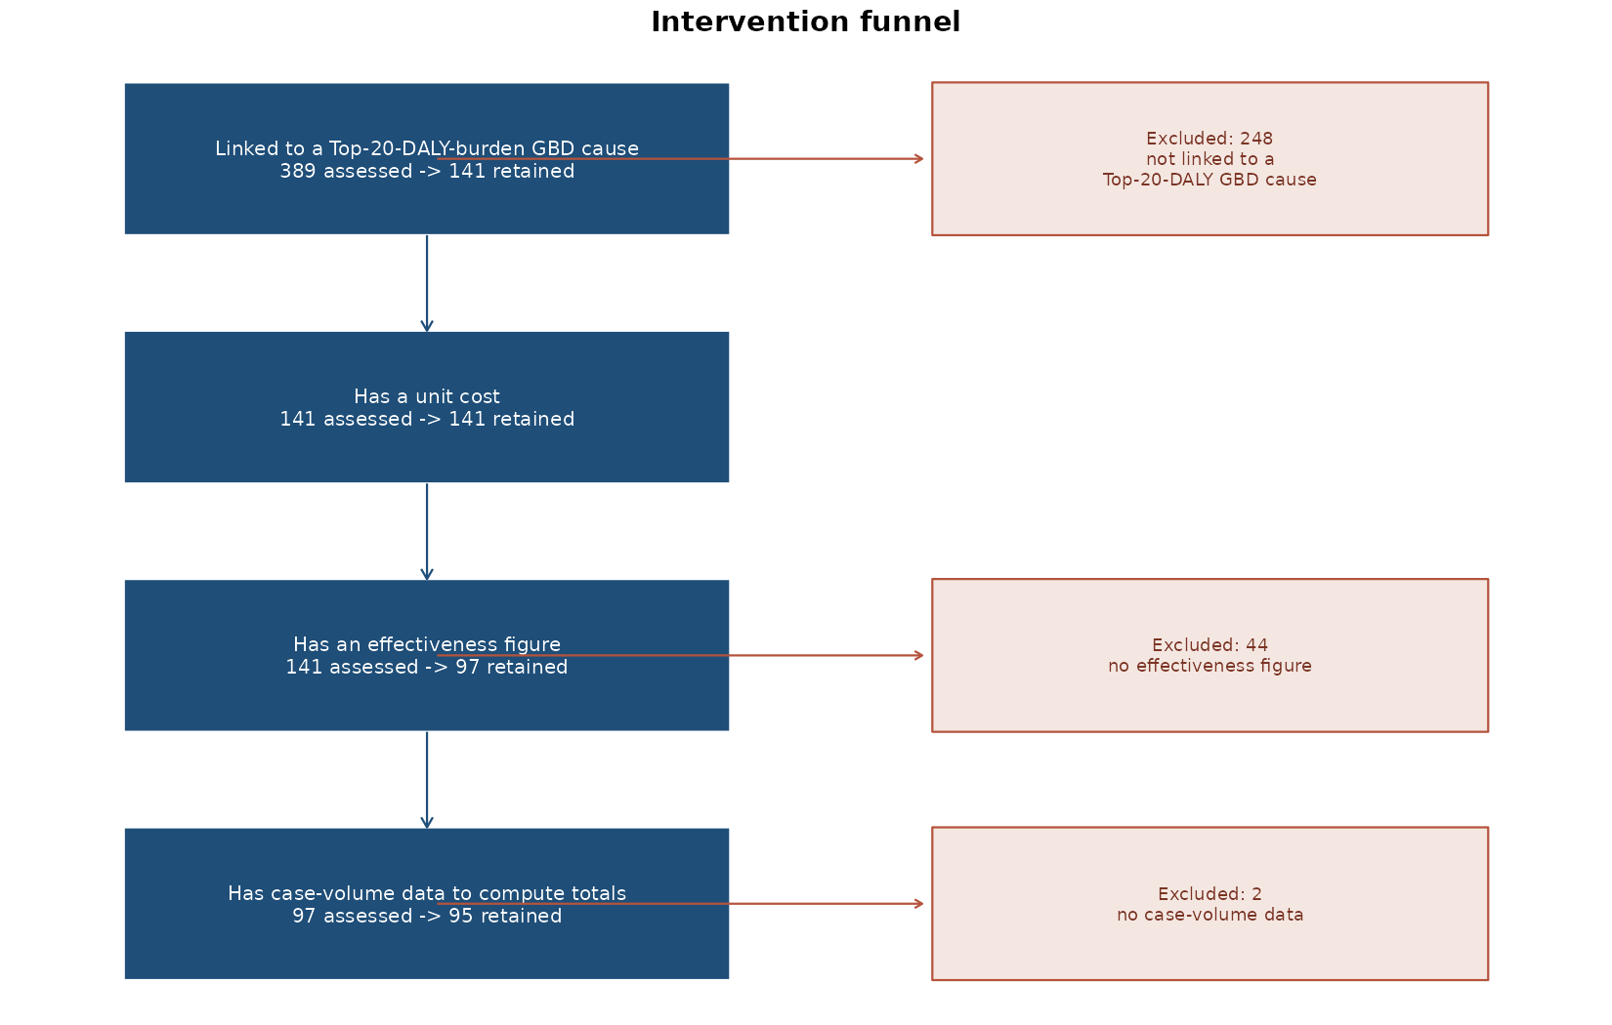

2.2.2 Key metrics and priority-setting method
Cost-effectiveness is assessed at a cost-effectiveness threshold (CET) of $485 per DALY averted, the Senegal-specific reference value used as the base case for this run, with sensitivity scenarios at 50%, 150%, and 200% of that value ($242.50, $727.50, $970).
For each of the 95 league-table interventions, an incremental cost-effectiveness ratio (ICER) is computed as total cost divided by total DALYs averted under full (100%) implementation of its target population; net health benefit (NHB) is computed as DALYs averted minus total cost divided by the CET, separately under full implementation and under each intervention’s own reported (realistic) coverage level. Interventions are ranked by full-implementation NHB, from highest to lowest, without filtering by the sign of that value. This follows the standard net-health-benefit framework for expressing cost in health-equivalent units at a given threshold (Stinnett & Mullahy, 1998; Drummond et al., 2015).
$${ICER}_{i} = \frac{{Total cost}_{i}}{{Total DALYs averted}_{i}}$$
i = the intervention. Total cost and total DALYs averted are both at full (100%) implementation of intervention i's target population.

2.2.3 Constrained optimization
Constrained optimization selects a coverage level for each intervention to maximize net DALYs averted subject to health-system resource constraints, rather than ranking interventions by ICER and filling a budget top-down (with results in Section 3.2). The two methods are mathematically equivalent whenever the only binding constraint is a single linear budget — the case in the budget-only scenario below; they diverge once health-workforce time constraints are added by cadre, which we illustrate below using workforce data from the published literature pending a Senegal-specific source (see Section 4).
We use a provisional consumables budget of $120 million, a working value pending a confirmed MSAS consumables-budget line item; it is not yet expressed in CFA francs or benchmarked against an actual government budget record, and is not yet a policy-ready ceiling. Formally, writing x_i ∈ [0,1] for the coverage share solved for intervention i, n_i for its cases in need, and λ for the CET, the linear program maximizes Σ_i (DALYs_i − Cost_i/λ) × n_i × x_i subject to Σ_i budget-cost_i × n_i × x_i ≤ B, following the mathematical-programming approach to health-resource allocation set out by Stinnett and Paltiel (1996).
$$max \sum_{i}{{DALYs}_{i} − \frac{{Cost}_{i}}{CET} × n_{i} × x_{i}}$$
i = the intervention; x_i ∈ [0,1] = the coverage share the model solves for; n_i = cases in need; CET = the cost-effectiveness threshold.
$$\sum_{i}{{BudgetCost}_{i} × n_{i} × x_{i}} ≤ B, 0 ≤ x_{i} ≤ 1$$
BudgetCost_i = the consumables-cost component of intervention i's price (drugs/commodities only); B = the consumables budget.

2.2.4 Distributional cost-effectiveness analysis
The distributional cost-effectiveness analysis (DCEA) follows the standard equity-stratified DCEA methodology, applied to the 86 interventions affordable at the $485 CET, for two equity-relevant stratifiers: wealth quintile and urban/rural residence. For each intervention, the eligible and treated population is apportioned to each group using a disease-prevalence share and a coverage/uptake indicator; the resulting DALYs averted (direct benefit) is netted against an opportunity cost apportioned by each group’s estimated share of health-system spending, giving a net benefit by group. Inequality in the resulting health distribution is summarized by an Atkinson equally-distributed-equivalent (EDE) health index, computed separately for each stratifier at an inequality-aversion parameter of ε=10, with a sensitivity range of ε=2 to ε=25. This follows the standard distributional cost-effectiveness analysis approach (Cookson, Griffin, Norheim & Culyer, 2021; Asaria, Griffin & Cookson, 2016), and its Atkinson equally-distributed-equivalent inequality index (Atkinson, 1970).

3. Results / Findings

3.1 Cost-effectiveness / priority setting
At the $485 base case, 86 of 95 interventions have an ICER at or below the threshold, implying a full-implementation budget of $195.7 million. Seven interventions have an ICER above threshold and two have an undefined ICER (zero DALYs averted under full implementation); all nine remain visible in the league table with a negative or undefined net health benefit rather than being removed.
The five interventions ranked highest by full-implementation net health benefit are malaria treatment for children aged 0-4 (ICER $0.56 per DALY averted, 53.3 million DALYs net benefit), uterotonics for postpartum hemorrhage (ICER $0.05, 4.0 million), the pneumococcal vaccine (ICER $2.55, 1.8 million), and basic and intensive psychosocial treatment with anti-depressant medication for anxiety disorders, tied (ICER $0.76 each, 1.3 million each).
Net health benefit, as used in this note, follows the standard net-DALYs-averted convention used in the constrained-optimization health-benefits-package literature: gross DALYs averted (the league table’s “Total DALYs averted, full implementation” column) net of the health opportunity cost of the resources the intervention consumes. The two figures are kept as separate columns throughout the league table rather than the net figure alone, so a reader can recover the gross health effect independently of the CET used to compute its opportunity cost.
$${NHB}_{i} = {DALYs}_{i} − \frac{{Cost}_{i}}{CET}$$
i = the intervention. DALYs_i and Cost_i are intervention i's own gross DALYs averted and total cost; CET is the cost-effectiveness threshold ($485/DALY averted, the Senegal reference value used in this note).
Figure 3: Efficiency frontier: DALYs averted per $1,000 spent, all costed interventions ordered by ICER, coloured by cost-effectiveness at the CET
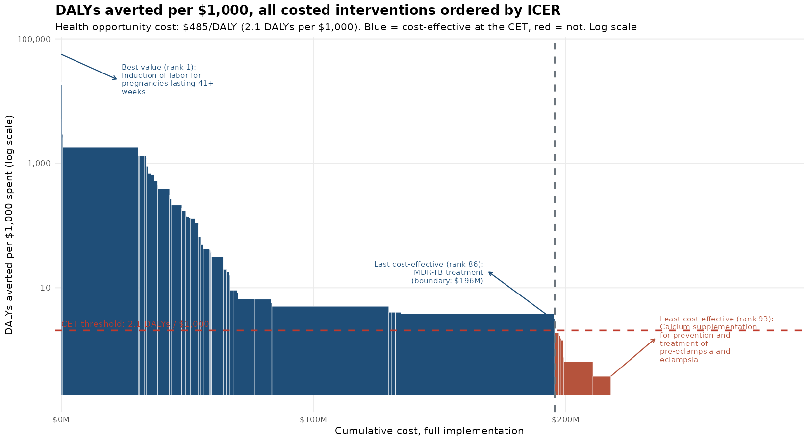
Figure 4: Interventions ranked by net health benefit, with cumulative spend
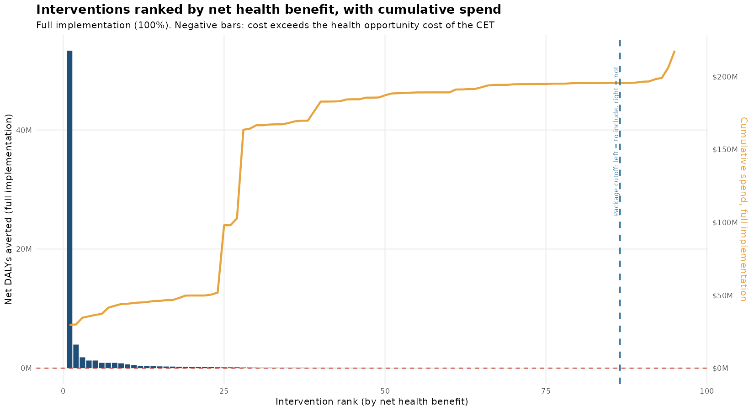
Raising the CET from $242.50 to $970 widens the affordable package from 76 to 90 of the 95 interventions and the corresponding full-implementation budget from $129.8 million to $199.0 million; total DALYs averted under full implementation rises from 71.2 million to 71.4 million across that range, a 0.4% change against a budget change of 53.3%. The marginal interventions admitted by a higher threshold contribute disproportionately little additional health relative to the budget already committed to the interventions affordable at $242.50.

3.2 Constrained optimization
Of the 93 league-table interventions with a computable cost, effectiveness, and non-zero case-volume figure, 86 have a positive net health benefit and would be included with no budget constraint at all (Table 4), at a highest ICER of $337.16 and 71.4 million total DALYs averted — the same count found cost-effective by ICER ranking in Section 3.1. Applying the $120 million provisional budget restricts the optimal package to 76 interventions, exhausting 100% of the budget, at a highest included ICER of $198.93; net DALYs averted are essentially unchanged relative to the unconstrained case (70.9 vs 71.0 million net DALYs, 71.1 vs 71.4 million total DALYs averted). An additional $1,000 added to the provisional budget would avert a further 2.97 net DALYs at the margin.
Table 4: Summary of results from the constrained optimization: no budget constraint vs the provisional $120 million budget
Metric | No budget constraint (CET only) | Provisional budget ($120M) | With health-workforce constraints
Number of interventions with positive net health benefit | 86 | 86 | 61
Number of interventions in the optimal package | 86 | 76 | 46
Net DALYs averted | 71,026,613 | 70,880,811 | 68,913,976
Total DALYs averted | 71,430,098 | 71,128,233 | 69,161,399
Highest ICER in the optimal package ($) | 337.16 | 198.93 | 198.93
Percentage of consumables budget required | — | 100% | 100%
Doctor/Clinical officer capacity used (%) | - | - | 49.3%
Nursing staff capacity used (%) | - | - | 21.7%
Pharmaceutical staff capacity used (%) | - | - | 100%
Laboratory staff capacity used (%) | - | - | 2.1%
Dental staff capacity used (%) | - | - | 0%
Mental health staff capacity used (%) | - | - | 100%
Nutrition staff capacity used (%) | - | - | 0%
Diagnostic imaging staff capacity used (%) | - | - | 0%
The health-workforce-constrained scenario retains 46 of the 68 optimizable interventions (against the same $120 million budget), a smaller package than the budget-only scenarios because pharmaceutical and mental-health staff time — not money — become the binding constraint, at 100% of the assumed capacity; doctor/clinical-officer and nursing time remain under half used. Laboratory, dental, nutrition and diagnostic/radiography staff are left out of Figure 5 altogether: none of the 68 matched interventions carries any recorded need for them in the reference data, so they would show a fixed 0% in every scenario rather than an optimization result. This bottleneck pattern is the kind a budget-only analysis cannot show at all, and is the main reason to extend this method to Senegal-specific workforce data once available.
By disease program, the provisional-budget package is concentrated in tuberculosis (27 of 34 candidate interventions, 79%) and maternal/newborn and reproductive health (18 of 20, 90%), with malaria and nutrition retained at only half of their candidate interventions (Table 5); the corresponding consumables spend is led by non-communicable diseases (44.8% of the provisional budget) and child health (29.8%), with every other program below 7% (Figure, below).
Table 5: Rate of inclusion of interventions from different disease programs in the optimal package
Program | Interventions considered | No budget constraint: included | No budget constraint: % | Provisional budget: included | Provisional budget: %
Child health | 10 | 9 | 90% | 9 | 90%
HIV/AIDS | 6 | 5 | 83% | 5 | 83%
Immunization | 3 | 3 | 100% | 3 | 100%
Malaria | 2 | 2 | 100% | 1 | 50%
Maternal/newborn and reproductive health | 20 | 19 | 95% | 18 | 90%
Mental, neurological, and substance use disorders | 6 | 6 | 100% | 6 | 100%
Non-communicable diseases | 6 | 5 | 83% | 4 | 67%
Nutrition | 6 | 3 | 50% | 3 | 50%
TB | 34 | 34 | 100% | 27 | 79%
Grand total | 93 | 86 | 92% | 76 | 82%
Figure 5: Health-system resource use by program: (a) budget only, (b) budget + health-workforce constraints
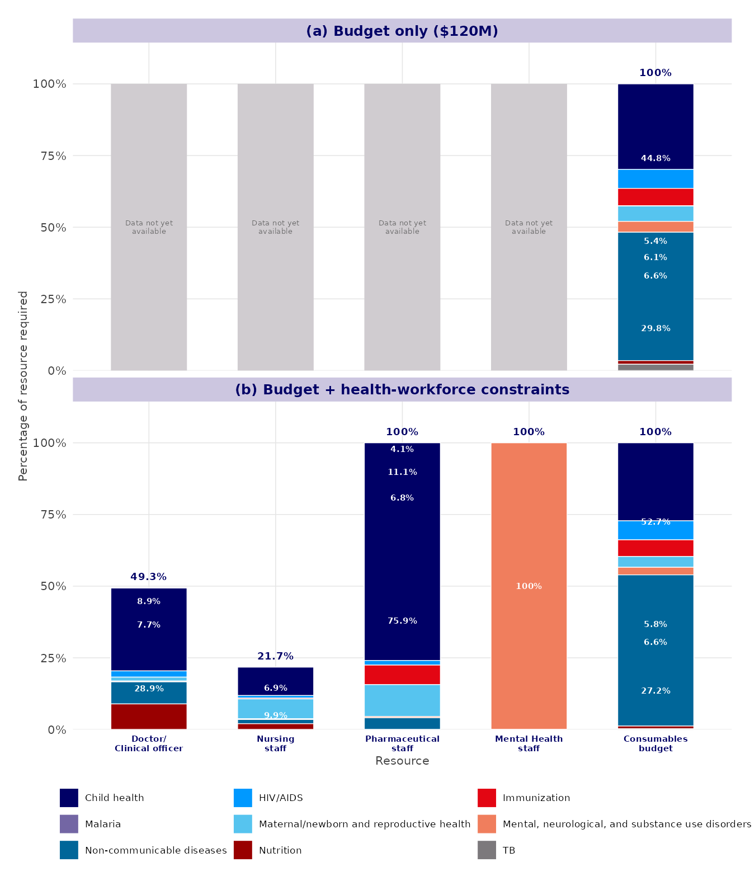
Note: percentage of each resource required, by disease program. Only the four health-worker cadres with a recorded need among the matched interventions are shown (laboratory, dental, nutrition and diagnostic/radiography staff are omitted - see main text). Panel (a) shows those four cadres as “not yet available” (no workforce constraint applied in that scenario); panel (b) applies workforce constraints using literature-derived data (see footnote above).
Figure 6: Marginal value of investing $1,000 in different health-system resources: (a) budget only, (b) budget + health-workforce constraints
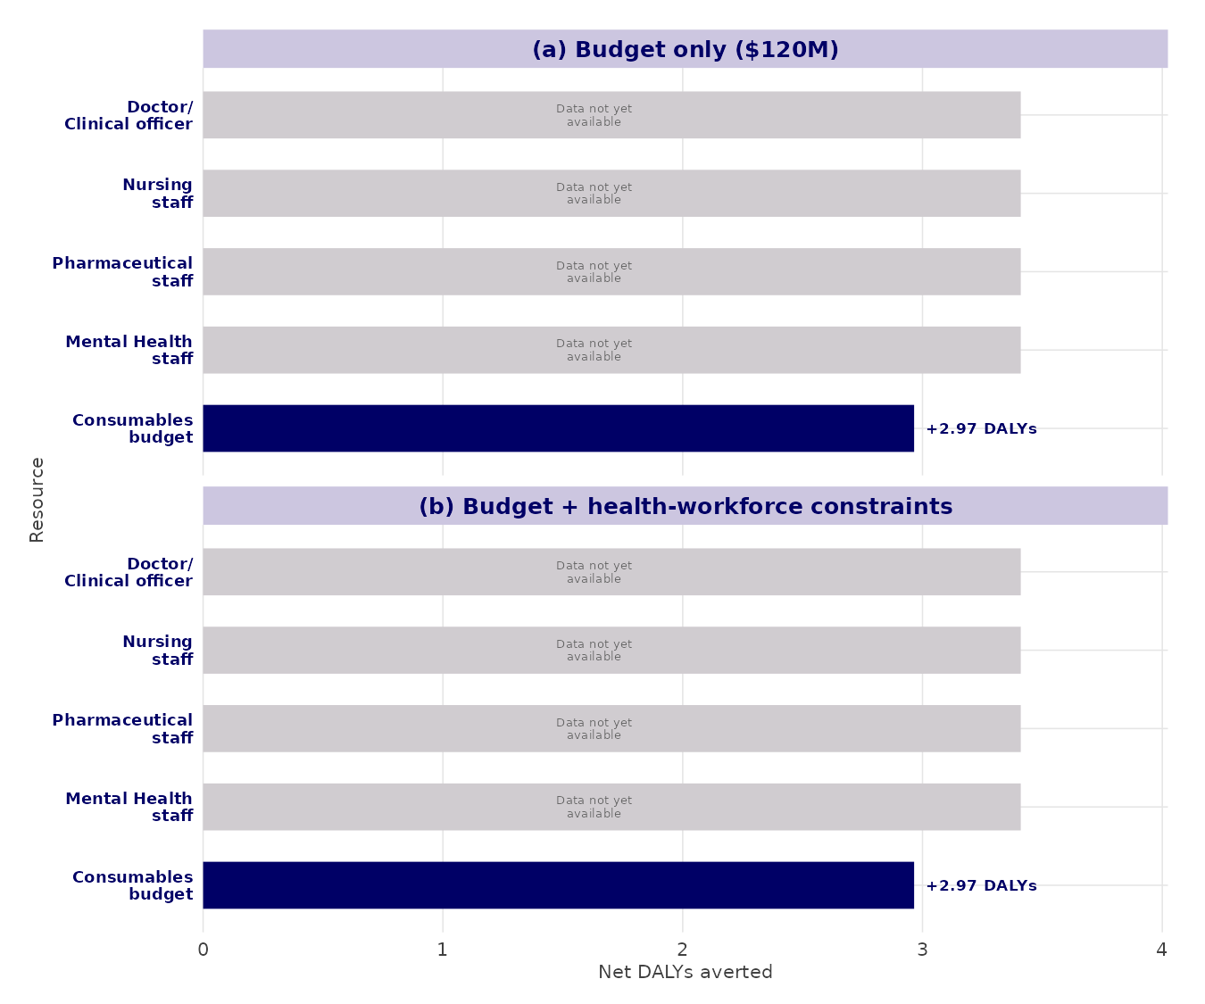
Note: additional net DALYs averted from $1,000 more of each resource. Health-worker-cadre values are not shown in either panel: converting $1,000 into cadre time requires a salary figure by cadre, not yet available for this exercise.
Scenarios (i)-(ii) reflect a single financial constraint only, with no health-workforce time or capacity constraint by cadre, no task-shifting scenario, and no substitutable or complementary intervention pairs identified (see Section 4 for the full list of gaps and the data needed to close them). Scenario (iii) illustrates the workforce-constrained extension using literature-derived data, pending a Senegal-specific workforce source. The $120 million budget figure is provisional and we will revise it once a confirmed MSAS consumables-budget line item is available; every downstream number in this section moves automatically when we do.

3.3 Distributional cost-effectiveness analysis (DCEA)
Under full implementation, net benefit rises with wealth quintile from 10.0 million DALYs in the poorest quintile (q1) to 19.3 million in the fourth quintile (q4), before falling to 14.0 million in the richest quintile (q5). By residence, net benefit is 36.7 million DALYs in urban areas against 34.3 million in rural areas.
The Atkinson index records a 9.5 million DALY-equivalent widening of wealth-quintile inequality and a 9.5 million DALY-equivalent narrowing of urban/rural inequality from the package, at ε=10. The package’s net-benefit gradient across wealth quintiles — lowest at the poorest quintile, highest at the fourth — is the source of the wealth-quintile result; its narrower urban/rural gap (36.7 against 34.3 million) is the source of the residence result.
Figure 7: Health equity impact plane, wealth quintile
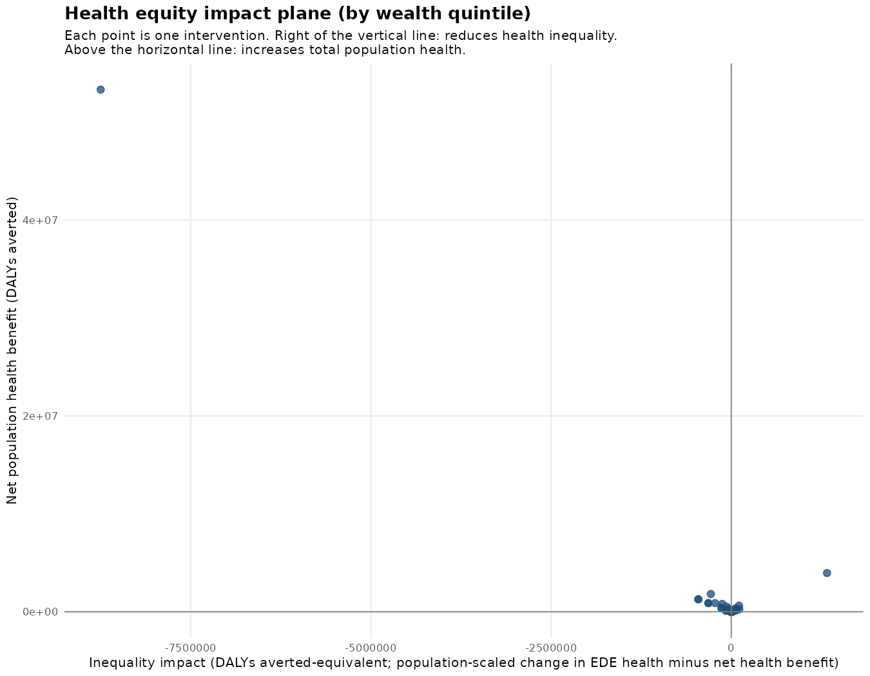
Figure 8: Health equity impact plane, residence
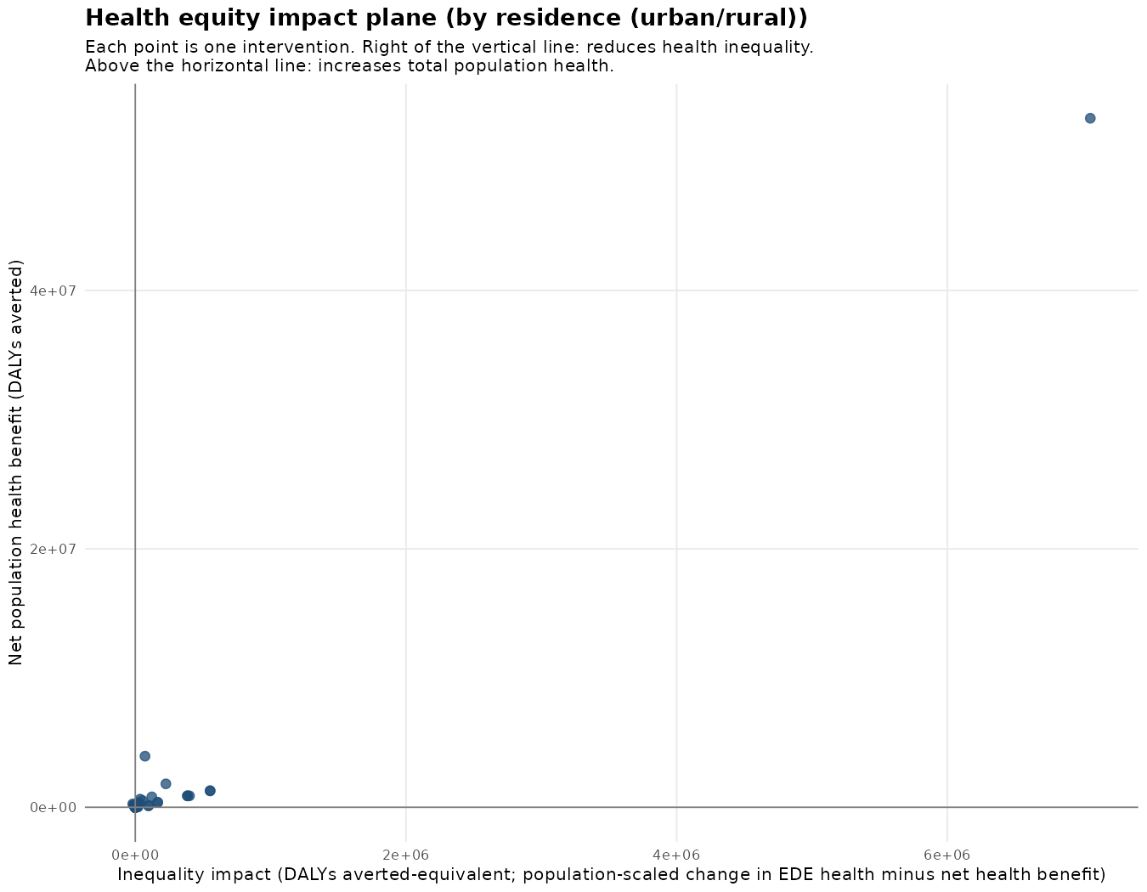
Four parameters underlying this analysis are held at a placeholder value pending Senegal-specific data: national healthy life expectancy (58 years, to be verified against WHO Global Health Estimates), national urban population share (39.6%, proxied from the EDS-Continue 2023 under-5 sample composition rather than a full-population census figure), the weight given to a mortality-based versus a prevalence-based component of the baseline health index (set at 0.5), and the opportunity-cost rate by wealth quintile and residence (no Senegal-specific estimate found in the DCEA preparatory workbook; the national CET is used uniformly across groups in its place).

4. Limitations
The four-filter selection in Section 2.2.1 is sequential: an intervention excluded at the GBD-cause or cost step is not tested against the effectiveness or case-volume criteria that follow it. An intervention excluded early for lack of cost data is not re-examined once effectiveness data become available.
Effectiveness figures for interventions without a Senegal- or Uganda-specific estimate are drawn from the Tufts Cost-Effectiveness Analysis Registry, a multi-country literature database; the resulting ICER reflects the cost and effect context of the source study rather than a Senegal-specific trial.
The DCEA baseline health index and opportunity-cost allocation rely on the four placeholder parameters listed in Section 2.1.4, pending access to Senegal Continuous DHS 2023 microdata (Household, Individual, Births, Children’s, and Siblings recodes) requested for this purpose.
We now include a first, budget-only version of package selection under a fixed consumables-budget envelope (Section 3.2), using a provisional USD working value rather than the CFA-franc government budget record specified in the EasyHealth WP3 analysis plan (Section 3 of the analysis plan template), alongside a workforce-constrained version using literature-derived data (Section 3.2). Still not included: Senegal-specific health-workforce capacity constraints by cadre, needed for a Senegal-specific version of the full constrained-optimization formulation (Section 7 of the analysis plan template); probabilistic sensitivity analysis with joint parameter uncertainty (Section 5 of the analysis plan template); and pre-registration of the analysis plan with MSAS sign-off (Section 8 of the analysis plan template). We propose these as the next iteration's scope, once we agree the CET base value, unit-cost source hierarchy, DCEA baseline parameters, and the provisional consumables budget confirmed in this note.
A parallel package-definition process is under way in Senegal: a technical working group has produced a facility-level service package (poste de santé to EPS3) for the SICRM, validated against the national health facility service-norms document (Tome 3 of the Carte Sanitaire) and a qualitative financial-protection criterion, rather than against cost-effectiveness. A preliminary correspondence between that package and this note’s league table is in progress; a positioning note — including a gap both frameworks currently share in their coverage of stroke, ischemic heart disease, cancer, and injury — will follow separately ahead of the planned Senegal field visit.
Two further modelling choices carry over unchanged from the ICER-ranking method and are not yet tested: interventions are treated as independent, so an intervention’s cost and effect do not depend on which other interventions are included in the package; and no substitutable or complementary intervention pairs are identified, so two interventions addressing the same need are both retained in the league table at their full computed value rather than capped at a shared eligible population.

References
Asaria, M., Griffin, S., & Cookson, R. (2016). Distributional cost-effectiveness analysis: a tutorial. Medical Decision Making, 36(1), 8-19.
Atkinson, A. B. (1970). On the measurement of inequality. Journal of Economic Theory, 2(3), 244-263.
Cookson, R., Griffin, S., Norheim, O. F., & Culyer, A. J. (Eds.). (2021). Distributional Cost-Effectiveness Analysis: Quantifying Health Equity Impacts and Trade-offs. Oxford University Press.
Drummond, M. F., Sculpher, M. J., Claxton, K., Stoddart, G. L., & Torrance, G. W. (2015). Methods for the Economic Evaluation of Health Care Programmes (4th ed.). Oxford University Press.
Stinnett, A. A., & Mullahy, J. (1998). Net health benefits: a new framework for the analysis of uncertainty in cost-effectiveness analysis. Medical Decision Making, 18(2_suppl), S68-S80.
Stinnett, A. A., & Paltiel, A. D. (1996). Mathematical programming for the efficient allocation of health care resources. Journal of Health Economics, 15(5), 641-653.

Appendix: Accompanying files
The full 389-intervention funnel log, the 95-intervention league table, the Table 4-8 cost-effectiveness detail, and the full DCEA output (distribution by intervention, per-group summaries, inequality metrics, and sensitivity analysis) are provided as separate Excel workbooks: league_table_final.xlsx, funnel_tracking.xlsx, detailed_findings.xlsx, and dcea_results.xlsx. The constrained-optimization results (Tables 4-5 in Section 3.2, and the per-intervention detail behind them) are provided in optimization_results.xlsx, and the accompanying supplementary tables (intervention-level parameters, scenario outcomes, and the placeholder structure for Senegal-specific workforce inputs) in optimization_supplementary_tables.xlsx.

Agence Nationale de la Statistique et de la Démographie (ANSD), 5e Recensement Général de la Population et de l’Habitat (RGPH-5), Rapport provisoire, chapitre 1, juillet 2024.
ANSD, Enquête Démographique et de Santé Continue (EDS-Continue) 2023, Rapport des indicateurs clés; DHS Program, Senegal Continuous DHS 2023 (FR368).
Institute for Health Metrics and Evaluation (IHME), Global Burden of Disease, Senegal extract, cumulative DALYs 2023.
Jamison D. et al. (2018), Disease Control Priorities, 3rd edition.
Stenberg K. et al. (2017), OneHealth Tool manual, Avenir Health/WHO.
ANSD (2026), Situation Économique et Sociale du Sénégal, Ed. 2024.
ANSD/MSAS workforce data.
Ministère de la Santé et de l’Action Sociale (MSAS), Plan National de Développement Sanitaire et Social (PNDSS) 2019-2028, ligne 52.
Comptes Nationaux de la Santé, MSAS.
ANSD, Situation Économique et Sociale du Sénégal, édition 2019 (publiée janvier 2022), section Santé.
Ministère des Finances et du Budget, Rapport d’exécution budgétaire, deuxième trimestre 2024.
Alwan A. et al. (2024), Ten Steps for Setting the Essential Package of Health Services in Pakistan.
This is an adjustable model parameter (not a fixed feature of the method): it can be revised as more precise information becomes available, and every downstream figure in this section updates automatically when it is.
This is an adjustable model parameter (not a fixed feature of the method): it can be revised as more precise information becomes available, and every downstream figure in this section updates automatically when it is.
This is an adjustable model parameter (not a fixed feature of the method): it can be revised as more precise information becomes available, and every downstream figure in this section updates automatically when it is.
Health-worker time-per-case and workforce-capacity figures for this scenario are drawn from the published literature behind this project's external validation exercise, not measured in Senegal - the same source and intervention-name crosswalk already used for Senegal's own effectiveness fallback (Section 2.1.4). 68 of the 93 optimizable interventions have a matching name in that source; the scenario is scoped to that subset.

