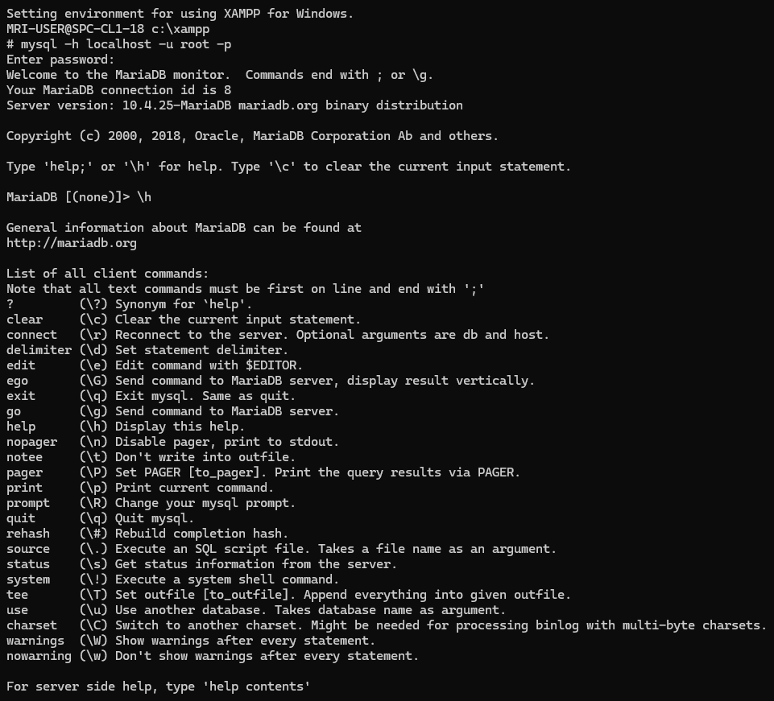
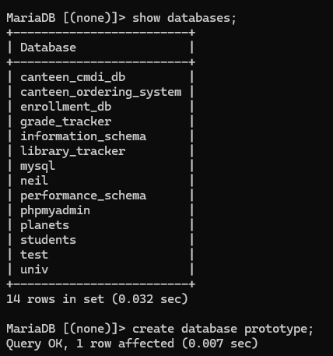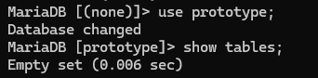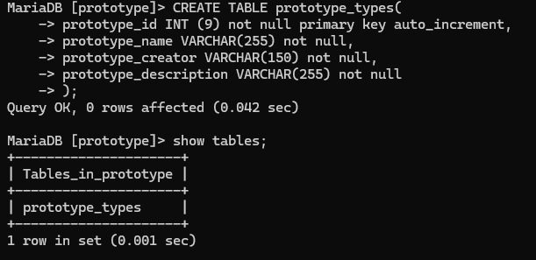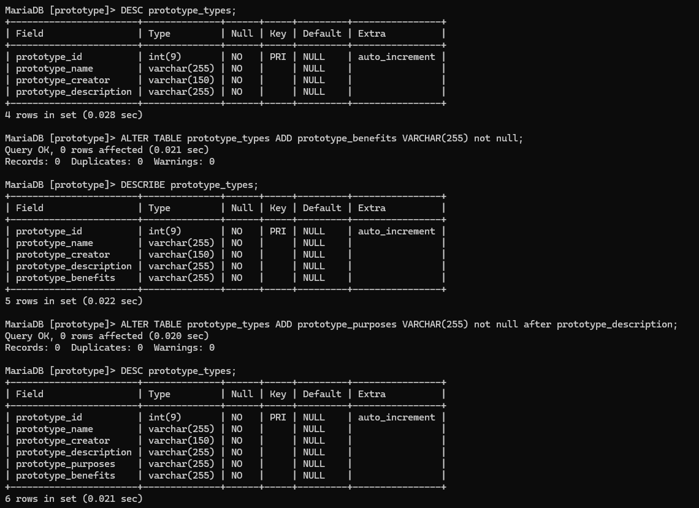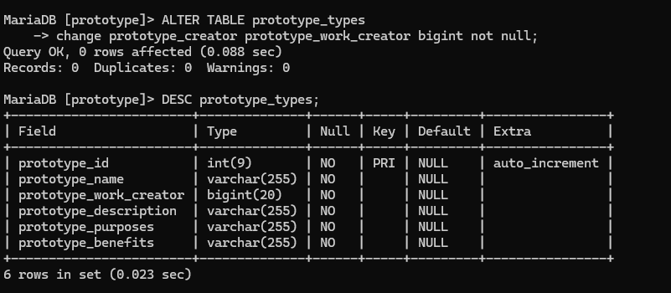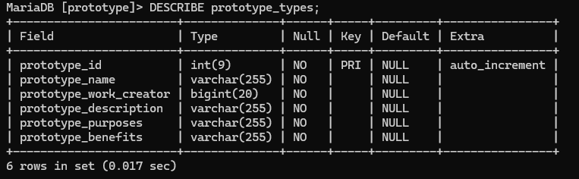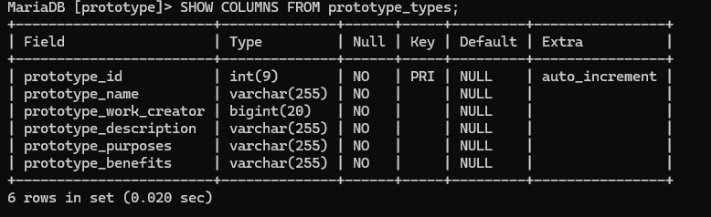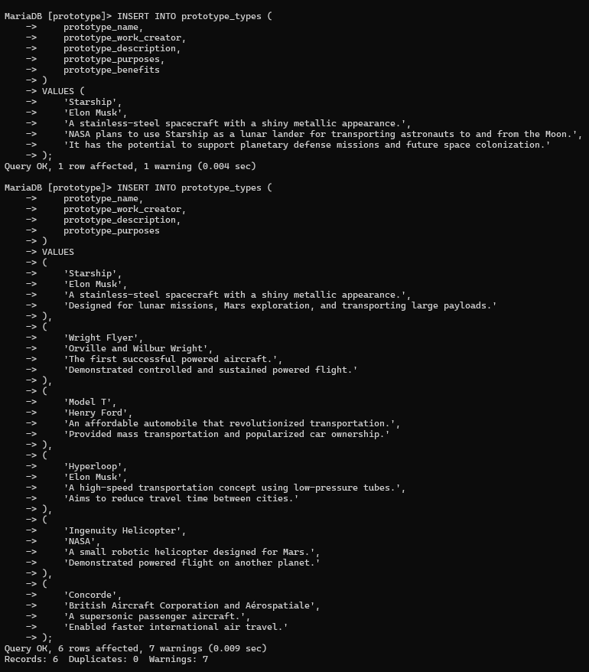
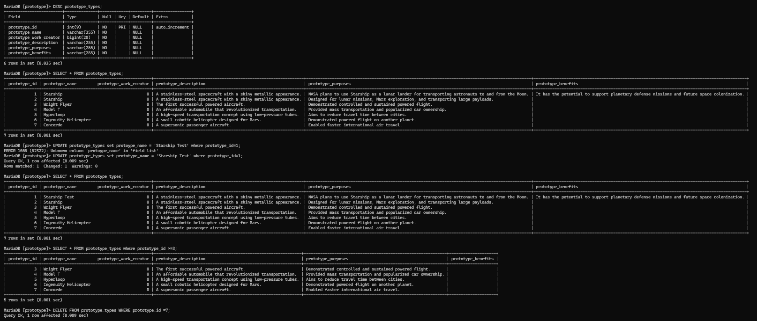

PROTOTYPE DATABASE MANAGEMENT SYSTEM USING MARIA DB ( XAMPP )
Made by: Prince Edward Guevara

Section: Indonesia

STEP-BY-STEP DOCUMENTATION GUIDELINES:
STEP 1: Open XAMPP Shell and Connect to Maria DB
Open XAMPP Control Panel and click Shell. Execute: mysql -h localhost -u root -p. When asked for a password, press “Enter” if no password is configured. Then type \h to display MariaDB help commands.

STEP 2: Display Existing Databases
Execute SHOW DATABASES; In display all databases available in MariaDB.
STEP 3: Create the Prototype Databases
Execute CREATE DATABASE prototype; to create a new database.

STEP 4: Select the Database
Execute USE prototype; to make it the active database.

STEP 5: Verify Tables
Execute SHOW TABLES; and observe that the database is empty.

STEP 6: Create the Table
Create prototype_types with ID, name, creator, and description fields.

STEP 7: Display Table Structure

Use DESC prototype_types; to verify the columns.

STEP 8: Add New Columns

Use ALTER TABLE to add prototype_benefits and prototype_purposes.
STEP 9:

