Revision History
Date | Version | Description | Author
06/10/2021 | 1.0 | Overview and abbreviations parts filled. Completed sections from 2.1 to 3.1. | Gufran Yeşilyurt  Murat Can Altun  Alanur Bilgili  Damla Tütüncü  Kaan Yılmaz  Görkem Öçmen
07/10/2021 | 1.1 | Gantt chart, risk analysis and risk planning tables are added. | Gufran Yeşilyurt  Murat Can Altun  Alanur Bilgili  Damla Tütüncü  Kaan Yılmaz  Görkem Öçmen
08/10/2021 | 1.2 | Document is done. | Gufran Yeşilyurt  Murat Can Altun  Alanur Bilgili  Damla Tütüncü  Kaan Yılmaz  Görkem Öçmen

TABLE OF CONTENTS

Revision History 1
1 Identification 3
1.1 Document overview 3
1.2 Abbreviations 3
1.2.1 Abbreviations 3
1.3 References 3
1.3.1 Project References 3
2 Software Development Activities 3
2.1 Software development process 3
2.1.1 Overview of process phases 3
2.1.2 Technical documentation 4
2.1.3 Deliverables 4
2.2 Software development tools 4
2.2.1 Workstation 4
2.2.2 Requirements management and documentation 4
2.2.3 Software Design 4
2.2.4 Coding and automated tests 4
2.2.5 Configuration management 4
2.3 Software development rules and standards 4
3 Responsibilities 5
3.1 Activities and responsibilities 5
4 Risk Assessment 5
4.1 Risk Analysis 6
4.2 Risk Planning 6

Identification

Document overview

This document contains the software development plan of software Pheria: A Miserable Adventure.

Pheria: A Miserable Adventure is a desktop-based game that allows players to create characters such as wizard, rogue, warrior, and druid. Players can also become designers. They can write their own stories, or they can choose the suitable one for them.

Abbreviations

Abbreviations

PAMA: Pheria: A Miserable Adventure
UML: Unified Modeling Language
IDE: Integrated Development Environment
JDK: Java Development Kit
SRS: Software Requirement Specification
STP: Software Test Plan
SDD: Software Design Document
STR: Software Test Report

References

Project References

# | Document Identifier | Document Title

Software Development Activities

The section lists and describes the software development activities of PAMA software development project.

Software development process

This is a course project, which adopts the waterfall model as the software development process.

Overview of process phases

The software development process for the project will be composed of the following phases:
- Planning
- Requirements Analysis
- Design
- Implementation
- Testing and Analysis

These phases will follow each other sequentially, where each phase starts just after the completion of the previous one. The following Gantt chart depicts the planned start date and duration for the phases.

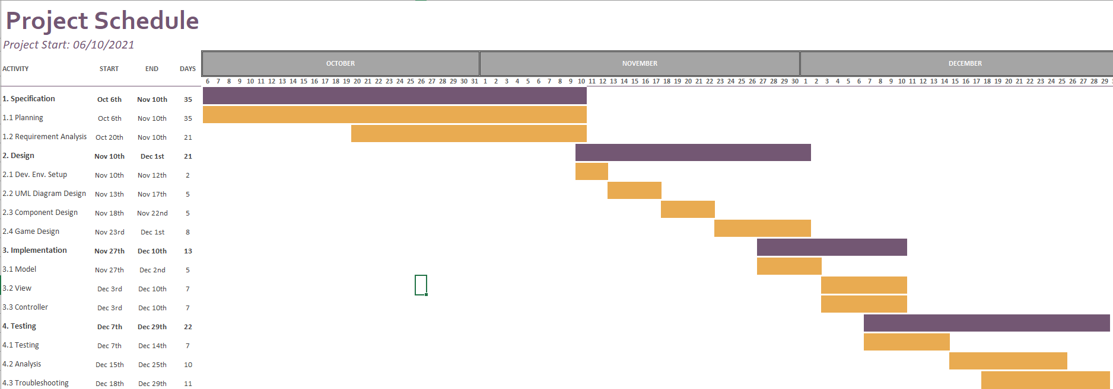

Technical documentation

The following documentation is produced during the software development phases:
- Software specification: SRS, STP
- Software detailed conception: SDD
- Software tests phases : STR
- Software analysis: SAR

Deliverables

The following items will be delivered at the end of the process:
- Technical documentation as outlined in Section 2.1.2
- Software and its configuration files

Software development tools

Workstation

6 laptop computers with following configuration
- Intel® Core™ i7-11800H CPU, 4.60 GHz, 32 GB RAM Windows 10
- Ryzen 9 3900x CPU, 3.8 GHz, 16 GB RAM, Windows 10
- Intel® Core™ i7-6700HQ CPU, 3.5 GHz, 16GB RAM, Windows 10
- Intel® Core™ i7-6920HQ, 2.90GHz, 32 GB RAM, Windows10
- Intel® Core™ i5, 1.40GHz, 8 GB RAM, macOS Big Sur 11.4
- Intel® Core™ i7-8550U, 1.80GHz, 16 GB RAM, Windows10

Requirements management and documentation

- Microsoft Word
- Discord
- Microsoft Excel

Software Design

- Argo for UML Diagram
- Java Swing Library for GUI Design

Coding and automated tests

- Java JDK 17
- JUnit 5
- IntelliJ IDEA v2021.2

Configuration management
GitHub will be used for software configuration management and tracking issues regarding the software development. A public repository will be created for this purpose.

Software development rules and standards
UML will be used for software design documentation.

Main coding language of the project is Java. Coding conventions of Java can be found at: http://www.oracle.com/technetwork/java/codeconvtoc-136057.html

Responsibilities

Activities and responsibilities

Activity | Responsibility | Comment
Project management | Gufran Yeşilyurt | Responsible for project progress and making sure that project should finish in a timely manner.
Configuration tools management | Gufran Yeşilyurt | Being admin in GitHub account of the project.
Setting up the Development tools | Görkem Öçmen | Making sure that everyone has necessary development tools.
GUI | Murat Can Altun, Damla Tütüncü, Kaan Yılmaz | Responsible for the GUI Design and development of the project.
Controller | Görkem Öçmen, Gufran Yeşilyurt, Alanur Bilgili | Responsible of combining the parts of the functions and GUI.
Model | Gufran Yeşilyurt, Alanur Bilgili | Drawing the UML Diagram and creating the initial classes.
Storyline & Game Design | Gufran Yeşilyurt, Damla Tütüncü, Murat Can Altun, Kaan Yılmaz | Designing game mechanics and writing storyline of chapters.

Risk Assessment

Risk Analysis

Risk | Probability | Effects
The time needed to develop the software could be underestimated. | High |  | Serious
Software tools cannot work together in an integrated way. | High |  | Tolerable
Any group member could be ill or unavailable. | High |  | Tolerable
Any group member could withdraw the course. | Moderate |  | Serious
Lack of adjustability for requirements change. | Low |  | Tolerable

Risk Planning

Risk | Strategy
Time Problems | Develop a more organized plan.
Software Problems | Change for compatible software.
Staff Problems | Reorganize the team by giving each member new tasks.
Requirement Changes | Dividing code into versions so that it can be recoverable.

http://www.github.com
http://www.uml.org/ 3 https://www.jetbrains.com/idea 4 https://junit.org/junit5 5 https://www.oracle.com/java/technologies/javase/jdk17-archive-downloads.html

