Revision History
Date | Version | Description | Author
30/10/2021 | 1.0 | Added the introduction part. | Kaan Yılmaz  Murat Can Altun
31/10/2021 | 1.1 | Edited the introduction part and added user requirement specifications | Gufran Yeşilyurt
01/11/2021 | 1.2 | Added Sequence Diagram | Görkem Öçmen
01/11/2021 | 1.3 | Added Activity and Use-Case Diagrams | Damla Tütüncü
01/11/2021 | 1.4 | Added System Architecture Diagram | Alanur Bilgili

TABLE OF CONTENTS
Revision History 1
1 INTRODUCTION 3
1.1 Document overview 3
1.2 System overview 3
1.3 Abbreviations 3
1.4 References 3
1.5 Conventions 3
2 REQUIREMENTS 4
2.1 User Requirements Specification 4
2.2 System Architecture 5
2.3 Use Cases and Usage Scenarios 5
2.4 System Requirements Specification 5

INTRODUCTION

Document overview

This document presents the software requirements specifications of PAMA software development project. It describes functional requirements, quality requirements, constraints, use cases, and usage scenarios. It also provides an overview of the system architecture.

System overview
Pheria: A Miserable Adventure is a desktop-based game that allows players to create characters such as wizard, rogue, warrior, and druid. Players can also become designers. They can write their own stories, or they can choose the suitable one for them.

Abbreviations
PAMA: Pheria: A Miserable Adventure
UML: Unified Modeling Language
GUI: Graphical User Interface
SRS: Software Requirement Specification
STP: Software Test Plan
SDP: Software Development Plan

References

# | Document Identifier | Document Title
[R1] | PAMA-SDP-2 | Software-Development-Plan
[R2] | PAMA-SRS-1 | Software-Requirements-Specifications

Conventions
Requirements listed in this document are constructed according to the following structure:

SRS-PAMA-001
Description of PAMA-001 requirement

Every system requirement id includes the id of the corresponding user requirement as a prefix.

SRS-PAMA-001.1
Description of PAMA-000.1 system requirement, which is related to the user requirement PAMA-000.1

REQUIREMENTS

User Requirements Specification

SRS-PAMA-001
PAMA shall validate that the user can see GUI.

SRS-PAMA-002
PAMA shall provide a Create a New Character button.

SRS-PAMA-003
PAMA shall enable the user to view the stories currently available to play.

SRS-PAMA-004
PAMA shall ensure that the user’s character meets the requirements of the story that the user wants to play.

SRS-PAMA-005
PAMA shall give the user the ability to browse between story, character, inventory pages while playing the game.

SRS-PAMA-006
PAMA shall provide an inventory button to view character equipment.

SRS-PAMA-007
PAMA shall give the user the ability to choose an option to proceed with the storyline.

SRS-PAMA-008
PAMA shall provide a character button that can be used to spend skill points.

SRS-PAMA-009
PAMA shall give the user the ability to write a new storyline.

SRS-PAMA-010
PAMA shall ensure that the user can play his/her own story if the game is not closed after the story is written.

SRS-PAMA-011
PAMA shall give the user the ability to fight the encounters.

SRS-PAMA-012
PAMA shall give the user the ability to trade with the traders.

System Architecture

This chapter should present a high-level overview of the anticipated system architecture, showing the distribution of functions across system modules.

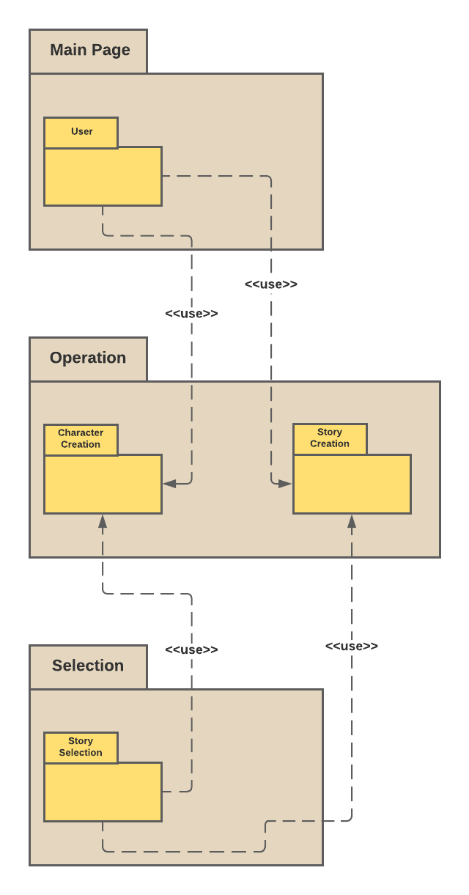

Use Cases and Usage Scenarios
Include here the relevant UML use case diagrams and sequence diagrams that depict a couple of usage scenarios for the system.

Sequence Diagram:
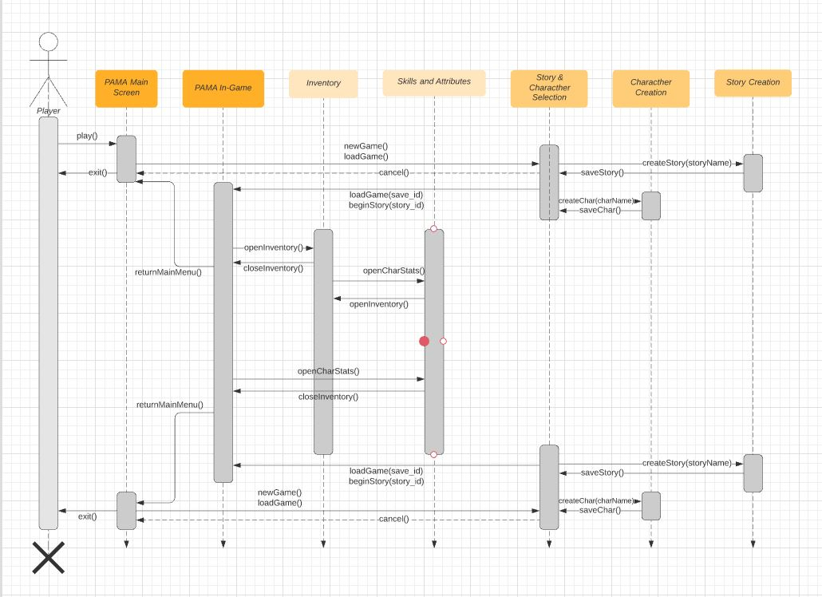

Use Case Diagram:
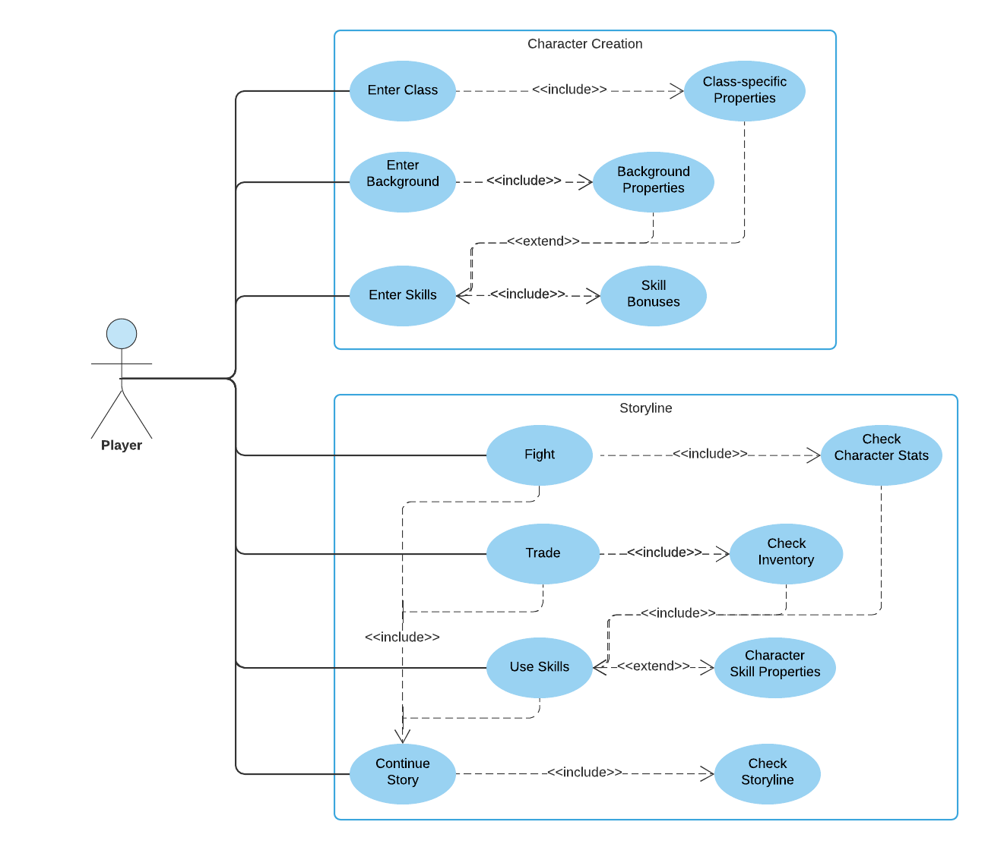
Activity Diagram:

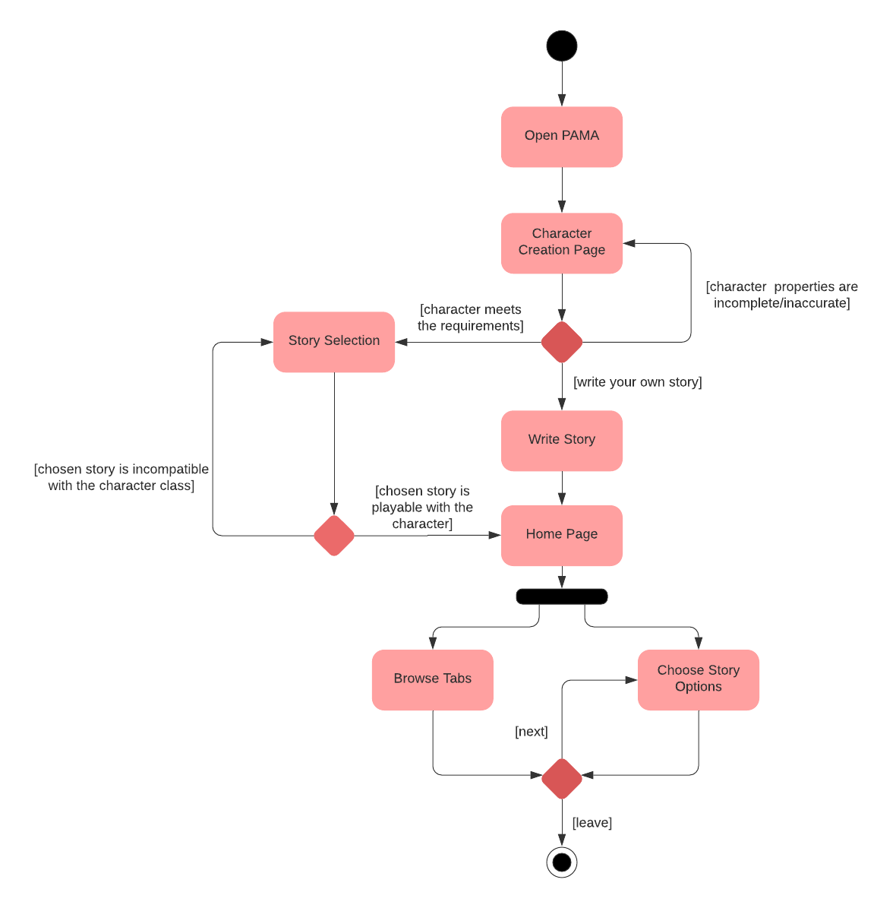

System Requirements Specification

This should describe the functional and nonfunctional requirements in more detail. Interfaces to other systems may be defined as well. In this case, activity diagrams and sequence diagrams should depict the protocols utilized in such interfaces. Some examples are provided:

SRS-FOO-003.2
FOO ensures that the displayed patient data are the same as read in the input files.
The patient’s data are:
- Name,
- Date of birth,
V1.0

SRS-FOO-004.1
FOO generates a log file containing:
- The state of the application and the steps performed to reach that state,
- The possible error logs, if any.
V1.0

