Revision History
Date | Version | Description | Author
30/10/2021 | 1.0 | Added the introduction part. | Kaan Yılmaz  Murat Can Altun
31/10/2021 | 1.1 | Edited the introduction part and added user requirement specifications | Gufran Yeşilyurt
01/11/2021 | 1.2 | Added Sequence Diagram | Görkem Öçmen
01/11/2021 | 1.3 | Added Activity and Use-Case Diagrams | Damla Tütüncü
01/11/2021 | 1.4 | Added System Architecture Diagram | Alanur Bilgili
1/11/2021 | 1.5 | Added System Requirement Specification | Gufran Yeşilyurt

TABLE OF CONTENTS
Revision History 1
1 INTRODUCTION 3
1.1 Document overview 3
1.2 System overview 3
1.3 Abbreviations 3
1.4 References 3
1.5 Conventions 3
2 REQUIREMENTS 4
2.1 User Requirements Specification 4
2.2 System Architecture 5
2.3 Use Cases and Usage Scenarios 6
2.4 System Requirements Specification 8

INTRODUCTION

Document overview

This document presents the software requirements specifications of PAMA software development project. It describes functional requirements, quality requirements, constraints, use cases, and usage scenarios. It also provides an overview of the system architecture.

System overview
Pheria: A Miserable Adventure is a desktop-based game that allows players to create characters such as wizard, rogue, warrior, and druid. Players can also become designers. They can write their own stories, or they can choose the suitable one for them.

Abbreviations
PAMA: Pheria: A Miserable Adventure
UML: Unified Modeling Language
GUI: Graphical User Interface
SRS: Software Requirement Specification
STP: Software Test Plan
SDP: Software Development Plan

References

# | Document Identifier | Document Title
[R1] | PAMA-SDP-2 | Software-Development-Plan
[R2] | PAMA-SRS-1 | Software-Requirements-Specifications

Conventions
Requirements listed in this document are constructed according to the following structure:

SRS-PAMA-001
Description of PAMA-001 requirement

Every system requirement id includes the id of the corresponding user requirement as a prefix.

SRS-PAMA-001.1
Description of PAMA-000.1 system requirement, which is related to the user requirement PAMA-000.1

REQUIREMENTS

User Requirements Specification

SRS-PAMA-001
PAMA shall validate that the user can see GUI.

SRS-PAMA-002
PAMA shall provide a Create a New Character button.

SRS-PAMA-003
PAMA shall enable the user to view the stories currently available to play.

SRS-PAMA-004
PAMA shall ensure that the user’s character meets the requirements of the story that the user wants to play.

SRS-PAMA-005
PAMA shall give the user the ability to browse between story, character, inventory pages while playing the game.

SRS-PAMA-006
PAMA shall provide an inventory button to view character equipment.

SRS-PAMA-007
PAMA shall give the user the ability to choose an option to proceed with the storyline.

SRS-PAMA-008
PAMA shall provide a character button that can be used to spend skill points.

SRS-PAMA-009
PAMA shall give the user the ability to write a new storyline.

SRS-PAMA-010
PAMA shall ensure that the user can play his/her own story if the game is not closed after the story is written.

SRS-PAMA-011
PAMA shall give the user the ability to fight the encounters.

SRS-PAMA-012
PAMA shall give the user the ability to trade with the traders.

System Architecture

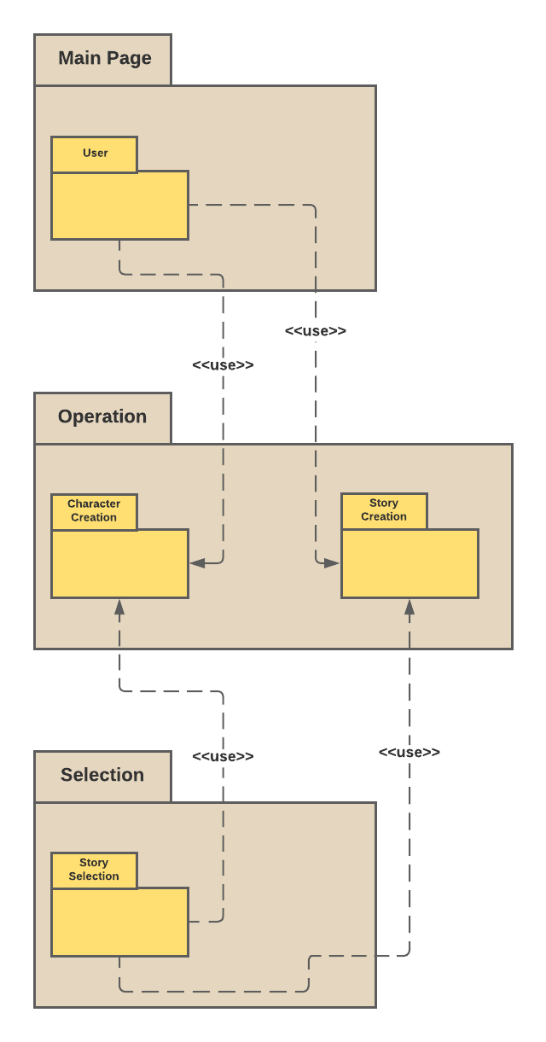

Use Cases and Usage Scenarios

Sequence Diagram:

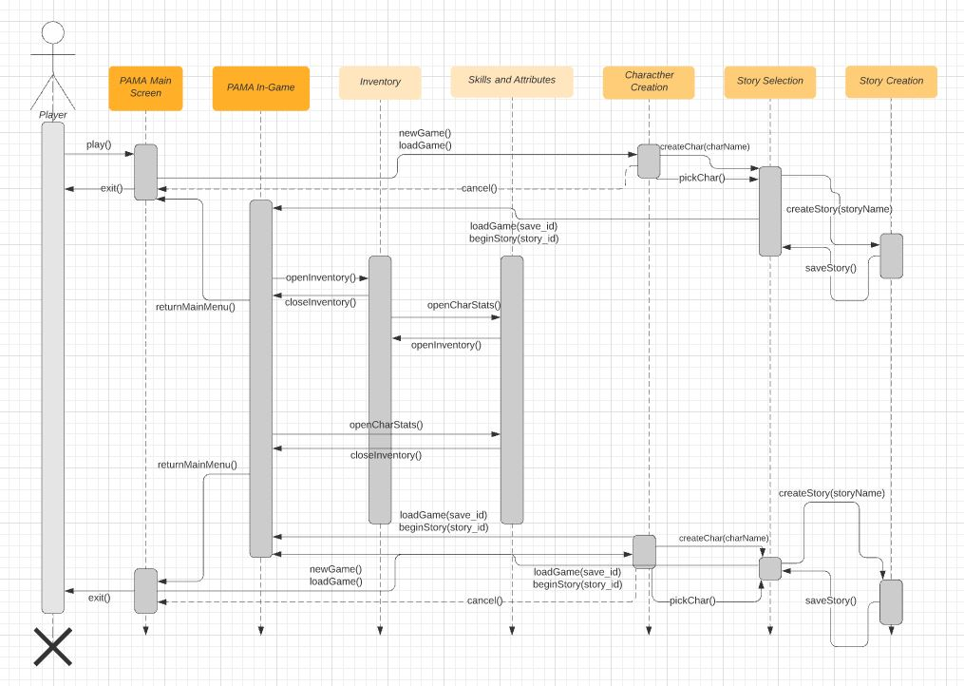

Use Case Diagram:
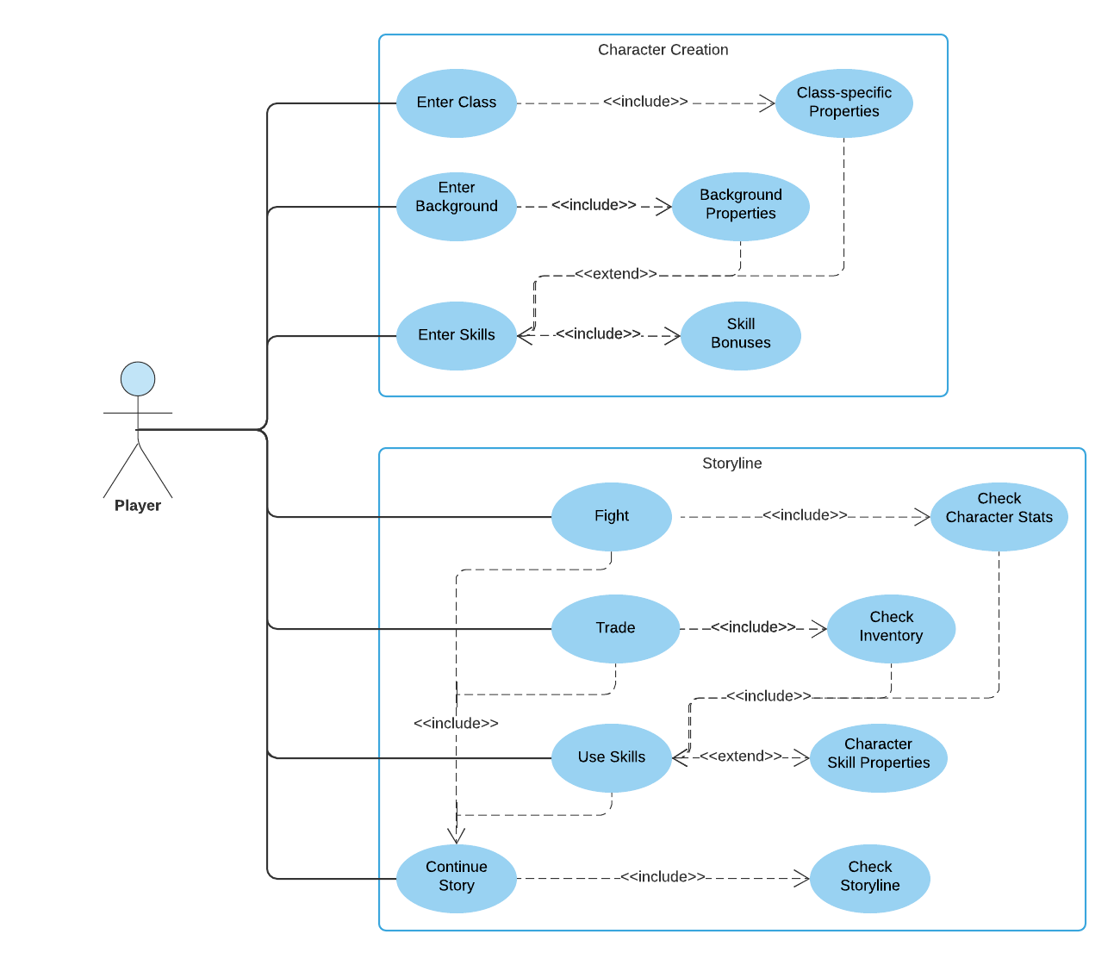
Activity Diagram:
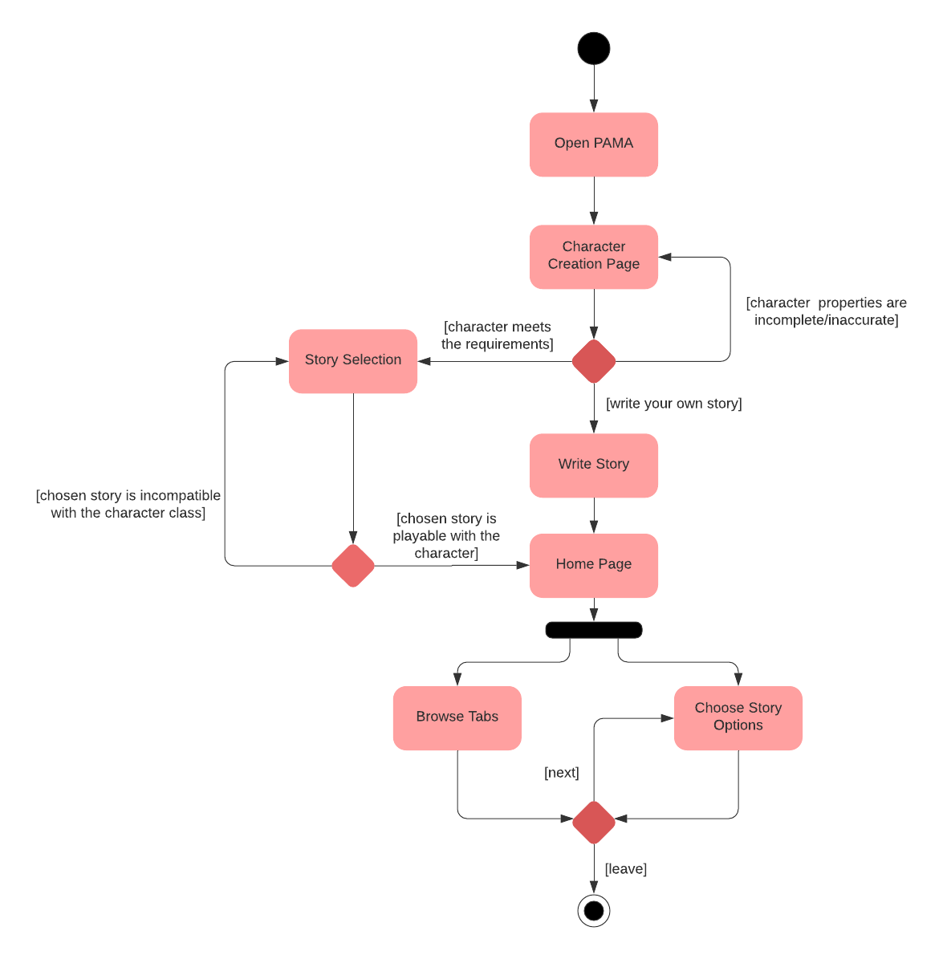

System Requirements Specification

SRS-PAMA-001.1
When the game is first started, it is going to pop up “Welcome to the PAMA” with a start button. If the player can’t see it and doesn’t click the button, the game is going to close.

SRS-PAMA-002.1
For creating a character PAMA shall ask the player for the following information:
- Character Class
- Character Race
- Character’s Background
- Distribution of the Skill Points

SRS-PAMA-003.1
PAMA shall validate if the player has got a character. If yes, it shall list all stories. If not, it shall not allow players to see stories.

SRS-PAMA-004.1
PAMA shall take the character and check if the stories are playable for it. If not, play buttons of these stories shall not be clickable and shall write a red note which checks attributes listed below:
- Character Class
- Character Race
- Character Background

SRS-PAMA-005.1
While playing the story, the player must be able to browse between the tabs that are on the left top corner, listed below:
- Story
- Character
- Inventory

SRS-PAMA-006.1
When the player clicks the inventory tab, the detailed window of equipment opens. PAMA shall ensure that the equipment data is displayed to the player, which are:
- Type
- Armor Bonus
- Dexterity Bonus
- Special Ability (If exists)

SRS-PAMA-006.2
PAMA shall validate that the character can’t equip 2 equipment at the same time if their type is the same as long as they are not daggers.

SRS-PAMA-007.1
Once the story begins it should proceed only with options that related to the story text provided to the player, for example:
- Flyt with the drunk Smithyman
- Offer a bribe to the bartender for local gossips
SRS-PAMA-008.1
When the player clicks the character tab, the detailed window of skills opens. PAMA shall ensure that the character data is displayed to the player, which are:
- Name
- Class
- Race
- Background
- Strength
- Dexterity
- Intelligence
- Charisma
- Proficiencies

SRS-PAMA-008.2
When the character levels up, PAMA shall ensure to increase the character’s skill points to spend.

SRS-PAMA-008.3
While the player spends skill points, PAMA shall ensure that the player can’t spend more skill points than given.

SRS-PAMA-009.1
For creating a new storyline, PAMA shall ask for the following information:
- Story text
- Event after the text

SRS-PAMA-009.2
After the story text, one of them shall be chosen from 4 events to proceed, which are:
- Fight
- Trade
- Conversation
- Finish the story

SRS-PAMA-010.1
After the new story is finished, PAMA shall list it in the story selection window.

SRS-PAMA-011.1
After the player chooses the option that leads to a fight, PAMA shall calculate the result of the fight according to the calculation below and print the appropriate text:
- Random number between 1 and 20 + Strength, Dexterity or Intelligence Bonus + Weapon Bonus – Enemy’s Armor

SRS-PAMA-012.1
After the player chooses the option that leads to trade, PAMA shall give an option to bargain.

SRS-PAMA-012.2
If the player chooses to bargain, PAMA shall calculate the result according to the calculation below:
- If (Random number between 1 and 20 + Charisma Bonus + 2 (If the character has got bartender proficiency)) for Player > (Random number between 1 and 20 + Charisma Bonus + 2 (If the trader has got bartender proficiency)) for Trader
SRS-PAMA-012.3
After the bargain’s result, PAMA shall set the equipment’s price according to the conditions listed below:
- If successful, the Selling Price is increased, and Buying Price is decreased for the player.
- If fail 2 times in a row, the trader refuses to sell or buy the item from the player.

