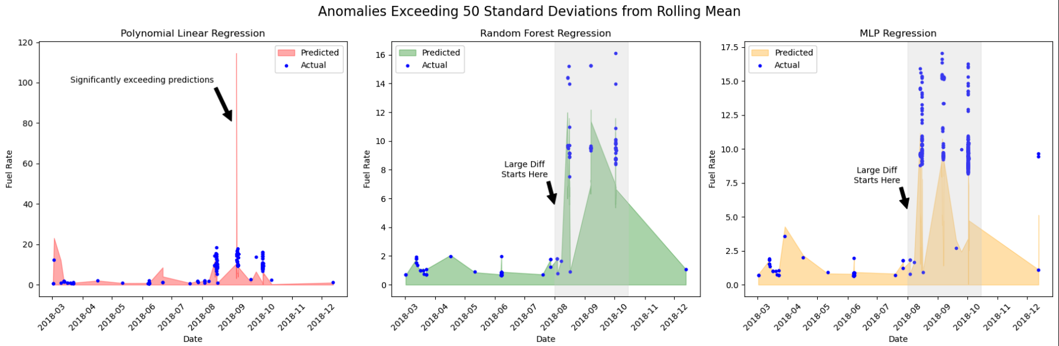

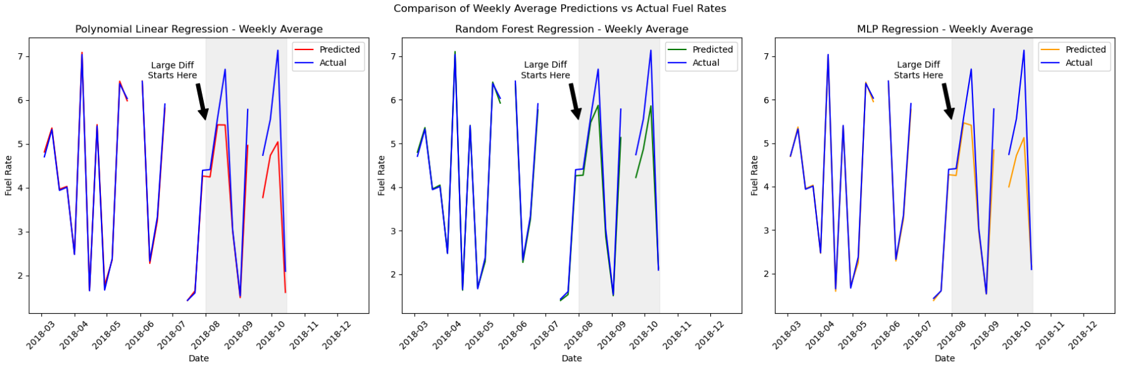

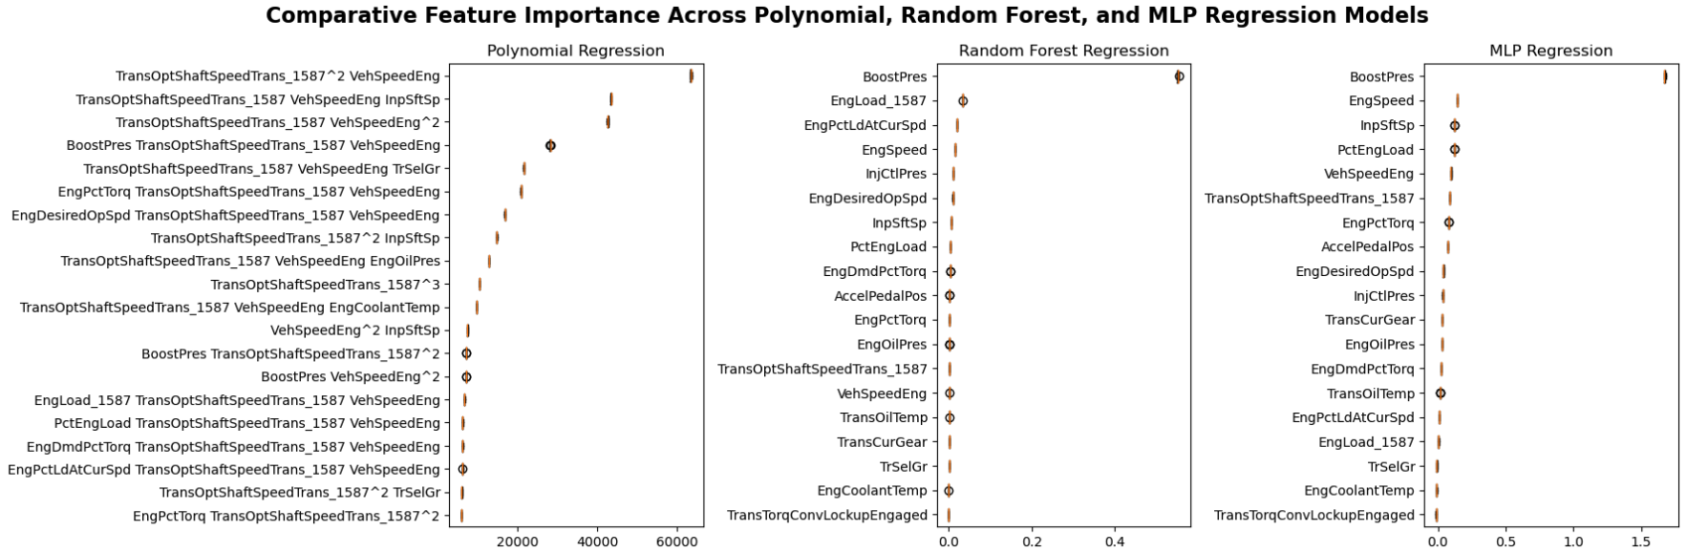

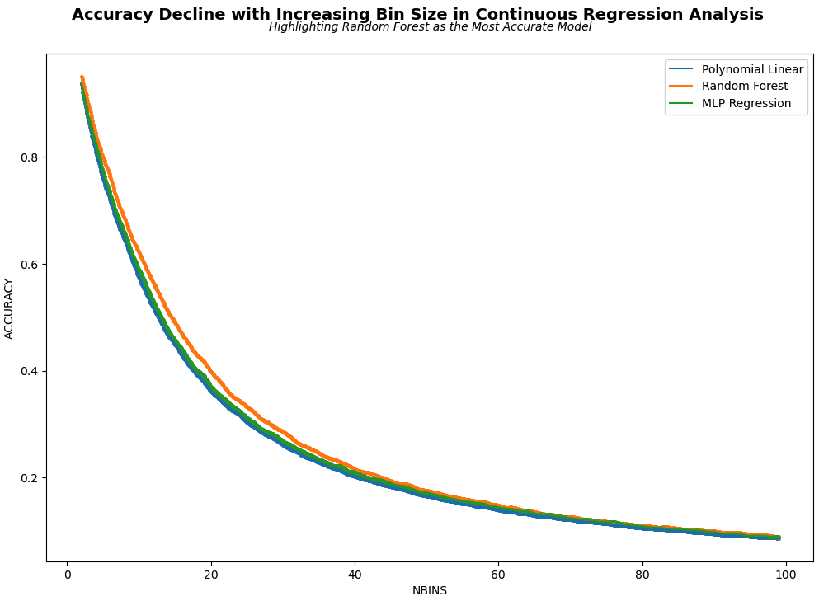

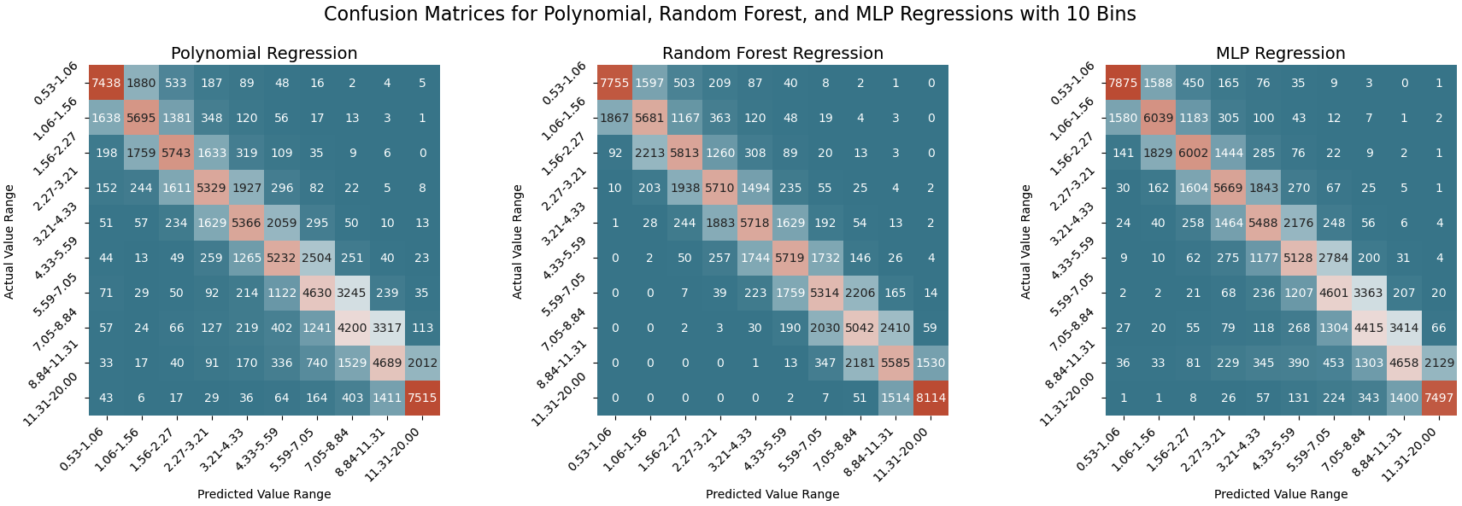

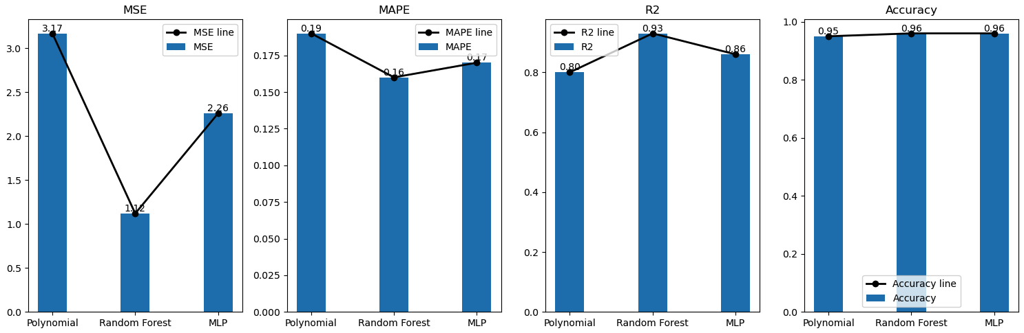

|  |  |  |  |  |  |
| --- | --- | --- | --- | --- | --- |
| Model | MSE | MAPE | R2 | Accuracy | Accuracy (95% CI) |
| Polynomial | 3.17 | 0.19 | 0.8 | 0.95 | 0.95 (+/- 0.04) |
| Random Forest | 1.12 | 0.16 | 0.93 | 0.96 | 0.96 (+/- 0.02) |
| MLP | 2.26 | 0.17 | 0.86 | 0.96 | 0.96 (+/- 0.04) |