WEEK 4

Model Training, Evaluation and Optimization
Logistics Delivery Performance Analysis & Late-Delivery Risk Prediction
Internship Project Report
Project Domain | Data Analytics and Machine Learning
Dataset | DataCo Smart Supply Chain Dataset
Tools | Python, Pandas, Scikit-learn, Matplotlib, Seaborn
Machine Learning Techniques | Logistic Regression, Decision Tree Classification, Hyperparameter Tuning, Cross-Validation
Reporting Phase | Week 4 — Model Training, Evaluation and Optimization

1. Executive Summary
This report presents the fourth and final phase of the Logistics Delivery Performance Analysis & Late-Delivery Risk Prediction project. The primary objective was to develop, train, evaluate, and compare machine learning classification models to identify late-delivery risk.
The analysis used the cleaned DataCo Smart Supply Chain dataset containing 180,519 records and 51 columns. Thirteen input features were selected for model development, and the target variable was Late_delivery_risk.
Two baseline classification algorithms, Logistic Regression and Decision Tree, were evaluated using five-fold stratified cross-validation and a separate test dataset. Hyperparameter tuning was subsequently performed on the Decision Tree model using GridSearchCV to improve its predictive performance.
The tuned Decision Tree achieved the highest F1 score of 0.6704 and recall of 0.5736 among the three evaluated models. Logistic Regression achieved the highest test accuracy of 0.6968 and precision of 0.8439. The models demonstrated moderate predictive performance, indicating that further improvements are necessary before practical deployment.
The project also generated a model comparison CSV file, a model performance comparison chart, a confusion matrix heatmap, and an ROC curve comparison to communicate the evaluation results clearly.

2. Project Objectives
The main objectives of Week 4 were:
- Build machine learning classification pipelines for late-delivery risk prediction.
- Apply appropriate preprocessing to numerical and categorical features.
- Evaluate the models using five-fold stratified cross-validation.
- Compare Logistic Regression and Decision Tree classification models.
- Tune Decision Tree hyperparameters using GridSearchCV.
- Evaluate final models on an independent test dataset.
- Generate visualizations to compare model performance.
- Document the findings, limitations, and recommendations for future improvement.

3. Dataset Overview
The cleaned dataset used for model training was DataCo_Week2_Cleaned.csv.
Dataset Property | Details
Total records | 180,519
Total columns | 51
Selected input features | 13
Target variable | Late_delivery_risk
Training records | 144,415
Testing records | 36,104
Training/testing split | 80% / 20%
Random state | 42
Validation method | Five-fold stratified cross-validation

The target variable represents the late-delivery risk classification used in the dataset. The models were trained to predict the target using the selected input features.
The train-test split used stratification to preserve the target-class proportions in both subsets. The test dataset was kept separate from model training and used for final evaluation.

4. Tools and Technologies Used
Python: Used to implement the complete machine learning workflow.
Pandas: Used for dataset loading, data handling, and preparation of model comparison results.
Scikit-learn: Used for preprocessing, pipeline creation, model training, cross-validation, hyperparameter tuning, and performance evaluation.
Matplotlib: Used to create model performance and ROC curve visualizations.
Seaborn: Used to create the confusion matrix heatmap.
CSV: Used to save the final model comparison results in a structured format.

5. Data Preprocessing
A preprocessing pipeline was developed to prepare numerical and categorical input features before model training.

5.1 Numerical Feature Processing
The numerical preprocessing pipeline included:
- Median imputation: Missing numerical values were replaced with the median of the relevant training feature.
- Standardization: StandardScaler was applied to scale numerical features.

5.2 Categorical Feature Processing
The categorical preprocessing pipeline included:
- Most-frequent imputation: Missing categorical values were replaced with the most frequently occurring training value.
- One-hot encoding: Categorical variables were converted into numerical representations using OneHotEncoder.
- Unknown category handling: handle_unknown="ignore" was used to handle categories not encountered during training.

5.3 Pipeline Implementation
A ColumnTransformer combined numerical and categorical preprocessing. The preprocessing steps and classification algorithms were integrated into Scikit-learn pipelines.
This pipeline-based approach ensured that preprocessing was fitted within each cross-validation training fold and that the final test data was not used to fit the preprocessing transformations.

6. Train-Test Split and Validation Strategy
The dataset was divided into training and testing subsets using an 80:20 ratio.
- Training set: 144,415 records.
- Testing set: 36,104 records.
- Random state: 42.
- Stratification: Enabled using the target variable.
Five-fold StratifiedKFold cross-validation was used to evaluate model stability. In this method, the training dataset is divided into five folds while preserving class proportions as closely as possible. Each fold is used for validation once while the remaining folds are used for training.
The evaluation metrics included accuracy, precision, recall, F1 score, and ROC-AUC.

7. Machine Learning Models

7.1 Logistic Regression
Logistic Regression was implemented as the first baseline classification model.
It estimates the probability that an observation belongs to a particular class. A maximum iteration limit of 1,000 was configured to support model convergence.
The model was evaluated using cross-validation and the independent test dataset.

7.2 Decision Tree Classifier
The Decision Tree model was implemented as the second baseline classifier.
The initial model used the following settings:
- Maximum tree depth: 10.
- Minimum samples per leaf: 20.
- Random state: 42.
The Decision Tree learns classification rules by splitting observations according to feature values. It can capture non-linear relationships, although its performance depends on the chosen tree parameters.

7.3 Hyperparameter Tuning
GridSearchCV was used to optimize the Decision Tree model.
The following hyperparameter combinations were evaluated:
Hyperparameter | Values Tested
Maximum depth (max_depth) | 6, 10, 14
Minimum samples per leaf (min_samples_leaf) | 10, 20, 50
Cross-validation folds | 5
Optimization metric | F1 score
Total parameter combinations | 9
Total model fits | 45

The best parameters identified by GridSearchCV were:
- max_depth = 14
- min_samples_leaf = 50
The best cross-validation F1 score was 0.6681.
The selected tuned model was then evaluated on the independent test dataset.

8. Five-Fold Cross-Validation Results
The following table presents the mean cross-validation scores and their standard deviations for the two baseline models.
Metric | Logistic Regression | Decision Tree
Accuracy | 0.6944 ± 0.0013 | 0.6914 ± 0.0007
Precision | 0.8407 ± 0.0033 | 0.8180 ± 0.0141
Recall | 0.5462 ± 0.0046 | 0.5629 ± 0.0152
F1 Score | 0.6622 ± 0.0026 | 0.6665 ± 0.0059
ROC-AUC | 0.7395 ± 0.0015 | 0.7393 ± 0.0016

Interpretation
Logistic Regression achieved higher mean accuracy and precision during cross-validation. The Decision Tree achieved higher mean recall and F1 score.
Both models produced similar ROC-AUC values, indicating comparable ranking performance under the selected validation setup.
The relatively small standard deviations for most Logistic Regression metrics suggest consistent results across the five folds. The Decision Tree showed greater variation in precision and recall.

9. Final Test Results
The models were evaluated on the separate test dataset containing 36,104 records.

9.1 Logistic Regression Results
Evaluation Metric | Score
Accuracy | 0.6968
Precision | 0.8439
Recall | 0.5485
F1 Score | 0.6649
ROC-AUC | 0.7409

The Logistic Regression model achieved 69.68% accuracy and 84.39% precision. Its recall of 54.85% indicates that it identified approximately 54.85% of the actual positive-class cases.

9.2 Logistic Regression Confusion Matrix
Actual / Predicted | Predicted On-Time (0) | Predicted Late (1)
Actual On-Time (0) | 14,300 | 2,008
Actual Late (1) | 8,938 | 10,858

The model correctly classified 14,300 class-0 cases and 10,858 class-1 cases. It incorrectly classified 2,008 class-0 cases as class 1 and missed 8,938 actual class-1 cases.

9.3 Decision Tree Results
Evaluation Metric | Score
Accuracy | 0.6926
Precision | 0.8280
Recall | 0.5546
F1 Score | 0.6642
ROC-AUC | 0.7438

The baseline Decision Tree achieved 69.26% accuracy. Its recall was slightly higher than that of Logistic Regression, and it produced the highest ROC-AUC among the three evaluated models.

9.4 Decision Tree Confusion Matrix
Actual / Predicted | Predicted On-Time (0) | Predicted Late (1)
Actual On-Time (0) | 14,028 | 2,280
Actual Late (1) | 8,818 | 10,978

The model correctly classified 14,028 class-0 cases and 10,978 class-1 cases. It incorrectly classified 2,280 class-0 cases as class 1 and missed 8,818 actual class-1 cases.

10. Tuned Decision Tree Results
GridSearchCV selected a Decision Tree with a maximum depth of 14 and a minimum of 50 samples per leaf.
The tuned model produced the following test results:
Evaluation Metric | Score
Accuracy | 0.6908
Precision | 0.8066
Recall | 0.5736
F1 Score | 0.6704
ROC-AUC | 0.7432

10.1 Tuned Decision Tree Confusion Matrix
Actual / Predicted | Predicted On-Time (0) | Predicted Late (1)
Actual On-Time (0) | 13,585 | 2,723
Actual Late (1) | 8,442 | 11,354

The tuned model correctly classified 13,585 class-0 cases and 11,354 class-1 cases. It incorrectly classified 2,723 class-0 cases as class 1 and missed 8,442 actual class-1 cases.

Interpretation
Compared with the baseline Decision Tree, hyperparameter tuning increased recall from 55.46% to 57.36% and the F1 score from 66.42% to 67.04%.
However, the tuned model's accuracy and precision were lower than those of the baseline Decision Tree. The tuning process therefore improved the selected F1 objective but did not improve every evaluation metric.

11. Overall Model Comparison
The final test results for all three models are summarized below.
Model | Accuracy | Precision | Recall | F1 Score | ROC-AUC
Logistic Regression | 0.6968 | 0.8439 | 0.5485 | 0.6649 | 0.7409
Decision Tree | 0.6926 | 0.8280 | 0.5546 | 0.6642 | 0.7438
Tuned Decision Tree | 0.6908 | 0.8066 | 0.5736 | 0.6704 | 0.7432

Key Findings
- Logistic Regression achieved the highest test accuracy at 69.68%.
- Logistic Regression achieved the highest test precision at 84.39%.
- The tuned Decision Tree achieved the highest test recall at 57.36%.
- The tuned Decision Tree achieved the highest test F1 score at 67.04%.
- The baseline Decision Tree achieved the highest test ROC-AUC at 74.38%.
- The tuned Decision Tree missed 8,442 actual positive-class cases, demonstrating that further improvement is needed for reliable late-delivery risk identification.
The most suitable model depends on the business objective. If the primary selection metric is F1 score, the tuned Decision Tree is the leading candidate among the three evaluated models. If higher precision is the priority, Logistic Regression is preferable based on these test results.

12. Model Performance Comparison Chart
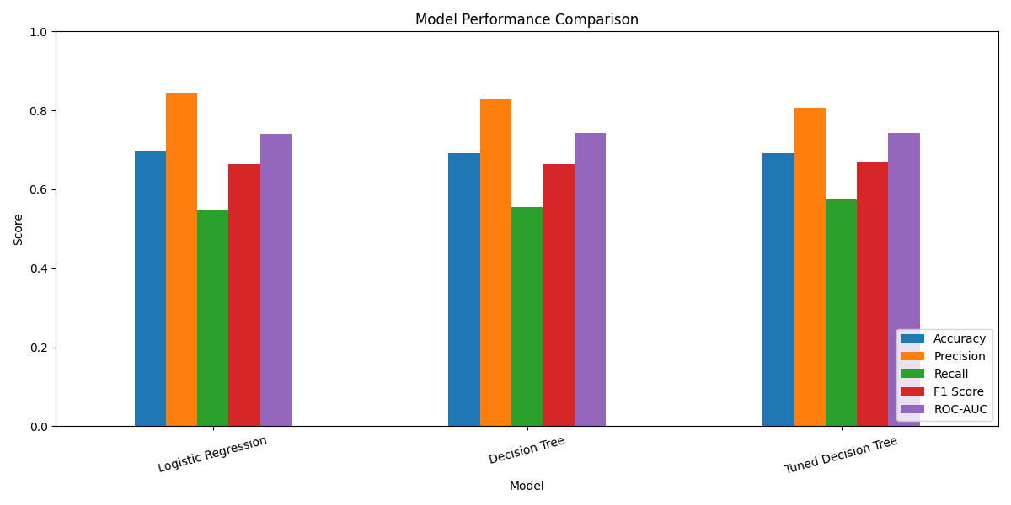
Figure 1: Model Performance Comparison
The bar chart compares the accuracy, precision, recall, F1 score, and ROC-AUC values of Logistic Regression, Decision Tree, and Tuned Decision Tree.

Interpretation
The visualization shows the relative strengths of the three models across the selected evaluation metrics. Logistic Regression has the highest accuracy and precision, while the tuned Decision Tree has the highest recall and F1 score. The baseline Decision Tree has the highest ROC-AUC.
This comparison makes it easier to identify the model that best aligns with the project's evaluation priorities.

13. Tuned Decision Tree Confusion Matrix Heatmap
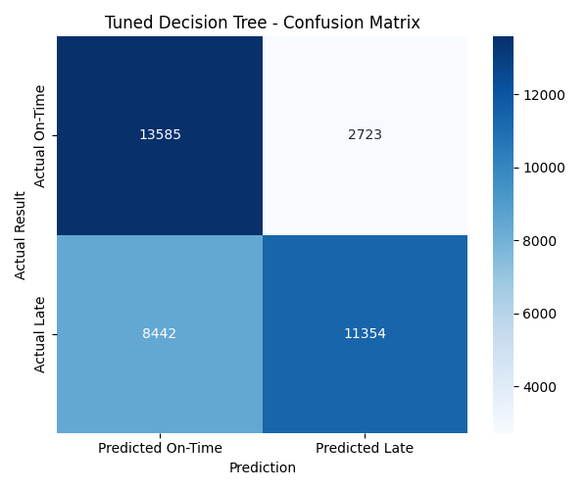
Figure 2: Tuned Decision Tree — Confusion Matrix
The confusion matrix heatmap illustrates the relationship between actual and predicted classes for the tuned Decision Tree model.
The matrix contains four outcomes:
- True Negatives (13,585): Class-0 cases correctly predicted as class 0.
- False Positives (2,723): Class-0 cases incorrectly predicted as class 1.
- False Negatives (8,442): Actual class-1 cases incorrectly predicted as class 0.
- True Positives (11,354): Class-1 cases correctly predicted as class 1.

Interpretation
The heatmap highlights both correct classifications and prediction errors. The model correctly identified 11,354 positive-class cases but missed 8,442 actual positive-class cases.
These false negatives are important because missed late-delivery risks may prevent logistics teams from identifying some shipments for early intervention.

14. ROC Curve Comparison
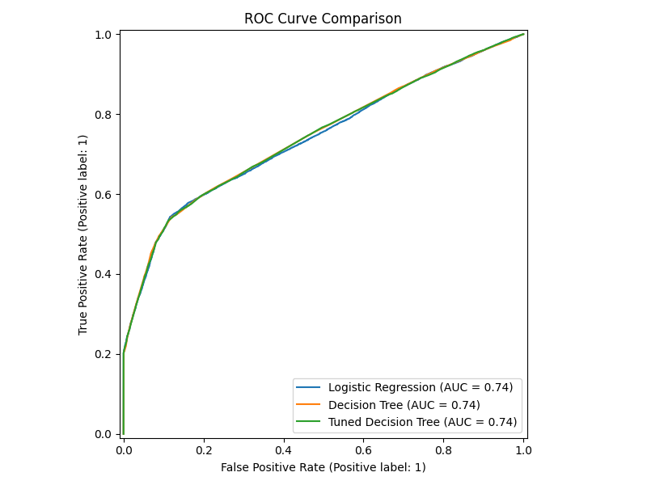
Figure 3: ROC Curve Comparison of the Three Models
The Receiver Operating Characteristic (ROC) curve illustrates the relationship between the true positive rate and the false positive rate across different classification thresholds.
ROC-AUC summarizes the model's ability to rank positive cases above negative cases. A higher ROC-AUC generally indicates better discrimination between the two classes.
The reported ROC-AUC scores were:
- Logistic Regression: 0.7409
- Decision Tree: 0.7438
- Tuned Decision Tree: 0.7432

Interpretation
The three ROC-AUC values are relatively close. The baseline Decision Tree achieved the highest ROC-AUC at 0.7438, followed by the tuned Decision Tree at 0.7432 and Logistic Regression at 0.7409.
These results suggest that all three models provide some ability to distinguish between the classes, although their predictive performance remains moderate.

15. Business Insights and Recommendations
Based on the evaluation results, the following recommendations are proposed.

15.1 Prioritize Risk Identification
The tuned Decision Tree achieved the highest recall and F1 score. It can be considered for further testing where identifying a larger proportion of positive-class cases is important.

15.2 Review False Negatives
The tuned model missed 8,442 actual positive-class cases. Further investigation should focus on why these cases were incorrectly classified and whether additional predictive information can improve detection.

15.3 Evaluate False Positives
The tuned model generated 2,723 false positives. Logistics teams should assess whether the operational cost of investigating incorrectly flagged shipments is acceptable.

15.4 Improve Feature Quality
Additional features may improve predictive performance if they are relevant and available before the prediction decision. Examples for investigation include historical delivery performance, planned transit time, shipping mode, and order characteristics, provided these are available in the source data and suitable for prediction.

15.5 Select Metrics According to Business Needs
Accuracy alone is not sufficient to select a model. Precision, recall, F1 score, ROC-AUC, and the costs of different prediction errors should all be considered.

15.6 Validate Before Deployment
The current results should be treated as an initial model evaluation. Additional validation on newer or time-separated data is required before the model is considered for operational use.

16. Limitations of the Analysis
The following limitations should be considered when interpreting the results:
- The models achieved moderate performance, with test accuracy ranging from 69.08% to 69.68%.
- The tuned Decision Tree recall of 57.36% indicates that a substantial proportion of actual positive-class cases were missed.
- The analysis used a random stratified train-test split. It did not establish performance on future time periods.
- The selected input features must be reviewed to ensure that they are available at the intended prediction time.
- The analysis does not establish that any particular feature causes late deliveries.
- The dataset may not represent current logistics operations or every delivery environment.
- The evaluation results alone do not establish that using the models will reduce actual delivery delays.
Future work should examine time-based validation, additional feature engineering, alternative classification models, decision-threshold optimization, and the practical costs of false positives and false negatives.

17. Project Deliverables
The following outputs were generated during Week 4:
File | Purpose
week4_pipeline.py | Python source code for training, evaluation, and tuning
week4_model_comparison.csv | Model comparison metrics
week4_model_comparison.png | Model performance comparison chart
week4_confusion_matrix.png | Tuned Decision Tree confusion matrix heatmap
week4_roc_curve.png | ROC curve comparison

The cleaned dataset used for model development was DataCo_Week2_Cleaned.csv.
The weekly internship documentation is maintained in four separate Word reports covering Weeks 1, 2, 3, and 4.

18. Final Conclusion
The fourth week completed the model training, evaluation, comparison, and hyperparameter tuning phase of the Logistics Delivery Performance Analysis & Late-Delivery Risk Prediction project.
Logistic Regression and Decision Tree classifiers were developed using preprocessing pipelines and evaluated through five-fold stratified cross-validation and an independent test dataset. GridSearchCV was then used to tune the Decision Tree model.
Among the evaluated models, the tuned Decision Tree achieved the highest F1 score of 0.6704 and recall of 0.5736. Logistic Regression achieved the highest accuracy of 0.6968 and precision of 0.8439, while the baseline Decision Tree achieved the highest ROC-AUC of 0.7438.
The project generated a model comparison CSV file and three visualizations to support the interpretation and communication of the findings. The results demonstrate the application of an end-to-end machine learning classification workflow to a logistics analytics problem.
Although the tuned Decision Tree showed improvements in recall and F1 score over the baseline Decision Tree, the models still missed a considerable number of actual positive-class cases. Further validation, feature review, and performance improvement are therefore recommended before practical deployment.
Overall, Week 4 completed the planned model development and evaluation activities and documented the results, limitations, and opportunities for future improvement.

