WEEK 3

Exploratory Data Analysis and KPI Findings
Logistics Delivery Performance Analysis & Late-Delivery Risk Prediction
Logistics Data Analyst Internship | Week 3 Project Report
Report detail | Information
Prepared by | Guggilapu Venkata Ramana
Project domain | Data Analytics
Dataset | DataCo Smart Supply Chain Dataset
Tools | Python, Pandas, Matplotlib, EDA, KPI Analysis
Reporting phase | Week 3 — EDA, KPI calculations, comparisons, and visualizations

1. Executive Summary
Week 3 examines historical supply-chain records to describe delivery outcomes, summarize shipping duration, compare reported late-delivery risk by shipping mode, and review selected correlations. The analysis uses the cleaned working dataset described in Week 2 and the supplied Week 3 summary results.
The working dataset contains 180,519 records and 51 columns. Late delivery is the largest reported delivery-status category, with 98,977 records (54.83%). Average actual shipping time is 3.50 days; its median is 3 days, compared with a reported scheduled-shipping median of 4 days. Reported risk percentages range from 38% for Standard Class to 95% for First Class.
These are descriptive, record-level findings. Shipping-mode percentages, variable definitions, and all calculations should be validated against the final cleaned dataset before operational decisions or predictive modeling. The charts in this report visualize the values supplied for Week 3; they do not replace a fresh calculation from the source data.

2. Objectives
- Describe the distribution of delivery-status categories.
- Summarize actual and scheduled shipping durations using the available statistics.
- Compare reported late-delivery risk percentages across shipping modes.
- Review reported correlations among shipping duration, risk, sales, and profit.
- Communicate findings through clear charts and KPI tables.
- Document limitations and prepare a leakage-aware foundation for Week 4 modeling.

3. Dataset and Methodology

3.1 Dataset Overview
The DataCo Smart Supply Chain Dataset contains order, customer, shipping, delivery, sales, profit, and product information. The Week 2 cleaned working dataset was reported as 180,519 rows by 51 columns. The unit counted in the reported results is a dataset record; one order may contribute multiple item-level records.
Attribute | Reported value
Records | 180,519
Columns in working dataset | 51
Late-delivery records | 98,977
Late-delivery record share | 54.83%
Remaining missing values reported in Week 2 | Customer Lname: 8; Customer Zipcode: 3

3.2 Analysis Workflow
The Week 3 workflow uses Pandas to load and inspect the prepared dataset, review status categories and shipping modes, summarize duration variables, calculate or review KPIs, and create Matplotlib visualizations. The supplied results are documented here as reported values; the original notebook or final cleaned CSV should be used to reproduce and validate them.
Illustrative inspection code:
import pandas as pd
import matplotlib.pyplot as plt
df = pd.read_csv("DataCo_Week2_Cleaned.csv")
print(df.shape)
print(df["delivery_status"].value_counts(dropna=False))
print(df[["days_for_shipping_real",
"days_for_shipment_scheduled"]].describe())

4. Delivery Status Distribution
Late delivery is the most frequent reported category, representing 54.83% of dataset records. Advance shipping accounts for 23.04%, shipping on time 17.84%, and shipping canceled 4.30%. Percentages are rounded and sum to approximately 100%.
Delivery status | Records | Share
Late delivery | 98,977 | 54.83%
Advance shipping | 41,592 | 23.04%
Shipping on time | 32,196 | 17.84%
Shipping canceled | 7,754 | 4.30%
Total | 180,519 | ~100.00%

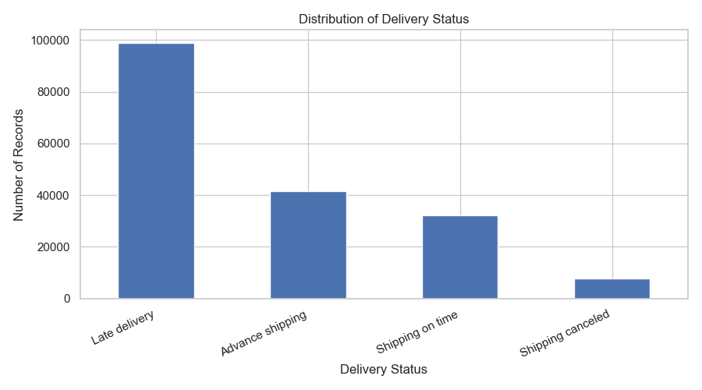
Figure 1. Delivery-status counts and reported shares.
Interpretation: late delivery is a prominent category and merits further investigation. The figures describe records, not necessarily unique orders or customers.

5. Actual and Scheduled Shipping Duration
Duration statistic | Reported value
Mean actual shipping time | 3.50 days
Median actual shipping time | 3 days
Median scheduled shipping time | 4 days

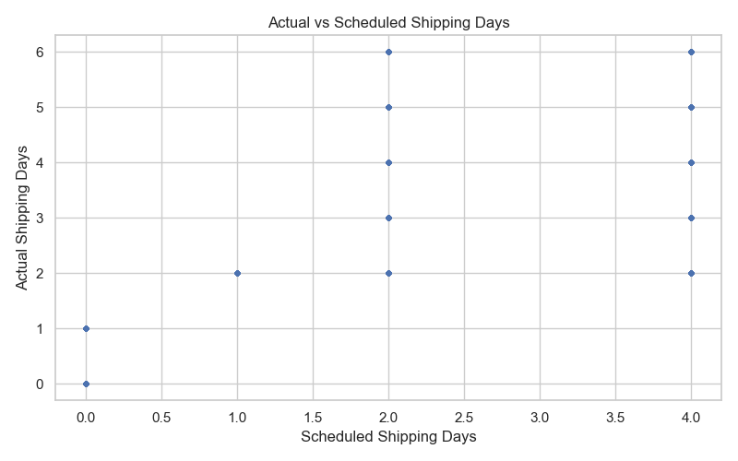
Figure 2. Actual versus scheduled shipping days, from the original Week 3 visualization.
Figure 2 provides the original actual-versus-scheduled comparison. The reported medians offer a summary, but schedule adherence should be calculated from paired record-level values using validated field definitions.

6. Late-Delivery Risk by Shipping Mode
Shipping mode | Reported late-delivery risk
First Class | 95%
Second Class | 77%
Same Day | 46%
Standard Class | 38%

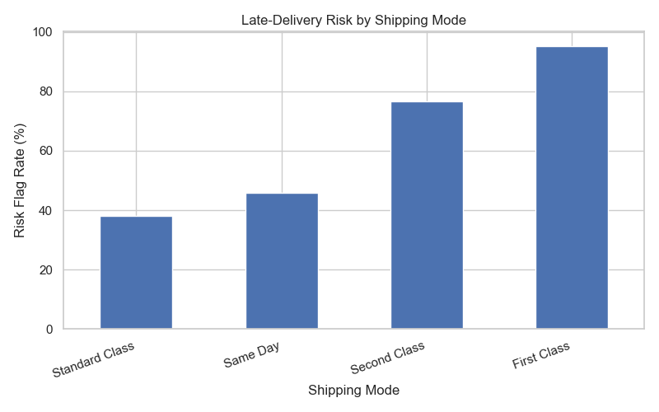
Figure 3. Reported risk percentages by shipping mode.
First Class has the highest supplied percentage and Standard Class the lowest. The calculation method and denominator were not supplied here. Confirm whether these percentages use the existing Late_delivery_risk field or a separately computed delivery outcome; the measures should not be treated as interchangeable without verification. These comparisons do not establish that shipping mode causes delays.

7. Correlation Analysis
Variable pair | Reported correlation | Interpretation
Actual shipping days and late-delivery risk | 0.401 | Positive association
Scheduled shipping days and late-delivery risk | -0.369 | Negative association
Sales and Order Profit Per Order | 0.13 | Weak positive association

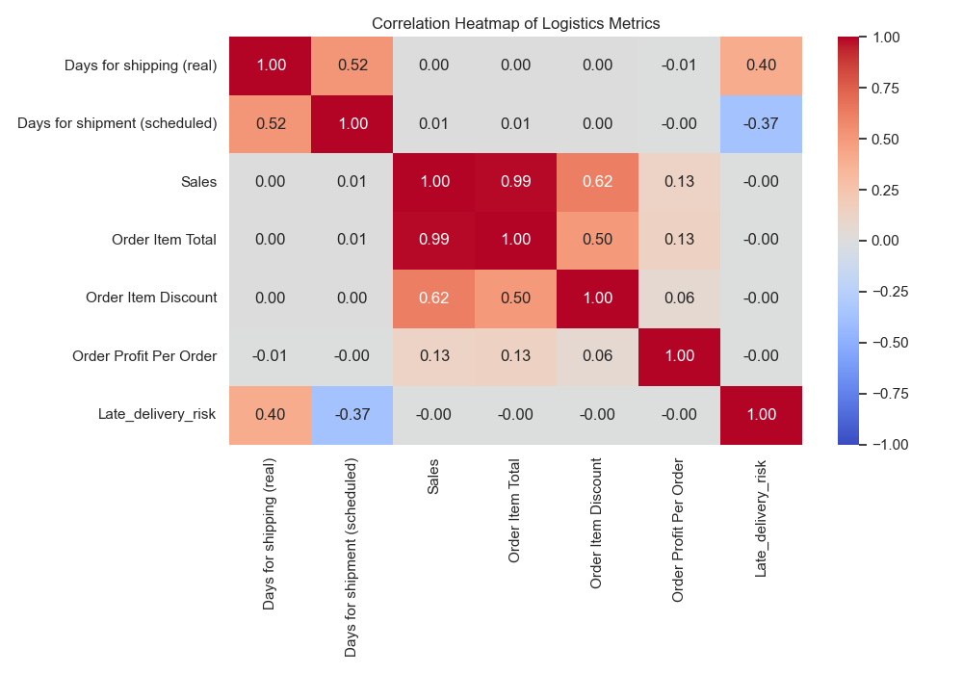
Figure 4. Original correlation heatmap of the selected logistics and financial metrics.
The original heatmap reports a correlation of 0.40 between actual shipping days and late-delivery risk, -0.37 between scheduled shipping days and late-delivery risk, and 0.13 between Sales and Order Profit Per Order. The plotted values are rounded to two decimal places. Correlation does not establish causation, and interpretation depends on variable definitions and encoding.

8. Key Performance Indicators
KPI | Reported value | Use
Total dataset records | 180,519 | Working dataset size
Late-delivery records | 98,977 | Record count classified as late
Late-delivery record share | 54.83% | Proportion of records classified as late
Mean actual shipping time | 3.50 days | Average actual duration
Median actual shipping time | 3 days | Central actual duration
Median scheduled shipping time | 4 days | Central scheduled duration
First Class reported risk | 95% | Shipping-mode comparison
Second Class reported risk | 77% | Shipping-mode comparison
Same Day reported risk | 46% | Shipping-mode comparison
Standard Class reported risk | 38% | Shipping-mode comparison

Each KPI should be documented with its formula, denominator, unit, and unit of analysis. Record-level measures should be supplemented with order-level measures where multiple records belong to an order.

9. Overall Findings and Recommendations

9.1 Findings
Late delivery accounts for 54.83% of reported records and is the largest status category. Actual shipping averages 3.50 days, with a median of 3 days; the scheduled-shipping median is 4 days. Supplied shipping-mode risk percentages vary, and reported correlations offer leads for investigation rather than evidence of cause and effect.

9.2 Recommendations
- Validate the shipping-mode risk calculation, denominator, and order mix against the analysis notebook.
- Compare actual and scheduled duration at the same record or order level using clearly defined metrics.
- Investigate late-delivery records by destination, order characteristics, and product category where fields are suitable.
- For pre-delivery prediction, exclude fields that reveal completed outcomes, including final delivery status and actual shipping duration.
- Use order-aware train/test splitting and fit preprocessing steps on training data only.
- Retain record-level and order-level KPIs separately when multiple item rows belong to one order.

10. Limitations
- The supplied results are summary values and were not recalculated from the cleaned CSV during report preparation.
- Records may represent line items rather than unique orders.
- The risk-by-shipping-mode formula and denominator require confirmation.
- Correlation does not imply causation and may reflect variable construction.
- Missing values reported in Week 2 should be checked again in the final working file.
- Historical patterns may not generalize to future operations.
- The original heatmap reports a Sales–Order Profit Per Order correlation of 0.13.

11. Conclusion and Week 4 Next Steps
Week 3 establishes a descriptive baseline for delivery status, shipping duration, reported shipping-mode risk, and selected correlations. Late delivery is prominent in the supplied record-level results, while the duration summaries and cross-mode percentages identify questions for validation. The findings should be verified against the cleaned dataset and the metric definitions documented before operational use.
Week 4 can build on this analysis by defining a prediction-time target, selecting only features available at that point, creating an order-aware data split, fitting a suitable model, and evaluating it with metrics appropriate to the class balance and business use case.

12. Project References
Dataset: DataCo Smart Supply Chain Dataset
https://www.kaggle.com/datasets/jolenechen/datacosupplychaindataset
Project GitHub Repository:
https://github.com/guggilapu-venkata-ramana/Logistics-Delivery-Performance-Analysis
Tools: Python, Pandas, Matplotlib, Exploratory Data Analysis, KPI Analysis, Data Visualization
END OF WEEK 3 INTERNSHIP PROJECT REPORT

