LDA classification for protein mapping

The code is written entirely in Python 3.8

Input files:

- Excel spreadsheet with NMR data of test protein
- Text file with amino acids sequence of the test protein (fasta file)
- Text file with BMRB entry IDs of the proteins for training set

Output files:

- Figure showing classification probabilities for each spin system in the input excel spreadsheet
- Excel spreadsheet with matrix of classification probabilities

Formatting the input files

- The spreadsheet containing NMR data of the protein under investigation must be a Microsoft excel file (extension *.xlsx, Libre Office extension *.odt not supported) and formatted as follows:

- Type ‘SSN’ for Spin Systems Numbers as header of the first column (cell A1). Then, starting from cell A2, place all the spin systems numbers in this column. These numbers can be in any order.

- Header for next columns go according to chemical shifts that will be used for the classification. There can be any number of chemical shifts and they can be placed in any order. Don’t leave empty columns in between. Names of chemical shifts should be abbreviated according to the following table:

Chemical shift | Header
Hα | HA
Hβ | HB
Cα | CA
Cβ | CB
H^{N} | H
N | N
CO | C

- Copy the chemical shift values for each spin system in the corresponding column. If there are missing chemical shift values, then those cells must be left as empty.

- The following Figure gives and example of how the spreadsheet may look like:

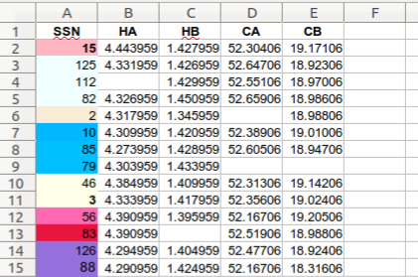

Example of input excel spreadsheet with NMR data on test protein.
Empty cells represent missing chemical shift values.

- The fasta text file must contain only the amino acids sequence of the test protein, without header or any extra information. The sequence can be split into more than one line, as in the following example:

MDVFMKGLSKAKEGVVAAAEKTKQGVAEAAGKTKEGVLYVGSKTKEGVVHGVATVAEKTK
EQVTNVGGAVVTGVTAVAQKTVEGAGSIAAATGFVKKDQLGKNEEGAPQEGILEDMPVDP
DNEAYEMPSEEGYQDYEPEA

- The text file containing the BMRB entry IDs of the proteins that will comprise the training set must have 1 entry ID per line, and it may contain any number of entry IDs. The file must be without header or any extra information. The following list is an example of the content of one such file:

6436
6869
11526
15176
15179
15180
15201
15225
15430

Executing the code

To use the code you must first get it from GitHub by either downloading it from

https://github.com/gugumatz/LDA-for-mapping-IDPs

or by synchronizing the GitHub repository with a directory in your computer and pulling the files. Example files will be downloaded along with the python code.

To execute the code, open a terminal in the same directory where the code is and type the following command line:

python3 ./LDA_code.py <test-protein>.xlsx <fasta>.txt <IDs>.txt

The input files should be typed in the order shown above: first the excel spreadsheet with NMR data of the test protein, followed by the fasta text file with the amino acid sequence and lastly the BMRB entry IDs text file for the training set.

Depending on the specifications of the computer where you run the code, the size of the data you input and your internet connection (for downloading the training set), the code takes between 5 and 30 seconds of run-time.

Reading the output files:

- After the code finishes executing a figure will pop up. This figure summarizes the results, showing the LDA classification probabilities for each of the spin systems given as input in the excel spreadsheet.

An example figure is shown in the next page. Spin systems numbers are shown in the vertical y axis and amino acid residue types in the horizontal x axis. Each amino acid type is represented by a different marker color in the plot, while marker sizes represent classification probabilities.

If there is a single marker aligned with a given spin system, it means that LDA found a probability greater than 90% that this spin systems is of the appropriate amino acid type. On the contrary, if more than 1 marker is aligned with a spin system, it means that classification probabilities are spitted among many amino acid types.

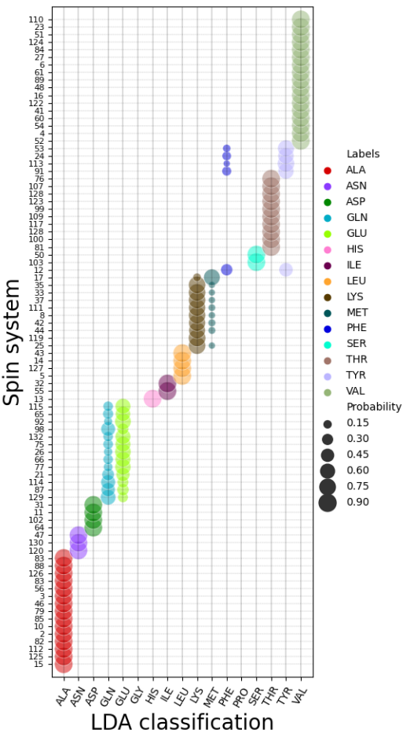
Important: the code trains the LDA model only with those residue types present in the amino acid sequence in the fasta file. Probabilities below 10% are automatically deleted from the figure to ease visualization.

Example output figure. Markers size represent classification probabilities given by the label to the right, and markers colors represent amino acid types. Colors are transparent to enable visualization of overlapping markers.

- The second output file is and excel spreadsheet named “Probabilities.xlsx” containing the same information as the output figure but in form of a table. The first column of the table holds the spin systems numbers, and subsequent columns the probabilities for each of the amino acid types present in the training set (which are drawn from the fasta text file).

