**PROGRAM**

<!DOCTYPE html>

<html>

<head>

<meta name="viewport" content="width=device-width, initial-scale=1">

<style>

body,html{

background-image: url("https://wallpaper.dog/large/10878257.jpg");

background-attachment: fixed;

background-repeat: no-repeat;

background-size: cover

}

div{

padding-left: 100px;

}

* {

box-sizing: border-box;

}

.container {

margin: 20px;

max-width: 600px;

padding: 20px;

background-color:floralwhite;

}

input[type=text],input[type=date] ,select,option,textarea{

width: 100%;

padding: 10px;

margin: 5px 0 22px 0;

border: none;

background:rgb(97, 98, 168);

}

input[type=text]:focus, input[type=date]:focus,select:focus,textarea:focus {

background-color: rgb(36, 16, 83);

outline: none;

}

.btn {

background-color: rgb(34, 36, 129);

color: white;

padding: 16px 20px;

border: none;

cursor: pointer;

width: 30%;

}

.btn:hover {

opacity: 0.9;

}

</style>

</head>

<body>

<div>

<form class="container" onsubmit="fun()" >

<center><h2>Its time to travel!!</h2></center>

<b>Passenger Name</b><input type="text" required>

<b>Age</b>

<input type="radio" name="r1">1-15

<input type="radio" name="r1">16-30

<input type="radio" name="r1">31-50

<input type="radio" name="r1">Above 50<br><br>

<b>Mobile Number</b><input type="text" required>

<b>International or Domestic Fight?</b>

<input type="radio" name="r2">International

<input type="radio" name="r2">Domestic<br><br>

<b>Travelling Date</b><input type="date" required>

<b>Departing From</b>

<select required>

<option></option>

<option>USA</option>

<option>London</option>

<option>Bangalore</option>

<option>Chennai</option>

</select>

<b>Destination</b>

<select required>

<option></option>

<option>USA</option>

<option>London</option>

<option>Bangalore</option>

<option>Chennai</option>

</select>

<button class="btn" onmouseover="bigImg(this)" onmouseout="normalImg(this)">Book Now</button>

</form>

</div>

<script>

function fun() {

if(confirm("Are you sure want to book the ticket??"))

{

alert("Ticket was booked!!");

}

}

function bigImg(x) {

x.style.width = "300px";

}

function normalImg(x) {

x.style.width = "150px";

}

</script>

</body>

</html>

**OUTPUT**

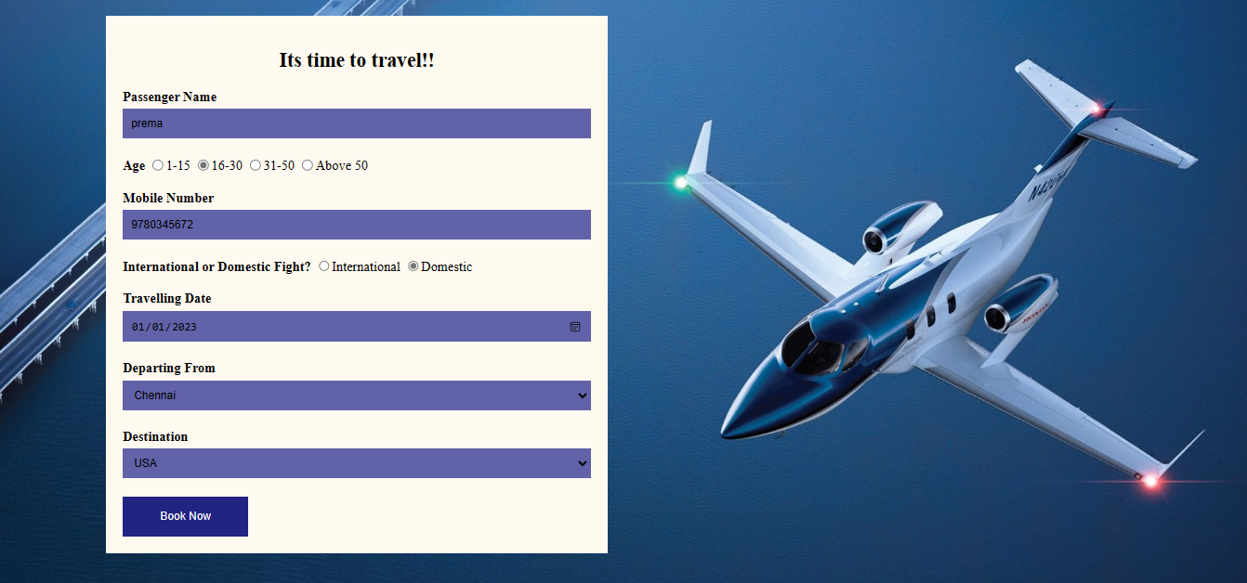

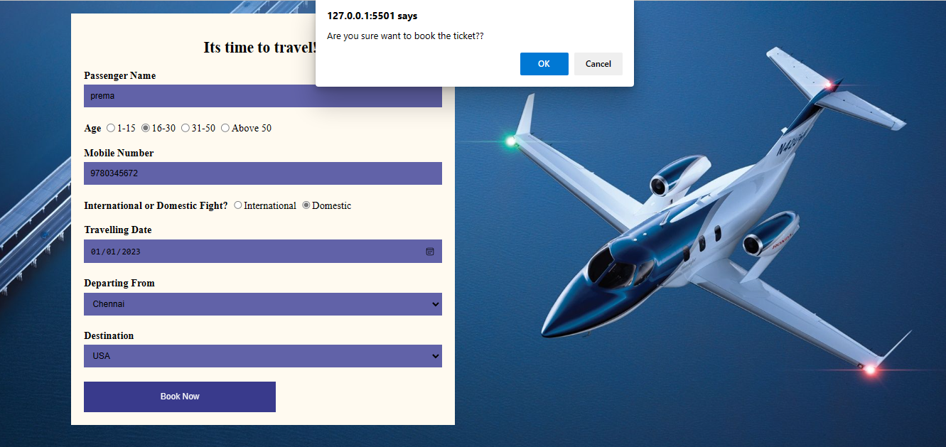

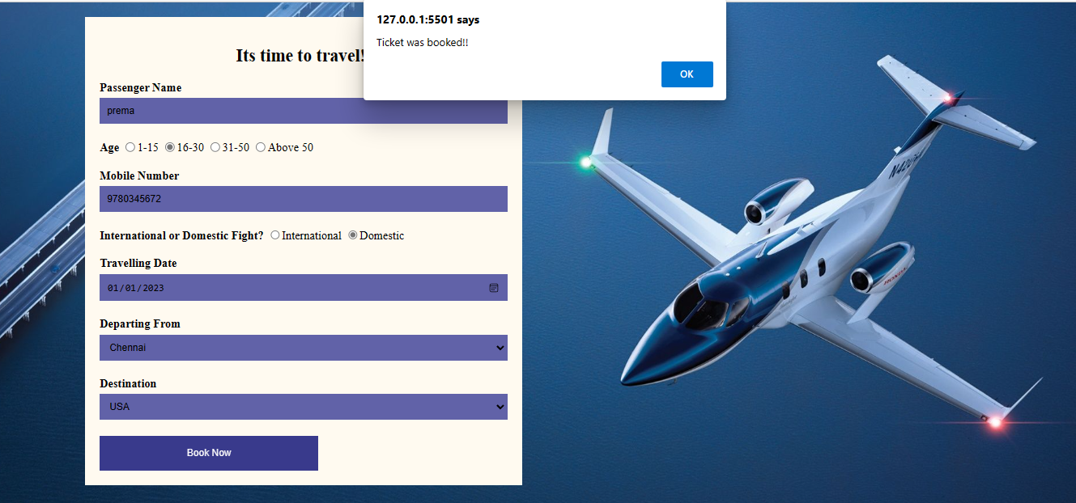

|  |  |  |
| --- | --- | --- |
| **COE** | **20** |  |
| **RECORD** | **15** |  |
| **VIVA** | **15** |  |
| **TOTAL** | **50** |  |

**RESULT**