**INTRODUCTION**

**1.1 About the Project**

**Elderly Care Support: A Helping Hand for a Connected Community**

**Elderly Care Support** is a web-based platform specifically designed to address this critical need. We recognize that seniors may face challenges in maintaining their independence as they age. Daily tasks like grocery shopping, home maintenance, and even social interaction can become more difficult.

**Bridging the Gap: Connecting Volunteers with seniors**

**Elderly Care Support** bridges this gap by fostering a supportive community. Our innovative platform connects volunteers with elderly individuals who require assistance. This allows seniors to maintain their independence in their own homes while receiving the help they need. Volunteers, in turn, gain the satisfaction of giving back to their community and making a positive impact on the lives of others.

**Beyond Assistance: A Holistic Approach to Well-Being**

**Elderly Care Support** goes beyond just providing assistance with daily tasks. Our platform aims to improve the overall well-being of elderly individuals by:

* **Combating Social Isolation:** Provides opportunities for social interaction and connection, reducing feelings of loneliness and isolation.
* **Empowering Independence:** Allows seniors to maintain control over their lives by delegating tasks while remaining in their own homes.
* **Fostering Community Spirit:** Connects volunteers and seniors, creating a sense of belonging and mutual support within the community.

**Elderly Care Support** is more than just a website; it's a social initiative. We are committed to creating a world where seniors can age with dignity, purpose, and a supportive community by their side.

.

**SYSTEM STUDY**

**2.1 Existing System**

## Existing Elderly Care Support Systems: Strengths and Limitations

There are several existing systems in place to support elderly individuals, each with its own strengths and weaknesses. Here's a breakdown to consider:

**Existing Systems:**

* **Government-funded programs:** These programs offer various services like subsidized home care, meal delivery, and transportation assistance. While crucial, they may have eligibility requirements, waiting lists, and limitations on the level of support provided.
* **Community initiatives:** These often involve local organizations, churches, or volunteer groups offering companionship programs, social activities, and transportation services within their communities. Strengths include a personal touch and local focus, but reach might be limited.
* **Private services:** These offer a wider range of personalized care options, including in-home care, assisted living facilities, and specialized services like medication management or medical transportation. However, private services can be expensive and may not be accessible to everyone.

**2.2 Disadvantages of Existing System**

* **Limited Scope:** Existing systems may not address the full spectrum of needs faced by seniors, particularly those related to technology, social interaction, or specific skills-based assistance.
* **Lack of Personalization:** While some personalization exists, especially in community initiatives, many programs offer a one-size-fits-all approach that might not cater to individual preferences and changing needs.
* **Accessibility Issues:** Limited resources and geographical reach can make it difficult for some seniors to access existing support systems, especially in rural areas or for low-income individuals.
* **Technology Gap:** Some programs might not leverage technology effectively, potentially excluding seniors who lack tech skills or access to digital devices.

**2.3 Proposed System**

The Elderly Care Support website seeks to overcome these limitations by providing a user-friendly platform that connects volunteers with elderly individuals in need of assistance. Through features such as task management, secure messaging, and community forums, the platform aims to offer personalized support and foster a sense of community among users.

Advantages of the proposed system include enhanced accessibility, personalized assistance, community engagement, and scalability to accommodate a growing user base. By leveraging technology, the platform aims to streamline the process of connecting volunteers with seniors and improve the overall quality of support provided.

**2.4 Advantages of Proposed System**

**Elderly Care Support** aims to bridge these gaps by:

* **Offering a Wider Range of Assistance:** Our platform facilitates tasks beyond standard care options, connecting seniors with volunteers for specific needs like grocery shopping or companionship.
* **Promoting Personalization:** Users can tailor their experience by specifying requirements for tasks and connecting with volunteers who best suit their needs.
* **Improved Accessibility:** The web-based platform removes geographical barriers and is accessible to seniors with internet access and basic digital literacy.
* **Focus on Technology:** We prioritize user-friendly technology to ensure inclusivity and empower seniors to connect and access services independently.

By combining technology with a community-oriented approach, **Elderly Care Support** aspires to complement existing systems and provide a more personalized, accessible, and holistic approach to elderly care support.

The disadvantages of existing systems include limited accessibility, lack of tailored assistance, and insufficient resources to address the individualized needs of seniors effectively.

**SYSTEM ANALYSIS**

**3.1 Packages Selected:**

**Front-End:**

* **HTML:** The core structure of the website, defining the content and layout.
* **CSS:** Responsible for the visual styling and presentation of the website, including fonts, colours, and layout.
* **JavaScript :** Adds interactivity and dynamic functionality to the website. Users can perform actions without full page refreshes, making the experience more seamless.

**Back-End:**

* **Node.js:** A server-side JavaScript runtime environment that allows you to build scalable web applications. It facilitates communication between the front-end and the database, handling user requests and logic execution.

**Database:**

* **MongoDB:** A NoSQL document database that stores data in flexible JSON-like documents. This makes it ideal for storing user information, task details, and other data associated with the Elderly Care Support platform.

**Benefits of Selected Technologies:**

* **Modern and Efficient:** This combination of technologies is widely used for modern web development, offering strong performance and scalability.
* **Cost-Effective:** Many of these tools are open-source or have free tiers, making development more affordable.
* **Large Developer Community:** Access to a vast community means readily available resources, tutorials, and support for troubleshooting.

**3.2 Resources Required:**

**Hardware:**

* **Servers:** These can be physical servers or cloud-based instances to host the website and database.
* **Development and Testing Machines:** Computers for developers and testers to work on the website functionalities.

**Software:**

* **Development Tools:** Code editors, version control systems (e.g., Git) for managing code changes, and testing frameworks to ensure quality.
* **Design Tools:** Software for creating user interfaces (UI) and user experience (UX) mock-ups.

**Human Resources:**

* **Developers (Front-End and Back-End):** Responsible for building the website functionalities.
* **Designer:** Creates visually appealing and user-friendly interfaces.
* **Project Manager:** Oversees the development process, manages tasks, and ensures project completion within deadline and budget.

**3.3 Data Flow Diagram:**

A data flow diagram (DFD) is a visual representation of how data moves within your system. Here's a breakdown of a potential DFD for Elderly Care Support:

**Entities:**

* **Volunteers:** Register, create profiles, browse tasks, and communicate with seniors.
* **Elderly Users:** Register, create profiles, post tasks, communicate with volunteers, and provide feedback.
* **Admin (Optional):** Manages user accounts, monitors system performance, analyses usage data.

**Processes:**

* **User Registration:** Captures user information and creates user accounts.
* **Profile Management:** Users can edit and update their profiles.
* **Task Management:** Seniors post tasks, volunteers browse and accept tasks.
* **Communication:** Secure messaging system allows communication between volunteers and seniors.
* **Data Storage:** User data, task details, and communication history are stored in the database.

**Data Flows:**

* User registration information flows from user to User Registration process.
* Updated profile information flows from user to Profile Management process.
* Task details flow from seniors to Task Management process.
* Communication messages flow between volunteers and seniors.
* All data is stored in the database.

Creating a DFD helps you visualize the system's functionality and identifypotential bottlenecks or areas for improvement. It also serves as a communication tool between developers and other stakeholders involved in the project.

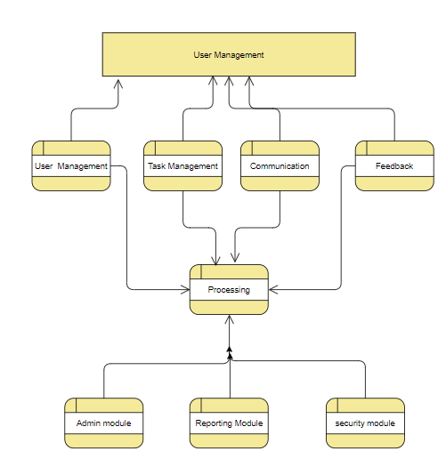

4. SYSTEM DESIGN

4.1 ARCHITECTURAL DESIGN:

The architectural design of the Elderly Care Support system adopts a three-tier architecture model to ensure scalability, maintainability, and security.

Presentation Layer (Front-End):

The front-end layer is responsible for the user interface, allowing users to interact with the system. Technologies such as HTML, CSS, and JavaScript are utilized to build a responsive and intuitive interface. Optionally, frameworks like ReactJS can be integrated to enhance user experience and streamline development.

Business Logic Layer (Back-End):

Sitting between the front-end and the database, the back-end layer serves as the engine of the system. Developed using Node.js, it handles critical tasks such as user authentication, task processing, and communication facilitation. By encapsulating business logic in this layer, the system maintains flexibility and modularity.

Data Layer (Database):

MongoDB serves as the data repository for the Elderly Care Support system. It stores user profiles, task details, messages, and other pertinent information. Adopting a NoSQL approach, MongoDB offers flexibility and scalability, enabling efficient data management and retrieval.

Benefits of Three-Tier Architecture:

- Scalability: Each layer can be scaled independently, allowing the system to accommodate a growing user base without compromising performance.

- Maintainability: Changes made to one layer have minimal impact on others, facilitating easier maintenance and updates.

- Security: By isolating the database layer, sensitive data is protected from direct access, enhancing overall system security.

I/O FORM DESIGN:

In designing input/output forms for the Elderly Care Support system, emphasis is placed on user-friendliness and accessibility.

User Registration:

The registration form captures essential user information such as name, contact details, and location. To enhance accessibility, large fonts and high contrast are utilized, ensuring readability for users with visual impairments. Additionally, pre-defined options and dropdown menus minimize the need for extensive typing, simplifying the registration process.

Task Management:

For elderly users, task management forms feature clear descriptions, location specifications, and instructions. Volunteer forms enable browsing, acceptance, and progress updates for assigned tasks. By incorporating accessibility features such as screen reader compatibility and keyboard navigation, the system caters to users with diverse needs.

Communication:

A secure messaging interface facilitates communication between users. Features include message history and clear sender/recipient information. Accessibility considerations ensure that all users, regardless of technological proficiency, can engage effectively with the messaging system.

TABLES:

The database schema for the Elderly Care Support system comprises several tables, each storing specific data points to ensure efficient data organization and retrieval.

- Users Table: Stores user information, including unique identifiers, contact details, and roles.

- Tasks Table: Contains details of tasks posted, such as descriptions, locations, and assigned volunteers.

- Profiles Table (Optional): Provides detailed user profiles, including biographical information and preferences.

- Messages Table: Archives communication history, recording sender and recipient IDs, message content, and timestamps.

- Feedback Table (Optional): Captures ratings and reviews from seniors for completed tasks, linked to task and user IDs.

- Admin Table (Optional): Manages administrative user details and access levels, if an admin panel is implemented.

**Normalization:**

Through normalization, data redundancy is minimized, and data integrity is improved. Relationships between tables are established using primary and foreign keys, ensuring efficient data retrieval and manipulation.

**Entity Relationship Diagram (ERD):**

The ERD visually represents the relationships between database entities, providing a comprehensive overview of data structure and relationships. By utilizing symbols and notations, the ERD communicates how tables are connected and the data they store.

By meticulously designing the system architecture, input/output forms, and database schema, the Elderly Care Support system ensures optimal functionality, usability, and data management capabilities.

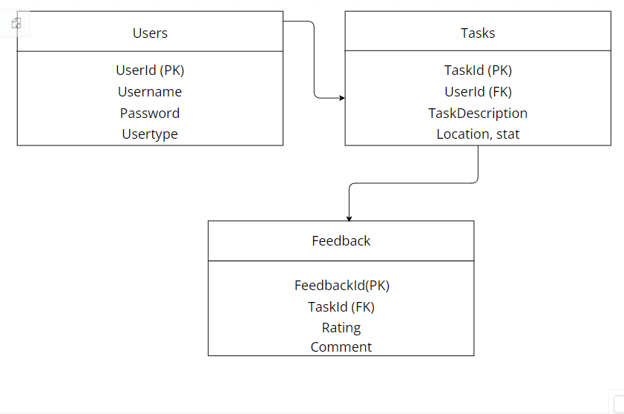

**SYSTEM DEVELOPMENT**

**5. FUNCTIONAL DOCUMENTATION:**

Functional documentation serves as a comprehensive guide for understanding the functionalities of the Elderly Care Support System. Here's an outline covering key aspects:

**User Registration:**

- **Process**: Detailed steps for user registration, including gathering essential information such as name, contact details, and location. Validation procedures ensure data accuracy and completeness.

- **Success**: Upon successful registration, users receive a confirmation message and gain access to the system's functionalities.

- **Error Handling:** Clear error handling procedures are outlined for scenarios involving invalid information or duplicate registrations. Users are prompted to correct errors and resubmit their registration details.

**Task Management:**

**Elderly User:**

- Search and Browsing: Elderly users can search and browse available tasks based on criteria such as location, category, and urgency.

- Posting New Tasks: Instructions for posting new tasks, including providing detailed descriptions, specifying location, and setting task deadlines.

- Managing Existing Tasks: Guidance on how users can manage existing tasks, including editing, updating, or canceling tasks as needed.

- **Volunteer**:

- Browsing Tasks: Volunteers can browse available tasks and filter them based on preferences and availability.

- Accepting Tasks: Steps for volunteers to accept tasks they're willing to assist with, confirming their commitment to the task.

- Managing Assigned Tasks: Instructions for volunteers to manage assigned tasks, including updating task status, communicating with task posters, and completing tasks within specified timelines.

**Benefits of Functional Documentation:**

- Clear Communication: Provides stakeholders with a shared understanding of the system's behaviour and functionalities, reducing misunderstandings and discrepancies.

- Improved Development Efficiency: Reduces ambiguity and streamlines the development process by providing developers with clear guidelines and requirements.

- Effective Maintenance: Serves as a reference point for future modifications and updates, enabling efficient maintenance and troubleshooting.

**5.2 SPECIAL FEATURES OF PROGRAMMING LANGUAGES/FRAMEWORKS:**

**HTML**:

- Structure and Content: HTML provides the foundation for structuring web pages, defining the layout, and organizing content elements such as text, images, and multimedia.

**CSS:**

- Styling and Presentation: CSS controls the visual appearance of web pages, allowing developers to customize colours, fonts, layouts, and other visual aspects to enhance the user experience.

**JavaScript:**

- Interactivity and User Experience: JavaScript adds dynamic features to web pages, enabling interactive elements such as forms, animations, and real-time updates, thereby enhancing user engagement and experience.

**Node.js:**

- Server-Side Scripting: Node.js allows developers to build server-side applications using JavaScript, facilitating seamless communication between the front-end and back-end components of the Elderly Care Support System.

**MongoDB:**

- NoSQL Data: MongoDB offers a flexible and scalable data storage solution, allowing developers to store and retrieve data in a document-oriented format, thereby accommodating the diverse and evolving needs of the Elderly Care Support System.

6. **TESTING**

**6.1 Types of Testing Done:**

During the development phase of the Elderly Care Support System, several types of testing are conducted to ensure the quality, reliability, and functionality of the system.

**Unit Testing:**

Unit testing involves testing individual components or units of code in isolation. Each unit is tested independently to verify that it performs as expected. This type of testing helps identify bugs and errors in specific functions or modules early in the development process. For example, unit tests may check the functionality of user registration, task creation, or message sending modules.

**Integration Testing:**

Integration testing focuses on testing the interactions between different modules or components of the system. It ensures that the integrated parts work together as intended and that data flows correctly between them. Integration tests help uncover issues such as interface mismatches, data inconsistencies, or communication errors between system components. For example, integration tests may verify that user registration data properly integrates with the user profile module and that task assignments are correctly communicated between users and volunteers.

**User Acceptance Testing (UAT):**

User acceptance testing (UAT) involves testing the system from the end user's perspective to ensure that it meets their requirements and expectations. UAT is typically conducted by real users or stakeholders who simulate real-world scenarios to validate the system's usability, functionality, and overall user experience. Feedback from UAT helps identify any usability issues, interface inconsistencies, or missing features that need to be addressed before the system is deployed to production. For example, UAT may involve elderly users posting tasks, volunteers accepting tasks, and both parties communicating through the messaging system to ensure a smooth user experience.

**6.2 Test Data and Output:**

In order to conduct testing effectively, examples of test data are used to validate different system functionalities. Test data represents various scenarios and inputs that users may encounter while using the system. Along with test data, expected output results are defined based on the system requirements and specifications.

For example, when testing the user registration functionality, test data may include different combinations of user information such as names, email addresses, and passwords. The expected output results would include successful registration confirmation messages or error messages for invalid inputs.

Similarly, when testing task management functionalities, test data may include sample task descriptions, locations, and timeframes. The expected output results would include tasks being successfully created, assigned, and completed, with appropriate notifications sent to users involved in the process.

By using test data and defining expected output results, the testing process aims to identify and resolve any issues or bugs in the system before it goes live. This helps ensure that the Elderly Care Support System is reliable, functional, and meets the needs of its users.

**7. USER MANUAL:**

The user manual provides comprehensive guidance for users on how to access and utilize the Elderly Care Support website effectively. It covers hardware and software requirements, installation procedures, and error handling to ensure a smooth user experience.

**7.1 Hardware Requirements:**

Minimum hardware specifications necessary for accessing the website are outlined. This includes basic requirements such as a computer or mobile device with internet connectivity. These specifications ensure optimal performance and compatibility with the platform.

For example:

- Computer or mobile device with internet connectivity

- Recommended screen resolution for optimal viewing experience

**7.2 Software Requirements:**

Software requirements essential for accessing the website are listed. This includes web browsers, operating systems, and any additional plugins or extensions necessary for seamless functionality. Users need to have these software components installed to access and use the website effectively.

For example:

- Web browser (e.g., Chrome, Firefox, Safari)

- Operating system (e.g., Windows, macOS, iOS, Android)

- Additional plugins or extensions (e.g., Adobe Flash Player, JavaScript enabled)

**7.3 Installation Procedure:**

Step-by-step instructions for installing and configuring the website on a local or remote server are provided. These instructions guide users through the setup process, ensuring a smooth and hassle-free installation experience. The installation procedure may include downloading necessary files, configuring server settings, and setting up database connections.

For example:

1. Download the latest version of the Elderly Care Support website from the official website.

2. Extract the downloaded files to your local server directory.

3. Configure database settings in the configuration file (if applicable).

4. Access the website through your web browser by entering the server's URL.

7.4 Error Messages:

Common error messages users may encounter while using the website are documented, along with troubleshooting tips or solutions. This information helps users resolve issues independently and ensures a positive user experience. Error messages may include login failures, invalid input notifications, or server connection errors.

For example:

- Error: "Invalid username or password. Please try again."

Solution: Double-check your username and password and ensure caps lock is disabled.

- Error: "Connection timed out. Please check your internet connection."

Solution: Verify your internet connection and try refreshing the page. If the issue persists, contact your internet service provider.

By providing clear instructions and troubleshooting guidance, the user manual aims to empower users to navigate the Elderly Care Support website with ease and confidence.

**8. CONCLUSION:**

The conclusion section serves as the final reflection on the Elderly Care Support project, providing a comprehensive summary of its achievements and outlining potential future directions for development and improvement.

**8.1 Summary of the Project:**

In this subsection, a detailed summary of the project's objectives, design, development process, and impact is provided. It encapsulates the essence of the project and its significance in addressing the needs of elderly individuals in the community.

For instance:

"The Elderly Care Support project embarked on a journey to create a holistic platform tailored to meet the diverse needs of our elderly population. Through meticulous planning, collaborative efforts, and a user-centred approach, we successfully developed a user-friendly website designed to facilitate access to essential support services for seniors. By focusing on enhancing social interaction, providing assistance with daily tasks, and promoting overall well-being, our platform endeavours to significantly improve the quality of life for elderly individuals while fostering a more inclusive and supportive community environment."

8.2 Future Enhancements:

This subsection delves into potential avenues for future development and enhancement of the Elderly Care Support platform. It considers user feedback, emerging technology trends, and evolving needs to chart a course for continued improvement and innovation.

For example:

"As we look towards the future, our commitment to serving the elderly community remains steadfast. We envision several exciting enhancements to the Elderly Care Support platform, including the integration of community forum to provide personalized assistance, expansion of social engagement features such as virtual events and support groups, and strategic partnerships with healthcare providers to offer telemedicine services. By remaining agile and responsive to the evolving needs of our users and leveraging cutting-edge technologies, we aim to propel the platform to new heights of effectiveness and accessibility, ensuring it continues to serve as a beacon of support and empowerment for elderly individuals in our community."

Through this elaboration, the conclusion section provides a fitting culmination to the Elderly Care Support project, encapsulating its achievements and paving the way for a future of continued growth and impact in the realm of elderly care support.