**FindBugs**

This is the web page for FindBugs, a program which uses static analysis (Analyzes code without running it) to look for bugs in Java code.  It is free software, distributed under the terms of the [Lesser GNU Public License](http://www.gnu.org/licenses/lgpl.html).

Looks for bug patterns, inspired by real problems in real code

Findbugs provides early feedback about potential errors in the code. This helps the developer to access these problems early in the development phase.

**Ways to run FindBugs**

Command line, ant, GUI

Provided in FindBugs download

[Eclipse](http://www.eclipse.org/)

Update site for Eclipse plugin: <http://findbugs.cs.umd.edu/eclipse>. Supported by the FindBugs project.

[Maven](http://maven.apache.org/)

<http://mojo.codehaus.org/findbugs-maven-plugin/>

[Netbeans](http://netbeans.org/)

[SQE: Software Quality Environment](http://kenai.com/projects/sqe/pages/Home)

[Jenkins](https://wiki.jenkins-ci.org/display/JENKINS)

[Jenkins FindBugs Plugin](https://wiki.jenkins-ci.org/display/JENKINS/FindBugs+Plugin)

[Hudson](http://wiki.hudson-ci.org/display/HUDSON/Home)

[HUDSON FindBugs Plugin](http://wiki.hudson-ci.org/display/HUDSON/FindBugs+Plugin)

[IntelliJ](http://www.jetbrains.com/idea/)

Several plugins, see <http://code.google.com/p/findbugs/wiki/IntellijFindBugsPlugins> for a description.

**Using FindBugs with eclipse plugin**

**Step1:** To install findbugs plugin goto **Help** > **Install New Software**. Then add <http://findbugs.cs.umd.edu/eclipse/> as shown below and click **OK** button.

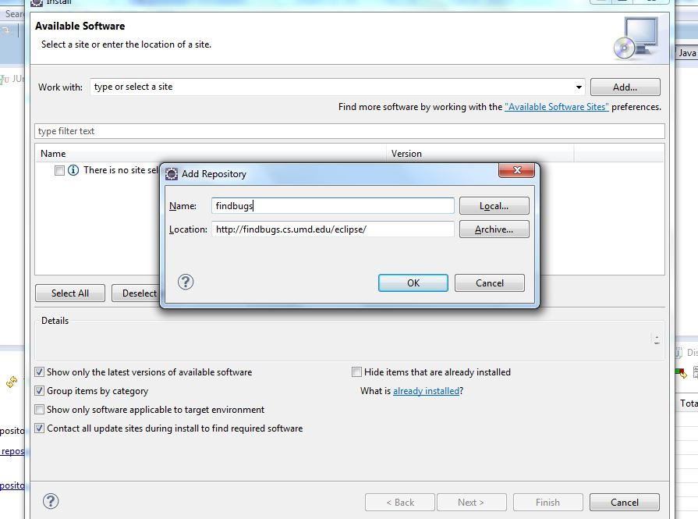

**Step2**: select FindBugs and click next .

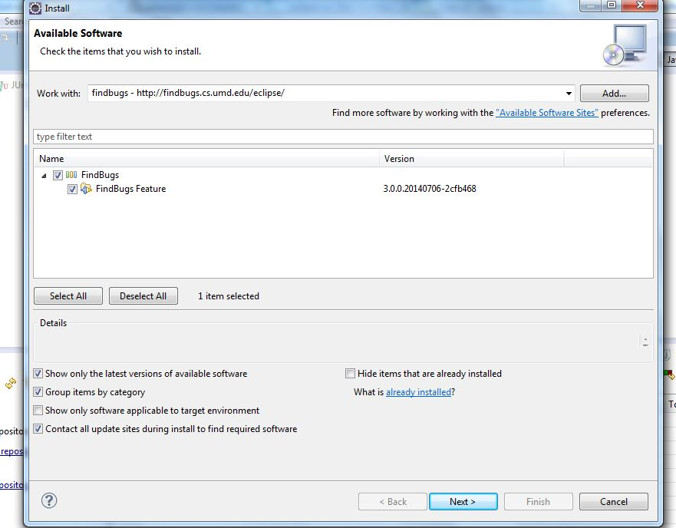

**Step 3 :** Again click nextas shown below.

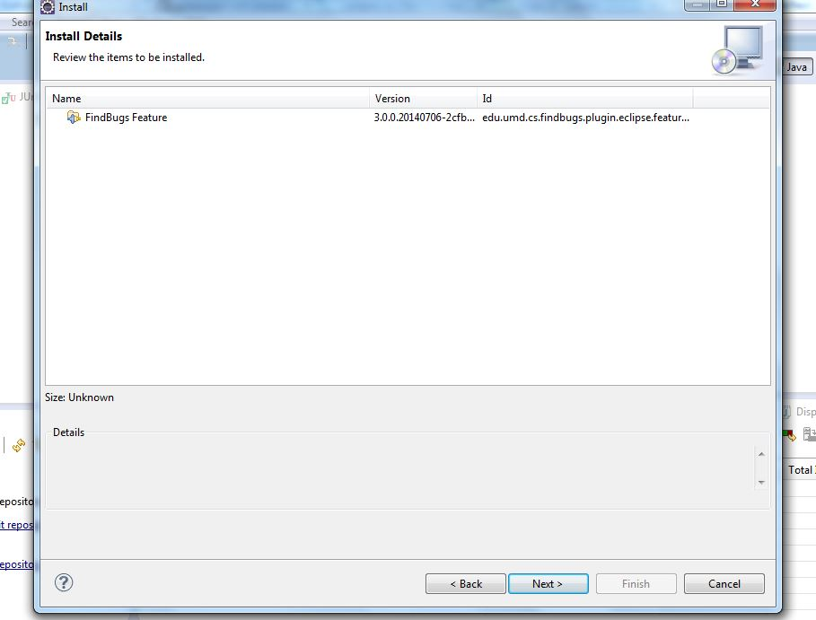

**Step 4**: Accept the terms of the license agreement and click finish

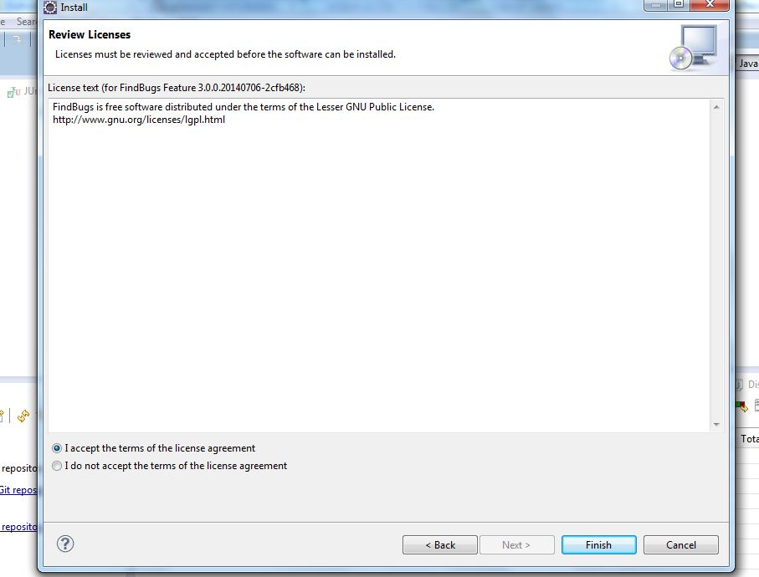

## FindBugs Configuration

After install, you can configure FindBugs from eclipse, goto **Window >Preferences >Java >FindBugs**

Here you can apply FindBugs filter, in order to utilizing different Findbugs bug patterns

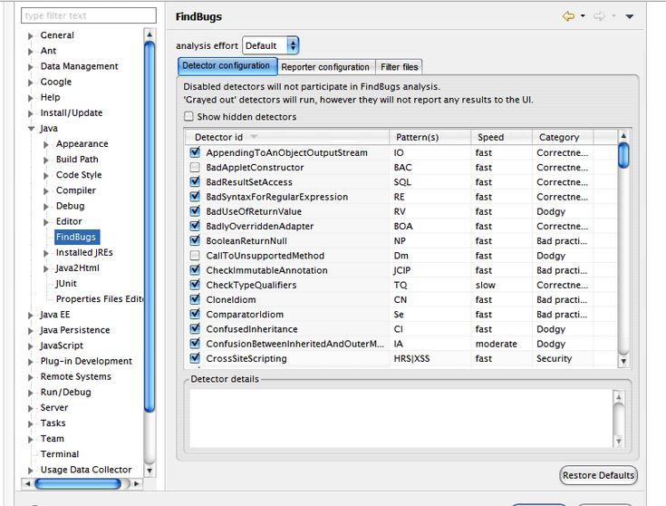

**Scan your code for bugs using findbugs**

Right click on your project goto **Find Bugs** option then select **Find bugs** as shown in the figure below.

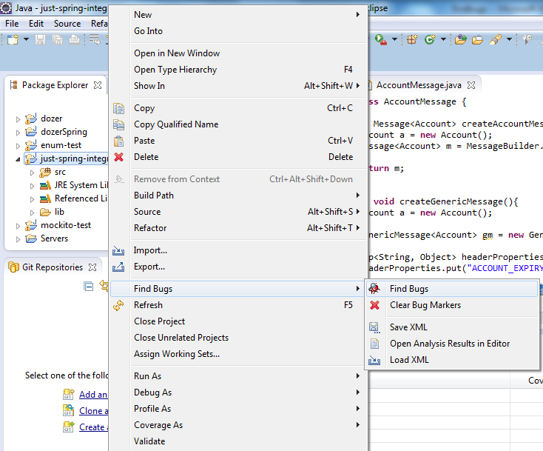

Now to the right of your project name the number of bugs will be displayed. To view all the bugs in detail you can switch to findbugs perspective( by **window > open perspective > other** then select findbugs ).

Findbugs perspective has important views like **Bug Explorer**, **Bug Info**. **Bug Explorer** lists all the bugs. If you double click a bug in the Bug Explorer then the location of that bug will be opened in your editor, and the details of that kind of bug will be shown on **Bug Info view.** Snapshot of Bug Explorer is given below.

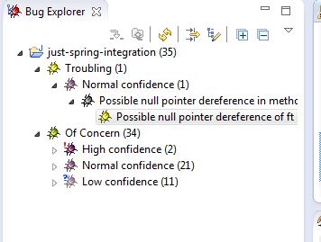

After you are done to clean the list of bugs right click on your project goto **Find Bugs** option then select **Clean Bug Markers.**