docker-compose up kafka-cluster

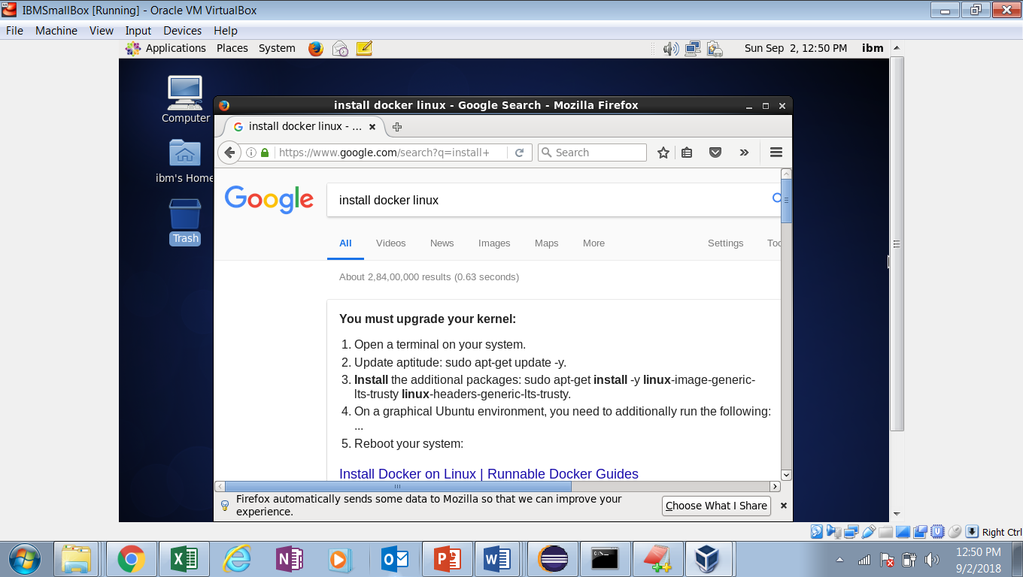

<https://runnable.com/docker/install-docker-on-linux>

Red Hat Enterprise Linux (RHEL) and CentOS

Open terminal

Log in as root:ibmroot

Follow instruction

sudo yum update -y

sudo yum install epel-release

sudo yum install docker-io

1. Download and install OVM (version 5.2.8)



Steps to create new box

1. Download and install oracle virtual box

Download centos

1. Download centos7. <https://www.centos.org/download/>
   1. File size - 4.2 GB
   2. Name: CentOS-7-x86_64-DVD-1804
2. Steps “https://www.youtube.com/watch?v=Pcl417NR2xc”
3. Open oracle virtual box
4. New🡪
   1. Name: IBMBigbox
   2. Type:Linux
   3. Version: redhut64
   4. Memory: 5024 MB
   5. Select “Create a virtual disk”
   6. Click on “Create” button

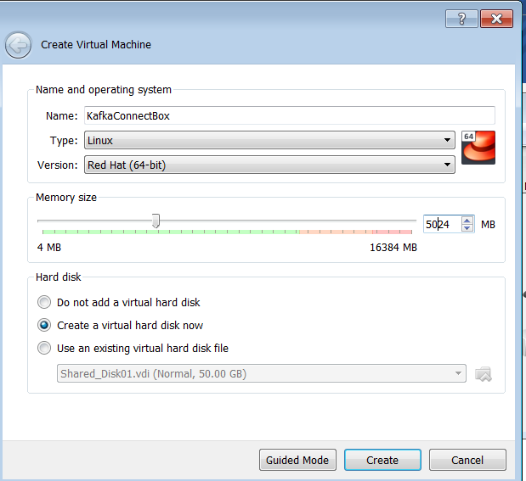

* 1. File size : 30 GB🡪 and click on “Create” button

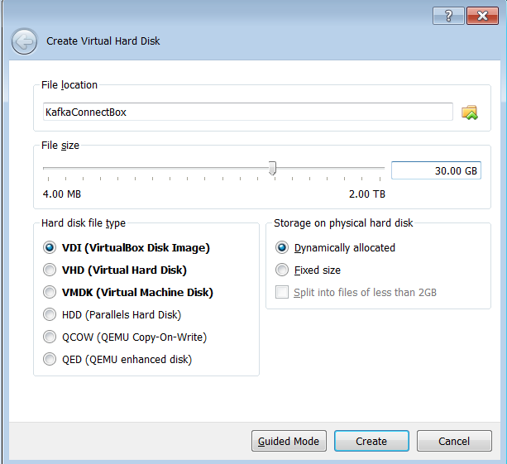

1. Settings🡪
   1. System🡪processor🡪cpu:2

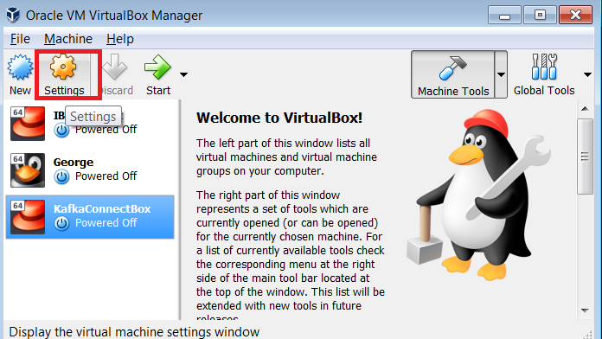

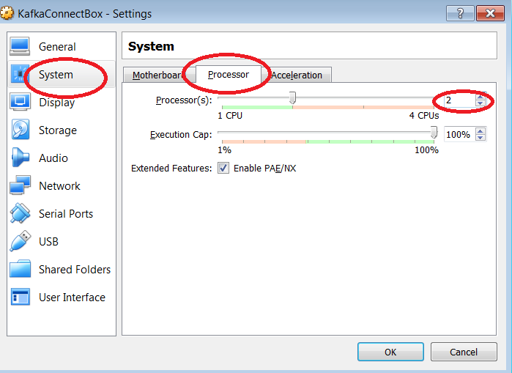

1. Storage🡪
   1. Controller🡪Empty🡪 click on disk sign at the right side🡪 “Choose Virtual Optical Disk

File”

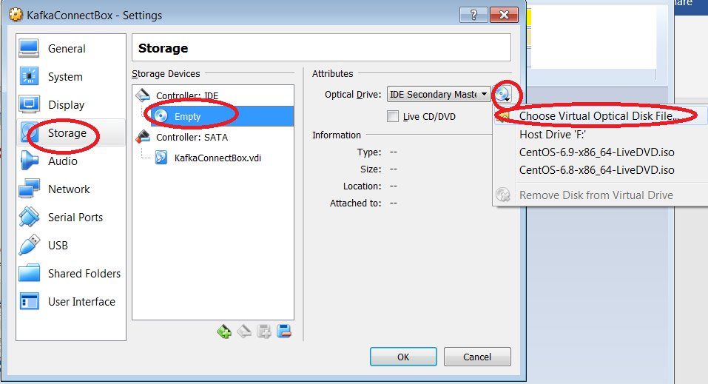

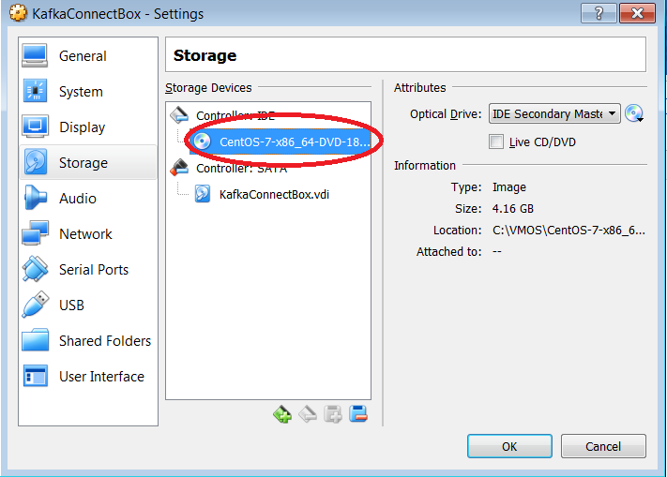

1. Ok
2. Start the box ( green arrow)

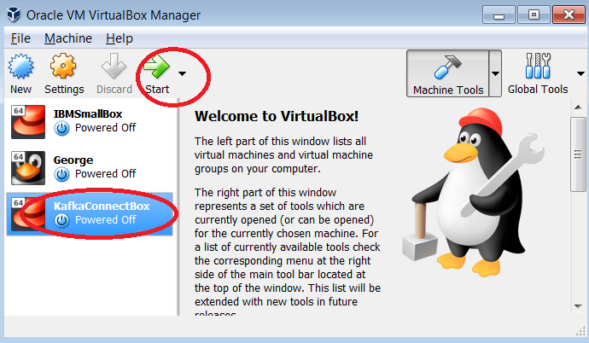

1. Automatically new linux box will open
   1. Use your right “ctrl” button for controlling the mouse inside and outside the box
   2. On the black screen select “install Centos Os 7” using up/down arrow button( after setting cursor using right “ctrl”)
   3. Select language: US🡪 English and press “continue” button (down)

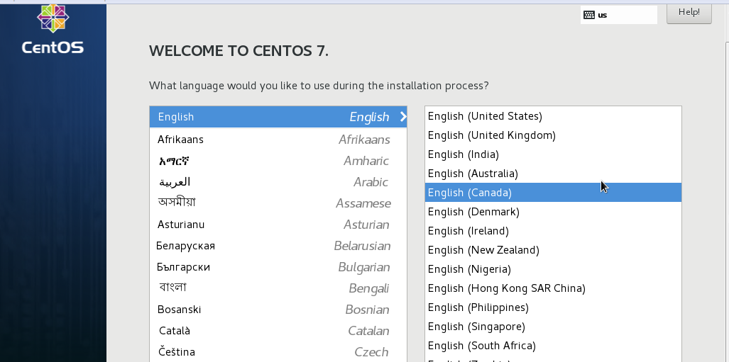

Set the time Region🡪 Asia and City 🡪 Kolkata

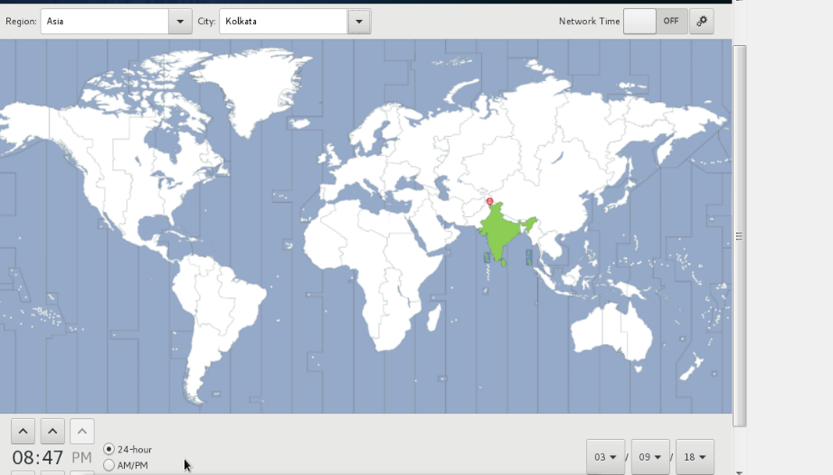

“Done”

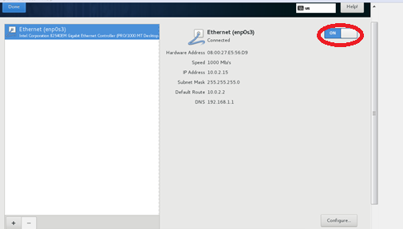

Press “Install” and set root password as “kafka” and create a new user

username: kafka

password: kafka

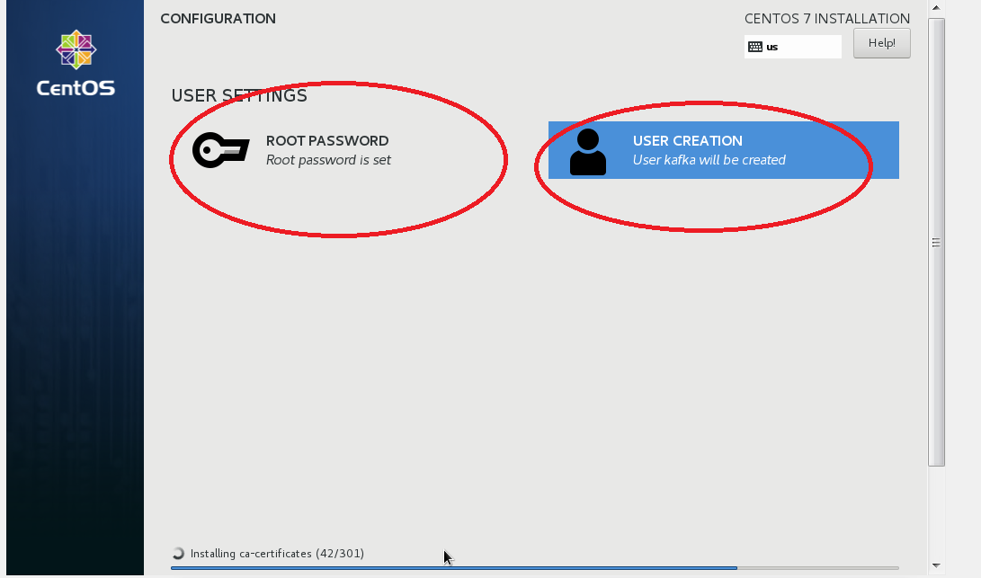

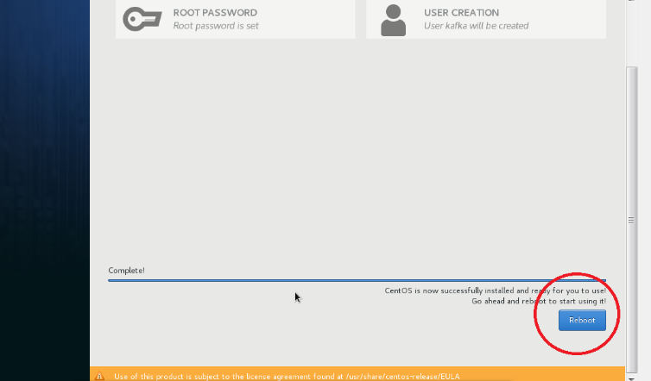

Reboot

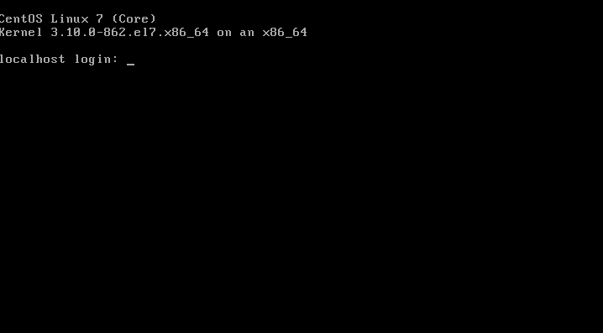

1. Configure the disk
   1. Close the alert
   2. Automatic login
   3. Double Click on “Install to hard drive” desktop folder
   4. Next🡪 us English🡪basic storage🡪discard data🡪city as Kolkata🡪root password🡪ibmroot🡪default option 🡪 write to disk
   5. This will take some time
   6. Close and restart the system from System tab inside VM
2. Select newly created VM🡪 settings🡪storage🡪remove cd image
3. Start the box
4. Create a new user
   1. User:Ibm
   2. Pasword:ibm
5. Install JDK 🡪  tar -xvf jdk-8u101-linux-i586.tar.gz

Kafka Connect

<https://gerardnico.com/dit/kafka/ksql>

https://dzone.com/articles/streaming-analytics-using-kafka-sql