Kafka-Connect Lab

By Goutam Chowdhury

1. We going to use [landoop image](https://github.com/Landoop/fast-data-dev) to run Kafka
2. Download landoop image and run the kafka cluster

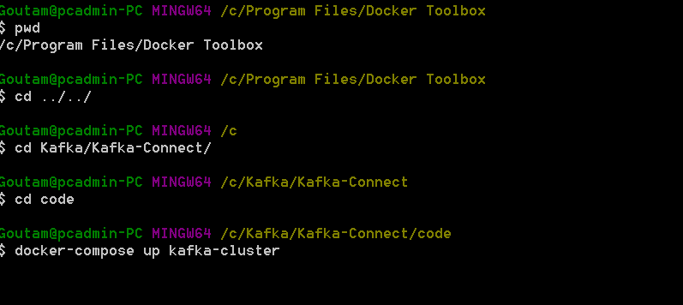

1. It will take 15-20 mins to download and start the container and final successful running will be looking like this

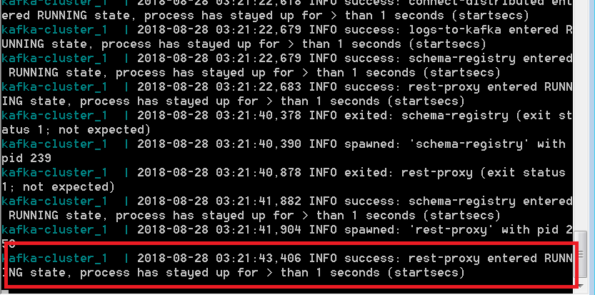

1. M nb cx cxcx xcx/xZAN jcIf we browse <http://192.168.99.100:3030/> then we will see below screenshot

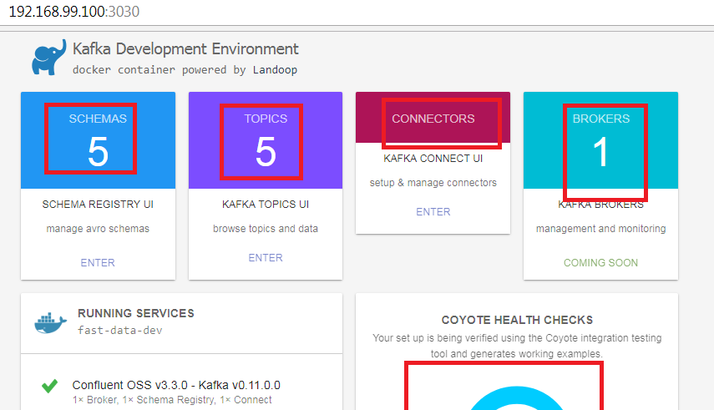

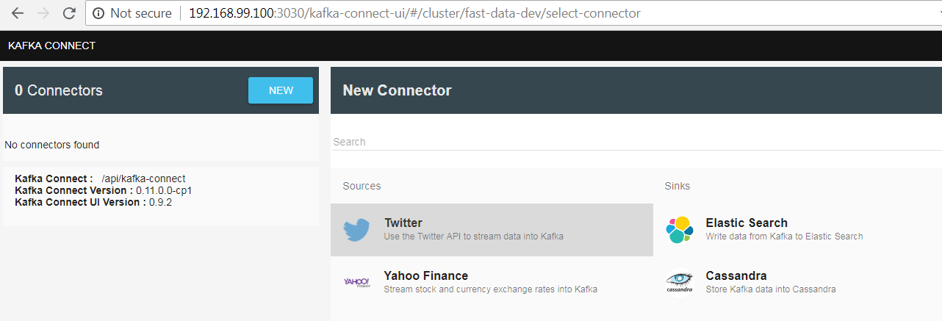

How to check logs

