Even Exercises 1.4-1.12 Long Jump

Tanuj Guha

Feb. 25, 2023

## Explore the Data

library (Stat2Data)  
data ("LongJumpOlympics2016")  
head (LongJumpOlympics2016)

## Year Gold  
## 1 1900 7.185  
## 2 1904 7.340  
## 3 1906 7.200  
## 4 1908 7.480  
## 5 1912 7.600  
## 6 1920 7.150

plot (LongJumpOlympics2016)

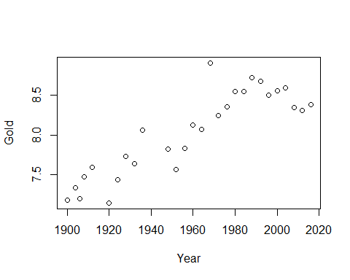

Does the distance of the Gold medal winning long jump in the Olympics depend on year?

## Fit the simple linear regression model

ljmod = lm (Gold ~ Year, data=LongJumpOlympics2016)  
summary (ljmod)

##   
## Call:  
## lm(formula = Gold ~ Year, data = LongJumpOlympics2016)  
##   
## Residuals:  
## Min 1Q Median 3Q Max   
## -0.39610 -0.15495 -0.00137 0.11606 0.75349   
##   
## Coefficients:  
## Estimate Std. Error t value Pr(>|t|)   
## (Intercept) -16.470194 2.666282 -6.177 1.56e-06 ***  
## Year 0.012508 0.001361 9.191 1.19e-09 ***  
## ---  
## Signif. codes: 0 '***' 0.001 '**' 0.01 '*' 0.05 '.' 0.1 ' ' 1  
##   
## Residual standard error: 0.2595 on 26 degrees of freedom  
## Multiple R-squared: 0.7646, Adjusted R-squared: 0.7556   
## F-statistic: 84.47 on 1 and 26 DF, p-value: 1.192e-09

## Exercise 1.4

0.012508 is the slope estimate.

plot (Gold ~ Year, data=LongJumpOlympics2016)  
abline (ljmod)

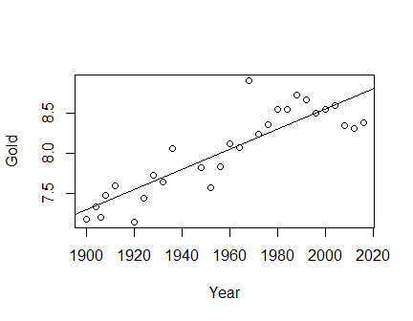

## Exercise 1.6

Y intercept ~ 7.4 units of Y axis. (FOR THIS GRAPH ONLY) Note: the units in Y-axis are positive for this graph because the year value in X-axis doesn’t begin at origin. At origin, the ‘true’ intercept would be -16.47

confint (ljmod)

## 2.5 % 97.5 %  
## (Intercept) -21.950814390 -10.98957270  
## Year 0.009710991 0.01530598

## Exercise 1.8

We expect the slope intercept to be between -21.95 and -10.98 units with 95% Confidence.

## Exercise 1.10

0.2595 (units of length)^2

## Exercise 1.12

26 degrees of freedom

## Assess the fit

par (mfrow = c(1, 2))  
plot (ljmod, which=1:2)

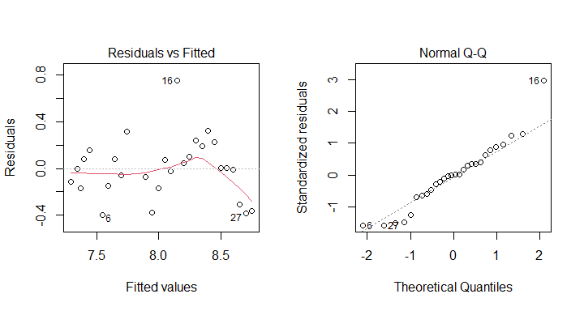

The residuals vs fitted plot does not indicate non-linearity, and there doesn’t appear to be any obvious outlier either.