Name: Gustavo Hammerschmidt.

Screenshot 1:
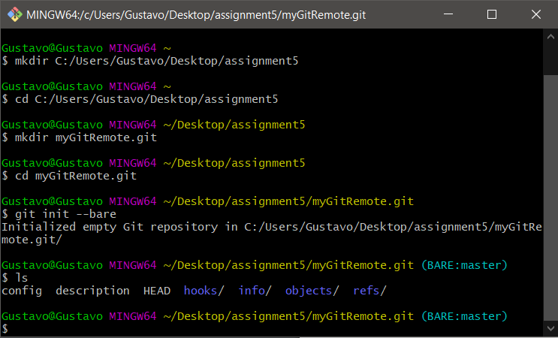

Screenshot 2:
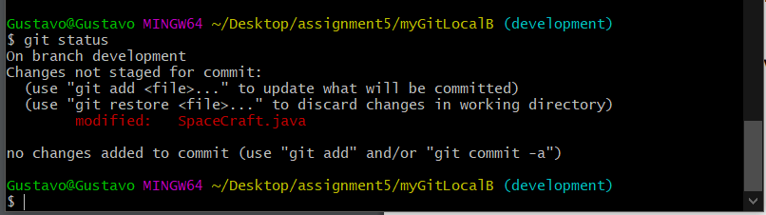

Screenshot 3 (Merge conflict message):
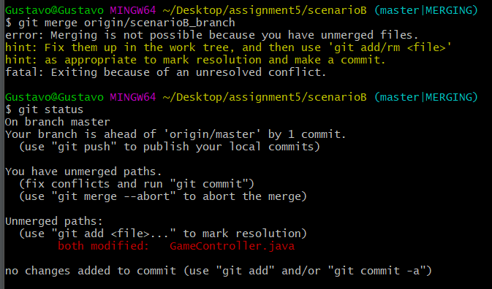

Screenshot 3 (Merge diff view of changes on both files):

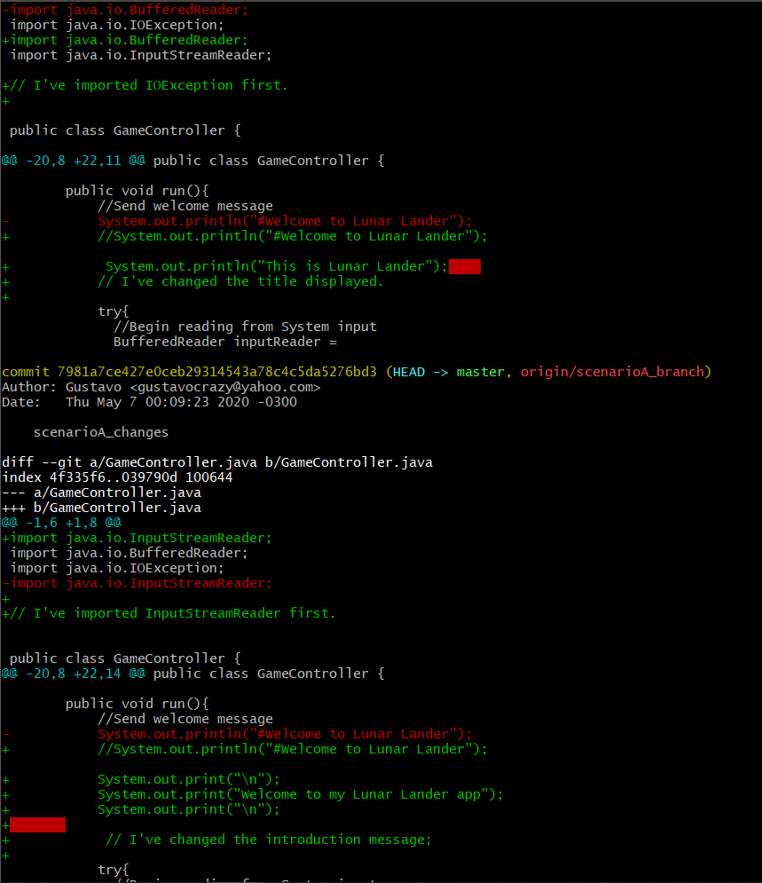

Screenshot 3 (Merge conflict fixed):
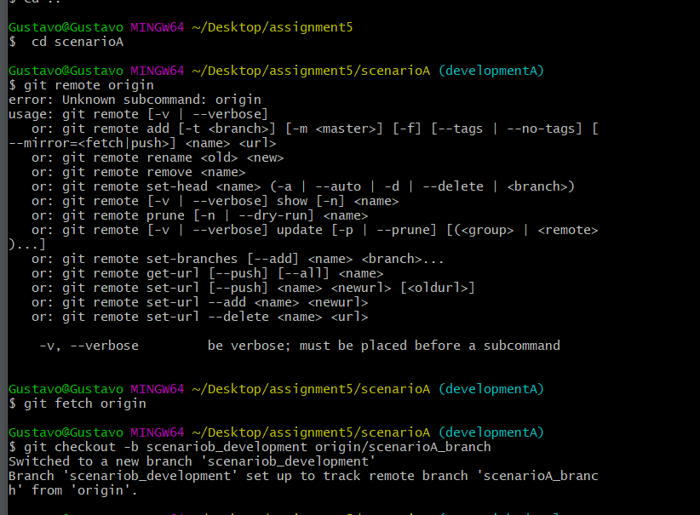

Question1:

No, the changes I have made did not show up because the development branch was not merged to the master branch.

Question 2:

Yes, because I have fetched the latest data from the repository.

Description of Task 1:

- I have made two local repositories, named: scenarioA and scenarioB. On both, I have changed the order of the imports in a way both would have the same imports, but in a different calling order. I have made changes to the way the title: "Welcome to Lunar Lander" was displayed in both files. To solve the merging conflict, I have executed the command diff to check where the conflicts happened, and then picked one of both files and manually changed the file to avoid conflicting with the other scenario file. Then, I have fetched the scenario with the origin and both scenarios had the changes I chose up to date. I sent three screenshots of number 3. screenshot3_merge_conflict_message shows the first time that a merge conflict message was reported; screenshot3_merge_diff_view shows the diff view of the changes on both files and screenshot3_merge_conflict_fixed shows the message that the conflict was resolved. I have sent a file with all the commands executed on the prompt throughout the whole assignment, named: prompt_command_execution.txt. I have also sent a zip folder that contains the git repository, screenshots, this file on docx version and the text files that I have made when working on the assignment as notes.

