Name: Gustavo Hammerschmidt.

Project 1 - Report

Test your program as following:
1. Run qualcommserver.py, viasatserver.py and localserver.py programs.
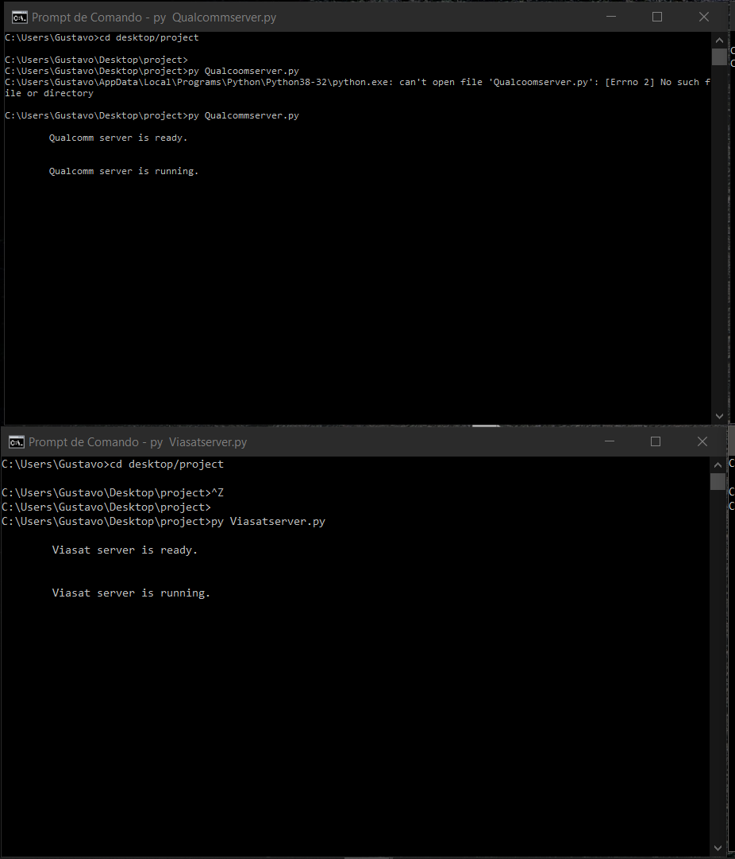

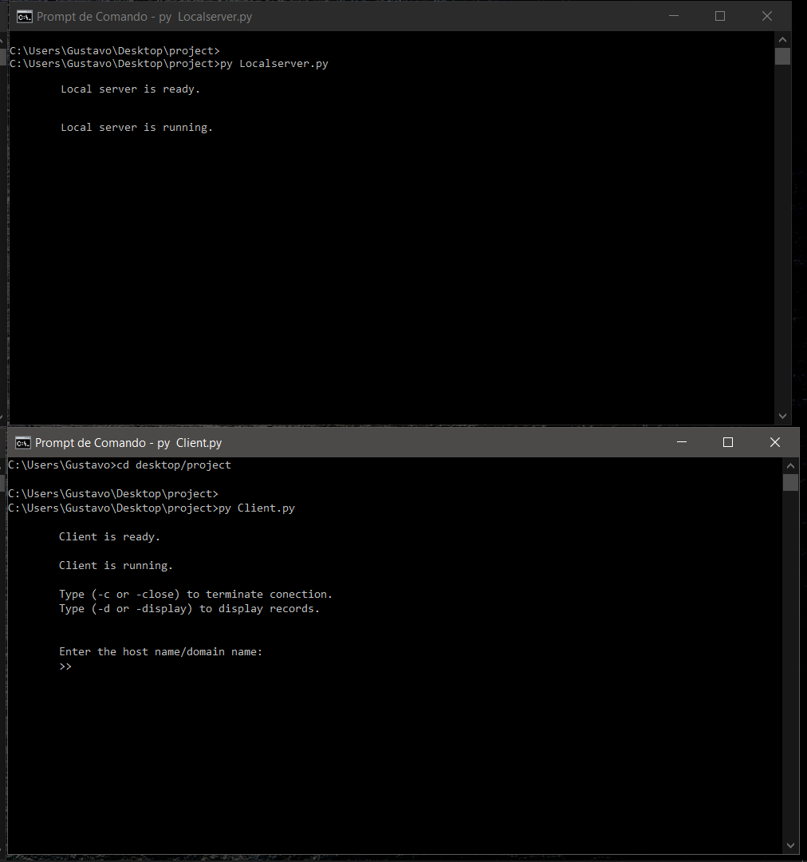

2. Run client.py. Then enter an A request for www.csusm.edu and an A request for my.csusm.edu. Recall that each time a system responds a request, it should print its current RR table. Wait for almost 20 seconds and then enter another A request for www.csusm.edu. Take a screen shot of the two tables to show that the client program did NOT send a request to the local DNS server for the second request for www.csusm.edu. The TTL of www.csusm.edu record should be 60 after the first response and some number below 60 after the second request. Also make sure that you don’t have two different records for the same hostname www.csusm.edu.

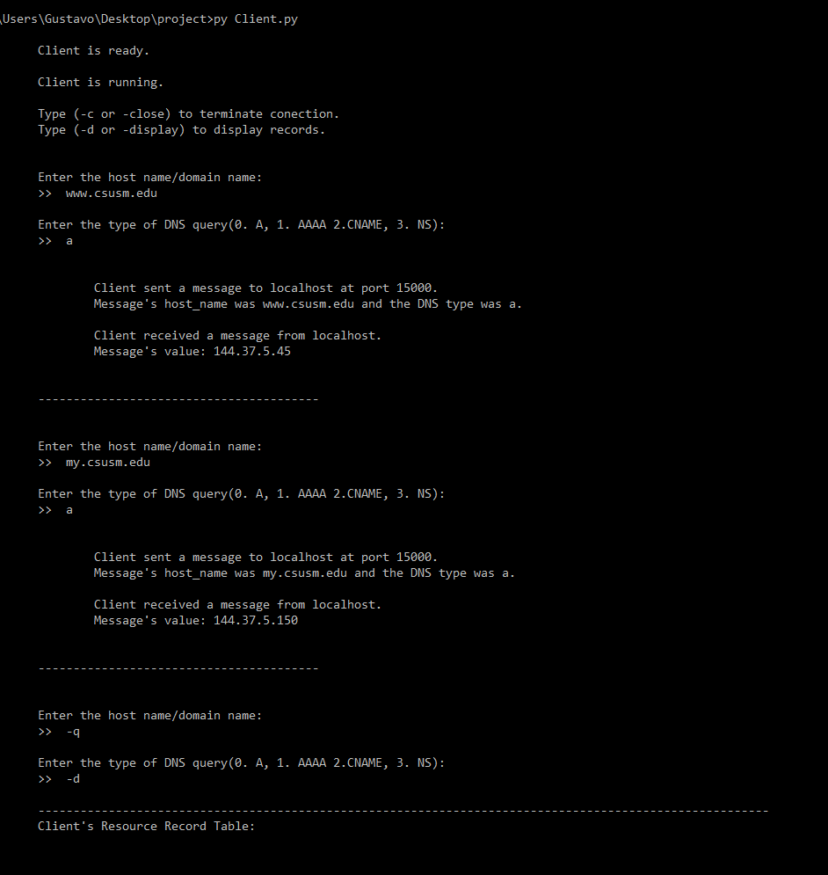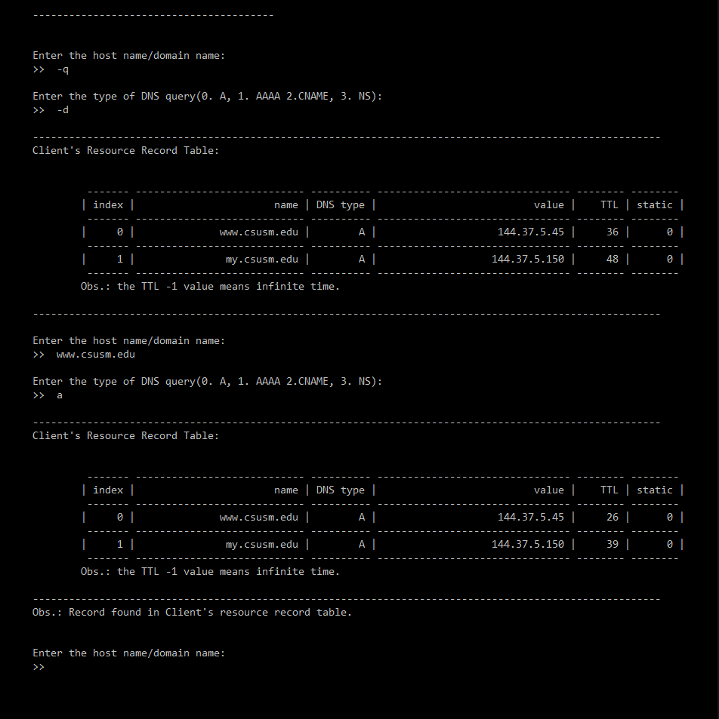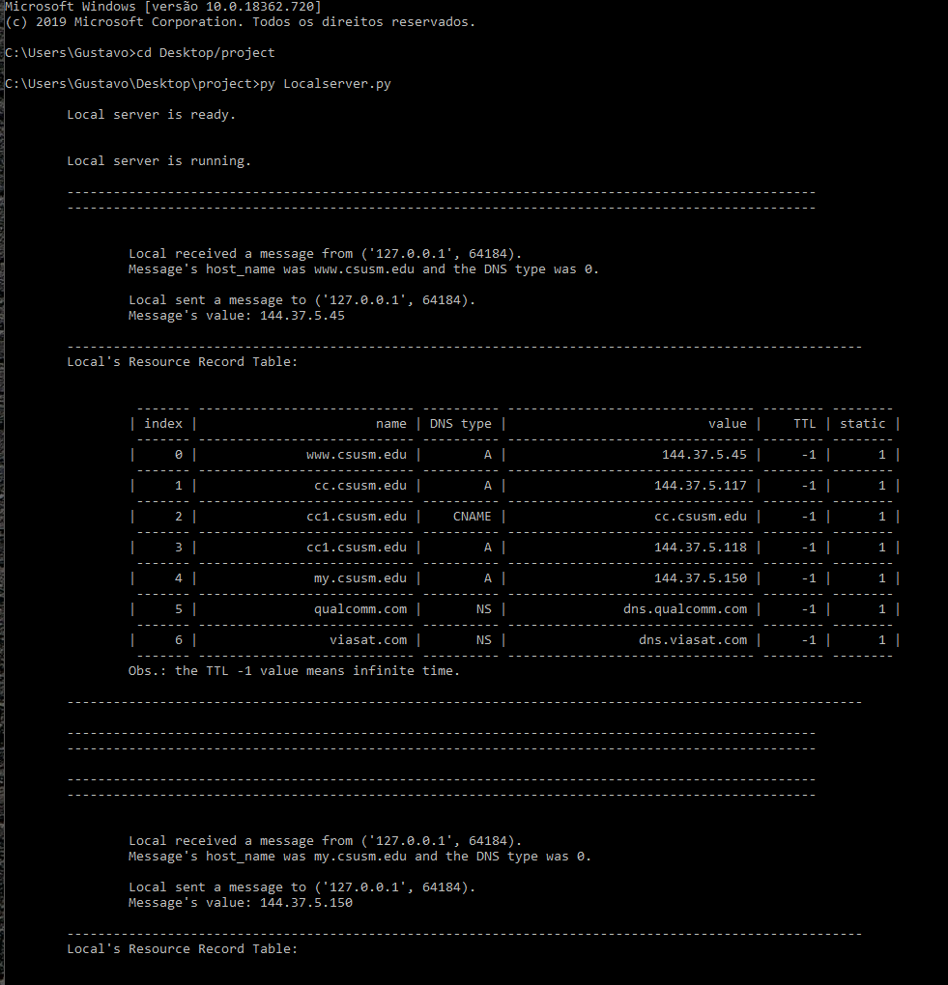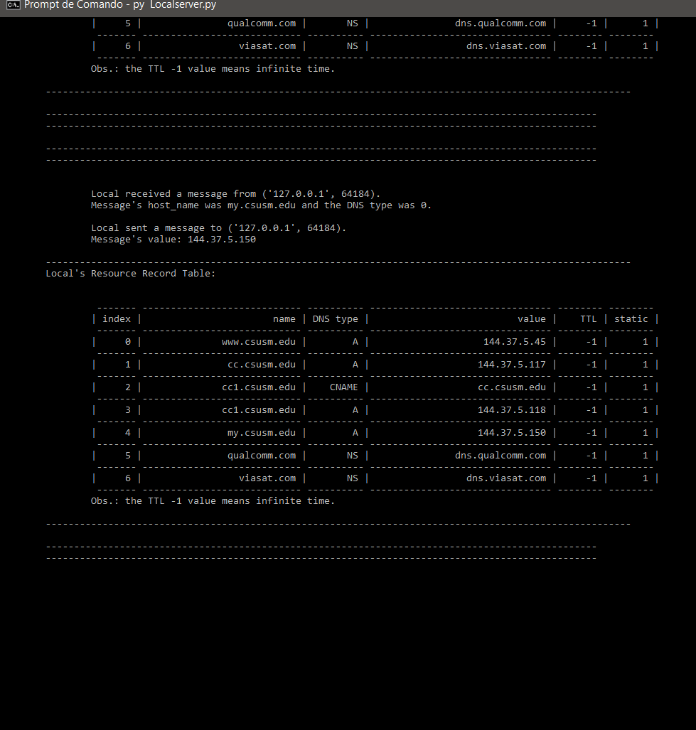

3. Do not close the first terminal for client.py. Run client.py again in a new terminal and enter an A request for www.csusm.edu. Observe that the new client program has its own RR table, which does NOT contain the records of the first client’s RR table. It separately sends a request to the local DNS server and once retrieved the Value, stores that in its own RR table with TTL=60. Take screenshots at each step and add them to your report file.

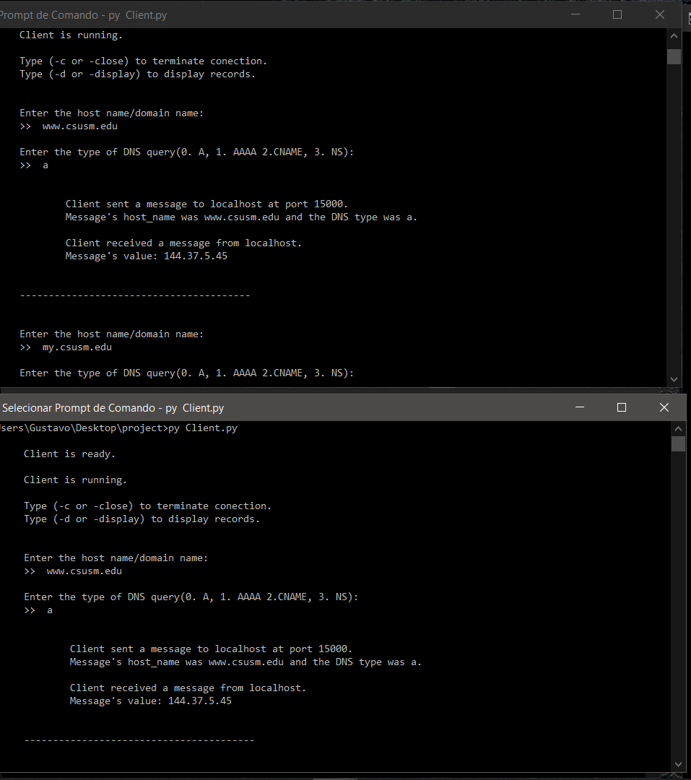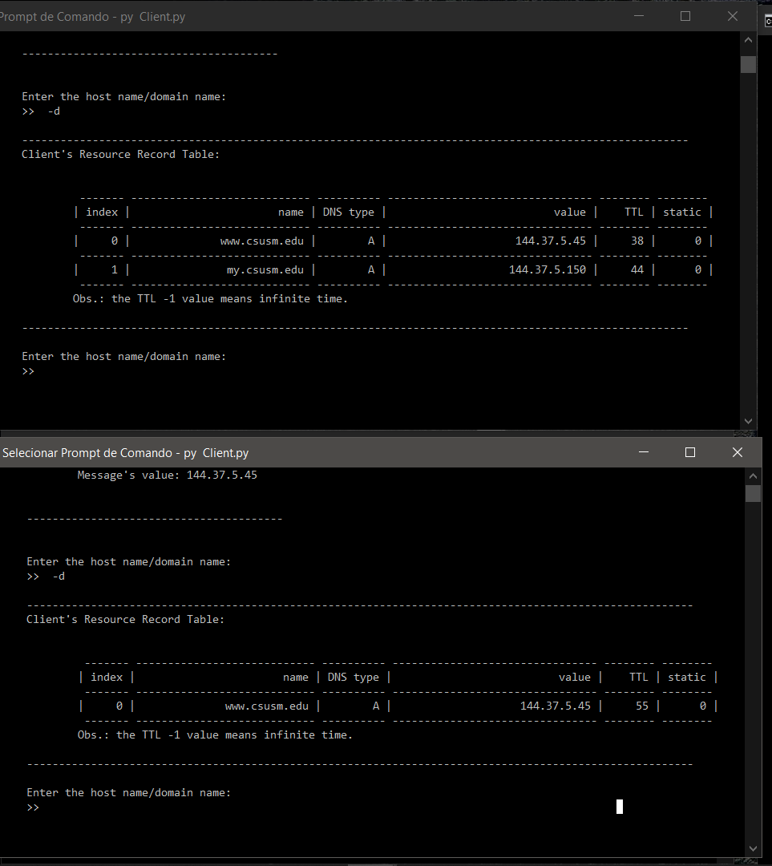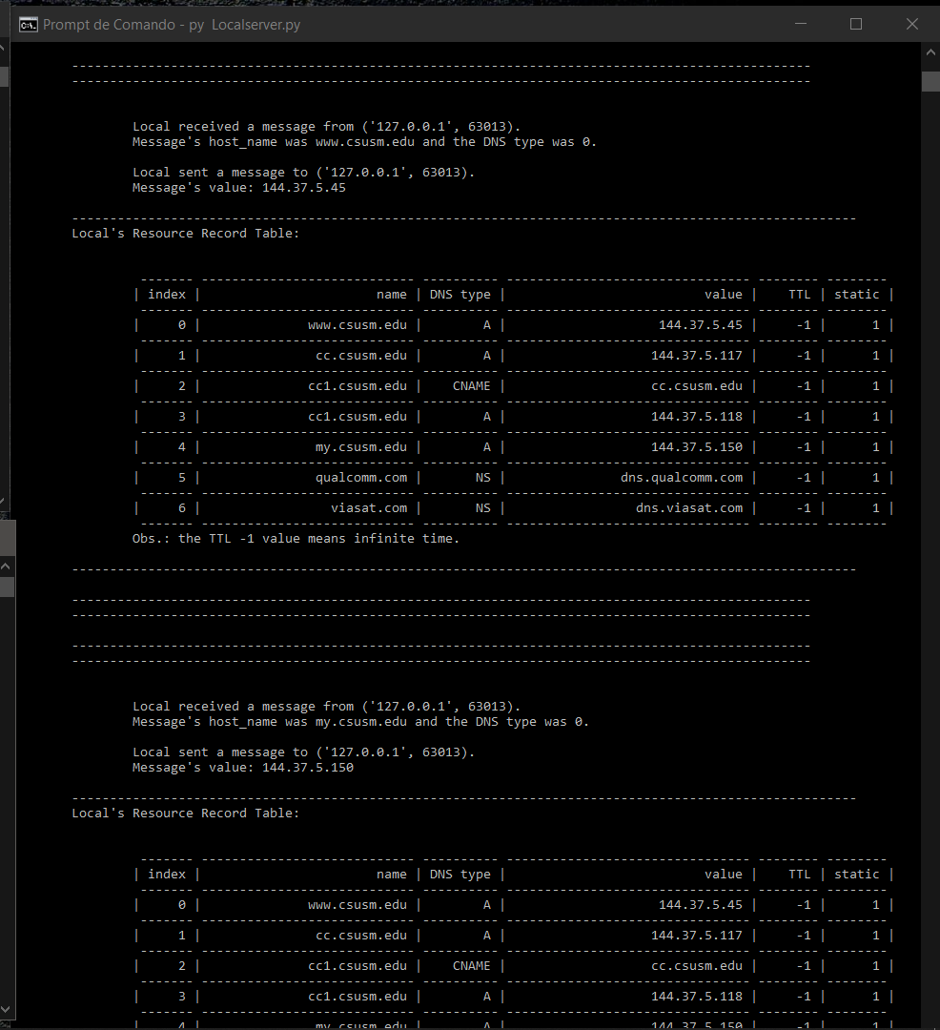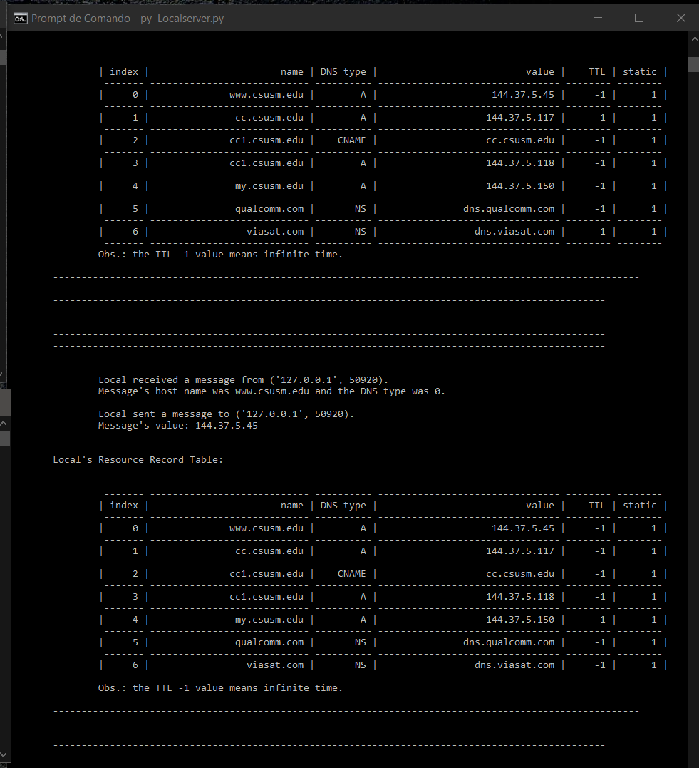

4. Enter a CNAME request for cc1.csusm.edu and then an NS request for qualcomm.com.

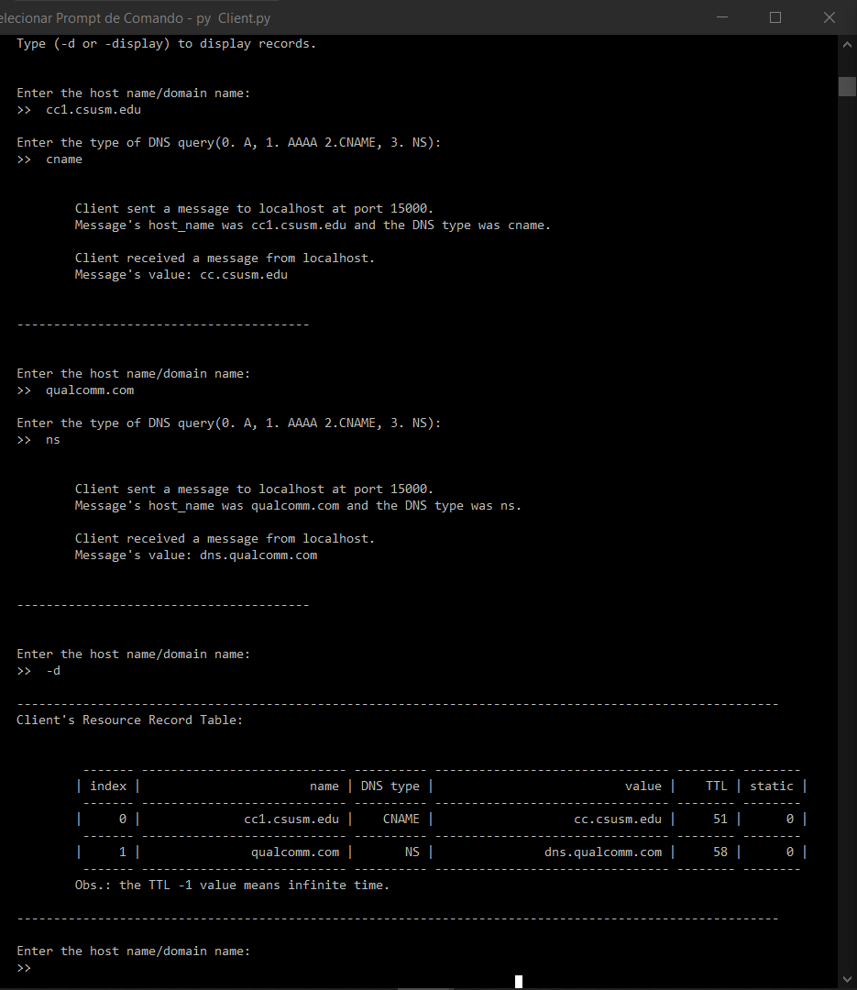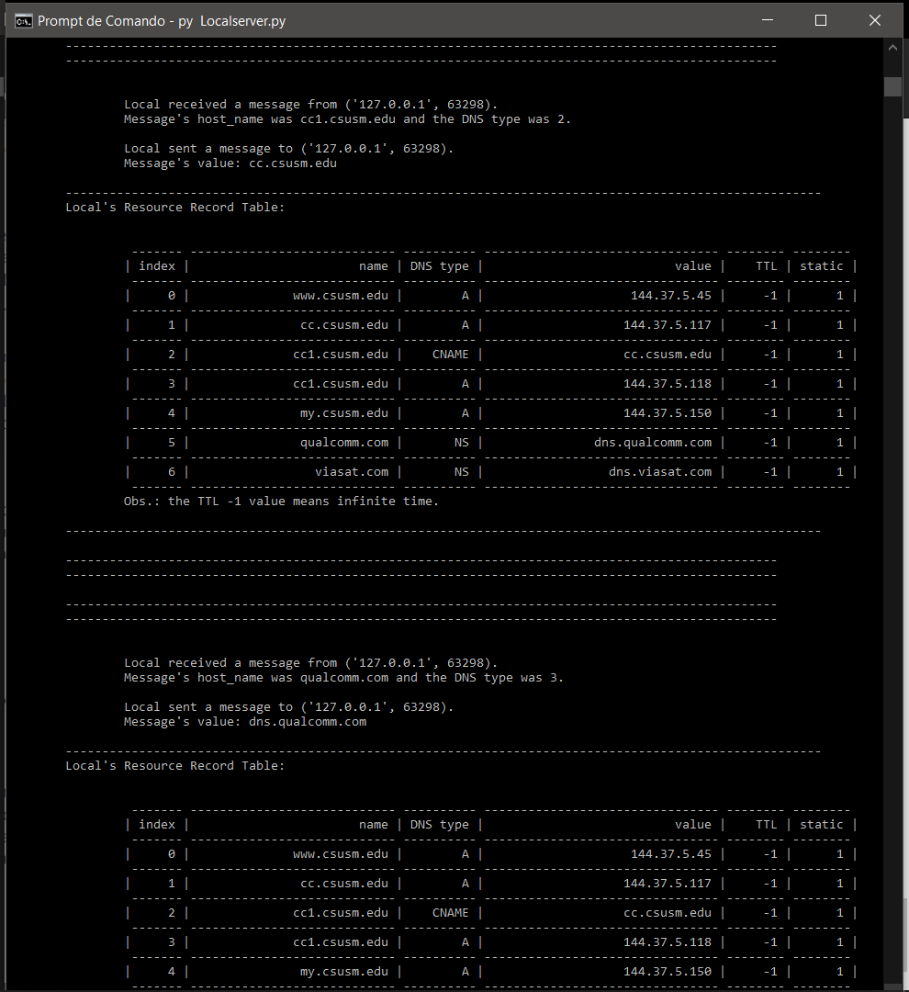

5. Enter an A request for www.ucsd.edu. The local DNS server should respond that it is unable to answer this query. Any query for hostnames that do not belong to CSUSM, Qualcomm or ViaSat domains will get the same respond from the local DNS server.

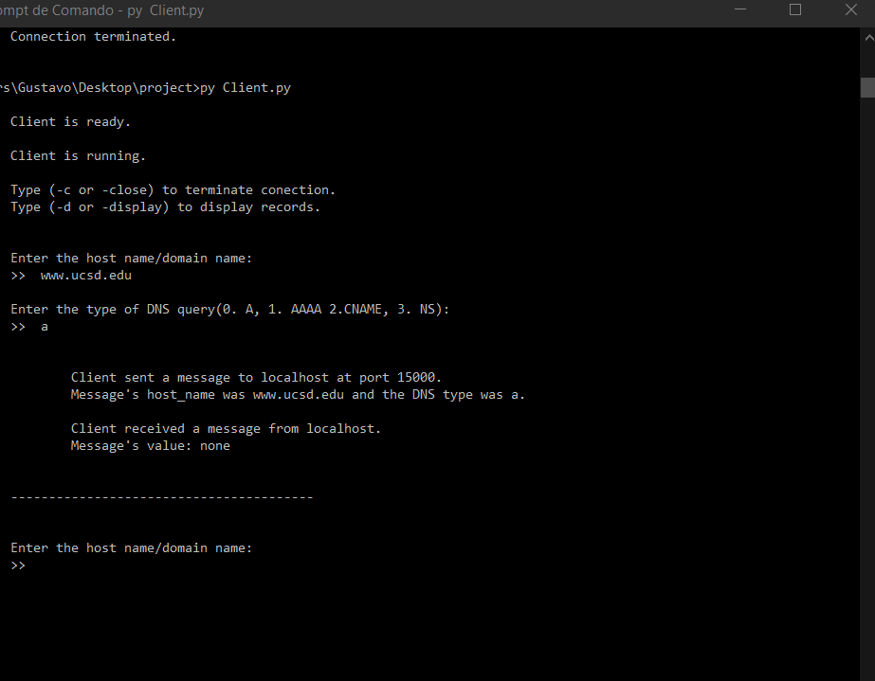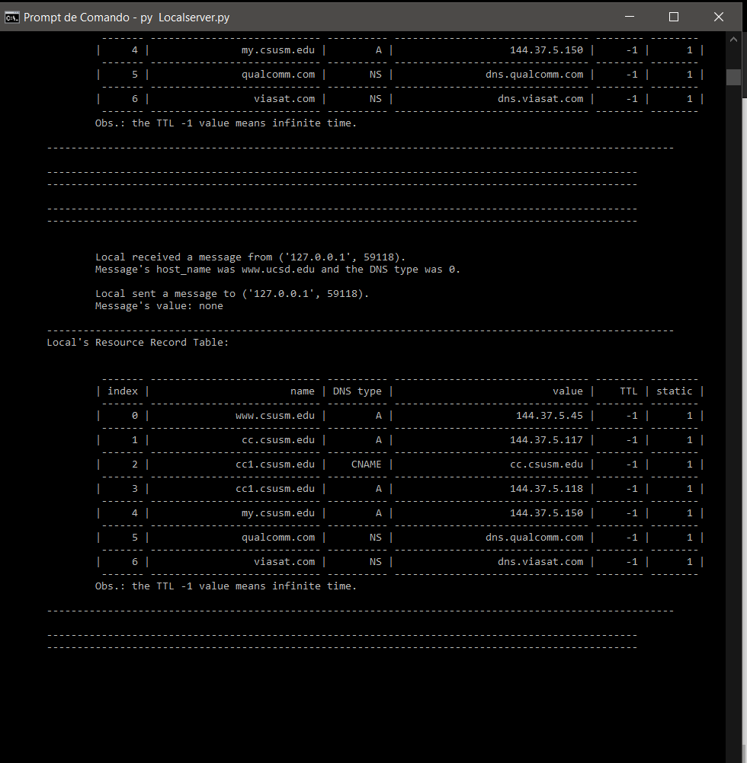

6. In one of the client terminals, enter an A request for www.qualcomm.com. Make sure that both Local DNS server and the client enter the record in their RR tables. Now immediately (before 60 seconds) in the other client terminal enter an A request for www.qualcomm.com. Take a screenshot of both tables and make sure that the Local DNS server does not send a new request for www.qualcomm.com and uses the already stored record in its RR table to respond the second request. After the second response, the TTL of this record in the local DNS server’s RR table should be a number below 60 seconds.

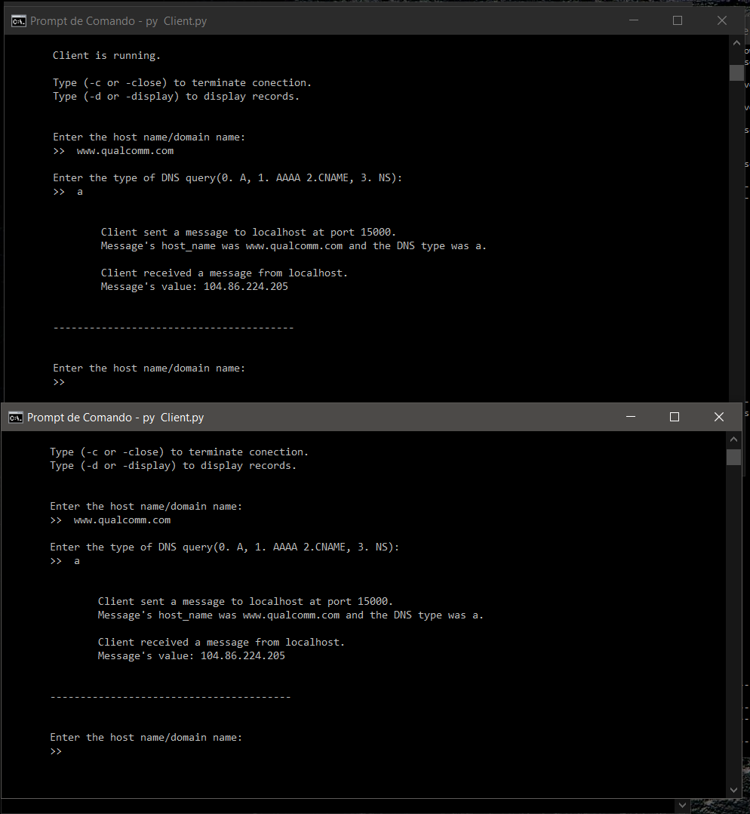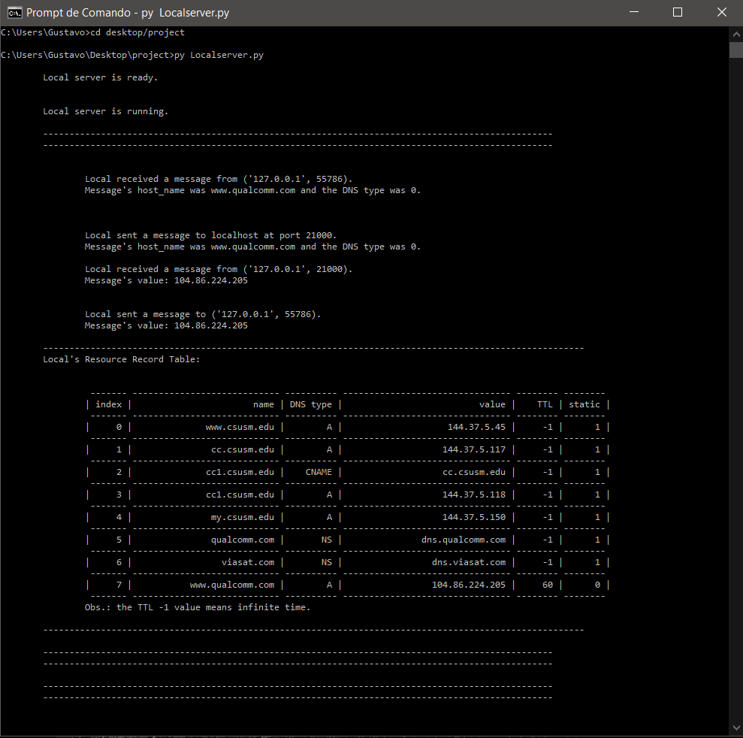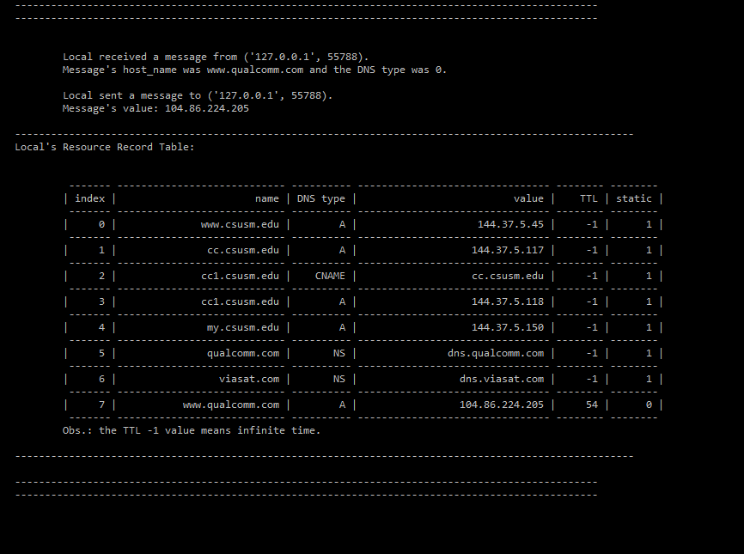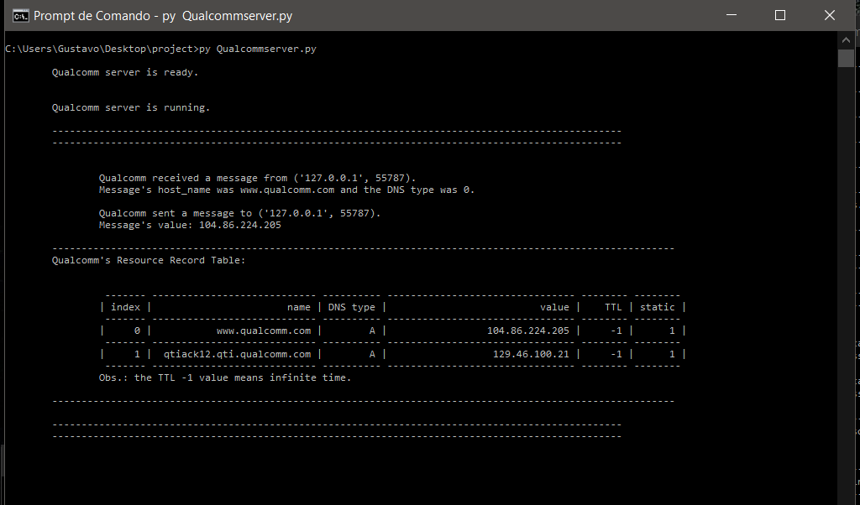

7. Enter an A request for www.viasat.com.

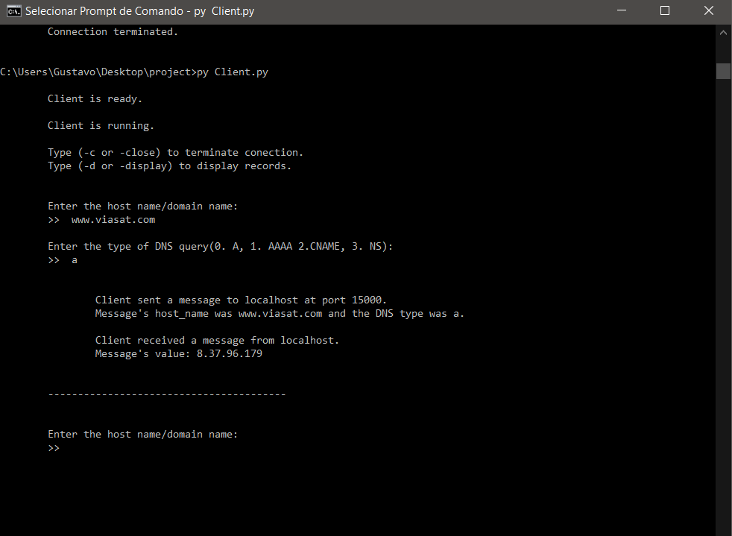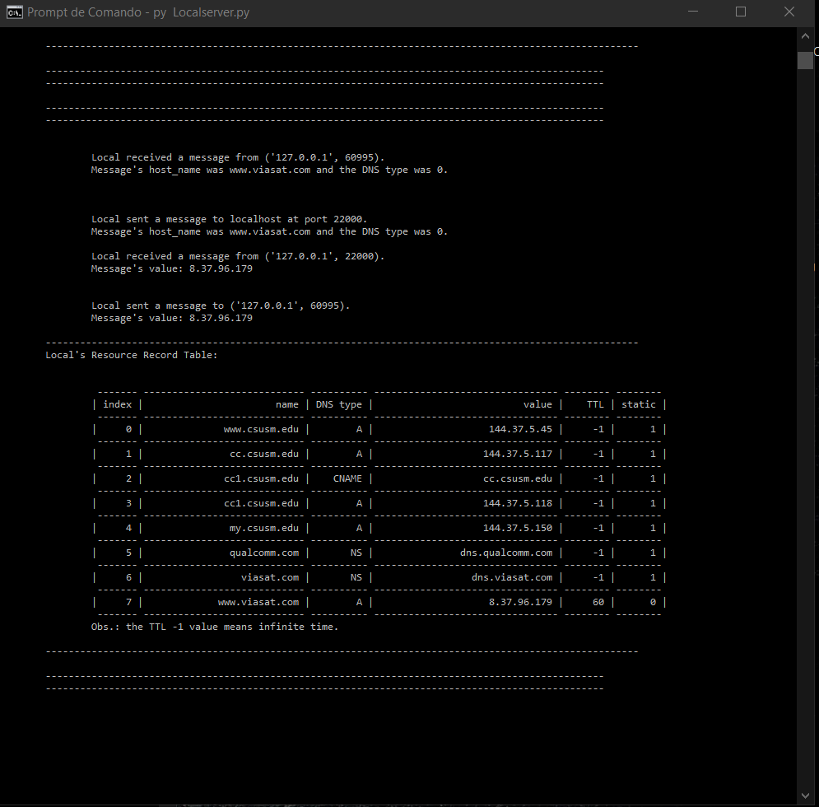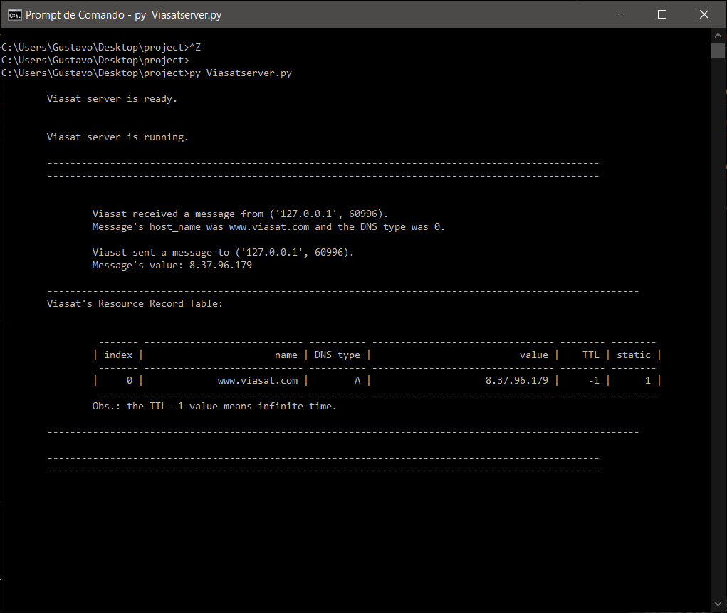

8. Extra credit test: Enter an A request for qtiack12.qti.qualcomm.com and an A request for www.viasat.com. Before you pass the 60 seconds TTL, run the admin program to display the RR table of the local DNS server. Both these records should show up in the admin terminal.

