**Pascal’s triangle**

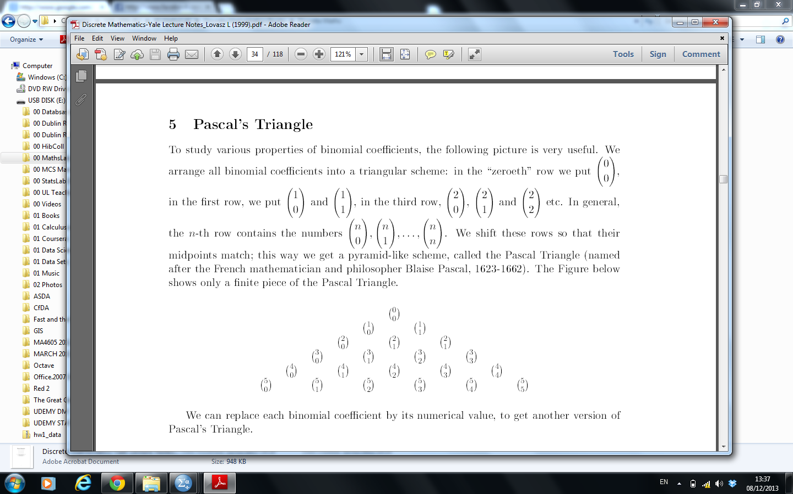

  
We can replace each binomial coefficient by its numerical value, to get another version of Pascal's Triangle.

