Question 1(a)

Upper Limit ; 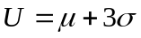
Lower Limit ; 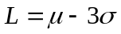

Standardisation
Apply the standardisation formula 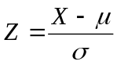 to both limits

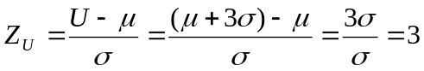
Similary

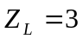

Probability of point being above Upper Limit

From Murdoch Barnes Tables (page 13) 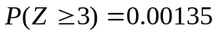

Probability of point being below Lower Limit

To find 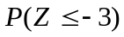 we use the “Property of Symmetry”

“Property of Symmetry” - 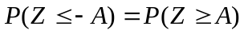 for any value A

Therefore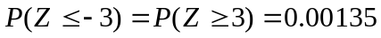

Conclusion:
Probability of point being outside the 3 Sigma limits is

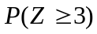+=0.00270 (i.e. 0.27%)

Question 1(b)

Upper Limit ; 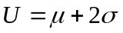
LowerLimit ; 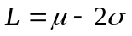

Standardisation
Apply the standardisation formula to both limits

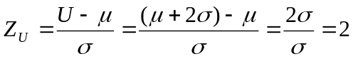
Similary

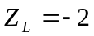

Probability of point being above Upper Limit

From Murdoch Barnes Tables (page 13) 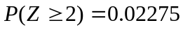

Probability of point being below Lower Limit

To find 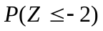 we use the “Property of Symmetry”

“Property of Symmetry” - for any value A

Therefore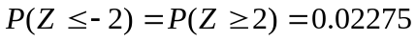

Conclusion:
Probability of point being outside the 3 Sigma limits is

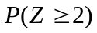+=0.04550 (i.e. 4.55%) Question 1(b)

Question 2C

Upper Limit ; 80.64 Mean 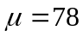
Lower Limit ; 75.36 Standard Deviation 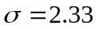

Standardisation
Apply the standardisation formula to both limits

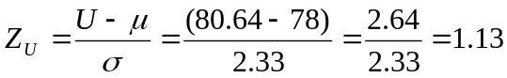
Similary

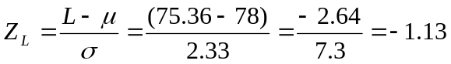

Probability of being above Upper Limit

From Murdoch Barnes Tables (page 13) 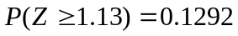

Probability of being below Lower Limit

To find 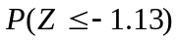 we use the “Property of Symmetry”

“Property of Symmetry” - for any value A

Therefore

Conclusion:
Probability of point being outside the specification limits

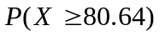+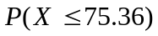is equal to

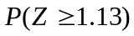+=0.2584 (i.e. 26%)

Question 3A

Upper Limit ; 90 Mean 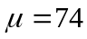
Lower Limit ; 50 Standard Deviation 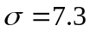

Standardisation
Apply the standardisation formula to both limits

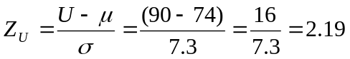
Similary

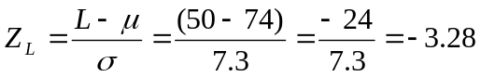

Probability of being above Upper Limit

From Murdoch Barnes Tables (page 13) 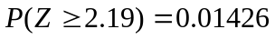

Probability of being below Lower Limit

To find 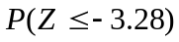 we use the “Property of Symmetry”

“Property of Symmetry” - for any value A

Therefore

Conclusion:
Probability of point being outside the specification limits is

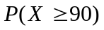+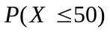is equal to

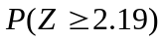+=0.01478 (i.e. 1.5%)

Question 3B

Upper Limit ; 90 Mean 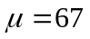
Lower Limit ; 50 Standard Deviation

Standardisation
Apply the standardisation formula to both limits

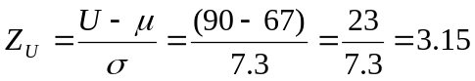
Similary

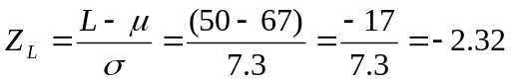

Probability of being above Upper Limit

From Murdoch Barnes Tables (page 13) 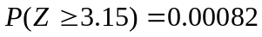

Probability of being below Lower Limit

To find 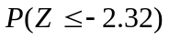 we use the “Property of Symmetry”

“Property of Symmetry” - for any value A

Therefore

Conclusion:
Probability of point being outside the specification limits is

+is equal to

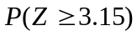+=0.01099 (i.e. 1.1%)

SPRING 2008

Q1. (a) A tyre manufacturer claims that under normal driving conditions, the tread life of a certain tyre follows a normal distribution with mean 50,000 miles and standard deviation 5000 miles.

(i) If your tyres wear out at 45,000 miles, would you consider this unusual? Support your answer with an appropriate probability calculation using the normal curve. [ 10 marks ]

(ii) If the manufacturer sells 100,000 of these tyres and warrants them to last at least 40,000 miles, about how many tyres will wear out before the warranty expires? [ 10 marks ]

Part (i) Solution

Test Value ; 45,000km Mean 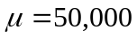km
Standard Deviation 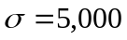km

Find 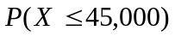

Standardisation
Apply the standardisation formula to test value
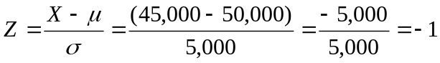

i.e. =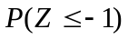

To find we use the “Property of Symmetry”

“Property of Symmetry” - for any value A

From Murdoch Barnes Tables (page 13) 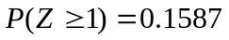

Therefore = 0.1587

“Complement Rule” 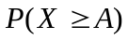=1- 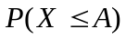for any given value A

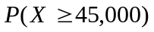=1- = 0.8413
Conclusion

15.87% of Tyres are expected to last less than 45,000km

84.13% of Tyres are expected to last longer than 45,000km

Part (i) Solution

Lower Limit ; 40,000km Mean km
Standard Deviation km

Find 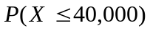

Standardisation
Apply the standardisation formula to limit
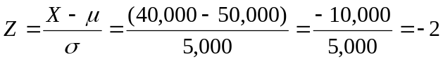

i.e. =

To find we use the “Property of Symmetry”

“Property of Symmetry” - for any value A
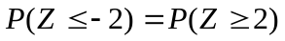

From Murdoch Barnes Tables (page 13)

Therefore = 0.02275

Conclusion
2.275% of Tyres are expected to last less than 40,000km

Of a Batch of 100,000 tyres, 2270 tyres will wear out before the warranty expires.

