Paper 2: Vitamin D

Windy Wang

# PAPER 2: VITAMIN D RESULTS

### Subject Characteristics

## [1] "Table 1: Subject characteristics across vitamin D status at baseline"  
## Stratified by vitdStatus  
## Deficient   
## n 291   
## Age (mean (sd)) 47.86 (9.37)   
## Sex = Male (%) 98 (33.7)   
## Ethnicity (%)   
## European 148 (50.9)   
## Latino/a 58 (19.9)   
## Other 51 (17.5)   
## South Asian 34 (11.7)   
## BMI (mean (sd)) 32.97 (6.76)   
## Waist (mean (sd)) 102.85 (15.44)   
## eGFR (mean (sd)) 97.74 (14.64)   
## ACR (median [IQR]) 0.56 [0.35, 0.95]   
## UrineCreatinine (mean (sd)) 12.56 (6.42)   
## UrineMicroalbumin (median [IQR]) 6.30 [3.00, 11.35]   
## UrinaryCalcium (mean (sd)) 2.36 (1.72)   
## UDBP (median [IQR]) 53.50 [10.45, 95.38]  
## udbpCr (mean (sd)) 6.88 (14.21)   
## VitaminD (mean (sd)) 35.07 (9.93)   
## PTH (mean (sd)) 4.96 (1.91)   
## MET (mean (sd)) 43.66 (66.01)   
## Systolic (mean (sd)) 126.16 (15.53)   
## Diastolic (mean (sd)) 80.67 (10.32)   
## MeanArtPressure (mean (sd)) 95.83 (11.20)   
## dmStatus (%)   
## NGT 238 (81.8)   
## PreDM 8 (2.7)   
## DM 45 (15.5)   
## Stratified by vitdStatus  
## Insufficient   
## n 263   
## Age (mean (sd)) 51.11 (10.31)   
## Sex = Male (%) 78 (29.7)   
## Ethnicity (%)   
## European 195 (74.1)   
## Latino/a 31 (11.8)   
## Other 21 (8.0)   
## South Asian 16 (6.1)   
## BMI (mean (sd)) 30.07 (5.28)   
## Waist (mean (sd)) 96.77 (14.89)   
## eGFR (mean (sd)) 92.60 (14.61)   
## ACR (median [IQR]) 0.57 [0.35, 0.93]   
## UrineCreatinine (mean (sd)) 11.39 (6.47)   
## UrineMicroalbumin (median [IQR]) 5.00 [2.10, 11.45]   
## UrinaryCalcium (mean (sd)) 2.29 (1.83)   
## UDBP (median [IQR]) 46.95 [16.84, 94.68]  
## udbpCr (mean (sd)) 7.70 (16.52)   
## VitaminD (mean (sd)) 60.87 (7.34)   
## PTH (mean (sd)) 4.39 (1.56)   
## MET (mean (sd)) 53.95 (64.24)   
## Systolic (mean (sd)) 126.82 (15.08)   
## Diastolic (mean (sd)) 80.05 (10.20)   
## MeanArtPressure (mean (sd)) 95.64 (11.02)   
## dmStatus (%)   
## NGT 219 (83.3)   
## PreDM 17 (6.5)   
## DM 27 (10.3)   
## Stratified by vitdStatus  
## Sufficient p test   
## n 128   
## Age (mean (sd)) 51.35 (10.32) <0.001   
## Sex = Male (%) 39 (30.5) 0.573   
## Ethnicity (%) <0.001   
## European 101 (78.9)   
## Latino/a 9 (7.0)   
## Other 14 (10.9)   
## South Asian 4 (3.1)   
## BMI (mean (sd)) 29.53 (5.59) <0.001   
## Waist (mean (sd)) 95.69 (14.32) <0.001   
## eGFR (mean (sd)) 92.95 (14.27) <0.001   
## ACR (median [IQR]) 0.46 [0.29, 0.77] 0.188 nonnorm  
## UrineCreatinine (mean (sd)) 11.38 (6.49) 0.064   
## UrineMicroalbumin (median [IQR]) 4.40 [2.07, 9.25] 0.028 nonnorm  
## UrinaryCalcium (mean (sd)) 2.25 (1.45) 0.797   
## UDBP (median [IQR]) 46.30 [19.69, 81.24] 0.805 nonnorm  
## udbpCr (mean (sd)) 6.27 (7.35) 0.616   
## VitaminD (mean (sd)) 90.46 (15.59) <0.001   
## PTH (mean (sd)) 4.08 (1.31) <0.001   
## MET (mean (sd)) 55.71 (63.46) 0.095   
## Systolic (mean (sd)) 125.66 (18.81) 0.779   
## Diastolic (mean (sd)) 79.58 (10.73) 0.579   
## MeanArtPressure (mean (sd)) 94.94 (12.66) 0.760   
## dmStatus (%) 0.016   
## NGT 112 (87.5)   
## PreDM 8 (6.2)   
## DM 8 (6.2)

## [1] "Table 2: Subject characteristics across visit numbers"  
## Stratified by VN  
## 1 3   
## n 729 636   
## Age (mean (sd)) 49.78 (10.03) 54.64 (9.97)   
## Sex = Male (%) 232 (31.8) 190 (29.9)   
## Ethnicity (%)   
## European 475 (65.2) 455 (71.5)   
## Latino/a 108 (14.8) 65 (10.2)   
## Other 89 (12.2) 65 (10.2)   
## South Asian 57 (7.8) 51 (8.0)   
## BMI (mean (sd)) 31.11 (6.18) 31.30 (6.35)   
## Waist (mean (sd)) 99.06 (15.30) 100.28 (15.21)   
## MET (mean (sd)) 50.32 (65.50) 48.24 (59.65)   
## VitaminD (mean (sd)) 55.42 (22.96) 74.00 (26.37)   
## PTH (mean (sd)) 4.56 (1.71) 4.99 (1.83)   
## UDBP (median [IQR]) 47.56 [15.30, 93.10] 39.96 [8.55, 89.91]  
## udbpCr (median [IQR]) 5.17 [2.51, 7.74] 4.91 [0.95, 7.85]   
## Systolic (mean (sd)) 126.19 (16.00) 127.29 (14.98)   
## Diastolic (mean (sd)) 80.13 (10.32) 80.04 (10.05)   
## MeanArtPressure (mean (sd)) 95.48 (11.40) 95.79 (10.65)   
## dmStatus (%)   
## NGT 601 (82.4) 380 (59.7)   
## PreDM 38 (5.2) 136 (21.4)   
## DM 90 (12.3) 120 (18.9)   
## Stratified by VN  
## p test   
## n   
## Age (mean (sd)) <0.001   
## Sex = Male (%) 0.472   
## Ethnicity (%) 0.031   
## European   
## Latino/a   
## Other   
## South Asian   
## BMI (mean (sd)) 0.583   
## Waist (mean (sd)) 0.144   
## MET (mean (sd)) 0.544   
## VitaminD (mean (sd)) <0.001   
## PTH (mean (sd)) <0.001   
## UDBP (median [IQR]) 0.050 nonnorm  
## udbpCr (median [IQR]) 0.281 nonnorm  
## Systolic (mean (sd)) 0.196   
## Diastolic (mean (sd)) 0.875   
## MeanArtPressure (mean (sd)) 0.610   
## dmStatus (%) <0.001   
## NGT   
## PreDM   
## DM  
## # A tibble: 3 x 2  
## VN n  
## <dbl> <int>  
## 1 1 670  
## 2 3 448  
## 3 6 116

### Cross-Sectional

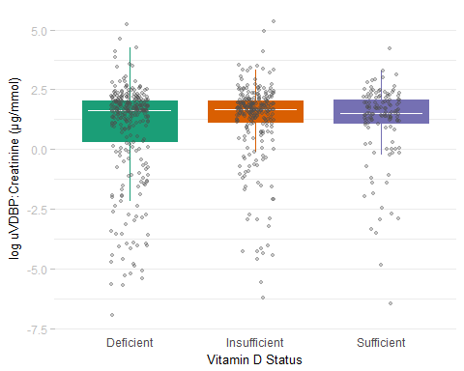

## # A tibble: 3 x 3  
## vitdStatus Median IQR  
## <ord> <dbl> <dbl>  
## 1 Deficient 1.623980 1.7037682  
## 2 Insufficient 1.679041 0.8999910  
## 3 Sufficient 1.522713 0.9956881  
## # A tibble: 3 x 2  
## vitdStatus n  
## <ord> <int>  
## 1 Deficient 291  
## 2 Insufficient 262  
## 3 Sufficient 128  
## Df Sum Sq Mean Sq F value Pr(>F)   
## vitdStatus 2 25 12.524 3.653 0.0264 *  
## Residuals 678 2324 3.428   
## ---  
## Signif. codes: 0 '***' 0.001 '**' 0.01 '*' 0.05 '.' 0.1 ' ' 1  
## Tukey multiple comparisons of means  
## 95% family-wise confidence level  
##   
## Fit: aov(formula = log(udbpCr) ~ vitdStatus, data = vitd)  
##   
## $vitdStatus  
## diff lwr upr p adj  
## Insufficient-Deficient 0.41036210 0.03998157 0.7807426 0.0255885  
## Sufficient-Deficient 0.32715417 -0.13409782 0.7884062 0.2191109  
## Sufficient-Insufficient -0.08320793 -0.55219341 0.3857775 0.9087354

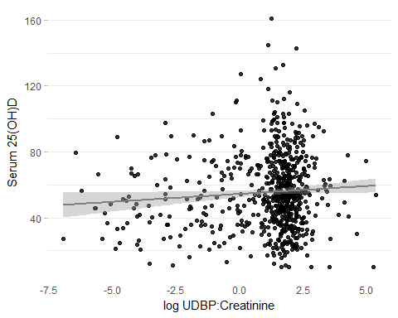

##   
## Spearman's rank correlation rho  
##   
## data: VitaminD and udbpCr  
## S = 51002000, p-value = 0.4183  
## alternative hypothesis: true rho is not equal to 0  
## sample estimates:  
## rho   
## 0.03106497

|  |  |  |  |  |
| --- | --- | --- | --- | --- |
| Yterms | Xterms | term | estCI | p |
| VitaminD | logudbpCr | <-Xterm | 0.96 (0.03, 1.88) | 0.04 |
| VitaminD | logudbpCr | <-Xterm | 0.32 (-0.53, 1.17) | 0.46 |
| VitaminD | logudbpCr | ageBase | 0.25 (0.09, 0.41) | <0.001 |
| VitaminD | logudbpCr | SexMale | 1.51 (-1.95, 4.96) | 0.39 |
| VitaminD | logudbpCr | EthnicityEuropean | 14.83 (11.39, 18.26) | <0.001 |
| VitaminD | logudbpCr | BMI | -1.2 (-1.46, -0.94) | <0.001 |
| VitaminD | logudbpCr | MET | 0.01 (-0.01, 0.03) | 0.4 |
| VitaminD | logudbpCr | fDMDM | -9.59 (-14.54, -4.65) | <0.001 |

#### Possible Effect Modifiers

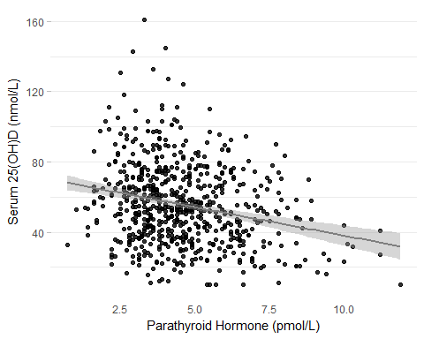

|  |  |  |  |  |
| --- | --- | --- | --- | --- |
| Yterms | Xterms | term | estCI | p |
| VitaminD | PTH | <-Xterm | -3.24 (-4.23, -2.24) | <0.001 |
| VitaminD | PTH | <-Xterm | -3.24 (-4.23, -2.24) | <0.001 |

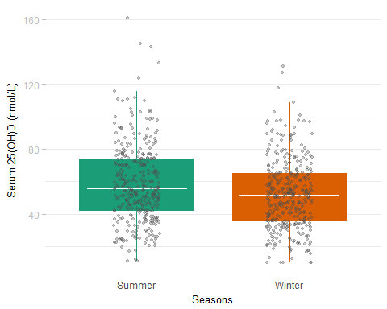

## # A tibble: 2 x 2  
## Season n  
## <chr> <int>  
## 1 Summer 358  
## 2 Winter 371  
## Df Sum Sq Mean Sq F value Pr(>F)   
## Season 1 7047 7047 13.61 0.000243 ***  
## Residuals 680 352038 518   
## ---  
## Signif. codes: 0 '***' 0.001 '**' 0.01 '*' 0.05 '.' 0.1 ' ' 1  
## 47 observations deleted due to missingness  
## Tukey multiple comparisons of means  
## 95% family-wise confidence level  
##   
## Fit: aov(formula = VitaminD ~ Season, data = dsBase)  
##   
## $Season  
## diff lwr upr p adj  
## Winter-Summer -6.428891 -9.850274 -3.007507 0.0002427

### Progression

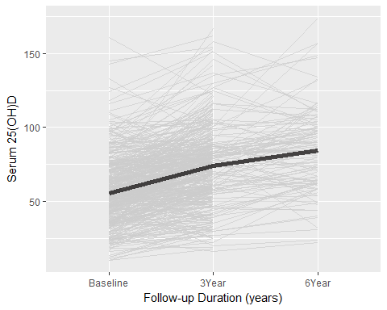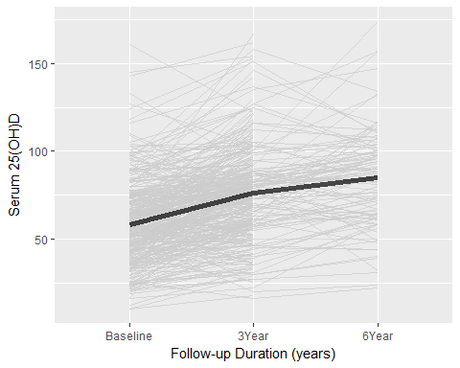

## Df Sum Sq Mean Sq F value Pr(>F)   
## fVN 2 95369 47684 74.93 <2e-16 ***  
## Residuals 864 549807 636   
## ---  
## Signif. codes: 0 '***' 0.001 '**' 0.01 '*' 0.05 '.' 0.1 ' ' 1  
## 372 observations deleted due to missingness  
## Tukey multiple comparisons of means  
## 95% family-wise confidence level  
##   
## Fit: aov(formula = VitaminD ~ fVN, data = dsComplete)  
##   
## $fVN  
## diff lwr upr p adj  
## 3Year-Baseline 18.332555 14.025870 22.63924 0.0000000  
## 6Year-Baseline 26.955529 20.519697 33.39136 0.0000000  
## 6Year-3Year 8.622974 2.089293 15.15665 0.0056913

### Generalized Estimating Equations

## [1] "Table 3: GEE results for uVDBP at baseline (predictor) with 25(OH)D and (outcomes), adjusted for follow-up duration (in months), baseline age, sex, ethnicity, physical activity (MET), BMI, diabetes status, and seasonality; subjects with deficient vitamin D status at baseline excluded (n = 713)."

|  |  |  |  |  |
| --- | --- | --- | --- | --- |
| Yterms | Xterms | term | estCI | p |
| log PTH (pmol/L) | Baseline uVDBP:cr (ug/mmol) | uVDBP:cr (ug/mmol) | -4.28 (-7.8, -0.63) | 0.02 |
| log PTH (pmol/L) | Baseline uVDBP:cr (ug/mmol) | Follow-up Duration (months) | 4.87 (2.61, 7.18) | <0.001 |
| log PTH (pmol/L) | Baseline uVDBP:cr (ug/mmol) | Baseline Age (years) | 2.55 (0, 5.17) | 0.05 |
| log PTH (pmol/L) | Baseline uVDBP:cr (ug/mmol) | SexMale | -1.72 (-7.1, 3.97) | 0.55 |
| log PTH (pmol/L) | Baseline uVDBP:cr (ug/mmol) | EthnicityEuropean | -7.45 (-12.34, -2.28) | 0.01 |
| log PTH (pmol/L) | Baseline uVDBP:cr (ug/mmol) | MET (kcal/kg/h) | -1.63 (-3.41, 0.18) | 0.08 |
| log PTH (pmol/L) | Baseline uVDBP:cr (ug/mmol) | BMI (kg/m^2) | 8.56 (5.75, 11.45) | <0.001 |
| log PTH (pmol/L) | Baseline uVDBP:cr (ug/mmol) | dmStatusPreDiabetes | -3.37 (-8.42, 1.96) | 0.21 |
| log PTH (pmol/L) | Baseline uVDBP:cr (ug/mmol) | dmStatusDiabetes | 7.56 (-6.22, 23.35) | 0.3 |
| log PTH (pmol/L) | Baseline uVDBP:cr (ug/mmol) | SeasonWinter | 2.87 (-0.93, 6.81) | 0.14 |
| log PTH (pmol/L) | Baseline uVDBP:cr (ug/mmol) | uVDBP:cr (ug/mmol):SeasonWinter | 9.63 (4, 15.56) | <0.001 |
| log 25(OH)D (nmol/L) | Baseline uVDBP:cr (ug/mmol) | uVDBP:cr (ug/mmol) | 0.1 (-1.4, 1.63) | 0.9 |
| log 25(OH)D (nmol/L) | Baseline uVDBP:cr (ug/mmol) | Follow-up Duration (months) | 19.66 (17.04, 22.34) | <0.001 |
| log 25(OH)D (nmol/L) | Baseline uVDBP:cr (ug/mmol) | Baseline Age (years) | 6.68 (3.93, 9.51) | <0.001 |
| log 25(OH)D (nmol/L) | Baseline uVDBP:cr (ug/mmol) | SexMale | 1.01 (-4.89, 7.28) | 0.74 |
| log 25(OH)D (nmol/L) | Baseline uVDBP:cr (ug/mmol) | EthnicityEuropean | 31.95 (23.84, 40.58) | <0.001 |
| log 25(OH)D (nmol/L) | Baseline uVDBP:cr (ug/mmol) | MET (kcal/kg/h) | 0.96 (-0.85, 2.8) | 0.3 |
| log 25(OH)D (nmol/L) | Baseline uVDBP:cr (ug/mmol) | BMI (kg/m^2) | -13.78 (-16.28, -11.2) | <0.001 |
| log 25(OH)D (nmol/L) | Baseline uVDBP:cr (ug/mmol) | dmStatusPreDiabetes | 4.28 (-1.23, 10.1) | 0.13 |
| log 25(OH)D (nmol/L) | Baseline uVDBP:cr (ug/mmol) | dmStatusDiabetes | 10.08 (-7.64, 31.21) | 0.28 |
| log 25(OH)D (nmol/L) | Baseline uVDBP:cr (ug/mmol) | SeasonWinter | -9.27 (-12.61, -5.8) | <0.001 |
| log 25(OH)D (nmol/L) | Baseline uVDBP:cr (ug/mmol) | uVDBP:cr (ug/mmol):SeasonWinter | -7.11 (-13.62, -0.1) | 0.05 |

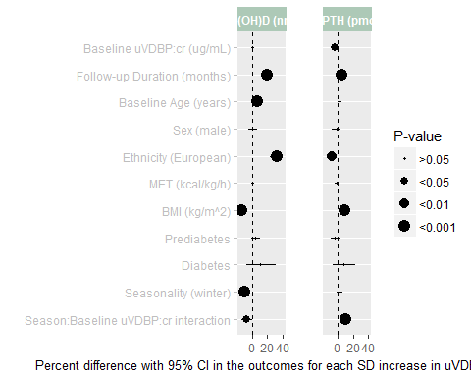

|  |  |  |  |  |
| --- | --- | --- | --- | --- |
| Yterms | Xterms | term | estCI | p |
| log PTH (pmol/L) | udbpCr | uVDBP:cr (ug/mmol) | -4.63 (-7.82, -1.34) | 0.01 |
| log PTH (pmol/L) | udbpCr | Follow-up Duration (months) | 4.53 (2.27, 6.85) | <0.001 |
| log PTH (pmol/L) | udbpCr | Baseline Age (years) | 2.73 (0.18, 5.34) | 0.04 |
| log PTH (pmol/L) | udbpCr | SexMale | -1.69 (-7.13, 4.07) | 0.56 |
| log PTH (pmol/L) | udbpCr | EthnicityEuropean | -7.04 (-11.97, -1.84) | 0.01 |
| log PTH (pmol/L) | udbpCr | MET (kcal/kg/h) | -1.64 (-3.43, 0.18) | 0.08 |
| log PTH (pmol/L) | udbpCr | BMI (kg/m^2) | 8.58 (5.76, 11.48) | <0.001 |
| log PTH (pmol/L) | udbpCr | dmStatusPreDiabetes | -2.92 (-8.03, 2.47) | 0.28 |
| log PTH (pmol/L) | udbpCr | dmStatusDiabetes | 9.54 (-4.62, 25.81) | 0.2 |
| log PTH (pmol/L) | udbpCr | SeasonWinter | 2.67 (-1.07, 6.56) | 0.16 |
| log PTH (pmol/L) | udbpCr | uVDBP:cr (ug/mmol):SeasonWinter | 5.89 (1.63, 10.33) | 0.01 |
| log 25(OH)D (nmol/L) | udbpCr | uVDBP:cr (ug/mmol) | 1.15 (-0.57, 2.91) | 0.19 |
| log 25(OH)D (nmol/L) | udbpCr | Follow-up Duration (months) | 19.87 (17.22, 22.58) | <0.001 |
| log 25(OH)D (nmol/L) | udbpCr | Baseline Age (years) | 6.5 (3.77, 9.3) | <0.001 |
| log 25(OH)D (nmol/L) | udbpCr | SexMale | 1.12 (-4.9, 7.53) | 0.72 |
| log 25(OH)D (nmol/L) | udbpCr | EthnicityEuropean | 31.3 (23.24, 39.89) | <0.001 |
| log 25(OH)D (nmol/L) | udbpCr | MET (kcal/kg/h) | 1.03 (-0.79, 2.89) | 0.27 |
| log 25(OH)D (nmol/L) | udbpCr | BMI (kg/m^2) | -13.76 (-16.25, -11.19) | <0.001 |
| log 25(OH)D (nmol/L) | udbpCr | dmStatusPreDiabetes | 3.98 (-1.52, 9.78) | 0.16 |
| log 25(OH)D (nmol/L) | udbpCr | dmStatusDiabetes | 9.68 (-8.06, 30.84) | 0.3 |
| log 25(OH)D (nmol/L) | udbpCr | SeasonWinter | -8.95 (-12.26, -5.52) | <0.001 |
| log 25(OH)D (nmol/L) | udbpCr | uVDBP:cr (ug/mmol):SeasonWinter | -2.15 (-6.76, 2.68) | 0.38 |

