Exploration of the relationship between parathyroid hormone and urinary vitamin D binding protein

WINDY WANG

May 25, 2016

## Urinary Calcium: Adjusted vs Unadjusted

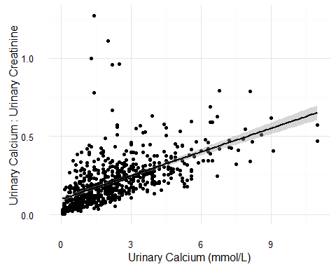

## [1] "Figure 1: Association between urinary calcium and urinary calcium adjusted for urine volume using urinary creatinine. Significance was assessed using Spearman's Rank Correlation, r = 0.69, p < 0.001."

Generally, there is a linear relationship between urinary calcium adjusted and unadjusted for urine volume (r = 0.69, *p* < 0.001), a few points deviate from the regression line.

All subsequent analysis will be performed using the adjusted urinary calcium variable to reduce variation between subjects.

## Urinary calcium and Parathyroid Hormone

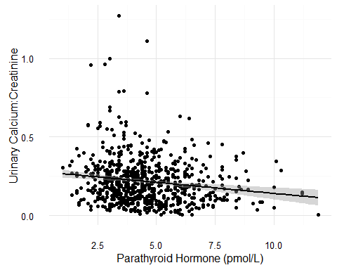

## [1] "Figure 2: Association between parathyroid hormone and urinary calcium. Significance was assessed using Spearman's Rank Correlation, r = -0.15, p < 0.001."

There is a slight negative relationship between parathyroid hormone (PTH) and urinary calcium (r = -0.15, *p* < 0.001). PTH increases renal reabsorption of calcium in order to increase serum levels. As expected, there is less urinary calcium when serum PTH concentrations are higher.

## Serum 25(OH)D and Urine Calcium

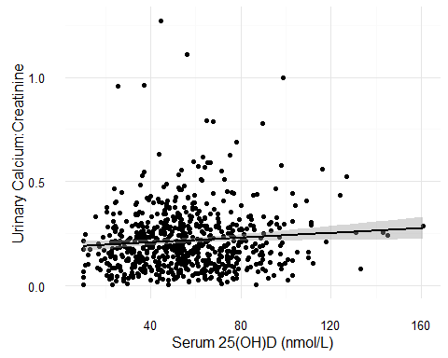

## [1] "Figure 3: Association between serum 25(OH)D and urinary calcium. Significance was assessed using Spearman's Rank Correlation, r = 0.07, p = 0.07."

There is a slight non-significant positive relationship between 25(OH)D and urinary calcium (r = 0.07, *p* = 0.07), possibly reflecting the a positive relationship between 25(OH)D and serum calcium. The weak association is likely because two different types of biomarkers are compared, i.e. serum versus urinary.