Serum 25(OH)D Relationships

WINDY WANG

May 13, 2016

## Purpose

The aim of this document is to explore how serum 25(OH)D levels relate to other variables. This exploration of the data may lead to better understanding of the interaction of urinary vitamin D binding protein and serum levels of vitamin D.

# Kidney Status

In a paper by Kalousova et al. (2015), it was found that plasma vitamin D levels decreased in subjects with worse kidney function (i.e. chronic kidney disease and long-term haemodialysis).

## Estimated Glomerular Filtration Rate

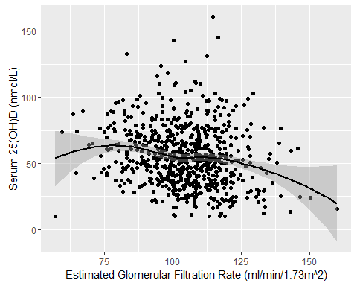

FIGURE 1: Relationship between estimated glomerular filtration rate and serum 25(OH)D concentrations.

In the PROMISE cohort at baseline, it appears that there is a significant relationship between estimated glomerular filtration (eGFR) rate and serum levels of 25(OH)D. Although the Spearman's coefficient is negative (r = -0.19, *p* = 0), a LOESS curve of the data shows a somewhat parabolic relationship. Subjects with eGFR classified as normal (90 - 125 ml/min/1.73m^2, according to National Kidney Foundation guidelines) tended to have higher levels of 25(OH)D, but subjects outside that range tended to have lower levels of serum 25(OH)D.

## Microalbuminuria

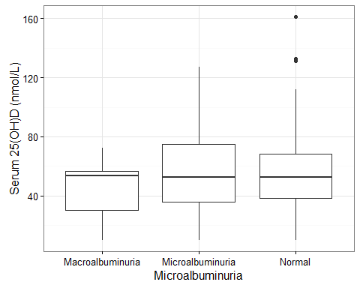 The microalbumin-to-creatinine ratio (MCR) was also examined as a measure of kidney function.In An one-way analysis of variance (ANOVA) showed that there was no significant differences between different microalbumin-to-creatinine ratio cut-offs and serum 25(OH)D status, p = 0.999

MCR was further examined as a continuous variable. Due to the skewed nature of

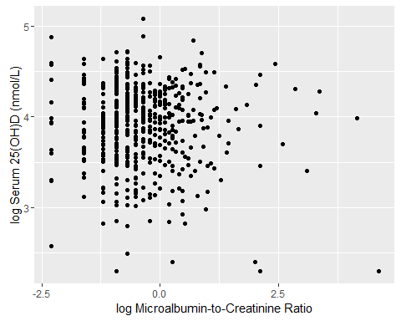

FIGURE 3: Relationship between microalbumin-to-creatinine ratio and serum 25(OH)D concentrations.

It was interesting to note that there were very few subjects with MCR greater than 50 (n = 2). In particular, 0 subjects have MCR over 100. According to the National Kidney Federation, MCR values over 100 are especially a cause for concern.

SID MicroalbCreatRatio eGFR MeanArtPressure ---- ------------------- ----- ----------------