Preliminary analysis of estimated glomerular filtration rate using the PROMISE cohort at baseline

WINDY WANG

May 12, 2016

## Subject Characterization

TABLE 1. Subject characteristics according to estimated GFR concentration categories.

|  |  |  |  |  |
| --- | --- | --- | --- | --- |
| Row | Normal | Mild | Moderate | Hyperfiltration |
| Age | 49.5 (9.1) | 56.3 (10.3) | 66.5 (12.0) | 38.7 (7.8) |
| Ethnicity |  |  |  |  |
| - European | 376 (65.5%) | 82 (73.2%) | 2 (100%) | 21 (41.2%) |
| - Latino/a | 88 (15.3%) | 16 (14.3%) |  | 9 (17.6%) |
| - Other | 65 (11.3%) | 7 (6.2%) |  | 16 (31.4%) |
| - South Asian | 45 (7.8%) | 7 (6.2%) |  | 5 (9.8%) |
| Sex |  |  |  |  |
| - Female | 421 (73.3%) | 31 (27.7%) | 1 (50%) | 50 (98%) |
| - Male | 153 (26.7%) | 81 (72.3%) | 1 (50%) | 1 (2%) |
| BMI | 31.2 (6.3) | 30.3 (5.5) | 29.4 (3.0) | 31.6 (7.2) |
| Waist | 98.6 (15.5) | 102.3 (13.6) | 105.3 (24.4) | 96.5 (17.3) |
| eGFR | 106.9 (8.6) | 82.0 (6.2) | 58.3 (1.7) | 132.5 (7.2) |
| MicroalbCreatRatio | 1.2 (3.6) | 1.0 (2.8) | 50.5 (69.9) | 1.7 (3.6) |
| UrineCreatinine | 11.4 (6.2) | 14.2 (6.5) | 10.3 (1.3) | 10.4 (6.6) |
| UrineMicroalbumin | 10.2 (17.9) | 10.0 (10.8) | 870.0 (1216.2) | 11.0 (12.7) |
| Creatinine | 67.8 (9.5) | 90.3 (7.5) | 112.5 (10.6) | 51.1 (8.5) |
| VitaminD | 54.7 (23.1) | 63.6 (19.4) | 41.8 (45.0) | 46.6 (24.1) |
| Diastolic | 80.2 (10.2) | 80.9 (9.6) | 66.5 (4.2) | 77.1 (12.5) |
| MeanArtPressure | 95.5 (11.3) | 97.4 (10.4) | 88.2 (0.4) | 91.0 (13.6) |
| Systolic | 125.9 (15.9) | 130.4 (14.2) | 131.8 (9.5) | 118.6 (17.4) |
| PTH | 4.6 (1.7) | 4.6 (1.5) | 8.7 (4.6) | 4.6 (1.8) |
| ALT | 31.3 (16.6) | 37.3 (20.5) | 33.0 (17.0) | 27.3 (15.5) |
| Glucose0 | 5.1 (0.9) | 5.3 (1.1) | 4.7 (1.6) | 5.0 (0.8) |
| Glucose120 | 6.6 (2.9) | 6.6 (3.1) | 5.5 (1.4) | 6.4 (2.7) |
| dm_status |  |  |  |  |
| - DM | 69 (12%) | 16 (14.3%) |  | 5 (9.8%) |
| - NGT | 479 (83.4%) | 86 (76.8%) | 2 (100%) | 44 (86.3%) |
| - Prediabetes | 26 (4.5%) | 10 (8.9%) |  | 2 (3.9%) |

## Blood Pressure

### Renal Autoregulation

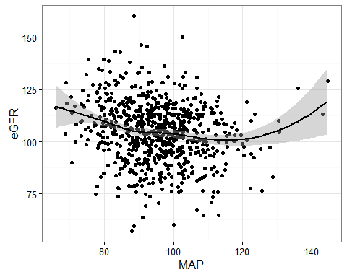

One would think that changes in the systemic blood pressure would cause changes in glomerular capillary pressure and thus, changes in the GFR. In healthy individuals, this does not occur because of renal autoregulation. Renal autoregulation involves feedback mechanisms intrinsic to the kidney that cause either dilation or constriction in the afferent arteriole so as to counteract blood pressure changes and keep a steady GFR. For instance, if the mean arterial pressure increases, renal autoregulation causes the afferent arteriole to constrict, preventing the pressure increase from being transmitted to the glomerular capillaries, and keeping the GFR from increasing. As shown in the graph, renal autoregulation normally operates to keep GFR steady over a wide range of blood pressures. Note, however, that renal autoregulation is disrupted in chronic kidney disease.

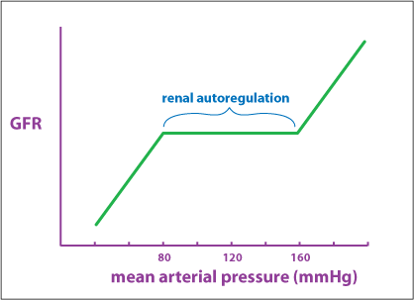

If blood pressure drops too low due to excessive fluid loss, then the sympathetic nervous system will override renal autoregulation. Sympathetic nerves innervate the afferent arteriole, causing smooth muscle contraction. The sequence of events is as follows: drop in mean arterial pressure (MAP), which is detected by arterial baroreceptors. This then leads to sympathetic nervous system activation, afferent arteriole constriction, and decreased GFR.