Exploration of the relationship between parathyroid hormone and urinary vitamin D binding protein

WINDY WANG

May 25, 2016

## Urinary Calcium: Adjusted vs Unadjusted

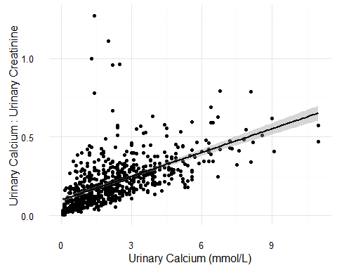

**Figure 1: Association between urinary calcium and urinary calcium adjusted for urine volume using urinary creatinine.** Significance was assessed using Spearman's Rank Correlation, r = 0.69, *p* < 0.001.

Generally, there is a linear relationship between urinary calcium adjusted and unadjusted for urine volume (r = 0.69, *p* < 0.001), a few points deviate from the regression line.

All subsequent analysis will be performed using the adjusted urinary calcium variable to reduce variation between subjects.

## Urinary calcium and Parathyroid Hormone

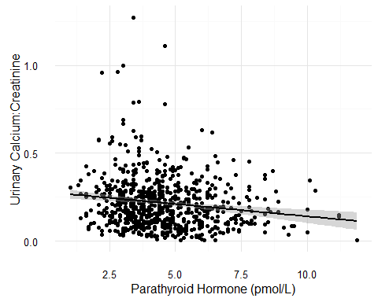

**Figure 2: Association between parathyroid hormone and urinary calcium.** Significance was assessed using Spearman's Rank Correlation, r = -0.15, *p* < 0.001.

There is a slight negative relationship between parathyroid hormone (PTH) and urinary calcium (r = -0.15, *p* < 0.001). PTH increases renal reabsorption of calcium in order to increase serum levels. As expected, there is less urinary calcium when serum PTH concentrations are higher.

The PROMISE cohort at baseline is still relatively healthy, and there are only 8 subjects with urinary calcium levels in the hypercalciuria range (>7 mmol/L). However, the association between PTH and urinary calcium may be distorted in people with worse kidney function, assuming that they will be unable to respond to PTH signals. Future analysis with prospective data may yield different relationships.

## Serum 25(OH)D and Urine Calcium

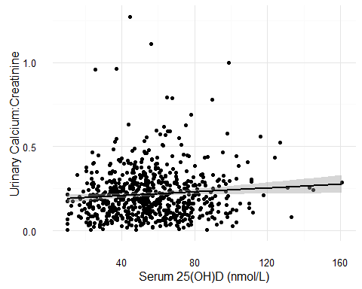

**Figure 3: Association between serum 25(OH)D and urinary calcium.** Significance was assessed using Spearman's Rank Correlation, r = 0.07, *p* = 0.07.

There is a slight non-significant positive relationship between 25(OH)D and urinary calcium (r = 0.07, *p* = 0.07), possibly reflecting a positive relationship between 25(OH)D and serum calcium. The weak association is likely because two different types of biomarkers are compared, i.e. serum versus urinary.