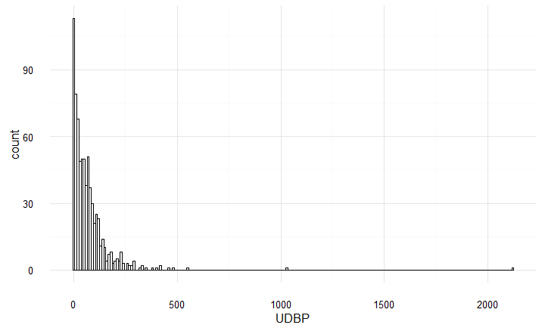

FIGURE 1. Distribution of urinary vitamin D binding protein after excluding hemolysed samples (as noted by Betty Wong).

There still appears to be a two subjects with very high UDBP concentrations (>1000 ng/mL), even though their samples were not marked as hemolysed. There were only two subjects with hemolysed samples for baseline measures; the readings were 2867 ng/mL and 128 ng/mL.

I also separated the samples marked as “<” (undetectable) and those with a reading below the lower detection limit (low UDBP). The number of subjects are slightly different in Table 1 compared to Table 2 likely due to the exclusion of hemolysed samples. I also ran ANOVAs on each variable, but did not include p-values due to space limitations. The same samples there showed significance in Table 2 were also significant in Table 1. Tukey’s HSD did not reveal significant differences between the “undetectable” and “low” groups for any variable.

Table 1 shows subject characteristics after separating “<” from the Low group, while Table 2 is the original subject characterization table (for comparison purposes).

TABLE 1. Subject characteristics according to urinary VDBP concentration categories after excluding of hemolysed samples.

|  |  |  |  |  |  |
| --- | --- | --- | --- | --- | --- |
|  | | Undetectable (<) (n=12) | Low UDBP (n=57) | Normal UDBP (n=360) | High UDBP (n=310) |
| Age | | 48.7 (11.4) | 47.8 (9.2) | 50.4 (10.1) | 49.6 (10.0) |
| Ethnicity | European | 6 (50%) | 32 (56.1%) | 238 (66.1%) | 205 (66.1%) |
| Latino/a | 6 (50%) | 10 (17.5%) | 55 (15.3%) | 42 (13.5%) |
| Other | - | 10 (17.5%) | 35 (9.7%) | 43 (13.9%) |
| South Asian | - | 5 (8.8%) | 32 (8.9%) | 20 (6.5%) |
| Sex | Female | 7 (58.3%) | 32 (56.1%) | 262 (72.8%) | 202 (65.2%) |
| Male | 5 (41.7%) | 25 (43.9%) | 98 (27.2%) | 108 (34.8%) |
| BMI | | 32.9 (10.2) | 33.0 (7.0) | 30.0 (6.2) | 32.0 (5.8) |
| Waist Circumference | | 97.5 (22.9) | 105.4 (17.5) | 96.1 (15.3) | 101.2 (14.1) |
| eGFR | | 98.9 (13.2) | 106.2 (12.5) | 105.0 (14.6) | 104.4 (14.6) |
| Microalbumin:Creatinine | | 0.7 (0.4) | 0.6 (0.4) | 1.1 (2.7) | 1.8 (7.1) |
| Urinary Creatinine | | 12.1 (3.3) | 13.5 (5.6) | 8.8 (5.2) | 14.9 (6.2) |
| Urinary Microalbumin | | 8.2 (5.2) | 6.7 (5.1) | 6.1 (10.6) | 21.2 (99.9) |
| Creatinine | | 76.5 (14.5) | 71.2 (11.3) | 69.3 (13.4) | 70.6 (13.7) |
| Serum 25(OH)D | | 51.0 (20.7) | 48.3 (20.3) | 57.9 (23.7) | 54.3 (22.5) |
| Diastolic Blood Pressure | | 77.1 (10.1) | 80.7 (9.7) | 78.7 (9.5) | 81.7 (11.1) |
| Mean Arterial Pressure | | 92.0 (10.7) | 95.7 (10.5) | 94.0 (10.9) | 97.2 (11.9) |
| Systolic Blood Pressure | | 121.7 (13.2) | 125.7 (13.9) | 124.6 (16.2) | 128.1 (16.0) |
| Parathyroid Hormone | | 4.7 (1.8) | 4.7 (1.8) | 4.2 (1.5) | 4.9 (1.8) |
| Alanine Amino Transferase | | 38.3 (13.5) | 36.5 (25.4) | 32.5 (14.3) | 33.7 (18.4) |
| Fasting Glucose | | 5.0 (0.5) | 5.4 (1.1) | 5.1 (0.9) | 5.1 (0.9) |
| 2h-post OGTT | | 5.4 (1.6) | 7.2 (3.9) | 6.4 (2.5) | 6.7 (3.2) |
| Diabetic Status | DM | - | 13 (22.8%) | 32 (8.9%) | 45 (14.5%) |
| NGT | 11 (91.7%) | 43 (75.4%) | 309 (85.8%) | 248 (80%) |
| Prediabetes | 1 (8.3%) | 1 (1.8%) | 19 (5.3%) | 17 (5.5%) |

*Values are reported as mean (standard deviation) for continuous variables, and n (percentage) for discrete variables. No significant differences were found between the “Missing” and “Low” groups, but this may be due to the low n in the “Missing” group.eHasdfasdf*

I added in ALT to examine liver function. There is a significant difference found (*p* = 0.005), and the difference is between Low-Normal (*p* = 0.018) and Normal-High (*p* = 0.048).

*TABLE 2. Subject characteristics according to urinary VDBP concentration categories.*

|  |  |  |  |  |  |
| --- | --- | --- | --- | --- | --- |
| ` | | Urinary VDBP categories | | | *p*-value |
| **Group 1**  < 1.23 ng/mL  (n = 88) | **Group 2**  1.23 – 60 ng/mL  (n = 484) | **Group 3**  > 60 ng/mL  (n = 390) |
| Age (years) | | 47.9 ± 9.5 | 50.4 ± 10.1 | 49.5 ± 10.0 | 0.14 |
| Sex (%) | **Female (n = 513)** | 57.1% | 72.7% | 65.5% | **0.03** |
| **Male (n = 237)** | 42.8% | 27.3% | 34.5% |
| Ethnicity (%) | **European (n=486)** | 54.3% | 66.5% | 65.8% | 0.09 |
| **Latino (n=115)** | 24.3% | 15.3% | 13.7% |
| **South Asian (n=56)** | 7.1% | 8.9% | 6.0% |
| **Other (n=89)** | 14.3% | 9.5% | 14.4% |
| BMI (kg/m2) | | 32.8 ± 7.6 | 30.0 ± 6.2 | 32.0 ± 5.8 | **0.001** |
| Waist circumference (cm) | | 103.5 ± 19.0 | 96.2 ± 15.3 | 101.2 ± 14.0 | **< 0.001** |
| Urinary albumin (mg/L) | | 7.3 ± 5.1 | 6.0 ± 10.3 | 18.3 ± 24.6 | 0.059 |
| Urinary creatinine (mmol/L) | | 13.8 ± 5.2 | 8.7 ± 5.1 | 15.1 ± 6.3 | **< 0.001** |
| Microalbumin-to-creatinine ratio | | 0.6 ± 0.4 | 1.1 ± 2.8 | 2.1 ± 8.2 | 0.08 |
| eGFR (mL/min/1.73m2) | | 97.9 ± 19.3 | 94.6 ± 14.8 | 94.8 ± 15.4 | 0.9 |
| Serum 25(OH)D (nmol/L) | | 48.1 ± 19.3 | 56.4 ± 22.0 | 54.4 ± 22.3 | **0.046** |
| Serum creatinine (μmol/L) | | 73.6 ± 12.2 | 70.7 ± 13.0 | 71.7 ± 16.6 | 0.239 |
| Mean arterial pressure (mmHg) | | 94.3 ± 10.3 | 94.9 ± 10.9 | 97.1 ± 12.2 | 0.06 |
| Systolic blood pressure (mmHg) | | 125.0 ± 13.8 | 124.6 ± 16.2 | 127.9 ± 16.1 | **0.02** |
| Diastolic blood pressure (mmHg) | | 80.1 ± 9.8 | 78.7 ± 9.5 | 81.6 ± 11.2 | **0.001** |
| Parathyroid hormone (pmol/L) | | 4.8 ± 1.9 | 4.4 ± 1.5 | 4.9 ± 1.8 | **< 0.001** |
| Blood glucose (mmol/L) | **Fasting** | 5.4 ± 1.0 | 5.0 ± 0.9 | 5.1 ± 0.9 | 0.2 |
| **2h OGTT** | 6.9 ± 3.6 | 6.3 ± 2.4 | 6.6 ± 3.1 | 0.7 |
| Glucose tolerance (%) | **Normal (n=592)** | 74.5 | 81.4 | 77.6 | 0.519 |
| **Prediabetes (n=32)** | 3.6 | 4.5 | 3.4 |
| **Diabetic (n=124)** | 21.8 | 14.1 | 19.0 |

*Values are reported as mean ± standard deviation. Significance for continuous variables were tested using analysis of variance (ANOVA), and significance for discrete variables were examined using chi-squared test of independence. Hemolysed samples were not removed from analysis.*