TABLE SHELLS

**Aims**:

1. Examine the cross-sectional association of urinary vitamin D binding protein loss with severity of kidney dysfunction, degree of glucose tolerance, and serum levels of 25-hydroxyvitamin D.
2. Identify metabolic risk factors for early renal decline in this cohort, specifically,

Table 1. Subject characteristics of the PROMISE cohort at baseline, 3-year, and 6-year.

|  |  |  |  |  |
| --- | --- | --- | --- | --- |
|  | | Baseline | 3-Year | 6-Year |
| Age (years) | |  |  |  |
| Ethnicity | European |  |  |  |
| Latino/a |  |  |  |
| Other |  |  |  |
| South Asian |  |  |  |
| Sex | Female |  |  |  |
| Male |  |  |  |
| BMI | |  |  |  |
| Waist Circumference (cm) | |  |  |  |
| Estimated GFR (ml/min/1.73m^2) | |  |  |  |
| Microalbumin:Creatinine | |  |  |  |
| Urinary Creatinine (mmol/L) | |  |  |  |
| Urinary Microalbumin (mg/L) | |  |  |  |
| Serum Creatinine (μmol/L) | |  |  |  |
| Urinary VDBP (ng/mL) | |  |  |  |
| Serum 25(OH)D (nmol/L) | |  |  |  |
| Diastolic Blood Pressure (mmHg) | |  |  |  |
| Mean Arterial Pressure (mmHg) | |  |  |  |
| Systolic Blood Pressure (mmHg) | |  |  |  |
| Parathyroid Hormone (pmol/L) | |  |  |  |
| Serum ALT (U/L) | |  |  |  |
| Glucose Levels (mmol/L) | Fasting |  |  |  |
| 2h OGTT |  |  |  |
| Diabetic Status | Diabetes |  |  |  |
| Normal |  |  |  |
| Prediabetes |  |  |  |

Figure: Boxplot of eGFR categories and UDBP (at different time points?)

Figure: Scatterplot of eGFR and UDBP (at different time points – separate by colour?)

Figure: Boxplot of MCR categories and UDBP

Figure: Scatterplot of MCR and UDBP

Figure: Boxplot of DM and UDBP

Figure: Scatterplot of UDBP and 25(OH)D

Figure/Table: Subgroup analysis of above to see if there are any groups in which 25(OH)D goes down with UDBP loss

**Longitudinal**

Figure: Mean urinary vitamin D binding protein concentrations across eGFR categories at different time points.

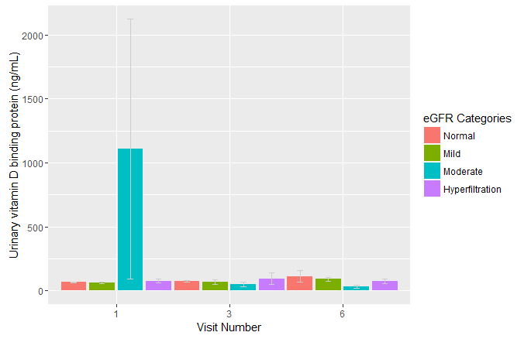

Figure: Mean urinary vitamin D binding protein concentrations across MCR categories at different time points.

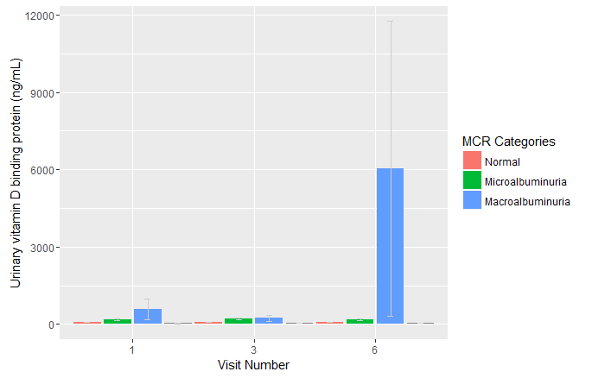

Figure: Mean urinary vitamin D binding protein concentrations across diabetic categories at different time points.

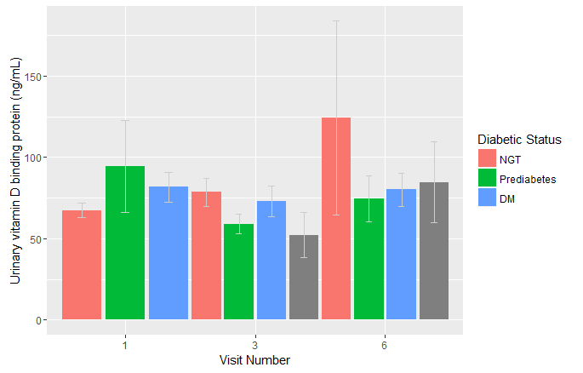

**Medication / Multiple Regression**

Figure: Bar graph/boxplot of medication (no medication, diabetes, hypertension, diuretic) versus UDBP concentration

Table: Multivariate analysis for the relationship between 25(OH)D and UDBP

|  |  |  |  |
| --- | --- | --- | --- |
| Model | Adjusted for | Beta | p-value |
| 1 | Unadjusted |  |  |
| 2 | Model 1 plus age, sex, ethnicity, BMI |  |  |
| 3 | Model 2 plus diabetic and kidney status |  |  |
| 4 | Model 3 plus medication (hypertension, diabetes, diuretic) |  |  |